Bahria University

Karachi Campus

LAB EXPERIMENT NO.

01

LIST OF TASKS

|  |  |
| --- | --- |
| **TASK NO** | **OBJECTIVE** |
| **1** | Implement the following network on packet tracer  Ping,   1. PC0 from PC5, 2. PC6 from PC2, 3. PC3 from PC1,   Also, display the above results in the simulation mode of packet tracer. Attach snapshots of the pinging results and the network created.Complete the table |

Submitted On:

**27/09/2023**

(Date: DD/MM/YY)

**LAB 01 INTRODUCTION TO PACKET TRACER**

Implement the following network on packet tracer.

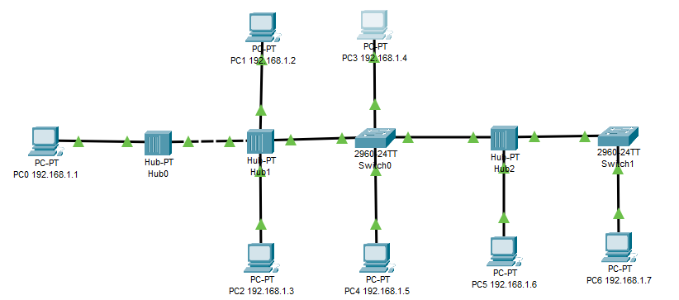

Ping,

1. PC0 from PC5,
2. PC6 from PC2,
3. PC3 from PC1,

Also, display the above results in the simulation mode of packet tracer. Attach snapshots of the pinging results and the network created.

**PC0 TO PC5**

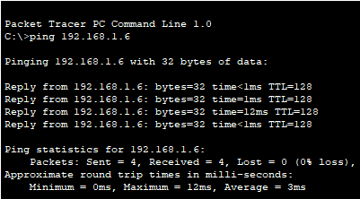

**PC6 TO PC2**

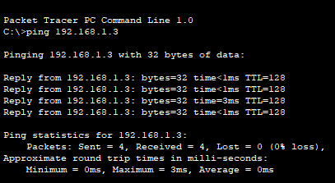

**PC3 TO PC1**

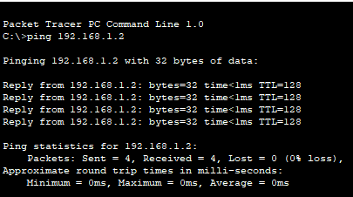

Complete the following table:

|  |  |
| --- | --- |
| End Device | IP Used |
| PC0 | 192.168.1.1 |
| PC1 | 192.168.1.2 |
| PC2 | 192.168.1.3 |
| PC3 | 192.168.1.4 |
| PC4 | 192.168.1.5 |
| PC5 | 192.168.1.6 |
| PC6 | 192.168.1.7 |