Bahria University,

Karachi Campus



LAB EXPERIMENT NO.

3

LIST OF TASKS

|  |  |
| --- | --- |
| TASK NO | OBJECTIVE |
| 1 | Run the following commands on the command prompt of your PCs and attach snapshots of the result:   * ping www.google.com * tracert www.yahoo.com * ping -i 6 www.facebook.com, did you receive the correct reply? If not, explain why. * nslookup www.live.com, did you result show ‘Non-authoritative answer’? If yes, explain what does it indicate, you are advised to browse the internet to attain this answer. |
| 2 | Differentiate between Ping and PathPing commands. |
| 3 | Find all Active/ Used IP addresses on your network. |
| 4 | How to verify connection with remote computer? |

Submitted On:

11-Oct -2023

(Date: DD/MM/YYYY)

**LAB 03 Diagnostic Utilities of a Network**

* Run the following commands on the command prompt of your PCs and attach snapshots of the result: i.

1. ping www.google.com

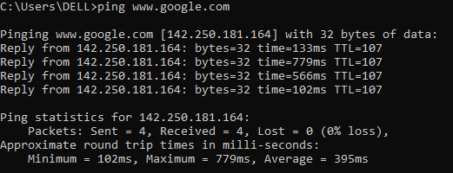

1. tracert www.yahoo.com

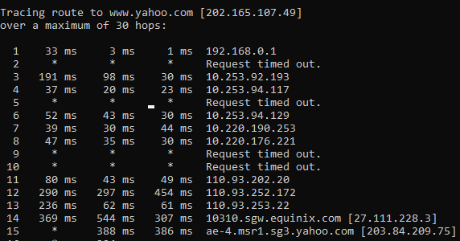

1. ping -i 6 www.facebook.com, did you receive the correct reply? If not, explain why

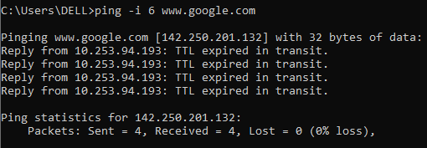

1. nslookup www.live.com, did you result show ‘Non-authoritative answer’? If yes, explain what does it indicate, you are advised to browse the internet to attain this answer.

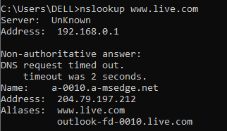

When using the nslookup utility to query Domain Name System (DNS) servers, you could see the message “Non-authoritative answer.” This tells you that the DNS server you're asking can't ensure that it has the official, up-to-date information for the domain name or IP address

* Differentiate between Ping and PathPing commands.

|  |  |
| --- | --- |
| **PING** | **PATHPING** |
| With ping, you get the latency and packet loss between the source and the destination | In pathping, you get a list of all the routers between the source and the destination, as well as the latency and packet loss between all the routers along the way and the source. |

• Find all Active/ Used IP addresses on your network.

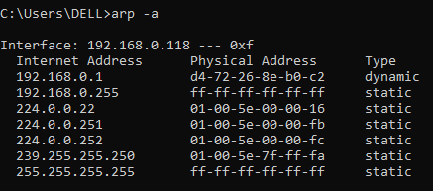

* How to verify connection with remote computer?

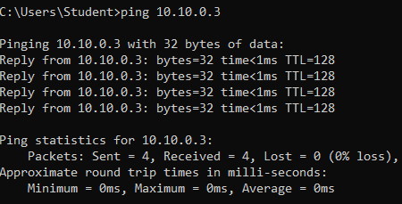

-w timeout

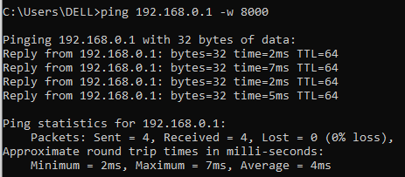

Destination-list

