**SOFTWARE CONSTRUCTION**

**KANWAL SHEHZADI 02-131212-027**

**RELEASE MANAGEMENT**

Release management is a critical process that oversees the entire software release lifecycle, encompassing development, testing, and deployment. When introducing a new product or making changes to an existing one, a reliable release management process ensures a smooth and successful transition. Here's an overview of the five primary steps in a release procedure:

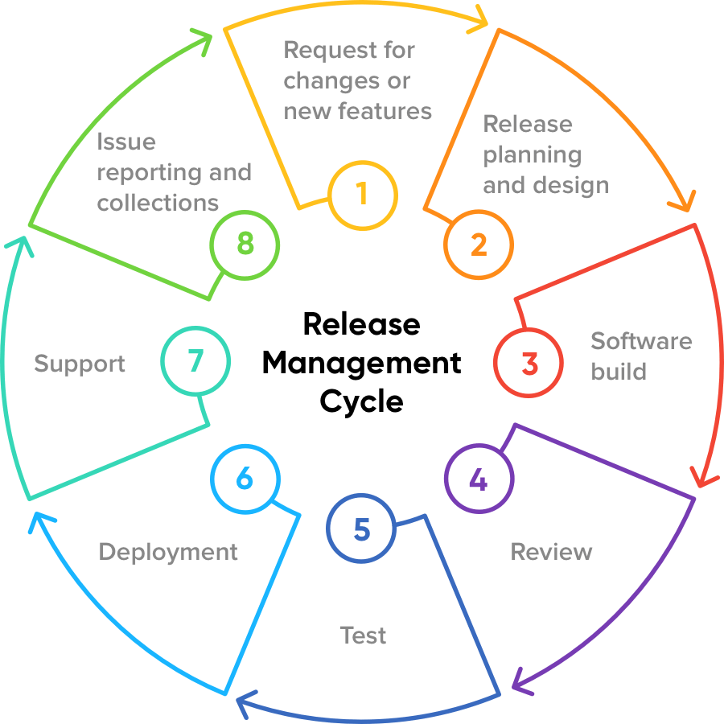

1. **Plan Release:**

In this phase, the entire release is meticulously structured, outlining the roadmap from start to finish.

**Example:** Utilizing the Systems Development Life Cycle (SDLC) or similar methods, teams create comprehensive release plans that include timelines, delivery dates, project requirements, and the overall project scope. Visual tools help create intuitive flowcharts, checklists, and workflows, enhancing clarity for both the team and stakeholders.

**Scenario:** Imagine a team is developing a cutting-edge virtual reality (VR) gaming experience. In the planning stage, you not only set timelines but also map out the user journey in the VR world. It's like orchestrating a thrilling adventure, ensuring that players seamlessly transition through different levels and challenges.

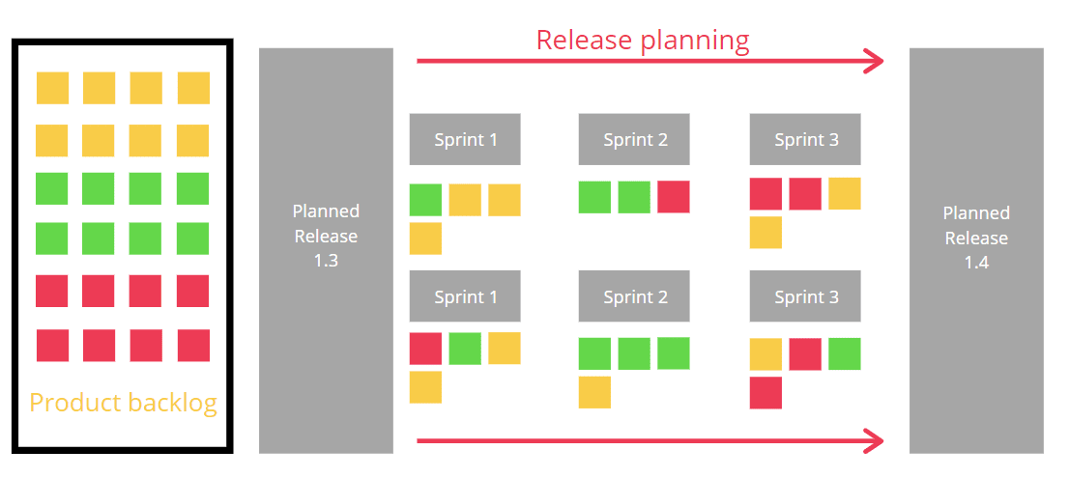

1. **Build Release:**

With the release plan in place, the actual development of the product begins, adhering to the outlined requirements.

**Example:** The product undergoes real-world scenario testing in a dedicated environment. This iterative process involves continuous development, testing, and refinement, with builds transitioning between stages until the final version is approved.

**Scenario:** A team is creating an innovative AI-driven personal assistant application. During the build phase, it's not just about coding; it's like crafting the personality of the assistant. Developers, like scriptwriters, carefully design the AI's responses, ensuring it becomes a helpful and friendly companion for users.

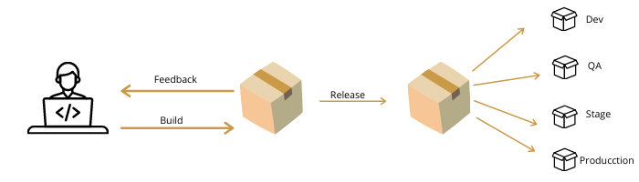

1. **User Acceptance Testing (UAT):**

Description: End users engage with the product, providing valuable feedback through beta trials or internal testing.

**Example:** UAT is a pivotal step, identifying bugs and issues that may have eluded earlier stages. The process involves continuous refinement based on user feedback until the build meets the necessary criteria for official launch.

**Scenario:** Let's say a company is launching a new e-learning platform. In the UAT phase, you release a beta version to a group of enthusiastic students and educators. Their feedback isn't just about identifying bugs; it's like refining the curriculum based on real classroom experiences, making the platform truly user-centric.

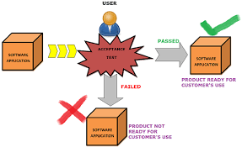

1. **Prepare Release:**

Description: The product undergoes final preparations, incorporating insights from UAT and undergoing a thorough quality assurance (QA) review.

**Example:** QA teams conduct final checks, ensuring the build aligns with business requirements outlined in the release plan. Validation by the functional team and approval from the product owner are essential before the build is considered ready for deployment.

**Scenario:** A team is developing a revolutionary health and wellness app. In the release preparation stage, it's not just about final checks; it's like preparing a personalized fitness plan for each user. The Quality Assurance team acts as fitness trainers, ensuring that every feature contributes to the overall health of the application.

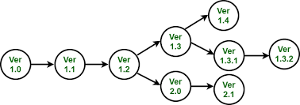

1. **Deploy Release:**

Description: The product is released into the live production environment, accompanied by messaging, education, and post-deployment assessment.

**Example:** Besides deploying the build, teams communicate changes to end-users and provide necessary training. Post-deployment meetings assess performance and address any lingering issues, contributing to continuous improvement for future releases.

**Scenario:** Picture a team launching a decentralized finance (DeFi) platform. The deployment is not just about sending the build live; it's like introducing a new financial district. You communicate with users about the novel financial tools available, providing educational resources as if you're guiding them through the bustling streets of a financial metropolis.

