Bahria University,

Karachi Campus



LAB EXPERIMENT NO.

04

LIST OF TASKS

|  |  |
| --- | --- |
| TASK NO | OBJECTIVE |
| 1 | In which year max no of fires were reported |
| 2 | Find average number of fires reported from highest to lowest with reference to state |
| 3 | Find the state names where fire was reported in Dec |
| 4 | Report top 3 states where highest number of fires were reported. |
| 5 | Report fires from Bahia, Acre, and Rio fetch data from 2010 to 2015 and number offires greater than 0. |
| 6 | Report year wise fires of the state with highest number of fires |
| 7 | Find aggregate(sum,count, avg, max, min) of number of fires state wise |

Submitted On:

20 OCT 2023

(Date: DD/MM/YYYY

**LAB 04 PANDAS BASIC**

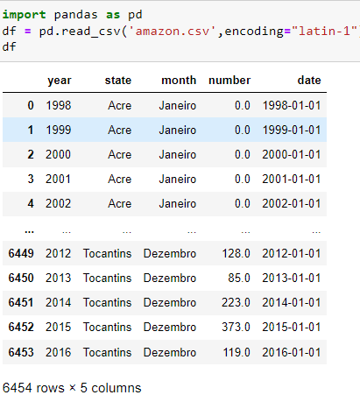

1. In which year max no of fires were reported

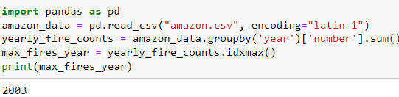

1. Find average number of fires reported from highest to lowest with reference to state.

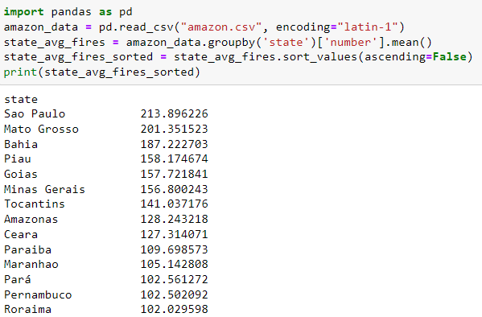

1. Find the state names where fire was reported in Dec.

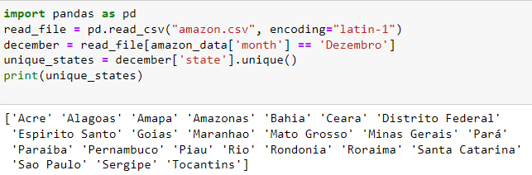

1. Report top 3 states where highest number of fires were reported.

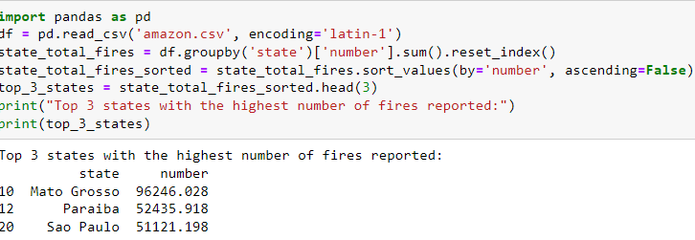

1. Report fires from Bahia, Acre, and Rio fetch data from 2010 to 2015 and number of fires greater than 0.

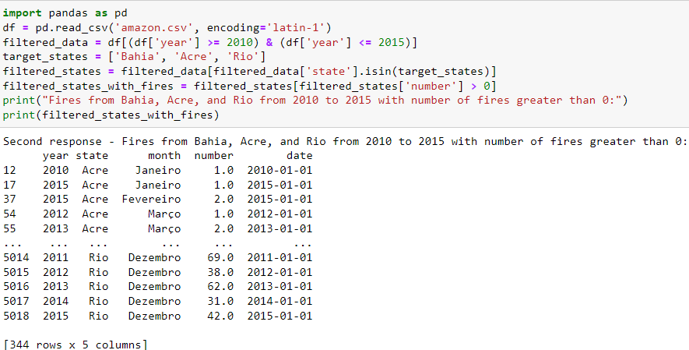

1. Report year wise fires of the state with highest number of fires.

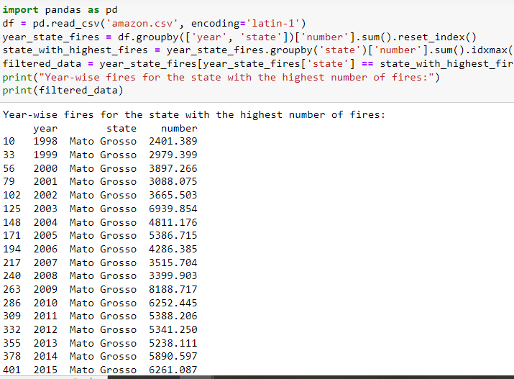

1. Find aggregate(sum, count, avg, max, min) of number of fires state wise.

