Bahria University

Karachi Campus

LAB EXPERIMENT NO.

01

LIST OF TASKS

|  |  |
| --- | --- |
| **TASK NO** | **OBJECTIVE** |
| **1** | Form groups of 4 or 5 students (with one of them as a leader and identify their roles). Brainstorm its features (each group must have unique project)(maximum member 3-4) and list 5 suitable project titles. Choose one of the projects from your list. Try to write (a hypothetical) project definition for it. |
| **2** | Submit project proposal in the next class along with group name, members name, leader name and their roles other than the above given example of project definition also use project management tool like trello to share the proposal with the team members of the group and paste just few screenshots as a proof of work. |

Submitted On:

**26/09/2023**

(Date: DD/MM/YY)

**LAB 01 INTRODUCTION TO PROJECT DEFINITION**

**Task 01:**

Form groups of 4 or 5 students (with one of them as a leader and identify their roles). Brainstorm its features (each group must have unique project)(maximum member 3-4) and list 5 suitable project titles. Choose one of the projects from your list. Try to write (a hypothetical) project definition for it.

Certainly, here are five suitable project titles, and I'll choose one of them to create a hypothetical project definition:

* Smart Home Energy Management System
* Urban Traffic Congestion Reduction Through AI
* Online Mental Health Support Platform
* Sustainable Agriculture Monitoring and Optimization
* AI-Powered Personalized Learning Platform

**PROJECT TITLE:** **ONLINE MENTAL HEALTH SUPPORT PLATFORM**

**Project Definition:**

The **"Online Mental Health Support Platform"** project aims to develop a comprehensive digital platform that offers accessible and effective mental health support to individuals globally. This platform will leverage technology and AI-driven solutions to provide a wide range of mental health resources, interventions, and real-time support, promoting overall well-being and reducing the stigma associated with seeking help for mental health issues. **The "Online Mental Health Support Platform"** project seeks to leverage technology to make mental health support more accessible and destigmatized, ultimately contributing to the well-being of users worldwide.

**Task 02:**

Submit project proposal in the next class along with group name, members name, leader name and their roles other than the above given example of project definition also use project management tool like trello to share the proposal with the team members of the group and paste just few screenshots as a proof of work.

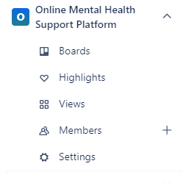

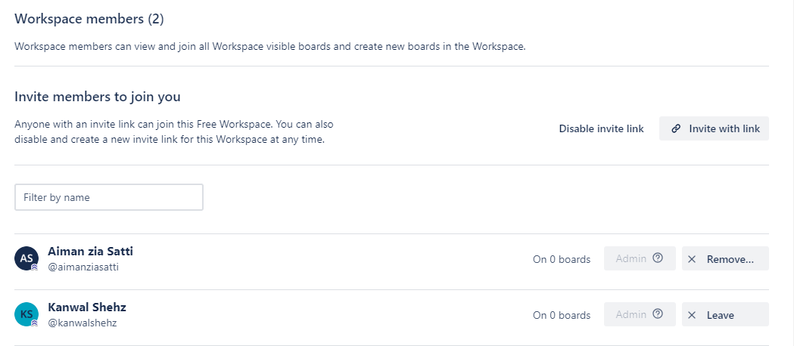

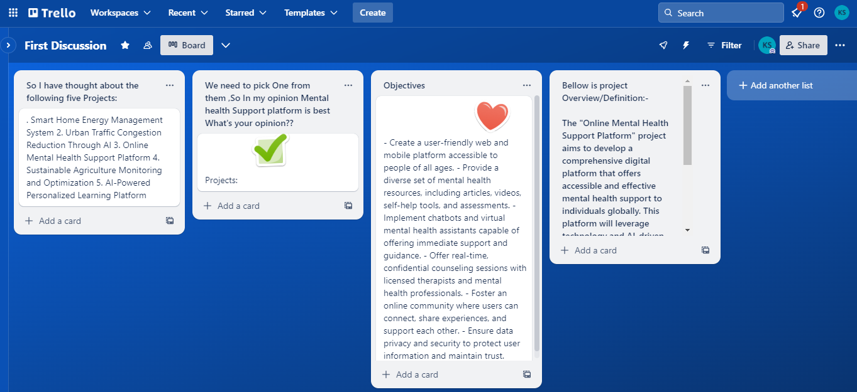



**FALL SEMESTER 2023, BSE-5B**

**SOFTWARE CONSTRUCTION SEN-311**

**Lab-1 “PROJECT PROPOSAL”**

**PROJECT TITLE:**

**ONLINE MENTAL HEALTH SUPPORT PLATFORM**

**Aiman Zia Satti (02-131212-028) – Group Leader**

**Kanwal Shehzadi (02-131212-027)**

**COURSE & LAB INSTRUCTOR: Dr Salahuddin & Engr. Hamza**

**Submission Date: September 26, 2023**

1. **PROBLEM STATEMENT**

Mental health issues are on the rise globally, and access to mental health services is often limited. To address this pressing problem, we propose the development of an Online Mental Health Support Platform.

1. **SCOPE**

Our platform will encompass the following key aspects:

* **Counseling Services:** Offering real-time chat and video counseling sessions with trained professionals.
* **Educational Resources:** Providing an extensive resource library with articles, videos, and interactive tools to promote self-help.
* **Inclusivity:** Ensuring multilingual and culturally sensitive services to reach a diverse user base.
* **Security and Compliance**: Adhering to data protection laws like HIPAA and GDPR to maintain user privacy and trust.
* **User Engagement:** Creating a user-friendly interface that encourages user engagement.
* **Monitoring and Evaluation:**Establishing metrics to track platform usage, user satisfaction, and content engagement.

1. **OBJECTIVES**

The primary objectives of our project are as follows:

* **Development:** Create a user-friendly online platform with features for mental health support.
* **Accessibility:** Offer accessible, reliable, and confidential support to individuals in need.
* **Awareness**: Raise awareness about mental health issues through educational resources.
* **Inclusivity:** Ensure inclusivity by providing services in multiple languages.
* **Privacy:** Prioritize data security and comply with international regulations.

1. **FUNCTIONALITIES**

* **Kanwal Shehzadi**
* She will be responsible for platform development.
* Develop the user-friendly website and mobile app.
* Translate content into multiple languages for inclusivity.
* Develop self-help resources, articles, and interactive tools.
* **Aiman Zia Satti**
* Set up a secure database for user information.
* Implement communication tools (text, audio, video).
* She will lead content creation and translation efforts.
* Collaborate with mental health professionals to create informative content.

1. **TECHNOLOGY**

* Our platform will utilize the latest technologies to deliver a seamless user experience:
* Front-end Development: HTML5, CSS3, JavaScript, React.js for web, and React Native for mobile.Back-end Development: Node.js, Express.js, and MongoDB for a scalable and secure database.