**LAB 03 SRS DOCUMENT “ONLINE MENTAL HEALTH SUPPORT PLATFORM”**

**1. INTRODUCTION**

* **PURPOSE OF THE DOCUMENT**

This document serves as a reference for all stakeholders involved in the development of  ***Online Mental Health Support Platform***. It provides a clear and concise description of the project's objectives, functionalities, and constraints.

* **SCOPE OF THE PROJECT**

The project's scope includes the development of an online platform accessible via web and mobile applications. It encompasses features such as user registration, therapist matching, secure communication channels, educational resources, and assessment tools for mental health evaluation. The scope also covers user support and maintenance.

* **OVERVIEW OF THE SOFTWARE BEING DESCRIBED**

The ***Online Mental Health Support Platform*** will offer a user-friendly interface, allowing users to access mental health services, connect with therapists, and access a library of mental health resources. It will prioritize user privacy, data security, and seamless communication with mental health professionals.

**2 . DOCUMENT CONVENTIONS**

Throughout this document, the following conventions and terminology will be used:

* **User:** Refers to individuals using the platform, including clients seeking support and therapists providing assistance.
* **Platform:** Refers to the ***Online Mental Health Support Platform***.
* **Administrator:** Refers to system administrators responsible for maintaining and monitoring the platform.
* **SRS:** Software Requirements Specification.
* **UI:** User Interface.
* **API:** Application Programming Interface.

**3. REFERENCES**

No external documents or sources are referenced in this SRS.

**4. OVERALL DESCRIPTION**

**4.1 PRODUCT PERSPECTIVE**

The ***Online Mental Health Support Platform*** is a standalone application designed to connect users with mental health professionals. It does not depend on any other external systems or platforms.

**4.2 PRODUCT FUNCTIONS**

* User registration and authentication
* User profile management
* Matching users with qualified therapists
* Secure and private messaging system
* Access to a library of mental health resources
* Assessment tools for mental health evaluation
* User support and assistance

**4.3 USER CLASSES AND CHARACTERISTICS**

The platform will serve two main user classes:

* **Clients:** Individuals seeking mental health support
* **Therapists:** Qualified mental health professionals providing support

**4.4 OPERATING ENVIRONMENT**

The platform will be accessible via web browsers (desktop and mobile) and dedicated mobile applications. It will require an internet connection for full functionality.

**4.5 DESIGN AND IMPLEMENTATION CONSTRAINTS**

* The platform must adhere to all relevant data protection and privacy regulations.
* Compatibility with various web browsers and mobile devices is essential.
* Security measures must be implemented to protect user data and communications.

**4.6 ASSUMPTIONS AND DEPENDENCIES**

The successful development of the platform assumes:

* Availability of qualified therapists willing to participate in the program.
* Reliable internet connectivity for users.
* Compliance with legal and regulatory requirements regarding mental health services and data privacy.

**5. SPECIFIC REQUIREMENTS**

**5.1 FUNCTIONAL REQUIREMENTS**

|  |  |  |
| --- | --- | --- |
| FR001 | User Registration | Users should be able to create an account with their personal information. |
| FR002 | User Authentication | User Authentication:  Users should be able to log in securely using username/email and password. |
| FR003 | Secure Communication | Provide a secure and private communication channel for users to interact with mental health professionals. |
| FR004 | User Matching | Match users with appropriate mental health professionals based on their needs and preferences. |
| FR005 | Appointment Scheduling | Users should be able to schedule appointments with mental health professionals. |

**5.2 NON-FUNCTIONAL REQUIREMENTS**

|  |  |  |
| --- | --- | --- |
| NFR001 | Security | The platform must comply with industry-standard security protocols to safeguard user data and maintain confidentiality. |
| NFR002 | Scalability | The system should be able to handle increased user loads as the platform grows, ensuring it remains responsive and efficient. |
| NFR003 | Usability | The platform should have an intuitive user interface, making it easy for users of varying technological abilities to access and utilize the services. |
| NFR004 | Availability | The platform should have high uptime and reliability to ensure users can access support whenever they need it, minimizing downtime. |
| NFR005 | Compliance | The system must adhere to all legal and ethical standards and regulations governing online mental health services, including telehealth compliance and data privacy laws. |

**5.3 EXTERNAL INTERFACES**

|  |  |
| --- | --- |
| Electronic Health Records (EHR) Systems | Secure access to client records for therapists and compliance with healthcare regulations. |
| Payment Gateway Services | Safe and convenient payment processing for therapy sessions and premium features. |
| Telehealth Platforms | Seamless video conferencing for remote mental health services. |
| Pharmacy and Laboratory Systems | Medication management and diagnostic test integration. |
| Language Translation Services | Real-time translation for diverse language accessibility. |

**5.4. SYSTEM FEATURES**

|  |  |  |
| --- | --- | --- |
| SF001 | User Registration and Authentication | This feature allows individuals to create accounts and securely log in to the platform. |
| SF002 | User Profiles | Users can build personal profiles with information and preferences |
| SF003 | Matching and Recommendation | Algorithms suggest therapists or resources based on user needs and preferences. |
| SF004 | Appointment Management | Users can schedule, manage, and receive reminders for therapy sessions. |
| SF005 | Real-time Communication | Enables secure, real-time messaging or video calls between users and professionals |
| SF006 | Crisis Support and Hotlines | Immediate access to crisis interventions and helplines for users in distress. |
| SF007 | Content Library | Provides a repository of articles, videos, and self-help materials on mental health topics |

**5.5. DATA REQUIREMENTS**

* + User account information (name, email, username, password)
  + User profiles (age, gender, communication preferences)
  + Therapist profiles (credentials, specialization)
  + Messaging history (text, audio, video)
  + Assessment results
  + Resource library content

**5.6. USE CASES OR SCENARIOS**

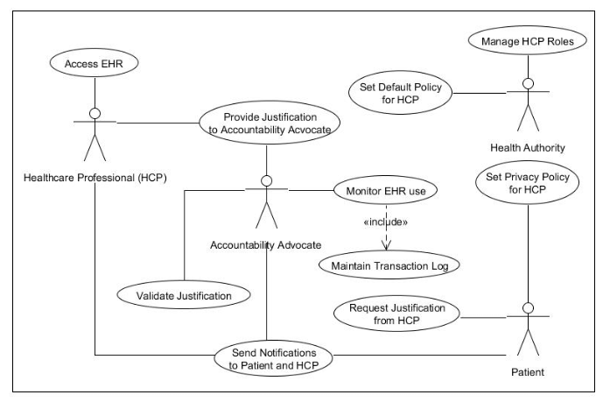

**6. USER INTERFACE REQUIREMENTS**

|  |  |
| --- | --- |
| **Design And Layout Specifications** | * + The user interface should employ a clean and intuitive design with calming colors to create a positive user experience.   + The layout should be responsive, adapting to various screen sizes and orientations on both web and mobile platforms. |
| **User Interaction And Navigation** | * + The navigation menu should be prominently displayed, allowing users to access key features with ease.   + Users should be able to initiate therapist matching, access the resource library, and use assessment tools from the homepage. |

**7. QUALITY ATTRIBUTES**

|  |  |
| --- | --- |
| **Reliability** | * + The platform should ensure secure data transmission and storage to maintain user trust.   + It should minimize downtime through effective error handling and regular maintenance. |
| **Availability** | * + The platform should have high availability (99.9%) to ensure users can access support when needed.   + Scheduled maintenance should be communicated to users in advance. |
| **Scalability** | * + The system should be designed to accommodate a growing user base.   + Scalability should not compromise performance. |
| **Maintainability** | * + The platform should support seamless updates and bug fixes without causing significant disruption.   + Codebase should be well-documented to ease maintenance efforts. |
| **Portability** | * + The web-based platform should be compatible with major web browsers, including Chrome, Firefox, Safari, and Edge.   + Mobile applications should be available for Android and iOS devices. |

**8. CONSTRAINTS**

* + Compliance with data protection laws (e.g., GDPR, HIPAA) and mental health practice regulations is mandatory.
  + Platform content must adhere to ethical guidelines and standards.

**9. ASSUMPTIONS AND DEPENDENCIES**

**9.1 ASSUMPTIONS**

* + Assumed the availability of qualified therapists willing to participate in the platform.
  + Users have access to stable internet connections to use the platform effectively.

**9.2 DEPENDENCIES**

* The platform may depend on third-party APIs for features like payment processing and external authentication.
* Maintenance and security updates may be dependent on external software libraries and services.

**10. APPENDICES**

* + Detailed use case diagrams, data flow diagrams, and wireframes will be included in separate documentation.
  + Any additional technical specifications or reference materials will be provided in the appendices.

**11. GLOSSARY**

* + **GDPR:** General Data Protection Regulation, a European Union regulation governing data protection and privacy.
  + **Web Browser:** Software application used to access and display web pages on the internet.
  + **Mobile Application:** Software designed to run on mobile devices, such as smartphones and tablets.