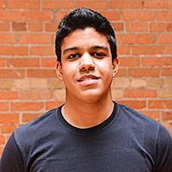

Vinicius is a brazilian 20-year-old computer science undergraduate student. He’s an adventurous guy and has an easy personality. He likes sports such as soccer, ice hockey and football.

Vinicius is at University of Toronto through a scholarship program named Science without Borders, sponsored by Brazil’s government. During this year, he has completed the Winter term at UTSC and a work term in a startup called Wattpad, the world’s largest community of readers and writers. He had a great experience to work as QA developer, being able to work with tools as GitHub, Selenium, Appium and Xcode during the summer.

Vinicius has experience with programming languages as Python, Java, C++ and some knowledge of mobile programming in iOS.

As an international student, Vinicius is always seeking for new experiences and people during his stay in Canada. He’s willing to help and provide any information about Brazil and Sao Paulo, his hometown.