**Dr. Alejandro Paz - Researcher**



Dr. Alejandro Paz, 30 years, is an Assistant Professor of Anthropology at the University of Toronto Scarborough. He is a calm and serene man, with a relaxed personality. He doesn’t have a strict routine since he believes that life may be enjoyed along with work duties. Besides his teaching and researching duties, he usually plays soccer and baseball in his neighborhood at Scarborough. Dr. Paz is single, but has one son from a previous marriage.

Dr. Paz has graduate affiliations in the departments of Anthropology and Linguistics, teaching courses in both departments. His researches include a variety of topics, including Language in Transnational and Global Contexts, Media and Publics, Translation and Commensuration, Pragmatics and Interaction and Israel in the Middle East. His current works are based on extensive ethnographic, archival and linguistic fieldwork in Israel and Palestine.

Since Dr. Paz doesn’t have a strict routine as a professor and researcher, when he is not teaching he can be either in his research lab in the Anthropology departments where he manages a research team with a graduate student or at his house, where he has a huge office to work on his researches from home.

Dr. Paz has great computer skills, being able to easily answer emails and write notes through his iPhone, and use a variety of computer software packages to collect, analyze and organize information and data in his MacBook, which he then present to other members of his department, either in a written report or oral presentation.

One of Dr. Paz’s main needs now is to be able to stay updated in the world’s ethnographic and transnational news and conflicts. Not only to be aware of what is happening but also to have reliable sources so that he can work through some of them in order to develop his researches. He needs a software that connects news sources in such a way that both the connection between the news and the sources are strictly reliable, coming from well-known news agencies and serious journalists. According to Dr. Paz, that would increase the productivity of his researches and be a valuable tool for his department in the future.

**Alex Ferguson - Graduate Student**

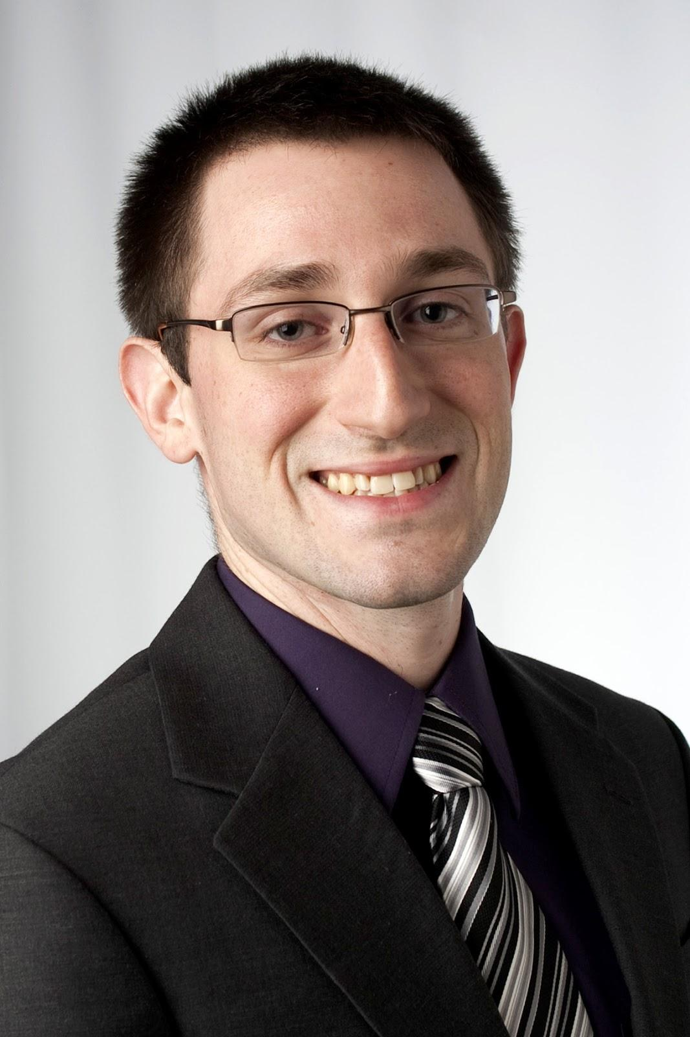

Alex Ferguson, 25 years, is a Graduate Student of the Anthropology Department at the University of Toronto Scarborough. He has a serious personality and is very hard-working and energetic. He always want to be on schedule and get things done, no matter how hard he has to work on them. Mr. Ferguson is engaged and expecting to get married within the next months. One of his main hobbies is fishing, which he believes is a good way to free his mind from his intense work scheduling.

Mr. Ferguson got a BSc in Anthropology at University of British Columbia. He was awarded as Alumni student for being outstanding scholarly during his undergraduate years. He specialized in Socio-Cultural Anthropology, emphasizing his interests in Middle East region.

Currently working with Dr. Alejandro Paz at the Anthropology Department at UTSC, Alex’s main responsibilities involve defining research parameters and expanding the knowledge of that research field by discovering an unique approach to different global conflicts/news to help Dr. Paz in his projects. That requires a lot of time looking for trustable sources and reliable connections between them to make resourceful articles.

With good skills in computer usage, being able to use applications to manage his researches such as word processors and web browsers, Alex’s work would be facilitated by a software that could make those connections between news sources and help him build solid articles for Dr. Paz to work in.