# Hyperledger Fabric

Hyperledger Fabric is a blockchain framework implementation and one of the Hyperledger projects hosted by The Linux Foundation. Intended as a foundation for developing applications or solutions with a modular architecture, Hyperledger Fabric allows components, such as consensus and membership services, to be plug-and-play. Hyperledger Fabric leverages container technology to host smart contracts called “chaincode” that comprise the application logic of the system.

In this document you will be getting a step by step guide on how to make a multi peer network in the fabric on a windows platform specifically.

Let us start with installing some Pre-requisites:-

STEP-1

Windows 10: Docker version 17.06.2-ce or greater is required, for Older versions of Windows: Docker Toolbox - again, Docker version Docker 17.06.2-ce or greater is required. You can easily download it from the official site of the docker community.

You can check the version of Docker you have installed with the following command from a terminal prompt:

docker **--**version

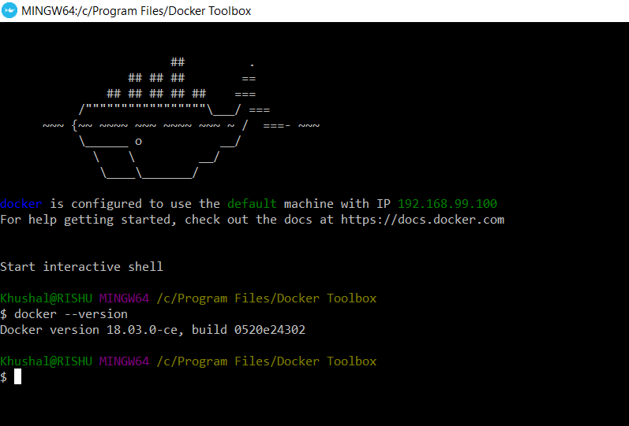

If you are developing on Windows 7, you will want to work within the Docker Quickstart Terminal which uses Git Bash and provides a better alternative to the built-in Windows shell.

However experience has shown this to be a poor development environment with limited functionality. It is suitable to run Docker based scenarios, such as Getting Started, but you may have difficulties with operations involving the **make** and **docker**commands.

On Windows 10 you should use the native Docker distribution and you may use the Windows PowerShell. However, for the Download platform specific binaries command to succeed you will still need to have the **uname** command available. You can get it as part of Git but beware that only the 64bit version is supported.

Before running any **git clone** commands, run the following commands:

git config **--global** core**.**autocrlf false

git config **--global** core**.**longpaths true

You can check the setting of these parameters with the following commands:

git config **--**get core**.**autocrlf

git config **--**get core**.**longpaths

These need to be false and true respectively.

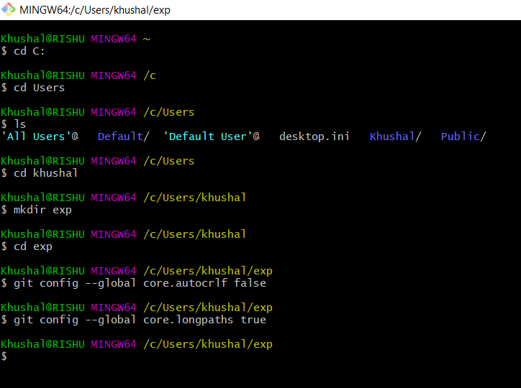

STEP2-(WINDOWS POWER SHELL)

You have to install nodejs for some commands to work, you can download it from the official nodejs site. This should be done in the windows power shell(Administrative mode)

we can install it using the following command in windows power shell:-

npm install **--global** windows**-**build**-**tools

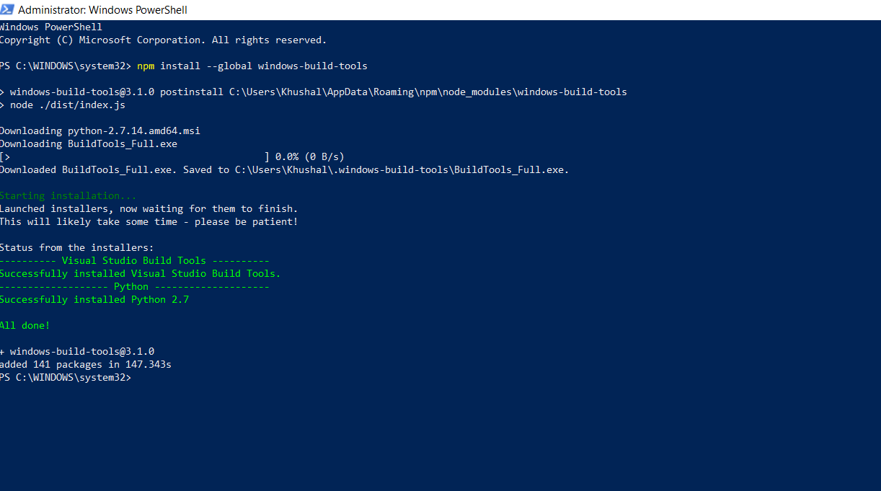

The above step should be done in the windows power shell(Administrative mode) , followed by another command:-

npm install **--global** grpc

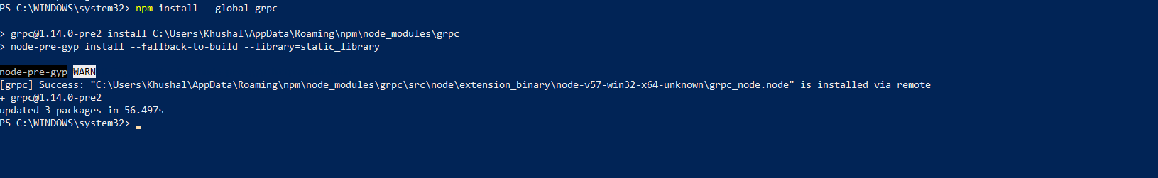

STEP-3

If you are running on Windows you will want to make use of the Docker Quickstart Terminal for the upcoming terminal commands. Please visit the Prerequisites if you haven’t previously installed it.

If you are using Docker Toolbox on Windows 7 or macOS, you will need to use a location under C:\Users (Windows 7) or /Users (macOS) when installing and running the samples.

Determine a location on your machine where you want to place the Hyperledger Fabric samples applications repository and open that in a terminal window. Then, execute the following commands:

git clone **-**b master https:**//**github**.**com**/**hyperledger**/**fabric**-**samples**.**git

cd fabric**-**samples

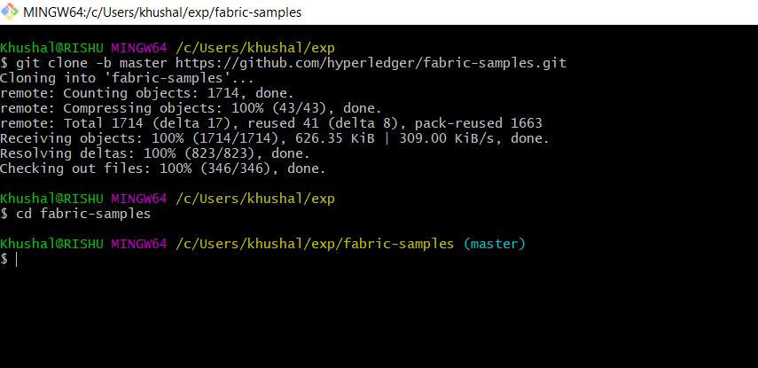

STEP-4

Next, we will install the Hyperledger Fabric platform-specific binaries. This process was designed to complement the Hyperledger Fabric Samples above, but can be used independently. If you are not installing the samples above, then simply create and enter a directory into which to extract the contents of the platform-specific binaries.

Please execute the following command from within the directory into which you will extract the platform-specific binaries:-

curl -sSL https://goo.gl/6wtTN5 | bash -s 1.1.0

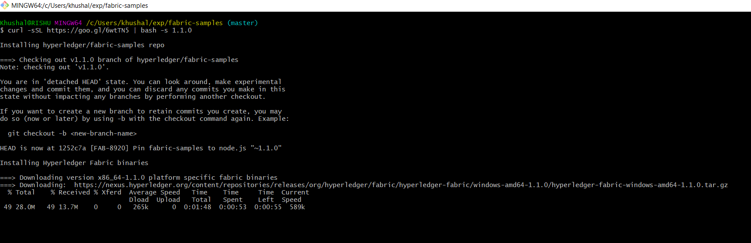

STEP-5

You may want to add that to your PATH environment variable so that these can be picked up without fully qualifying the path to each binary. e.g.:

export PATH=<path to download location>/bin:$PATH

EG🡪 export PATH=/C:/Users/Khushal/exp/fabric-samples/bin:$PATH

Finally, the script will download the Hyperledger Fabric docker images from Docker Hub into your local Docker registry.

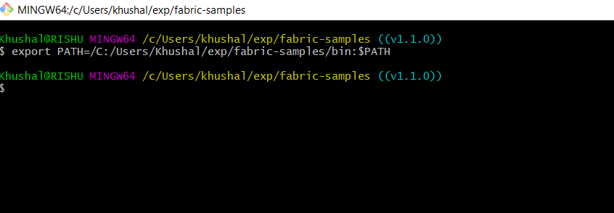

STEP-6

The build your first network (BYFN) scenario provisions a sample Hyperledger Fabric network consisting of two organizations, each maintaining two peer nodes, and a “solo” ordering service.

You will also need to download and install the Hyperledger Fabric Samples. You will notice that there are a number of samples included in the **fabric-samples** repository. We will be using the **first-network** sample. Let’s open that sub-directory now.

cd fabric-samples/first-network

We provide a fully annotated script - byfn.sh - that leverages these Docker images to quickly bootstrap a Hyperledger Fabric network comprised of 4 peers representing two different organizations, and an orderer node. It will also launch a container to run a scripted execution that will join peers to a channel, deploy and instantiate chaincode and drive execution of transactions against the deployed chaincode.

Ready to give it a go? Okay then! Execute the following command:

./byfn.sh -m generate

You will see a brief description as to what will occur, along with a yes/no command line prompt. Respond with a **y** or hit the return key to execute the described action.

This first step generates all of the certificates and keys for our various network entities, the genesis block used to bootstrap the ordering service, and a collection of configuration transactions required to configure a Channel.

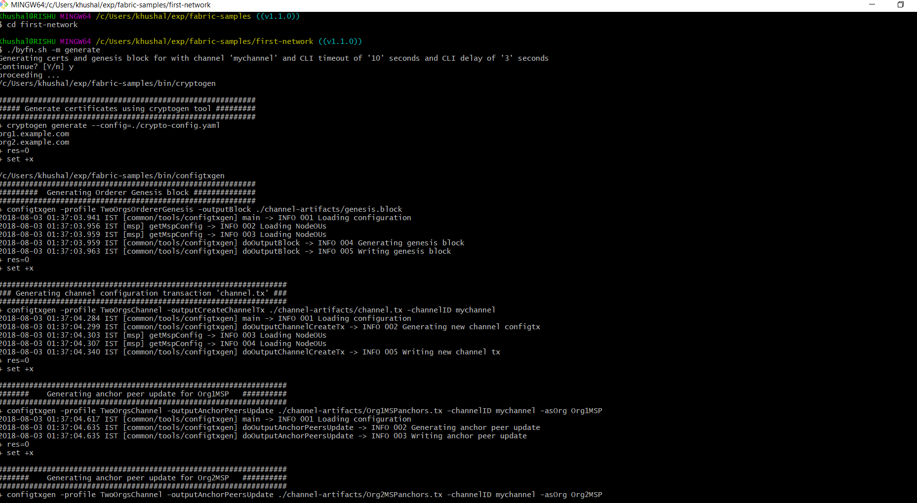

STEP-7 (Bring Up the Network)

Next, you can bring the network up with one of the following commands:

./byfn.sh -m up

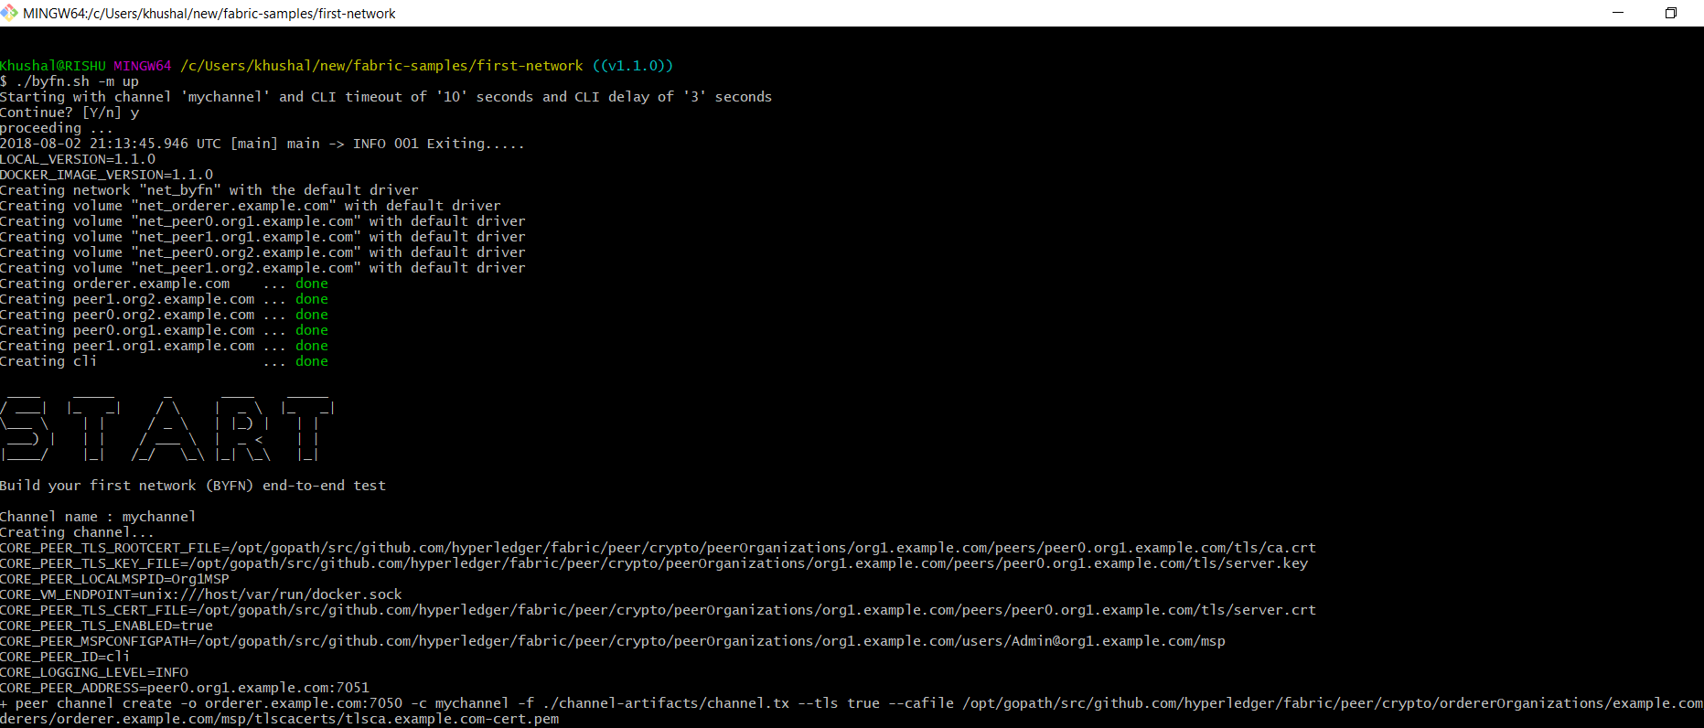

You will see a brief description as to what will occur, along with a yes/no command line prompt. Respond with a **y** or hit the return key to execute the described action.

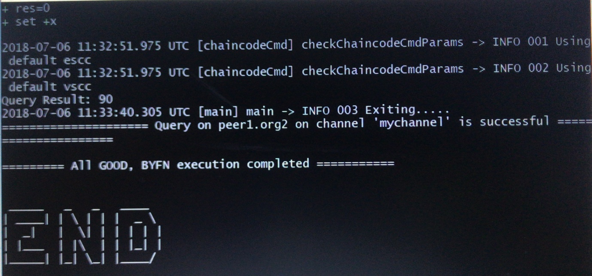

The above command will compile Golang chaincode images and spin up the corresponding containers. Go is the default chaincode language, however there is also support for Node.js chaincode

STEP-8(Bring Down the Network)

Finally, let’s bring it all down so we can explore the network setup one step at a time. The following will kill your containers, remove the crypto material and four artifacts, and delete the chaincode images from your Docker Registry:

./byfn.sh -m down

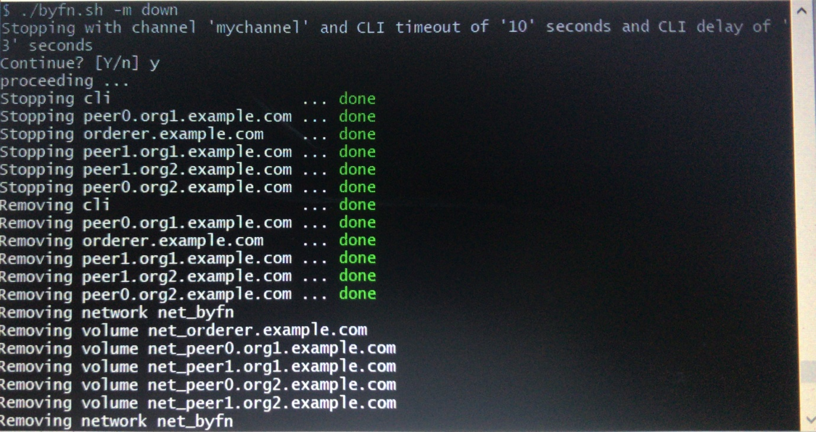

Hence this documentation shows the easy installation and working of a multi peer hyperledger fabric on windows platform.