**Part1 二因子组合平均收益率**

Average monthly percent excess returns for portfolios formed on Size and B/M, Size and OP, Size and Inv;

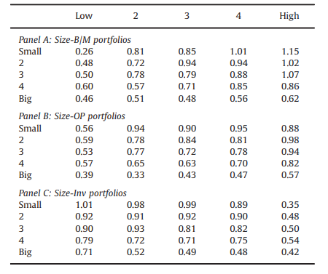

**Part2 因子构建**

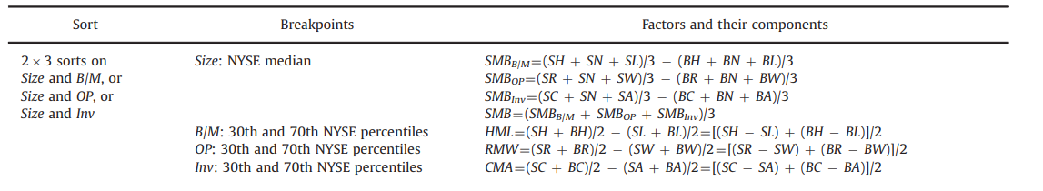

**Part3 因子性质分析**

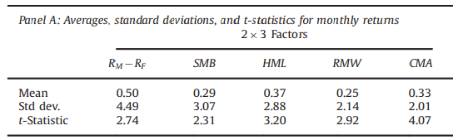

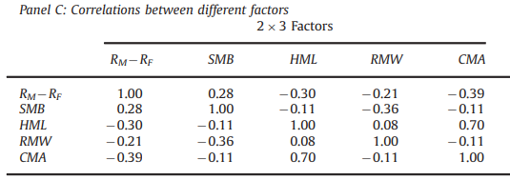

**Part4 因子在资产组合中的解释力**



