68090500402

#include <stdio.h>

#include<string.h>

int main() {

char name[50];

int age;

// name[50];

scanf("%s", &name);

scanf("%d", &age);

printf("hello %s , you are %d year old",name,age);

return 0;

}

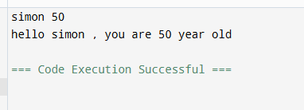

int main(){

int c;

scanf("%d",&c);

float f;

f= (c\*9/5) + 32;

printf("Fahrenheit = %.2f",f);

return 0;

}

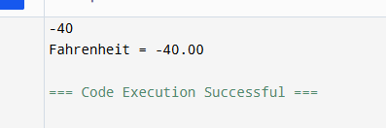

int main(){

char name[100];

int num;

// printf("Name: %s \nFavorite number: %d", name,num);

fgets(name,sizeof(name), stdin);

scanf("%d", &num);

printf("name: %s Favorite number: %d",name,num);

return 0;

}

