VISUAL DESIGN

Screenplay is little more than a bare skeleton for a motion picture. All visual design flows from the original script

Key members of the production team who plan the visual design of film.

director

cinematographer

production designer

costumer

This team works toward single goal: creating a master plan for a consistent visual style that is artistically suited to the film story being told.

Considerations:

lighting

aspects to emphasize

filming in a studio or location

costumes / makeup

Color versus Black and White Photography

Color can prettify the subject of a film

Black and white focuses attention on important aspects. Can be used to suggest dark underworld (Film Noir)

95% of all movies have been made in color.

Color enhances reality and image carries more information.

Screen Format

Standard Screen versus Wide screen

SS great for romance and personal dramatic stories

WS Epic storytelling, fantasy, science fiction, horror

Film Stock and High Definition Videography

Artistic perfection of HD goes beyond reality. Manipulating pixels. Similar to music on CDs

Film Stock appears as if video was captured in the moment (Beginning of *Citizen Kane* / *The Incredibles*) Images are gritty and less realistic. Manipulating actual film. Similar to music on vinyl records.

Production Design / Art Direction

Modern production designers make detailed sketches and plans for the set and then supervise the construction, painting, furnishings, and decoration until an exact visual appearance is achieved.

In order to do this, the production designers consult the director, cinematographer, and the costumer to achieve a unified visual effect.

A basic blueprint is the script. Design is an expressive use of objects, forms, and colors in the service of the script.

A script may suggest visual metaphors and reinforce the need for a specific color palette, so that a few carefully chosen colors are emphasized to suggest a mood or atmosphere.

For example there's some unwritten rule that horror movies should be blue:

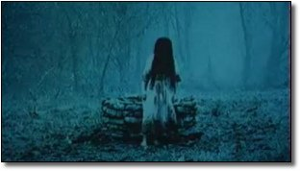 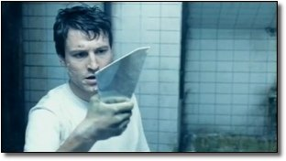

The Ring Saw

Meanwhile, apocalyptic movies are gray and washed out:

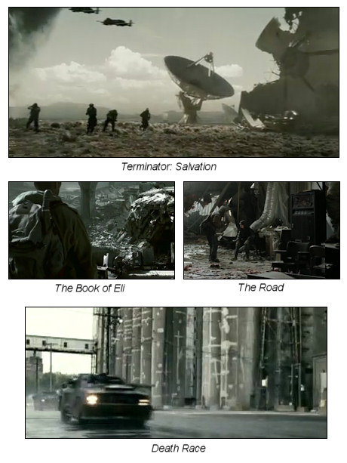

Movies where reality is off-kilter will be green:

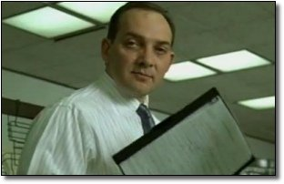 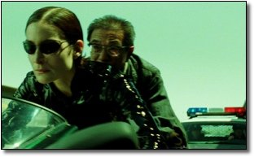  
Fight Club The Matrix Trilogy

The production designer can also enhance concepts from the script by controlling the sense of space in a given scene going from claustrophobic to an illusion of space. (Forced perspective)

**forced perspective**: A production design technique that physically distorts certain aspects of the set and diminishes the size of objects and people in the background to create the illusion of greater foreground-to-background distance

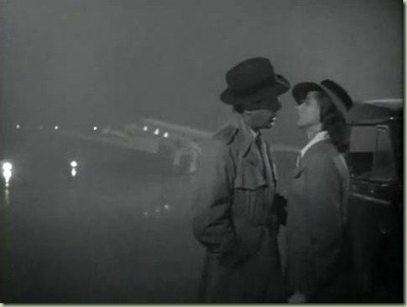

Concluding scene of Casablanca .

The setting is a powerful cinematic element by itself that can factor into the story in four ways.

1. Temporal factor: the time period when a story occurs
2. Geographic Factor: physical location and its characteristics
3. Social structures and economic factor
4. Customs, moral attitudes, and codes of behavior

Each factor has an important effect on the problems and characters present within a story.

Consider while watching a movie what purposes the setting is serving in the story.

1. Setting as determiner of character: suggests a naturalistic role of setting / sometimes the environment may function as an antagonist in the plot.

2. Setting as a reflection of character: provides clues to understanding characters in the story

3. Setting for verisimilitude: creates a feeling of authenticity by including to make a place feel real

4. Setting for sheer visual impact: affects the reader in a powerful way to show the grandeur or beauty of a place

5. Setting to create emotional atmosphere: creates an overall mood or emotional atmosphere for the viewer that allows for a viewer to suspend their disbelief

6. Setting as a symbol: represents more than just a place; an idea connected with a place

7. Setting as a microcosm: suggests that the human actiivty in a small place represents human behavior or human condition on a larger scale

Studio versus Locatin Shooting: Currently directors prefer the studio for three reasons

1. Many current directors were raised on the studio products of the 1930s, 1940s, and 1960s

2. Movies compete with made-for-television movies which are usually filmed on location, have relatively small budgets, and pay less attention to visual texture and production design than movies on the big screen althoogh this changing with series like The Sopranos and Breaking Bad.

3. Directors prefer a completely controlled environment where lighting and sound can be strictly controlled by the director without concerns for traffic, outside sounds, and spectators

Overall, audiences are disappointed with a truly realistic setting and expect to see a heightened reality, which filming in a studio can provide.

On the other hand, a realistic story with a “too perfect” reality can be considered un-realistic by an audience so reality must be subdued for the modern audience. Sometimes this calls for a mixture of studio filming and on location filming where the illusion becomes that both types of scenes are part of the same neighborhood.

Period Pieces: a film that takes place not in the present but in some earlier historical period; in depth research is necessary to travel back in time and still give the audience a sense of reality or authenticity

Living Spaces and Offices: sets are carefully constructed to become personalized environments that reflect a character or underscore or enhance the mood of each scene. Films based on novels may refer back to novel for setting details. When sets have windows the production designer will also have to create a world outide of the window

Fantasy Worlds: elements of a fantasy world will need additional elements to help the audience feel they have been transported to another world or another time that may have never existed

Costume and Make up Design

This part of visual design also comes from the screenplay or script

An illusion can be created for each actor. Three creators of illusion: hairstylist, makeup artist, and clothes designer.

Period films are the most demanding in this aspect.

Makeup can transform an actor into another version of himself or herself. Such changes can be gradual or abrupt. (Citizen Kane) Sometimes an actor known for beauty can take on an “ugly” role with an effective use of makeup.

Lighting: this aspect can have a significant effect if the script calls for it. Lighting can become a magical tool to create a geographical area, a particular focal point, or a way to affect the mood in a film

Three elements of lighting:

intensity: Low-key lighting or high-key lighting

low-key lighting: puts most of the set in shadow; just a few highlights define the subject

high-key lighting: creates more lights than shadows

direction: overhead lighting, strong side lighting, back lighting, front lighting

Cinematographer assumes the primary responsibilty for lighting

Budgetary Effects on the Visual Design: low budget films are often made with a lack of visual style