BRERP Document Management System

Technical guide
Architecture, implementation, operations and CBS integration
Developer reference for the BRERP DMS and its integration through BRGateway24. This guide identifies the main code paths, configuration points, authorization checks and operational considerations used to maintain and extend the module.
Version 1.1 | September 2026
Audience Developers, integration engineers and technical support

Contents

1. Overview 3
2. System Architecture 4
3. Request Lifecycle and Authentication 7
4. Functional Flows 9
5. Authorization and Permissions 15
6. APIs and Integration 22
7. Operations 38
8. Extending the System 39
Appendix A - Permission and Module Reference 40
Appendix B - Glossary 41

1. Overview

1.1 Purpose
This guide explains how the BRERP Document Management System (DMS) is built and how to change it safely. It covers the architecture, the main functional flows, how authorization is wired end to end, and the integration with core banking (CBS) through the API gateway. The end-user manual covers day-to-day usage.

1.3 Technology stack
Concern | Technology
Language / framework | PHP 8.3, Laravel 11
Database | Microsoft SQL Server (sqlsrv driver). Session, cache and queue are database-backed (SESSION_DRIVER, CACHE_STORE, QUEUE_CONNECTION = database).
Authentication | Session guard for the web UI; Laravel Sanctum personal access tokens for APIs; TOTP two-factor (pragmarx/google2fa-laravel).
Authorization | spatie/laravel-permission 6.x with local overrides, Laravel policies, and per-record grants in t_SpecialPermissions.
Front end | Server-rendered Blade views; jQuery/select2 and htmx-style partial loading (HandleHtmxRequests, ReturnContentFragment).
Documents | phpoffice/phpword, phppresentation, maatwebsite/excel, dompdf, intervention/image, getid3 for extraction, conversion and preview.
Audit | spatie/laravel-activitylog through the activity() helper on every state change.
Packaging | Docker (docker/Dockerfile, docker-compose.yml); cron scheduler and queue worker (docker/erp-worker.config).
Gateway | ASP.NET Core 8 Web API (separate repository), forwards CBS calls to the DMS.

2. System Architecture

2.1 Component view
The DMS is a layered monolith. Browsers reach it directly over HTTPS. CBS never calls it directly: it goes through the gateway, which authenticates CBS, then calls the DMS as a dedicated service account.
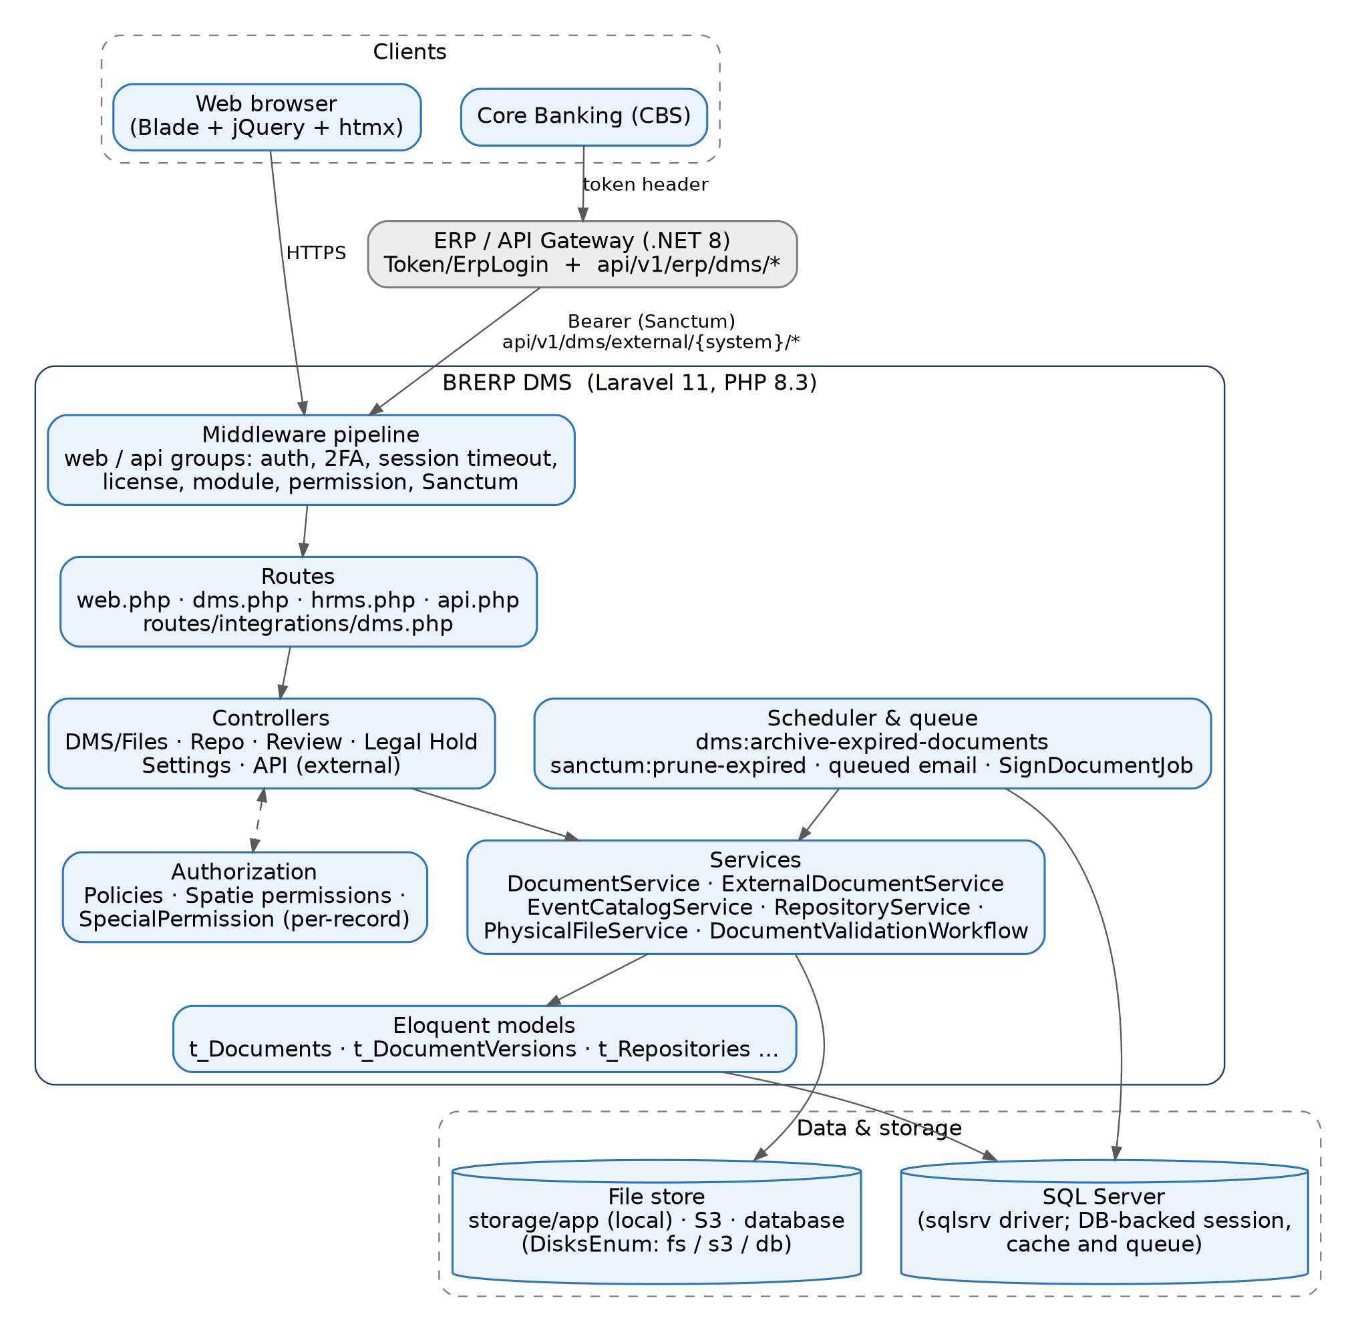
Figure 1. Logical architecture and data stores

2.2 Repository layout
Path | Contents
routes/web.php, auth.php | Web entry: login, 2FA, profile, settings (users, roles, workflows, teams, backups, modules).
routes/dms.php | All DMS UI routes, under module:700000, prefix dms.
routes/api.php | Health check, OTP, dms/documents (Sanctum), and the v1 group that includes routes/integrations/dms.php.
routes/integrations/dms.php | Verification intake and the external (CBS) document API.
app/Http/Controllers/DMS/* | Files, Repo, Review, LegalHold, Tags, Settings, Verification, API (external), Dashboard, physical-registry controllers.
app/Services/DMS/* | Business logic: DocumentService, ExternalDocumentService, EventCatalogService, RepositoryService, PhysicalFileService, RegistryService, AutoTaggingService, Verification/DocumentValidationWorkflow.
app/Models/DMS/* | Eloquent models (documents, versions, repositories, holds, reviews, validations, registry, event types, source systems).
app/Policies/DMS/* | One policy per protected model, registered in AppServiceProvider::boot.
app/Enums/* | Core/PermissionEnum, ModulesEnum, RoleEnum, VisibilityEnum; DMS/* status enums.
app/Http/Middleware/* | Session, licence, module, permission and external-source middleware.
app/Console/Commands/* | dms:archive-expired-documents, licence tools, backups, email queue.
database/seeders/* | Modules, permissions, document types, event types, registries, validation types.
tests/Feature/DMS/* | Workflow, verification intake, event catalog and external API tests.

2.3 Coding conventions that matter
- Tables and columns. Tables are prefixed t_ (for example t_Documents, t_DocumentVersions, t_SpecialPermissions). Columns are PascalCase. Timestamps are CreatedOn, ModifiedOn, DeletedOn (soft deletes); actors are CreatedBy, ModifiedBy, DeletedBy (via UserActorTrait).
- Polymorphic keys. Relation::morphMap maps short keys (for example UserID, the document primary-key name) to model classes; the Party and Model columns of t_SpecialPermissions hold these keys, not class names.
- Business errors. Services throw ErroredException; controllers turn it into a 422 (or $e->toJson()), and bootstrap/app.php provides a safety net so it never becomes a 500.
- Audit. State changes call activity()->causedBy($user)->performedOn($model)->event(...)->log(...). External calls log the CBS operator (actor) in the message.
- API casing. The api middleware group appends TransformApiResponse, which camel-cases the keys of successful JSON responses. Renaming a key in a controller changes the wire contract.
- Files. Bytes are written to a DisksEnum disk (fs, s3, db) as {uuid}.data; a double SHA checksum is stored. The database row holds name, mime type and version metadata.

2.4 Core data model
Entity (table) | Role
Repository (t_Repositories) | Hierarchical container with Visibility and per-record grants.
Document (t_Documents) | Logical document: name, type, expiry, ArchivedOn, SourceSystemId, external entity type/id, source module.
DocumentVersion (t_DocumentVersions) | One row per file version; Document::current is the latest.
DocumentAttribute | Name/value properties (for example cbs.class, source.*).
SpecialPermission (t_SpecialPermissions) | Per-record grant: Party (user/team), Permission (RoleEnum r/w/s/a), Model/ModelID.
DocumentCheckOut | Check-out record; status out, cin, can.
DocumentReview / DocumentReviewAnnotation | Review request (pe/rv) and annotations.
DocumentValidation, Type, Attribute | Approval or signing request, its type/workflow, and captured fields.
LegalHold, DocumentLegalHold | Hold (A/R/C) and its document links.
DMSTags, DocumentTags, DocumentTaggingRules | Tags and automatic tagging.
Registry, StorageLocation, PhysicalFile, PhysicalDocument, PhysicalFileRequest, PhysicalFileCheckout, PhysicalFileMovement | Physical registry.
SourceSystem, EventType, EventProperty, EventModuleMap | External-system integration catalog.
Module (t_Modules) | Menu tree with Route and RequiredPermission.
Role, ModelRole (t_ModelRoles), Permission (t_Permissions) | RBAC; a user gets roles per branch through t_ModelRoles.

3. Request Lifecycle and Authentication

3.1 Web request pipeline
Every DMS page passes through the middleware stack below before reaching a controller. The group is declared in routes/web.php: web, auth, active-module-route, and, for routes/dms.php, module:700000.
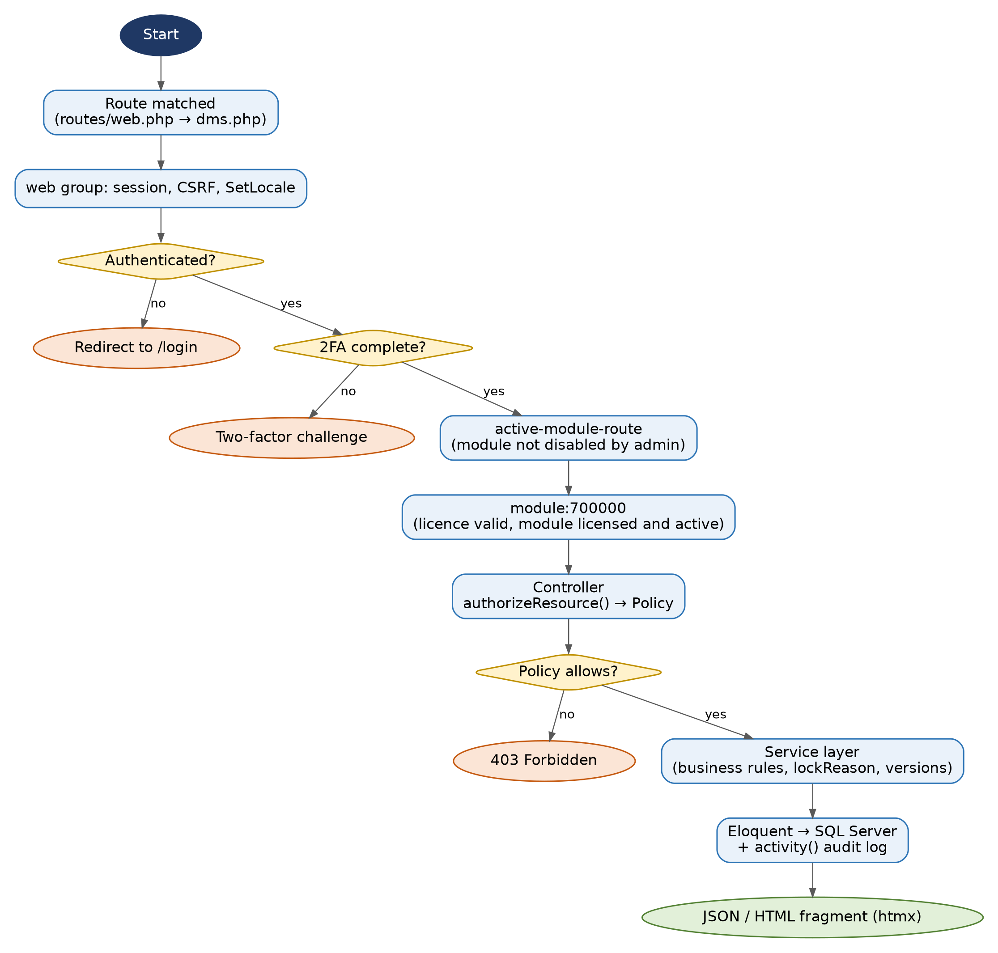
Figure 2. Web request pipeline for a DMS route
Middleware (alias) | Behaviour
auth, ensure_2fa | Requires a session; blocks until the TOTP challenge is complete when 2FA is enabled.
active-module-route | ModuleService::isRouteModuleActive: 403 if the route belongs to a module (or ancestor) disabled in Module Settings.
module:700000 (RequireModule) | 402 if the licence is invalid; 403 if the module or an ancestor is inactive or not licensed (parent licence is inherited).
EnforceSessionTimeout, EnsureSingleActiveSession, EnsureFreshPermissions | Part of the web group in app/Http/Kernel.php: idle time-out (config/idle.php, SESSION_LIFETIME default 20) with warn/extend endpoints; one active session per user via a session token; permission reload after a cache reset.
permission, role, role_or_permission, canAction | Route-level checks. The DMS routes mostly rely on policies instead (section 5).

3.2 Login and two-factor flow
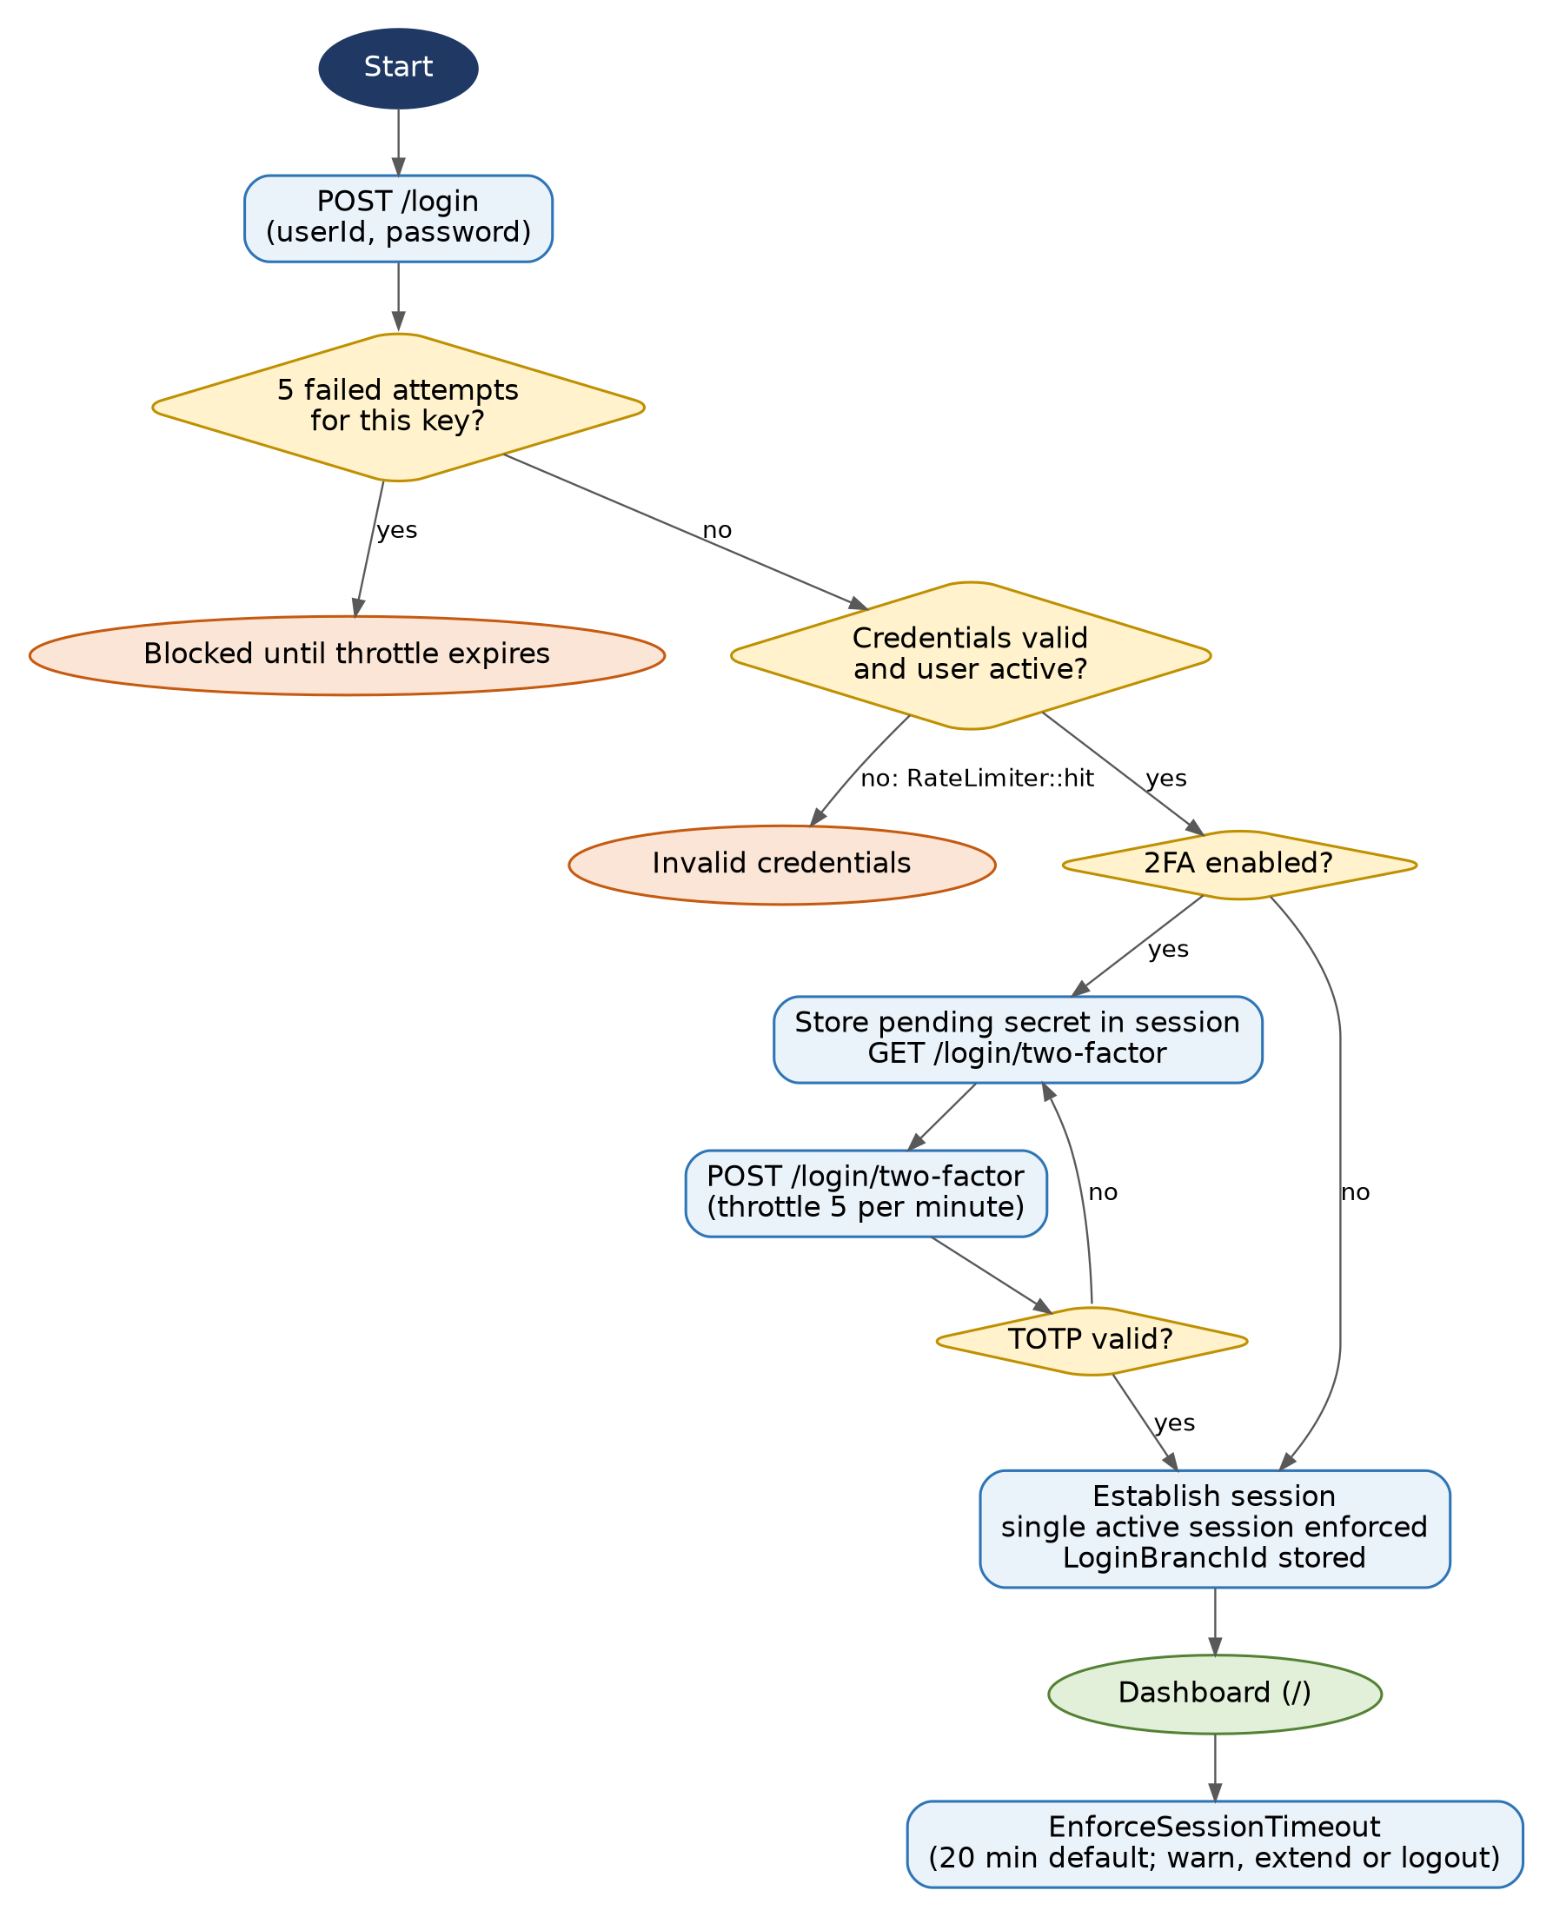
Figure 3. Login with throttling, TOTP and session establishment
Key classes: AuthenticatedSessionController, LoginRequest (throttle key, 5 attempts), TwoFactorController, EnsurePendingTwoFactor, EnsureTwoFactorComplete. The active branch is stored in the session as LoginBranchId and drives role resolution (section 5.4).

4. Functional Flows
Each flow shows the normal sequence and the checks that can stop it. Class names point to where to read the code.

4.1 Document upload
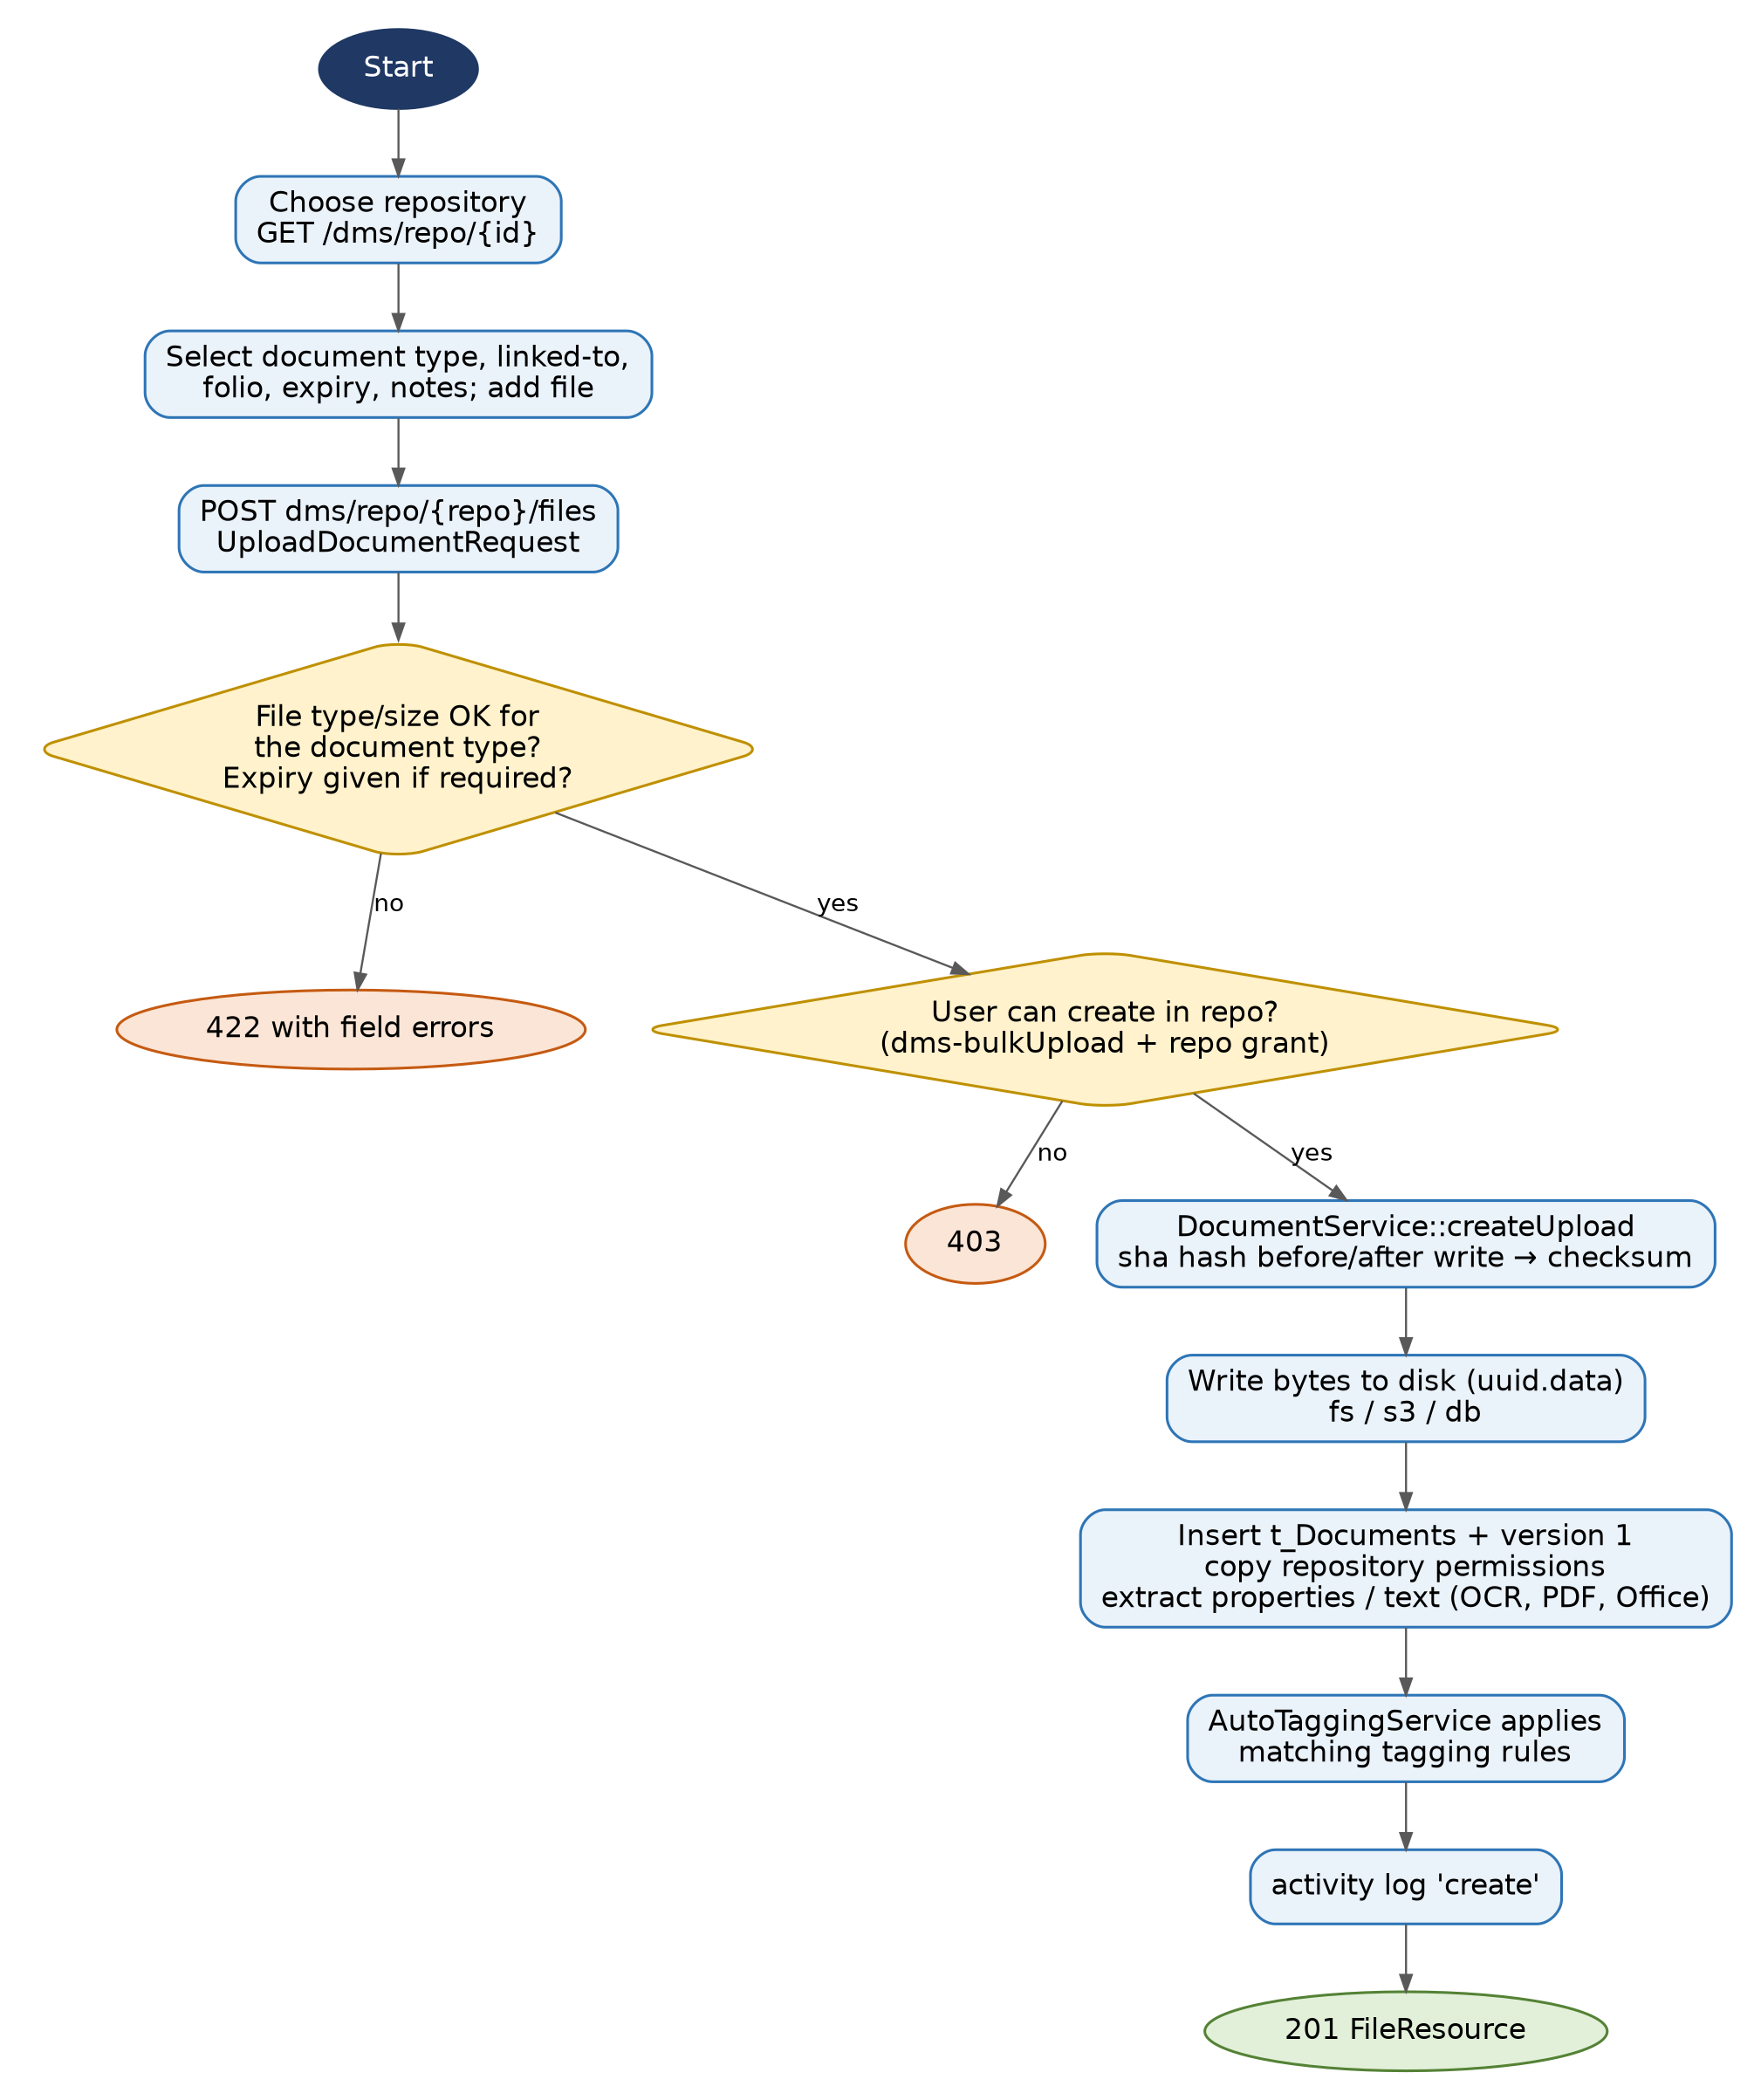
Figure 4. Document upload from the repository screen
Entry: DocumentController::store (route files.store under dms/repo/{repository}), request UploadDocumentRequest, service DocumentService::createUpload. The document type (DMSDocumentType) supplies accepted extensions, MaxSizeMB and whether an expiry is required. A folio groups related documents into a case. Bulk upload uses the same service.

4.2 Check-out and check-in
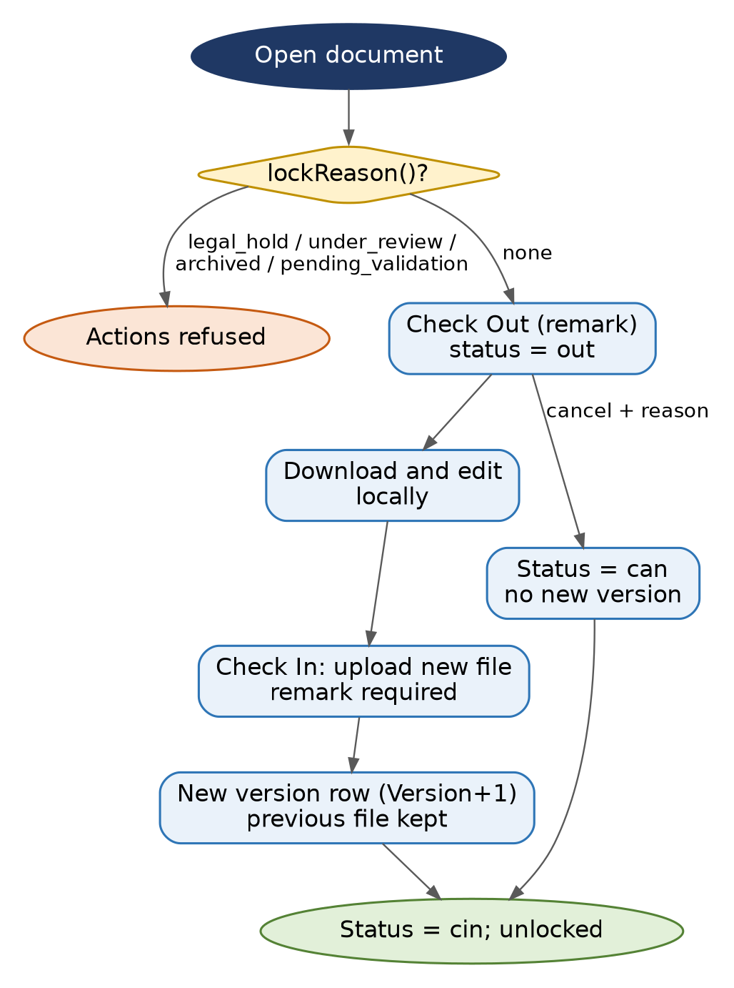
Figure 5. Check-out, check-in and cancel
DocumentCheckOutController and DocumentService::checkout, checkin, forceCheckout. DocumentService::lockReason() is the single place that decides whether a document is frozen: legal_hold, under_review, archived, checked_out or pending_validation, in that priority order. Both the UI and the external API call it.

4.3 Validation, approval and signing
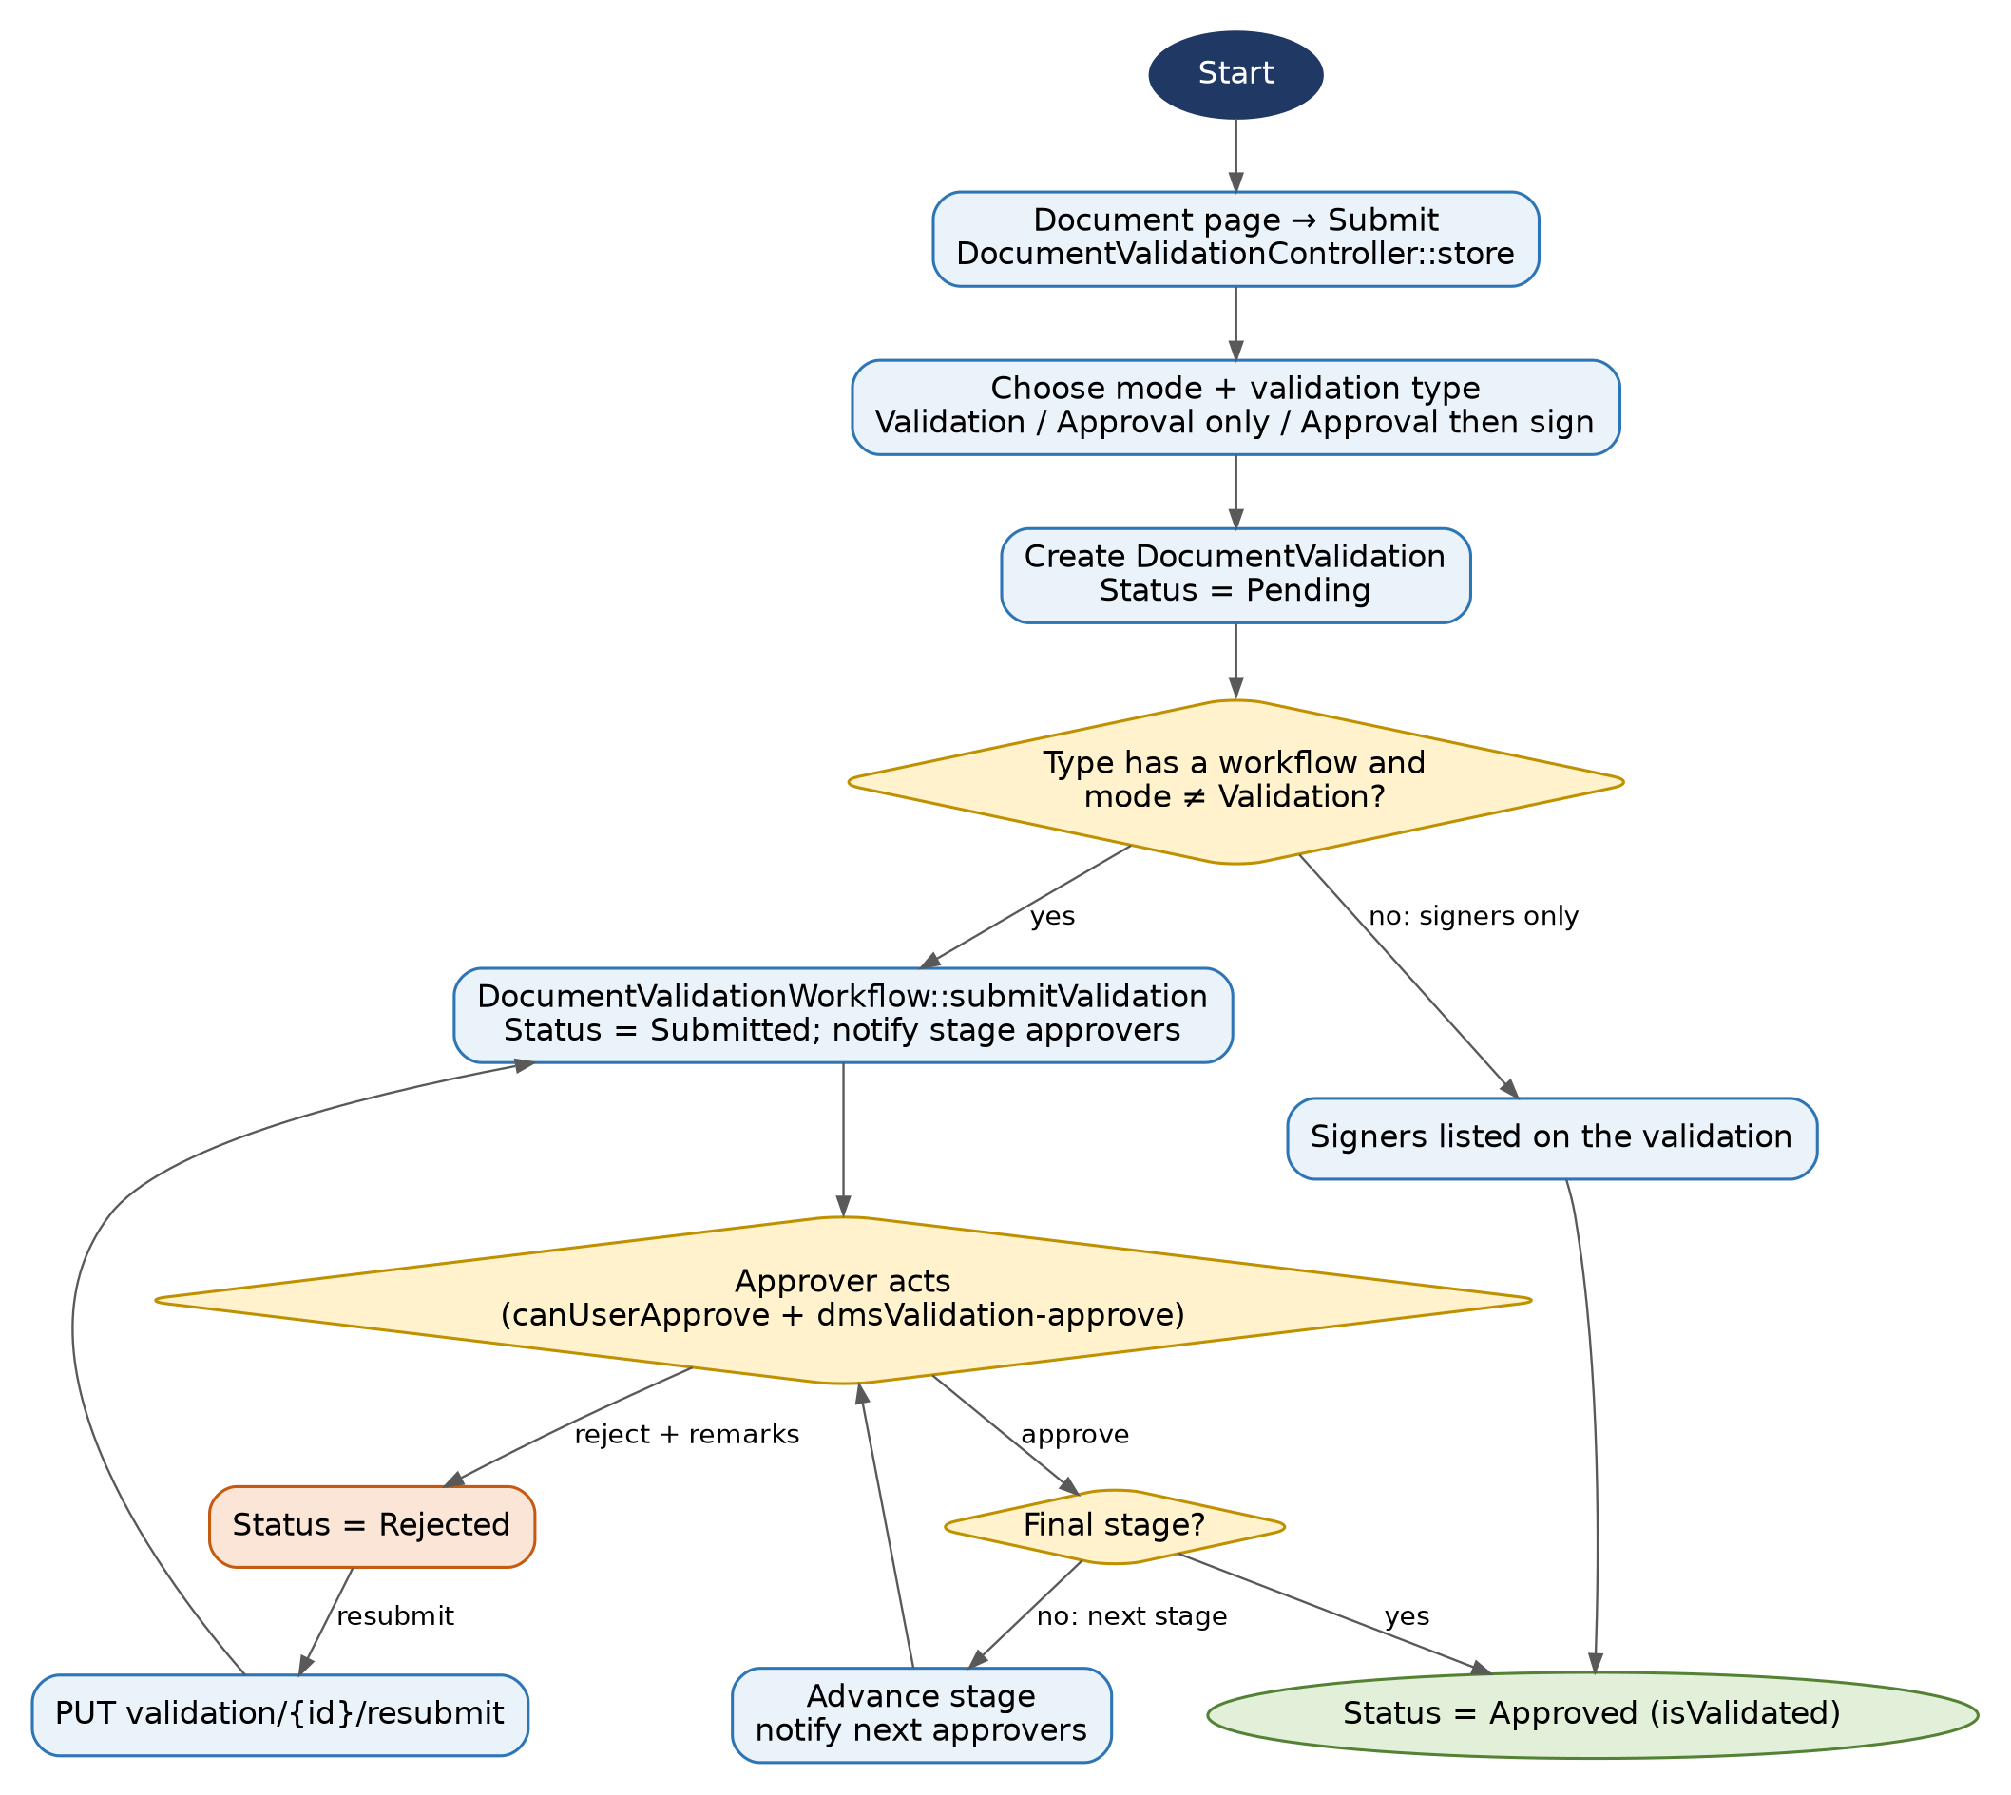
Figure 6. Validation workflow and approver decisions
DocumentValidationController (web) creates the request; DocumentValidationWorkflow moves it through Workflow stages; SignatureService/SignService and SignDocumentJob apply signatures. Status values are pe, su, ap, re (DocumentValidationStatusEnum). Submission modes: va (validation, signers), ap (approval only), av (approval then sign). Approval needs the dmsValidation-approve permission plus stage membership (canUserApprove).

4.4 Review and annotation
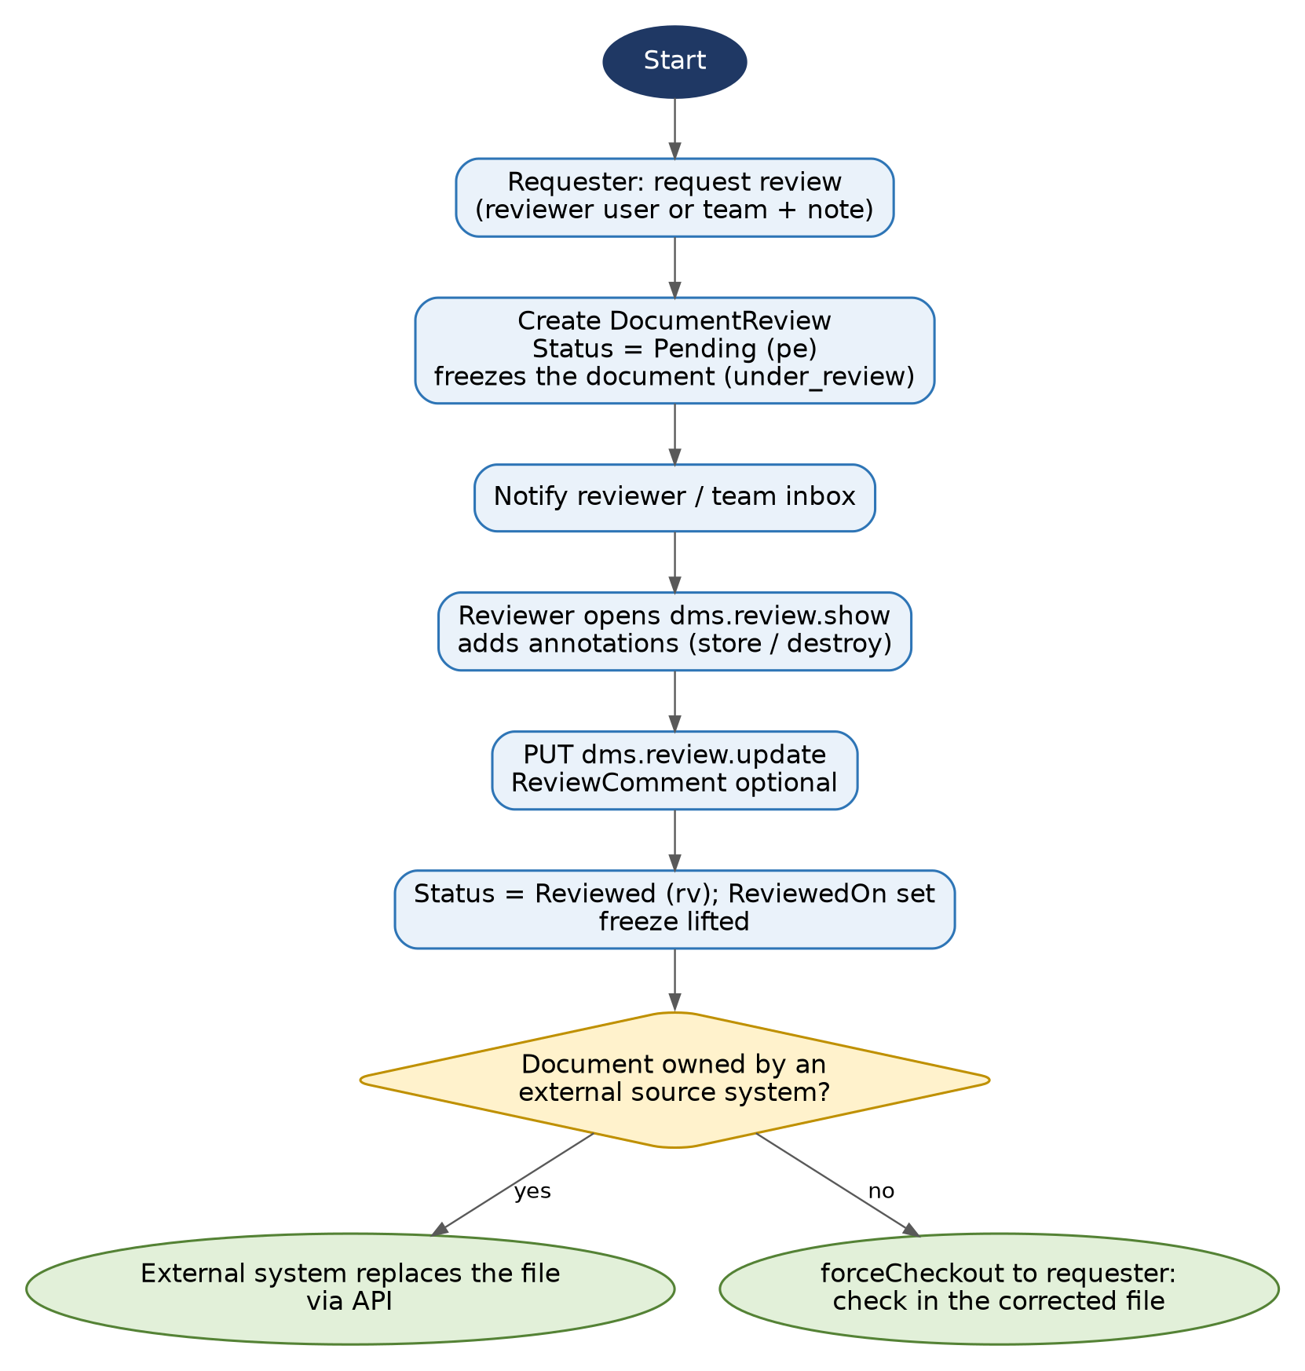
Figure 7. Review request to completion
DocumentReviewController::update marks the review complete and, for internal documents only, force-checks the document out to the requester so they can check in the corrected file. Documents owned by an external system are excluded because the service account cannot check files back in.

4.5 Legal hold
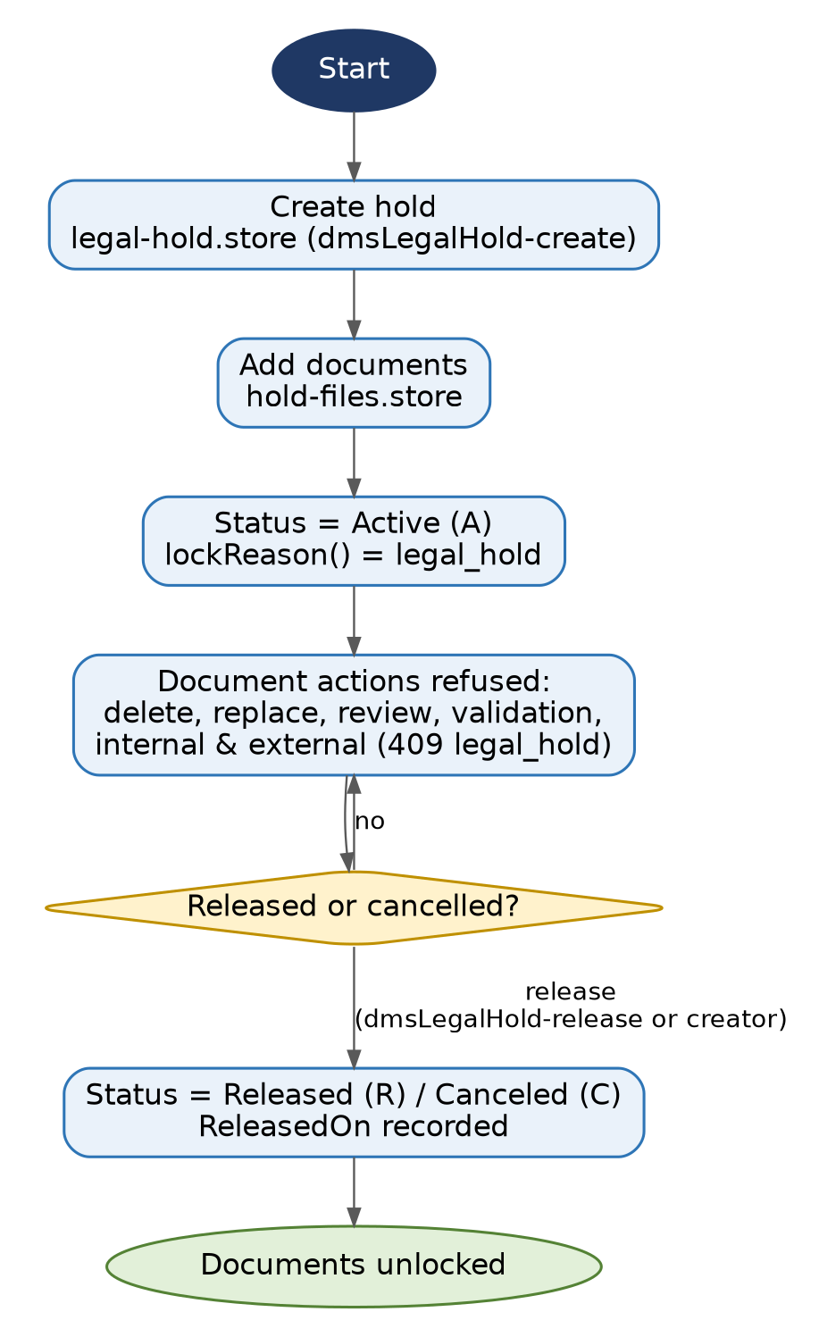
Figure 8. Legal hold lifecycle
LegalHoldController, DocumentLegalHoldController, LegalHoldPolicy (create and release use dmsLegalHold-create / -release; the creator can also update). While active, isHold() makes lockReason() return legal_hold, which every path respects, including the external API.

4.6 Archive, trash and expiry
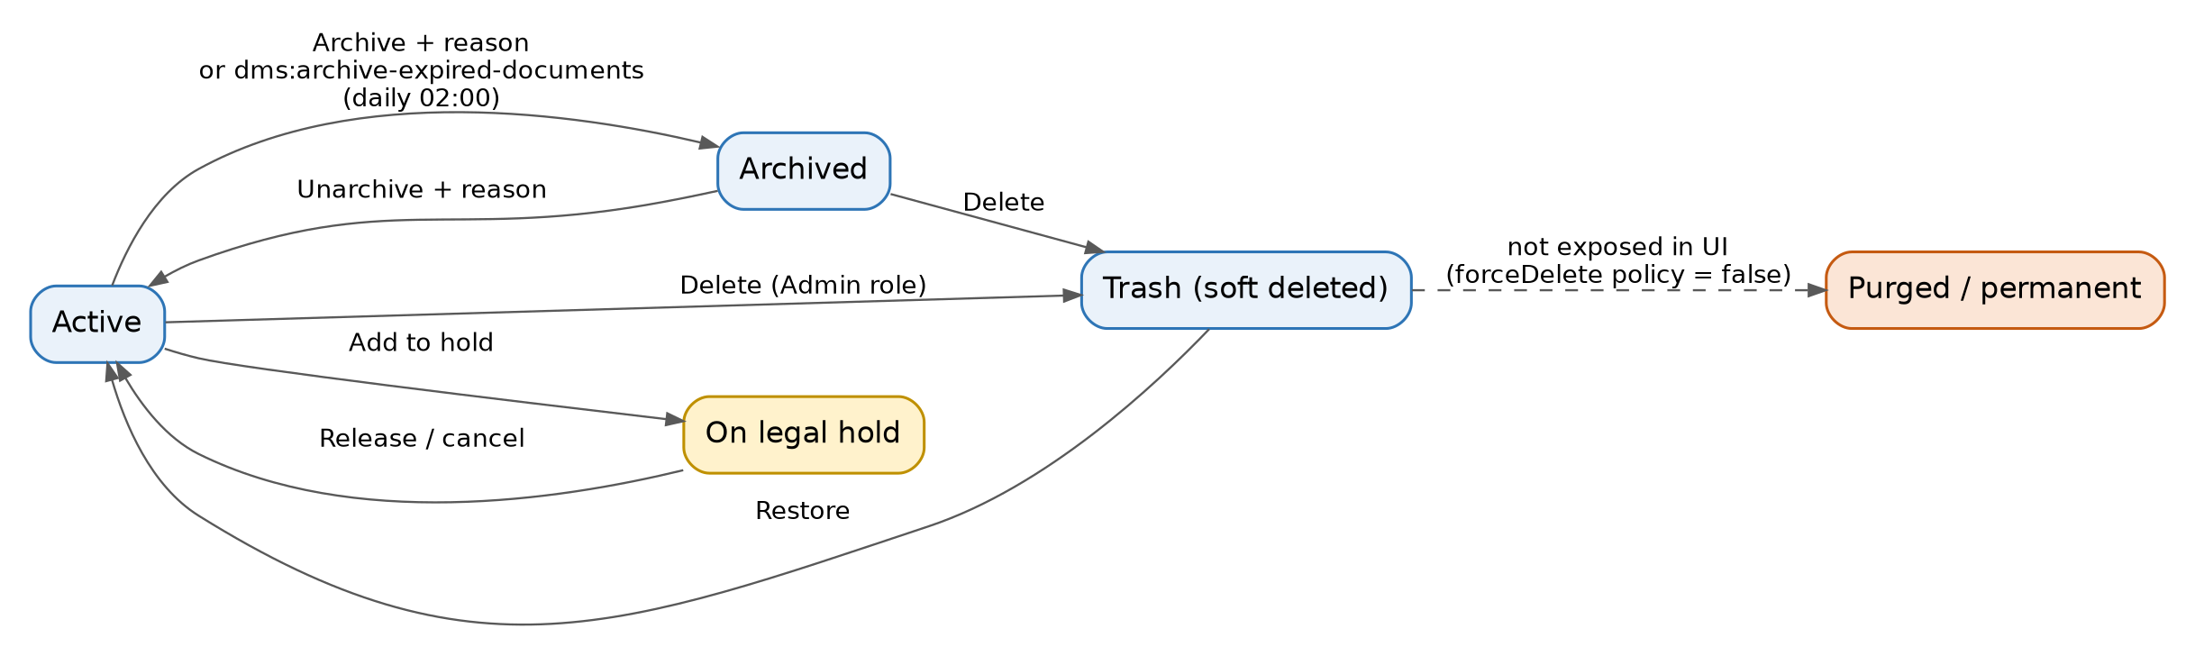
Figure 9. Document lifecycle states
DocumentArchiveController and DocumentService::archive / unarchive require a reason. The scheduler runs dms:archive-expired-documents daily at 02:00: documents with a past ExpiryDate are archived with reason expired and the uploader is emailed. TrashDocumentController lists deleted and archived documents.

4.7 Physical registry
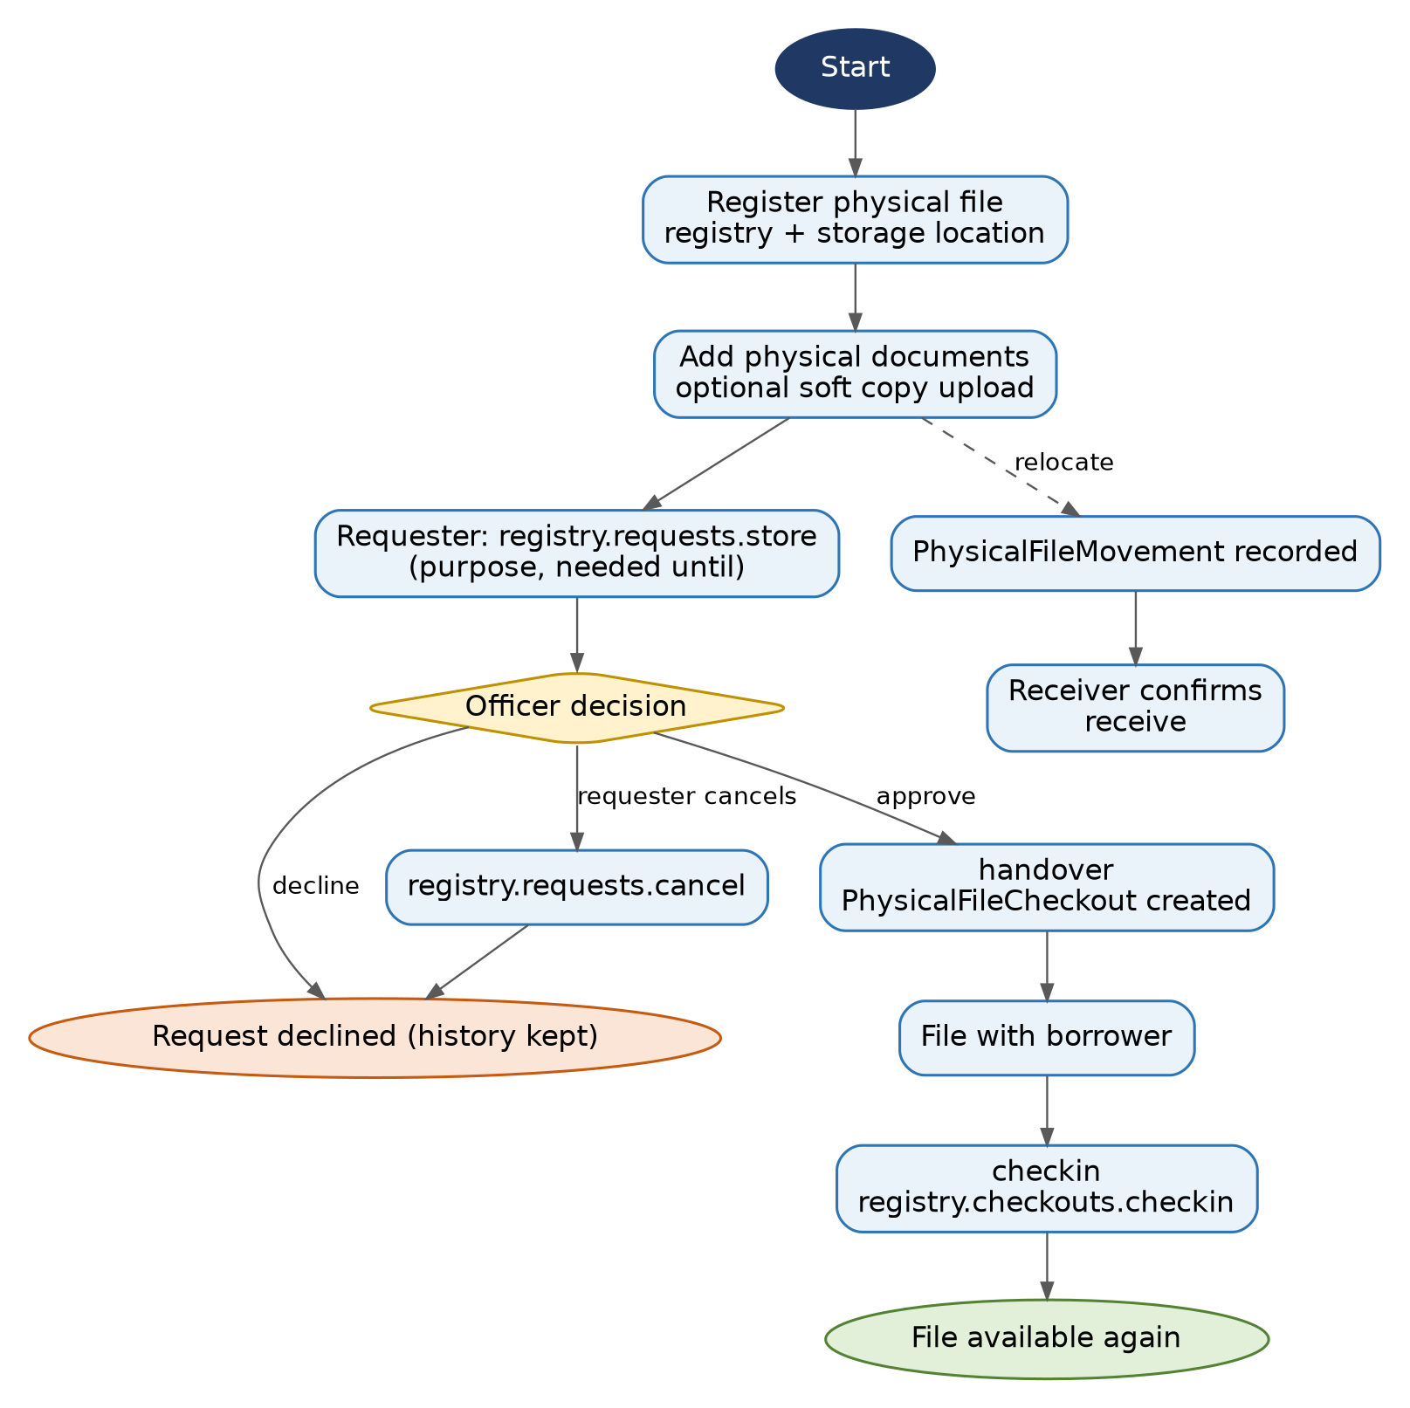
Figure 10. Physical file request, handover, return and movement
PhysicalFileController, PhysicalFileRequestController, PhysicalFileCheckoutController, PhysicalFileMovementController, with PhysicalFileService, RegistryService, StorageLocationService and RegistryAccessService (registry-level grants).

5. Authorization and Permissions
Authorization is layered. A request must pass every layer that applies to it. Understanding which layer answers which question is the key to changing permissions without breaking access.
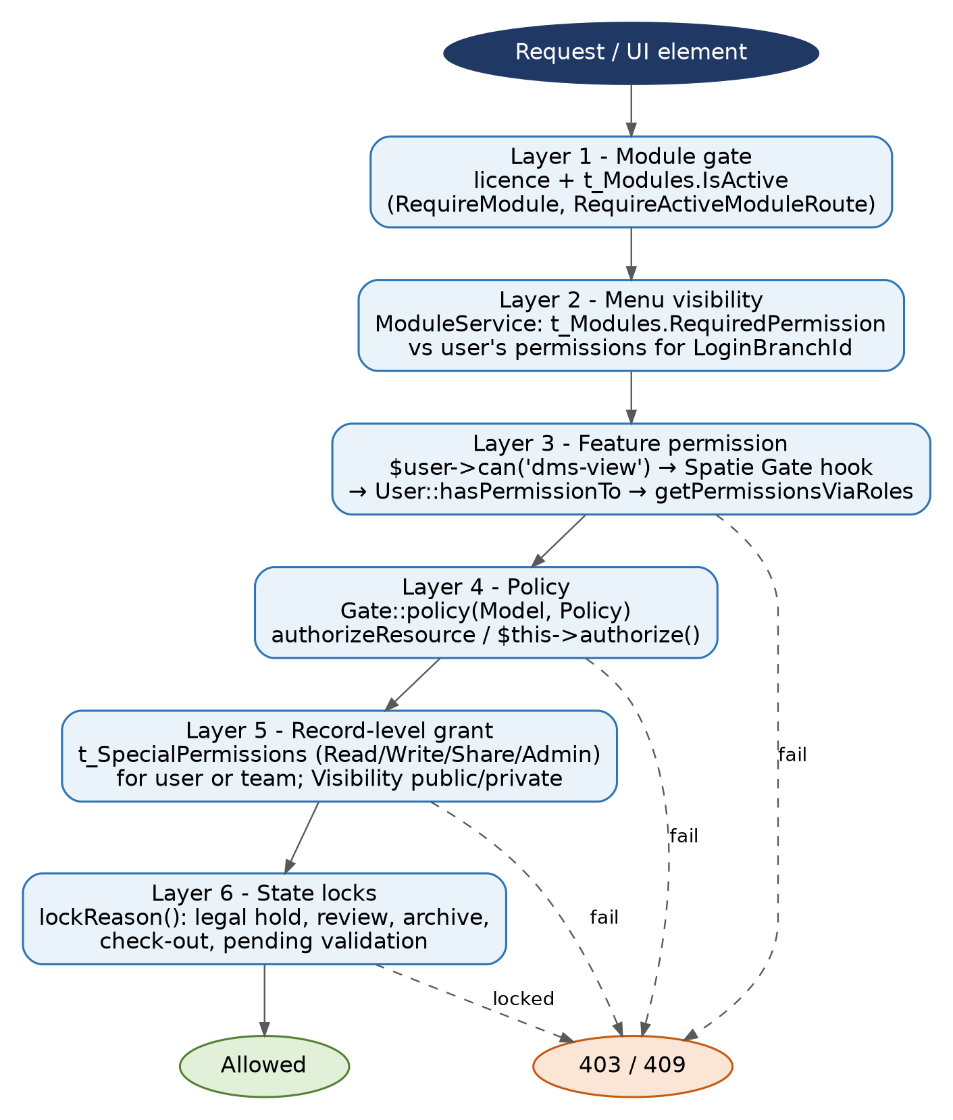
Figure 11. Layers of access control
# | Layer | Question answered
1 | Licence and module switches | Is this module licensed and enabled at all? (RequireModule, RequireActiveModuleRoute, t_Modules.IsActive)
2 | Menu visibility | Should this user see the menu item? (ModuleService, t_Modules.RequiredPermission)
3 | Feature permission | Does any of the user's roles (for the login branch) contain this permission name? ($user->can())
4 | Policy | May this user perform this ability on this model? (Gate::policy, authorizeResource, authorize)
5 | Record grant | Was this user or one of their teams granted Read/Write/Share/Admin on this record, or is it Public? (t_SpecialPermissions)
6 | State lock | Is the record currently frozen? (lockReason())

5.1 The permission enum (source of truth)
App\Enums\Core\PermissionEnum is a string-backed enum. The case value is the permission name stored in t_Permissions.name and used everywhere in code (PermissionEnum::DMSView->value is dms-view). The enum also carries presentation and grouping logic:
Method | Purpose
display() | Groups permissions for the Roles screen (Documents, Widgets, Layouts, Users, Lists, Branches, Workflow, Employees).
module() | Maps each permission to a ModulesEnum (DMS 700000, HRM 1000000, Settings 9800000). The seeder writes this to t_Permissions.ModuleId.
title(), subName() | Labels shown on the Roles screen (for example dmsLegalHold-release → "Legal Holds" / "Release").
isAssignableToRoles(), isAssignableInRolesScreen(), rolesScreenModules() | Control which permissions can appear in role editing (DMS, Settings, HRM).
approvals() | Permissions that mark an approver capability (dmsValidation-approve).

Permission name | Enum case | Typical use
dms-view | DMSView | See DMS menus, repositories; viewAny on documents and repositories
dms-bulkUpload | DMSBulkUpload | create on documents and repositories; Bulk Upload menu
dmsLegalHold-create/view/release | DMSLegalHold* | Legal hold policy
dmsValidation-approve | DMSValidationApprove | Approve or reject validations
dmsRegistry-manage | DMSRegistryManage | Registry administration; also the permission gating the Roles menu row in ModuleSeeder
dmswidgets-*, dmslayouts-* | DMSWidgets*, DMSLayouts* | Dashboard widgets and layouts
admin | Admin | Super-user checks inside policies and scopes
users, roles, teams, users-nonExpiringSessions | Users, Roles, … | User administration
lists-*, branch-*, workflow-*, organization-profile | … | Settings screens
employee-*, department | Employees*, Departments | HR screens (retained)

5.2 Database representation
Table | Purpose
t_Permissions | Spatie permissions table: name, guard_name, plus custom ModuleId. Custom Spatie model classes are set in config/permission.php (role model App\Models\Auth\Role).
t_Roles | Roles (name, audit columns). Baseline roles: admin, Default.
role-permission pivot | Role to permission, with CreatedBy/ModifiedBy (written by the seeder and RoleController).
t_ModelRoles | Custom. User to role per branch: model_id, model_type (UserID), role_id, BranchId, soft deletes. Spatie's native model_has_roles is not used for users.
t_Modules | Menu tree: ModuleID, Name, ParentID, Route, RequiredPermission, IsActive.
t_SpecialPermissions | Per-record grants: Party + PartyID (user or team), Permission (r/w/s/a), Model + ModelID.
t_Teams, t_TeamUser | Teams, used as grantees in t_SpecialPermissions.

5.3 Seeding and wiring: `RolePermissionSeeder`
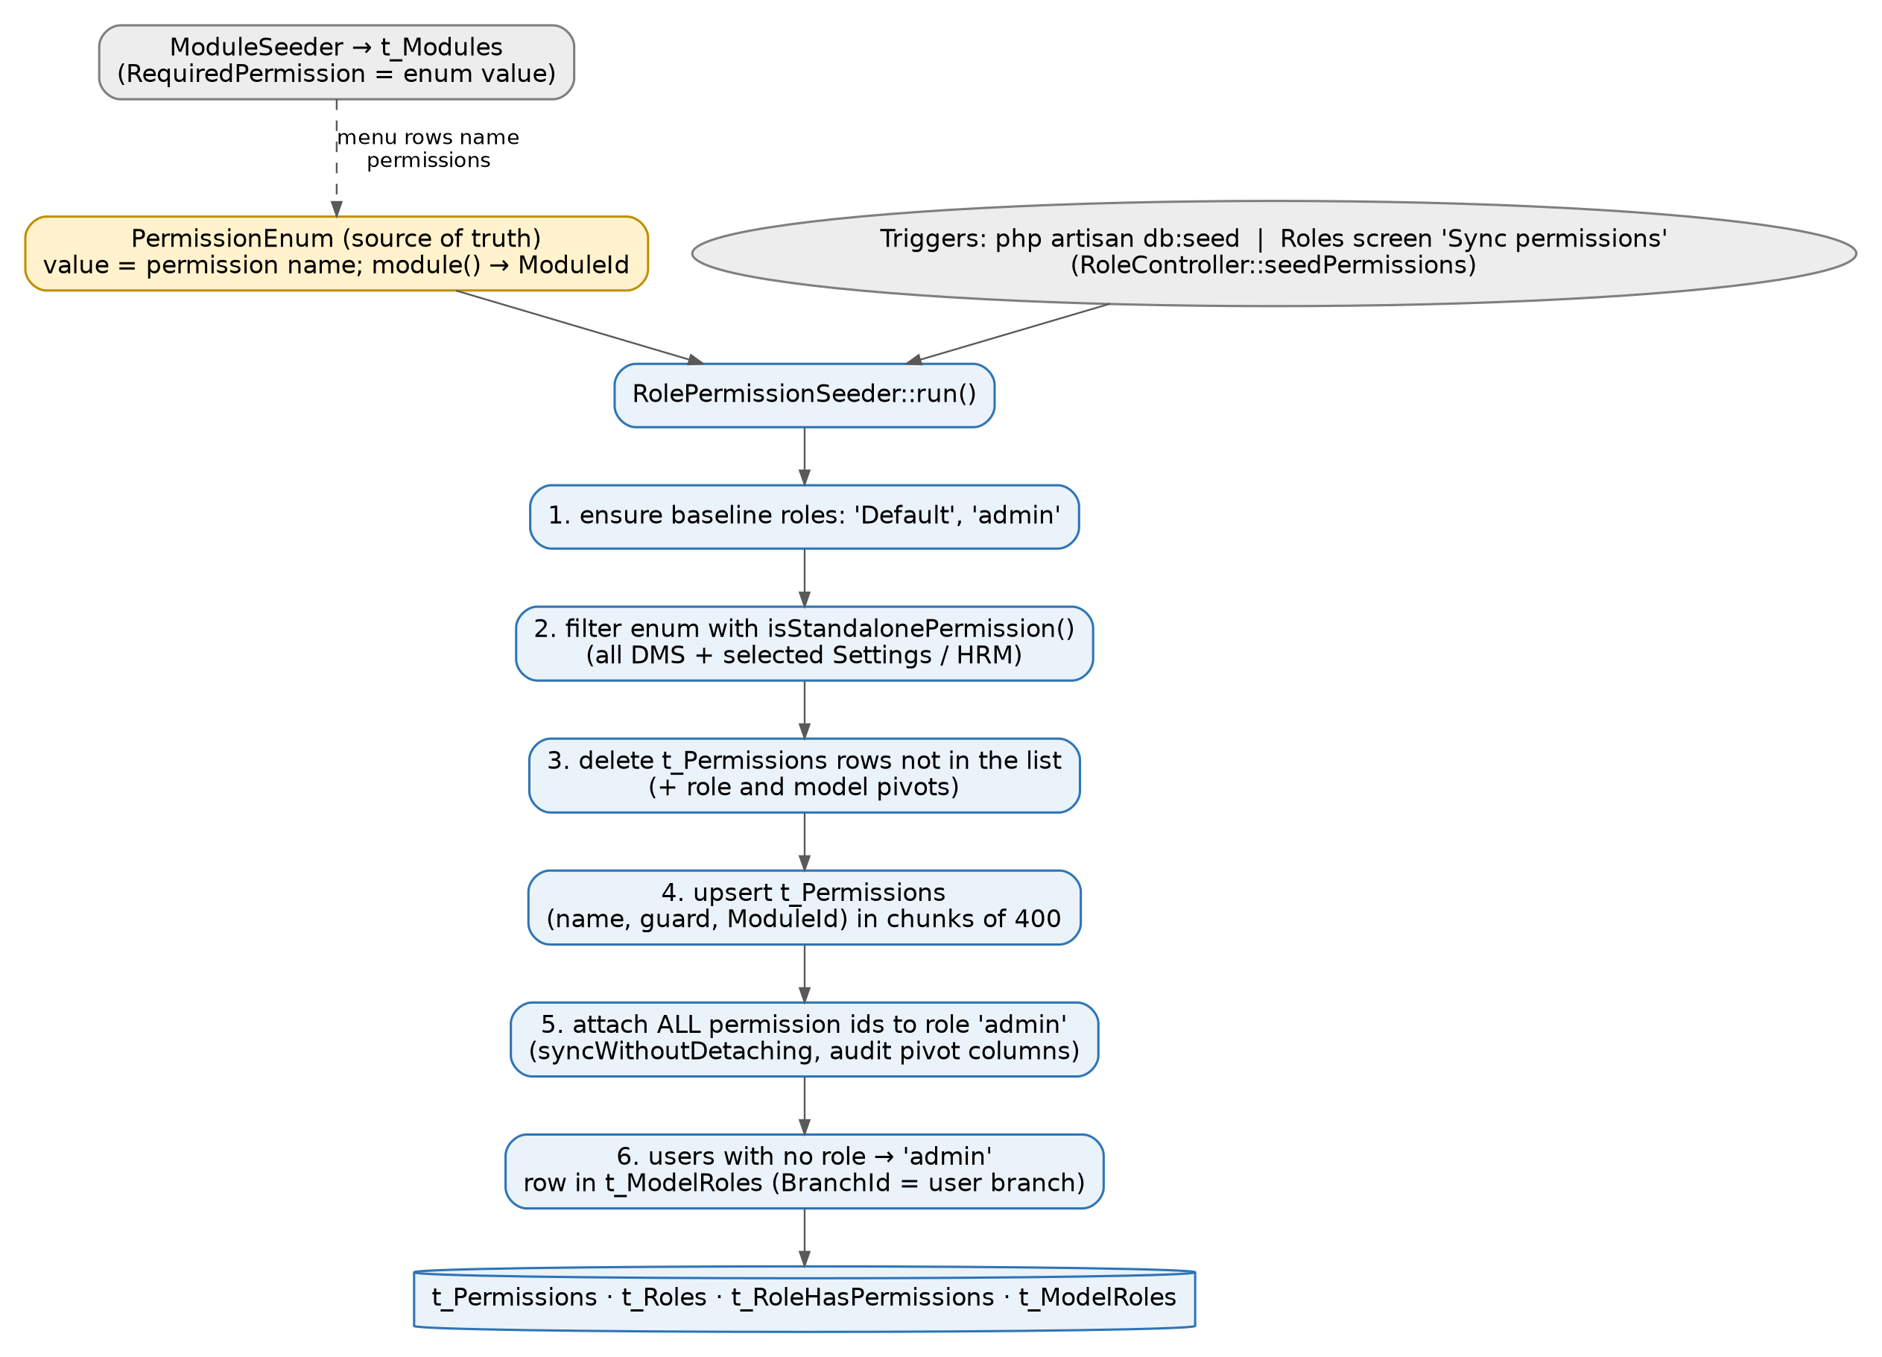
Figure 12. How the enum reaches the database and the admin role
Sequence in DatabaseSeeder: UserSeeder, BranchSeeder, then ModuleSeeder, then RolePermissionSeeder. The seeder is idempotent and can be re-run from the Roles screen ("Sync permissions", POST settings/roles/seed-permissions) after adding an enum case.
- Baseline roles. Creates Default if missing and admin (createOrFirst).
- Filter the enum. isStandalonePermission() keeps every DMS-module permission plus an explicit list of Settings and HR permissions (Admin, Users, Roles, Teams, Lists, OrganizationProfile, SetBaseCurrency, Branch*, Workflow*, Employees*, Departments). Adding a permission outside DMS requires adding it to that list.
- Remove obsolete rows. Any t_Permissions row whose name is not in the filtered list is deleted, along with its role and model pivot rows, in a transaction.
- Upsert. Inserts or updates name, guard_name, ModuleId in chunks of 400, keyed by (name, guard_name).
- Grant everything to `admin`. All permission ids are attached with syncWithoutDetaching in chunks of 500, with CreatedBy/ModifiedBy on the pivot.
- Bootstrap users. Any user that has no role gets admin for their own branch (BranchId ?? 1) in t_ModelRoles.
Implementation note. Step 3 deletes permissions that are not enum cases. Any permission created by hand in the database (or by another module) is removed the next time the seeder runs. Dynamic permissions are shown in the Roles screen only when ModuleId is the DMS module and the name is not an enum value (RoleController::getDynamicPermissionGroups).

5.4 How a user's permissions are resolved
- The user logs in and picks or defaults to a branch; LoginBranchId is stored in the session.
- User::getPermissionsViaRoles() returns permissions whose roles are linked to this user in t_ModelRoles for that branch. With no branch in the session it returns nothing.
- User gets Spatie's HasRoles through the HasBranchRoles trait, but overrides hasPermissionTo($name) to check only that branch-scoped collection. Spatie registers a Gate::before hook that calls checkPermissionTo(), which calls the override, so $user->can('dms-view'), @can, authorize() and policies all end up here.
- User::hasRole() and getRoleNames() are likewise branch-scoped and read t_ModelRoles.
$user->can(PermissionEnum::DMSView->value); // Gate -> Spatie hook -> User::hasPermissionTo()
$user->hasRole(['admin']); // t_ModelRoles for the current branch
$user->getPermissionsViaRoles()->pluck('name'); // menu and UI checks

Implementation note. EnsureFreshPermissions comments say admins bypass through a Gate::before in AppServiceProvider. No such hook exists in the code: admin gets its power only from holding every permission through the seeder, and from explicit can(PermissionEnum::Admin->value) checks in some policies and scopes. Do not rely on a bypass.

5.5 Menu visibility
ModuleSeeder writes t_Modules rows such as [701000, 'Recent Documents', 700000, 'repo.recent', 'dms-view']. ModuleService::navbar() builds the tree for the logged-in user, keeping an item only if it is active and its RequiredPermission (which may list alternatives separated by |) is in the user's permission set. Empty parents with no visible children are dropped. The rendered HTML is cached per user, branch, locale and a version derived from max(t_Modules.ModifiedOn); RoleController::update clears the cache for users of the edited role.

5.6 Policies (gates)
Policies are registered in AppServiceProvider::boot with Gate::policy(Model::class, Policy::class). Controllers call $this->authorizeResource(Model::class) (for example DocumentController, RoleController) or $this->authorize('update', $document). Blade also exposes @canRead, @canWrite, @canUpdate, @canDelete, @canApprove, backed by PermissionResolver.
Policy | Rule summary
DocumentPolicy | viewAny: dms-view. view: admin permission or record visible via Document::user(). create: dms-bulkUpload. update: Admin/Share/Write grant. share: Admin/Share. delete/admin: Admin grant. restore, forceDelete: always false.
RepositoryPolicy | viewAny: dms-view; view: Repository::user() (admin permission sees all). create: dms-bulkUpload. update: admin permission, or creator of a public repo, or Admin/Share/Write grant. share: admin permission or Admin/Share grant.
LegalHoldPolicy | viewAny/view: dmsLegalHold-view; create: -create; update/delete: creator or -release.
DocumentValidationPolicy, DocumentValidationTypePolicy, DocumentReviewPolicy | Approver membership and dmsValidation-approve; type administration; reviewer or requester.
RegistryPolicy, StorageLocationPolicy | Grants on the registry node; admin permission bypasses per-record grants for administration.
SourceSystemPolicy, EventTypePolicy, DMSDocumentTypePolicy, LinkedToTypePolicy, DMSTagPolicy, DMSSignaturePolicy | Configuration screens.
RolePolicy, TeamPolicy, UserPolicy, CrmBranchPolicy, WorkflowPolicy, … | Administration.

5.7 Per-record grants: `SpecialPermission`
Documents, repositories, registries, storage locations and physical files use SpecialPermissionTrait. Roles here are RoleEnum: r Read, w Write, s Share, a Admin. Visibility is pub or pri (VisibilityEnum).
Scope | Meaning
scopeUser($user) | Public rows, or rows with any grant for the user or one of their teams. Use for "may look".
scopeUserRole($user,[roles]) | Public rows, or rows granted one of the listed roles. Use for reads that a public row may satisfy.
scopeUserGrant($user,[roles]) | Only rows with an actual grant. Use for "may act": a public registry is visible to everyone but not administrable by everyone.
scopeUserCreator($user) | Public rows, or private rows created by the user.
Repository::scopeUser | Override: users holding the admin permission see every repository, so system-created private repositories are never orphaned.

Grants are managed from the "Permissions" panels: DocumentPermissionController, RepositoryPermissionController, RegistryPermissionController, PhysicalFilePermissionController (index, store, destroy) and the visibility endpoints. Repository grants are copied to new documents on upload (copyRepoPermissions).

5.8 Legacy resolvers
PermissionResolver and the canAction middleware implement a submodule-action matrix (read, write, update, delete, approve) derived from permission names of the form submodule.action and t_SubModules. Submodules with no defined permissions are treated as open. Only the @canRead-style Blade directives and canAction routes use it. New DMS code should use policies and PermissionEnum.

5.9 Cache and freshness
- Spatie caches the permission registry under spatie.permission.cache. RoleController::update calls forgetCachedPermissions(). php artisan permission:cache-reset clears it manually; ClearPermissionCacheWithSessions also clears sessions.
- EnsureFreshPermissions reloads the user's relations when the cache key is missing.
- PermissionResolver keeps a per-request static cache keyed by user and branch.
- The navbar cache (section 5.5) is cleared for role members on role update; adding a menu row bumps the modules version automatically.

5.10 Role administration rules
- RoleController::store/update write the role and sync permissions in a transaction, recording an activity entry.
- preventSelfLockout stops a user removing the role-management permission from every role they hold.
- User-role assignment is per branch: UserRoleController (storeBranch, update, destroy, and the by-keys fallbacks) and User::syncRolesWithBranch, which soft-deletes previous assignments so history is kept.

5.11 Checklist: adding a new permission
- Add a case to PermissionEnum (kebab-or-camel-action value, following existing naming).
- Return the right ModulesEnum from module() and add a label in title() and a group in display().
- If it is not a DMS permission, add it to the list in RolePermissionSeeder::isStandalonePermission().
- Reference it in policies or controllers with PermissionEnum::X->value (never a raw string).
- If it should hide a menu item, put the value in the t_Modules row in ModuleSeeder (use | for alternatives).
- Run php artisan db:seed --class=RolePermissionSeeder (or use "Sync permissions"). Then assign it to non-admin roles on the Roles screen.
- Add a feature test that a role without it receives 403.

6. APIs and Integration

6.1 API surface at a glance
Endpoint group | Auth | Purpose
/api/health | none | Liveness check.
/api/auth/otp/send, verify | none | OTP helpers.
GET/POST /api/dms/documents, GET /api/dms/preview | Sanctum + VerifiedUser | First-party document list, upload and preview for a signed-in API user.
POST /api/v1/dms/verification/data | HTTP Basic (DMSAuthMiddleware) | CBS pushes a client-onboarding record that needs document validation.
GET /api/v1/dms/preview | HTTP Basic | Embeddable preview by documentId.
/api/v1/dms/external/{system}/* | Sanctum token from .../token | External document API used by CBS via the gateway.
/api/v1/currencies, countries, enums/{codeId} | none | Reference data.

Note: routes/integrations/dms.php is included inside Route::prefix('v1') in routes/api.php, so its real paths start with /api/v1/dms/. The comment in config/dms.php says /api/dms/verification/data; the routable path is /api/v1/dms/verification/data.

6.2 Integration architecture: CBS → Gateway → DMS
CBS raises documents against its own records (an account, a loan application, a loan). It calls the gateway, which is the only system that knows the DMS credentials. The gateway forwards the call to the DMS external API and returns the DMS response untouched.
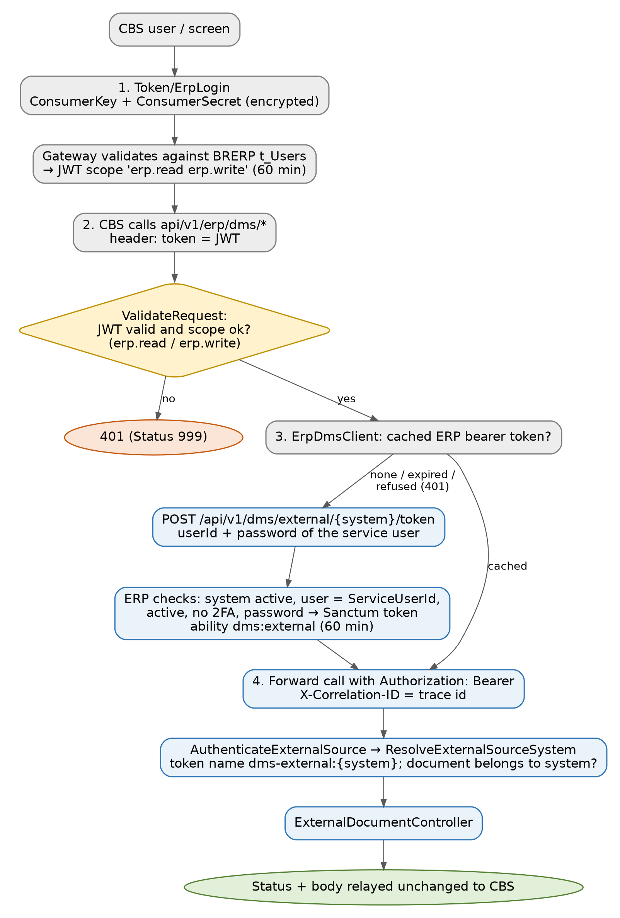
Figure 13. Trust chain and token handling between CBS, gateway and DMS
Actor | Responsibility
CBS | Authenticates its own operators, calls Token/ErpLogin for a gateway token, sets actor and actorName from its own session on every write. Must store the DMS documentId and operator in its own audit trail.
Gateway (ErpDmsController, ErpDmsClient) | Validates the CBS caller's JWT and scope, logs into the DMS as the service user once and caches the bearer token in memory until 2 minutes before expiry, forwards only allow-listed fields, adds X-Correlation-ID, relays status and body unchanged.
DMS (AuthenticateExternalSource, ResolveExternalSourceSystem, ExternalDocumentController) | Authenticates the service user's token, scopes every call to the source system, enforces event, file, property and lock rules, and records the operator in source.* attributes and the activity log.

6.3 Gateway configuration (`AppSettings`)
Key | Meaning
ErpApiUrl | Base address of the DMS, for example https://erp.example/.
ErpApiConsumerKey, ErpApiConsumerSecret | Encrypted (EnAction128) DMS service-account user id and password. Must be the source system's service user, without two-factor. Supply per environment; never commit.
ErpDmsSystemCode | DMS source system code, CBS. Used in the URL path.
ErpApiTimeoutSeconds | Per-call timeout, default 300 (uploads).
ErpApiAllowInvalidCertificate | Development only.

If any of the first four are unset every DMS endpoint on the gateway answers 503.

6.3.1 Actual CBS configuration for the ERP DMS
Configure CBS to call the API gateway, never the ERP application directly. In CBS open Other Modules > ERP Integration and create or update the ERP connection with the values below. Names may be presented slightly differently by a CBS release, but the stored values and wire behaviour are the contract.
CBS setting | Value to configure | Developer note
Integration / status | ERP Integration; Enabled | Use one environment-specific record (DEV, UAT or PROD).
Gateway base URL | https://<gateway-host>/ | This is BRGateway24, not ErpApiUrl and not a direct BRERP URL.
Authentication path | POST /Token/ErpLogin | Content-Type: application/json.
Consumer Key | <EnAction128-encrypted ERP service-user ID> | Generate using the gateway UserKey; do not enter plaintext or commit the value.
Consumer Secret | <EnAction128-encrypted ERP service-user password> | Must represent the same active ERP user selected as CBS ServiceUserId in DMS Source Systems.
DMS API prefix | /api/v1/erp/dms | Append the endpoint paths in section 6.6.
Token header | token: <AccessToken> | Do not use Authorization: Bearer. Refresh by calling ErpLogin after expiry or a 401.
Timeout | At least 300 seconds for upload calls | Align with gateway ErpApiTimeoutSeconds; do not automatically retry uploads.
CBS authentication request (the values stored by ERP Integration):
{
"ConsumerKey": "<encrypted ERP service-user ID>",
"ConsumerSecret": "<encrypted ERP service-user password>"
}
CBS must apply these values on every DMS operation:
Value | Source in CBS | Sent as
module | Current CBS screen/module ID (for example 1330) | Form/query field module; it must be mapped to an active DMS event.
entityType | Business object being viewed | ACCOUNT, APPLICATION or LOAN.
entityId | Stable CBS account/application/loan identifier | Never a display label; use the same identifier when listing documents.
actor | Authenticated CBS operator ID | Server-derived on every write/content call; never trust a browser-supplied value.
actorName | Authenticated operator display name | Optional display/audit value.
documentId | Returned by the ERP after upload | Persist beside the CBS record and include it in the CBS audit trail.
At screen load call GET events with module and entityType, render only the returned active events, document types and properties, then call GET documents with entityType and entityId. Do not hard-code the event catalog in CBS: DMS administrators control it from Settings > DMS > Event Types.

6.3.2 Matching gateway and ERP configuration
The CBS record above works only when the gateway and ERP describe the same identity and source-system code. Use placeholders in source control and inject secrets per environment.
"AppSettings": {
"ErpApiUrl": "https://<erp-host>/",
"ErpApiConsumerKey": "<encrypted ERP service-user ID>",
"ErpApiConsumerSecret": "<encrypted ERP service-user password>",
"ErpDmsSystemCode": "CBS",
"ErpApiTimeoutSeconds": 300,
"ErpApiAllowInvalidCertificate": false
}
Equivalent deployment variables are AppSettings__ErpApiUrl, AppSettings__ErpApiConsumerKey, AppSettings__ErpApiConsumerSecret, AppSettings__ErpDmsSystemCode, AppSettings__ErpApiTimeoutSeconds and AppSettings__ErpApiAllowInvalidCertificate. In BRERP, select the same user under Settings > DMS > Source Systems > CBS, keep the source active, disable 2FA for this non-interactive service user, and activate only the reviewed CBS event/module mappings. ErpApiAllowInvalidCertificate must remain false outside local development.
Configuration verification sequence:
POST /Token/ErpLogin returns Success=true, StatusCode=000 and an AccessToken.
GET /api/v1/erp/dms/events?module=1330&entityType=ACCOUNT with token: <AccessToken> returns 200 (an empty data array means no active mapped event).
Upload one test document, retain its documentId, list the same entity and confirm the document is returned.
Fetch /documents/{documentId}/content?actor=<operator> and confirm the MIME type and file bytes.
Check the ERP activity log for the CBS actor and X-Correlation-ID; remove the test document according to the environment's data policy.

6.4 DMS-side configuration
- Source system (Settings > DMS > Source Systems, table via SourceSystem): Code (CBS), Name, ServiceUserId (the ERP user the gateway logs in as), IsActive. Seeded by DMSEventTypesSeeder, initially attributed to the system user until an admin points it at a dedicated account.
- Event type (EventType): Code, Name, ExternalEntityType (ACCOUNT, APPLICATION, LOAN), AllowReplace, IsActive, a list of allowed document types, allowed modules (EventModuleMap = CBS screen ids), properties (EventProperty, the form), optional default reviewer (user or team) and validation type.
Seeded event | Entity type | CBS modules | Document types (examples)
CBS_ACCOUNT_DOCUMENTS | ACCOUNT | 1330, 4032, 4063 | NATIONAL_ID, PASSPORT_PHOTO, PROOF_OF_RESIDENCE, PAYSLIP
CBS_APPLICATION_DOCUMENTS | APPLICATION | 1097, 1095 | LOAN_APP_FORM, EMPLOYER_CONFIRMATION, TITLE_DEED, …
CBS_LOAN_DOCUMENTS | LOAN | 1094, 1098 | LOAN_AGREEMENT, PAYROLL_DEDUCTION_FORM, CREDIT_LIFE_CERT, DEMAND_LETTER

Events are seeded inactive: which document types belong on which CBS screen is a business decision, and an active event is offered to CBS users immediately. Seeded properties: cbs.class (list: IDEN, ADDR, INCM, SECU, OTHE; required), cbs.location, cbs.received_by (required), cbs.received_date (datetime, required), cbs.remarks.

6.5 Authentication reference

Step 1 - CBS obtains a gateway token
POST {gateway}/Token/ErpLogin
Content-Type: application/json

{ "ConsumerKey": "<encrypted user id>", "ConsumerSecret": "<encrypted password>" }

200 { "Success": true, "Message": "Authentication successful", "StatusCode": "000",
"AccessToken": "<jwt>", "ExpiresIn": 3600 }
401 { ... "Authentication failed. Invalid credentials." }

The JWT carries the scope erp.read erp.write. Both scopes are granted together because there is one trusted ERP integration identity. The gateway reads this token from the `token` request header (not Authorization). A missing or invalid token gives 401 with Status: "999"; a valid token without the required scope is also refused.

Step 2 - Gateway logs into the DMS (internal)
POST {ErpApiUrl}/api/v1/dms/external/CBS/token (throttle: 10 per minute per IP)
Content-Type: application/json

{ "userId": "<service user>", "password": "<password>" }

200 { "data": { "token": "<sanctum token>", "tokenType": "Bearer",
"expiresAt": "2026-09-26T11:00:00+00:00" } }
401 { "message": "Authentication failed. Invalid credentials." }

The token is valid for 60 minutes, has the ability dms:external, is named dms-external:{system} and works only for that source system. Login succeeds only if the user is the source system's ServiceUserId, is active, has no two-factor enabled and the password verifies. All failures read the same. Tokens expire and are pruned daily (sanctum:prune-expired). If the DMS returns 401 to a cached token, the gateway re-logs in once and retries that one call.

6.6 Endpoint reference (gateway `api/v1/erp/dms`)
All calls need the token header. Reads need erp.read, changes need erp.write. The DMS path each call maps to is /api/v1/dms/external/{system}/... with the system code from ErpDmsSystemCode.
Verb | Gateway path | Scope | DMS path
GET | events?module=&entityType= | erp.read | events
GET | documents?entityType=&entityId=&event=&module= | erp.read | documents
GET | documents/{id} | erp.read | documents/{id}
GET | documents/{id}/content?actor= | erp.read | POST documents/{id}/link then signed GET documents/{id}/content
POST | documents (multipart) | erp.write | documents
POST | documents/{id}/replace (multipart) | erp.write | documents/{id}/replace
POST | documents/{id}/review | erp.write | documents/{id}/review
POST | documents/{id}/validation | erp.write | documents/{id}/validation

6.6.1 GET events
Lists the events a CBS screen (module id) may raise, with everything needed to render the upload form. module is required (gateway 400 {"message":"module is required."} otherwise); entityType filters by ACCOUNT, APPLICATION or LOAN.
GET /api/v1/erp/dms/events?module=1330&entityType=ACCOUNT
token: <jwt>

200
{ "data": [ {
"code": "CBS_ACCOUNT_DOCUMENTS", "name": "Account documents", "description": null,
"externalEntityType": "ACCOUNT", "allowReplace": true,
"review": { "defaultReviewer": "Registry Team", "defaultKind": "team" },
"validation": { "available": true, "type": "Client Onboarding" },
"documentTypes": [ { "code": "NATIONAL_ID", "name": "National ID",
"allowedExtensions": ["pdf","jpg","png"], "maxSizeMB": 5, "expiryRequired": false } ],
"properties": [
{ "name": "cbs.class", "label": "Document class", "type": "list", "required": true,
"options": [ { "value": "IDEN", "label": "Identification" } ] },
{ "name": "cbs.received_by", "label": "Received by", "type": "string",
"required": true, "options": null } ] } ] }

Property type is one of string, integer, float, boolean, datetime, time, list. Only active events that have at least one active document type are returned.

6.6.2 GET documents (for one record)
GET /api/v1/erp/dms/documents?entityType=ACCOUNT&entityId=0010000059251&event=&module=

200 { "data": [ <document>, ... ] }
400 { "message": "entityType and entityId are required." } (gateway)

6.6.3 The document object
{
"documentId": "DOC-...", "name": "id-front.pdf", "mimeType": "application/pdf",
"event": { "code": "CBS_ACCOUNT_DOCUMENTS", "name": "Account documents" },
"documentType": { "code": "NATIONAL_ID", "name": "National ID" },
"entity": { "type": "ACCOUNT", "id": "0010000059251" },
"module": 1330, "version": 1, "size": 184223,
"uploadedOn": "2026-09-26T09:12:44+00:00", "modifiedOn": "2026-09-26T09:12:44+00:00",
"expiryDate": null,
"status": {
"state": "active", "onHold": false, "underReview": false, "archived": false,
"checkedOut": false, "pendingValidation": false, "validated": false,
"lockReason": null, "canReplace": true,
"holdReleasedOn": null, "lastReviewedOn": null,
"review": { ... }, "validation": { ... }
},
"properties": [ { "name": "cbs.class", "value": "IDEN" } ]
}

Field | Notes
status.state | One of active, validated, legal_hold, under_review, pending_validation, archived, checked_out (the lock reason, else validated, else active).
status.canReplace | event.allowReplace and no lock. Use it to enable the Replace button.
status.review | Latest review: pending or reviewed, reviewer, comment.
status.validation | Latest validation: pending, submitted, approved, rejected, and rejection reason.
properties | Only the properties defined on the event, latest value per name, in event order.

6.6.4 POST documents (upload)
Multipart form. The gateway requires file and actor, rejects non-multipart requests (400) and files over 100 MB, and forwards only the fields listed below (unknown fields are dropped).
Field | Req. | Rules (enforced by the DMS)
file | yes | Must satisfy the document type: allowed mime types (from its extensions) and MaxSizeMB (default limit 20 MB when no type).
event | yes | Event code available from module for this source system (max 50).
documentType | cond. | Code from the event's documentTypes. Optional only when the event has exactly one type, otherwise 422 "Choose which document this is."
module | yes | Integer ≥ 1, the CBS screen raising the event; must be mapped to the event.
entityId | yes | CBS record id (account, application or loan), max 100.
actor | yes | CBS operator id, max 100. Set from the CBS session.
actorName | no | Display name, max 150.
properties | cond. | JSON list of { "name", "value" }. Validated by EventPropertyValidator against the event's definitions (required, type, list options).
expiryDate | cond. | Date after today. Required when the document type has ExpiryRequired.
notes | no | Max 2000.

POST /api/v1/erp/dms/documents
token: <jwt>
Content-Type: multipart/form-data

file=@id-front.pdf
event=CBS_ACCOUNT_DOCUMENTS
documentType=NATIONAL_ID
module=1330
entityId=0010000059251
actor=CS.OFFICER
actorName=Counter Officer
properties=[{"name":"cbs.class","value":"IDEN"},
{"name":"cbs.received_by","value":"Teller One"},
{"name":"cbs.received_date","value":"2026-09-26"}]
notes=Scanned at counter

201 { "data": <document> }
422 { "message": "...", "errors": { "event": ["This event is not available from that module."],
"file": ["The uploaded file is not allowed for this document type."],
"properties.cbs.class": ["..."] } }
500 { "message": "failed to store the document" }

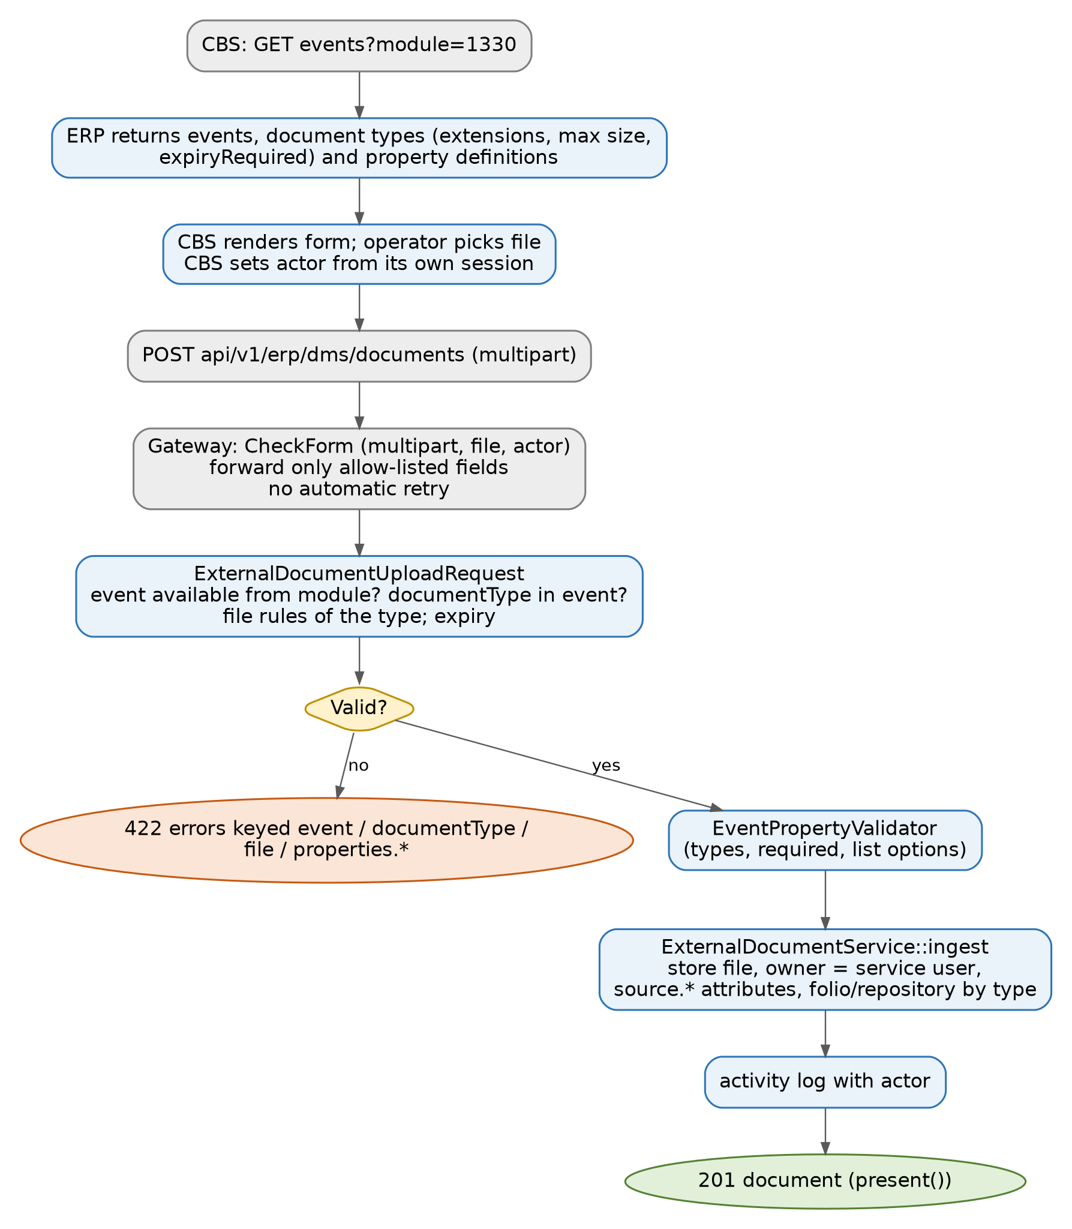
Figure 14. End-to-end external upload (events → form → upload → validation)
Implementation note. The gateway never retries an upload: a retry after the request reached the DMS would file the document twice. On 502/504 CBS must call GET documents?entityType=&entityId= to check whether the document already exists before trying again.

6.6.5 POST documents/{id}/replace
POST /api/v1/erp/dms/documents/{id}/replace
Content-Type: multipart/form-data
file=@clearer-scan.pdf actor=CS.OFFICER actorName=Counter Officer remark=Clearer scan

200 { "data": <document with version + 1> }
409 { "message": "document cannot be changed: legal hold.", "reason": "legal_hold" }
404 { "message": "document not found" }

Creates a new version (DocumentService::newVersionExternal). Refused while locked, and only documents filed by the same source system are reachable.

6.6.6 POST documents/{id}/review
POST /api/v1/erp/dms/documents/{id}/review
Content-Type: application/json
{ "actor": "CS.OFFICER", "actorName": "Counter Officer",
"note": "Please check the stamp", "reviewer": "<DMS user ID, optional>" }

201 { "data": <document with status.review.pending> }
422 { "message": "..." } // no reviewer named and no default on the event

Reviewer is the named reviewer, else the event's default user or team. A team review appears in every member's inbox. Empty fields are dropped by the gateway before forwarding. actor is required by the gateway (400 otherwise).

6.6.7 POST documents/{id}/validation
POST /api/v1/erp/dms/documents/{id}/validation
{ "actor": "CS.OFFICER", "actorName": "Counter Officer", "note": "" }

201 { "data": <document with status.validation.pending/submitted> }
422 { "message": "..." } // event has no validation type

6.6.8 GET documents/{id}/content
The gateway calls POST documents/{id}/link with {"actor"}, receives a 5-minute signed URL, then fetches the bytes itself presenting the host that was signed, and streams them back. The DMS address never reaches CBS and the link cannot be reused. The DMS logs a view activity naming the actor.
GET /api/v1/erp/dms/documents/{id}/content?actor=CS.OFFICER

200 <bytes> Content-Type: <mime>; Content-Disposition: inline|attachment; filename="..."
Cache-Control: private, no-store
400 { "message": "actor is required." }

-- DMS internal --
POST /api/v1/dms/external/CBS/documents/{id}/link { "actor": "CS.OFFICER" }
200 { "data": { "url": "https://.../documents/{id}/content?actor=...&expires=...&signature=...",
"expiresAt": "2026-09-26T09:17:44+00:00" } }

6.7 Error contract
Status | From | Meaning / action
400 | Gateway | Missing module, entityType/entityId, actor, file, or not multipart.
401 | Gateway or DMS | Missing/invalid token header or scope (gateway body Status: "999"); DMS token refused (the gateway retries login once).
404 | DMS | Unknown or inactive system, or document not found (also when the document belongs to another system, so ids cannot be probed).
409 | DMS | Document is locked. reason: legal_hold, under_review, archived, checked_out, pending_validation. Show the reason; do not retry.
422 | DMS | Validation failed (errors keyed by field) or nothing to route to (no reviewer or validation type).
500 | DMS | Unexpected failure (logged server-side).
502 | Gateway | DMS unreachable or credentials could not be decrypted.
503 | Gateway | DMS integration not configured.
504 | Gateway | DMS took too long (timeout).

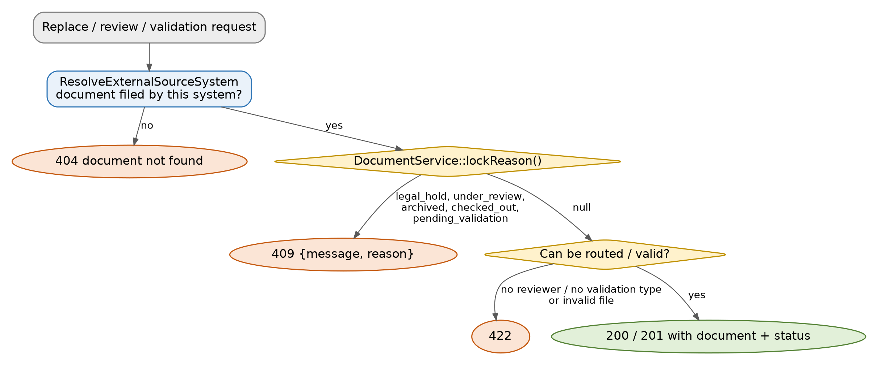
Figure 15. Lock and validation checks on changing calls
Legal hold is enforced in the DMS whichever system asks; the gateway and CBS do not need to check it.

6.8 Other integration endpoints

Verification intake: `POST /api/v1/dms/verification/data`
Used by CBS to register a client-onboarding record that needs documents validated. Auth is HTTP Basic, compared with the APICredential row of integration DMSCoreBanking (Configuration.user / pass). The controller creates a DocumentValidation with no document yet (the document is uploaded later, which is also when the approval workflow starts).
Field | Rules
member_name, branch_id, application_id, member_class, identification_number, gender, date_of_birth, captured_by, status, member_number | Required. application_id becomes the validation id and must be unique across all types, including soft-deleted rows; a duplicate returns Application ID already exists. with status: 999. date_of_birth must be a date.
mobile_number, email_address, member_status | Optional.
validation_type | Optional ValidationTypeId; otherwise config('dms.verification.default_validation_type') (DMS_DEFAULT_VALIDATION_TYPE).

200 { "status": "success", "message": "document validation created successfully",
"data": { "status": "000", "fields": [ { "fieldName": "MEMBER_NAME", "item": "...",
"itemElementName": "String" } ] } }
422 { "status": "error", "errors": { ... } }

Keys reach the caller camel-cased by TransformApiResponse; the code notes that renaming Fields, FieldName, Item, ItemElementName changes the wire contract.

Preview: `GET /api/v1/dms/preview?documentId=`
Returns the embeddable preview page (dms.files.preview) for a document, matched on DocumentId or Id. Same Basic auth.

6.8.1 Complete POST request payload examples
The following examples cover every POST route in the API surface in section 6.1. Gateway-facing calls use the token header returned by /Token/ErpLogin. Direct external-DMS examples are included for gateway developers and Postman testing; CBS itself must use the gateway paths.

POST /api/auth/otp/send
Content-Type/auth: application/json
{
"email": "developer@example.com"
}

POST /api/auth/otp/verify
Content-Type/auth: application/json
{
"email": "developer@example.com",
"code": "123456"
}

POST /api/dms/documents
Content-Type/auth: multipart/form-data; Authorization: Bearer <Sanctum token>
file=@sample.pdf

POST /Token/ErpLogin (CBS to gateway)
Content-Type/auth: application/json
{
"ConsumerKey": "<encrypted ERP service-user ID>",
"ConsumerSecret": "<encrypted ERP service-user password>"
}

POST /api/v1/erp/dms/documents (CBS to gateway)
Content-Type/auth: multipart/form-data; token: <gateway JWT>
file=@id-front.pdf
event=CBS_ACCOUNT_DOCUMENTS
documentType=NATIONAL_ID
module=1330
entityId=0010000059251
actor=CS.OFFICER
actorName=Counter Officer
properties=[{"name":"cbs.class","value":"IDEN"},{"name":"cbs.received_by","value":"Teller One"},{"name":"cbs.received_date","value":"2026-09-26 10:30"}]
expiryDate=2030-01-31
notes=Scanned at counter

POST /api/v1/erp/dms/documents/{documentId}/replace
Content-Type/auth: multipart/form-data; token: <gateway JWT>
file=@clearer-scan.pdf
actor=CS.OFFICER
actorName=Counter Officer
remark=Clearer scan

POST /api/v1/erp/dms/documents/{documentId}/review
Content-Type/auth: application/json; token: <gateway JWT>
{
"actor": "CS.OFFICER",
"actorName": "Counter Officer",
"note": "Please check the stamp",
"reviewer": "<optional DMS user ID>"
}

POST /api/v1/erp/dms/documents/{documentId}/validation
Content-Type/auth: application/json; token: <gateway JWT>
{
"actor": "CS.OFFICER",
"actorName": "Counter Officer",
"note": "Validate against the CBS record"
}

POST /api/v1/dms/external/CBS/token (gateway to ERP)
Content-Type/auth: application/json
{
"userId": "<ERP service-user ID>",
"password": "<ERP service-user password>"
}

POST /api/v1/dms/external/CBS/documents/{documentId}/link (gateway internal)
Content-Type/auth: application/json; Authorization: Bearer <DMS token>
{
"actor": "CS.OFFICER"
}

POST /api/v1/dms/verification/data
Content-Type/auth: application/json; HTTP Basic credentials for integration DMSCoreBanking
{
"member_name": "Jane Mwansa",
"branch_id": "001",
"application_id": "APP-2026-000123",
"mobile_number": "+260970000000",
"member_class": "INDIVIDUAL",
"email_address": "jane@example.com",
"identification_number": "123456/78/1",
"gender": "F",
"date_of_birth": "1990-05-14",
"captured_by": "CS.OFFICER",
"status": "PENDING",
"member_status": "ACTIVE",
"member_number": "0000123456",
"validation_type": "<optional ValidationTypeId>"
}
For multipart requests the values shown one per line are form parts, not a JSON body. Optional values may be omitted. The upload event, documentType and property names must come from GET events for the current module; examples are illustrative but use the current seeder's event code.

6.9 Testing an integration
- Import docs/BRERP_DMS_External_API.postman_collection.json and BRERP_Local_Environment.postman_environment.json (base_url = http://localhost:8000/api; calls are under /v1/dms/external/{{dms_system}}).
- Automated coverage: tests/Feature/DMS/ExternalDocumentApiTest.php, EventCatalogTest.php, DocumentVerificationIntakeTest.php, DocumentValidationWorkflowTest.php (php artisan test).
Implementation note. The Postman upload example still uses the older event code CBS_ACC_NATIONAL_ID. The current seeder defines CBS_ACCOUNT_DOCUMENTS and expects documentType (for example NATIONAL_ID). Update the collection before using it as a contract.

6.10 Security properties of the integration
- No shared static API key on document calls: only a short-lived token bound to one source system and one service user.
- The service account must not use 2FA; treat its password as a secret and rotate it via the gateway configuration.
- Cross-system isolation: documents are looked up by source system, and a foreign id reads as 404.
- Non-repudiation: the CBS operator is recorded as source.* attributes and in the activity log. The gateway must not accept actor from browsers.
- Files are never exposed by URL to CBS; signed links last 5 minutes and are consumed by the gateway.

7. Operations

7.1 Scheduled work
Command | Schedule | Purpose
app:process-queued-email-command | every minute | Send queued emails.
auth:clear-resets | every 6 hours | Purge expired password-reset tokens.
dms:archive-expired-documents | daily 02:00 | Archive documents past ExpiryDate, notify uploader.
sanctum:prune-expired --hours=24 | daily | Delete expired API tokens (external tokens live 60 min).

Additional commands: dms:* reminders for rejected check-outs, licence import/verify (LicenseImportCommand, LicenseVerifyCommand), system backups (RunDueSystemBackups), permission:cache-reset. A cron entry running php artisan schedule:run every minute and a queue worker (docker/erp-worker.config) are required.

7.2 Licensing
RequireLicense and RequireModule consult LicensingService. DMS is module 700000. An invalid licence gives 402 on module routes and the licence page (/admin/license) is reachable for upload. Admins can also switch modules on or off (Settings > Module Settings); disabling a parent hides its children.

7.3 Safety switches
- migrate:fresh, migrate:refresh, migrate:reset and db:wipe are blocked unless ALLOW_DATABASE_WIPE=true (AppServiceProvider).
- Production sessions: 20-minute idle time-out, one active session per user, secure headers via SecureHeaders on API responses.
- GET /debug/auth in routes/web.php is a debugging endpoint that reports session and cookie state without authentication. Remove or protect it before production.

7.4 Deployment
Build with docker/Dockerfile; docker-compose.yml mounts logs and files (storage/app) as persistent volumes and joins the external Applications network. Note that the compose file also bind-mounts .:/var/www, which contradicts its own comment about removing that mount; remove it for production. docker/entrypoint.sh caches config, routes and views, runs migrate --force, then runs ModuleSeeder, CodeDetailSeeder and RolePermissionSeeder on every container start.

8. Extending the System

8.1 Add a document type for CBS
- Create the document type (Settings > DMS > Document Types) with extensions, MaxSizeMB, expiry rule and linked-to type.
- Open the event (Settings > DMS > Event Types), add the type to the event's list and confirm the CBS module ids it may be raised from.
- Activate the event. CBS calls events?module= and sees it immediately.
- No gateway change is needed: the gateway forwards documentType as sent.

8.2 Add a new external system
- Create a dedicated ERP service user (active, no 2FA).
- Create a SourceSystem with a new Code pointing at that user.
- Define its events, modules and properties.
- Give the caller (or a new gateway build) the system code and credentials; the URL path is /api/v1/dms/external/{code}/....

8.3 Add a new DMS feature with proper authorization
- Model and migration with t_ table, PascalCase columns, audit columns.
- Policy in app/Policies/DMS and registration in AppServiceProvider.
- Controller with authorizeResource or explicit authorize.
- Route inside routes/dms.php (inherits module:700000).
- Menu row in ModuleSeeder with RequiredPermission.
- Permission as in section 5.11.
- Call activity() on every state change and respect lockReason() where the record can be frozen.

8.4 Known inconsistencies to be aware of
Item | Detail
Gate::before admin bypass | Documented in a comment but not implemented (section 5.4).
Roles menu permission | ModuleSeeder gates the Roles menu row on dmsRegistry-manage, not roles.
Postman collection | Uses an old event code (section 6.9).
config/dms.php path | Mentions /api/dms/verification/data; actual path is /api/v1/dms/....
Seeder deletes unknown permissions | Hand-made permissions are removed on the next run (section 5.3). Because docker/entrypoint.sh runs the seeder on every start, this happens on each deploy or restart.
/debug/auth route | Unauthenticated debug endpoint.

Appendix A - Permission and Module Reference
ModuleID | Menu item | Route / required permission
700100 | Dashboard | documentdashboardwidgets.index · dmswidgets-view
701000 | Recent Documents | repo.recent · dms-view
702000 | Repository | repo.index · dms-view
703000 | Tags | file-tags.index · dms-view
704000 | Bulk Upload | files.upload · dms-bulkUpload
705000 | Legal Hold | legal-hold.index · dmsLegalHold-view
706000 | Document Validation | dms.validation.index · dms-view
706100 | Document Review | dms.review.index · dms-view
797100–797600 | Signatures, Validation Types, Registry (797300), Manage Registries, Linked-to Types, Document Types | dms-view
798000 | Trash | document-trashed.index · dms-view
799000 | Reports | dms-reports.index · dms-view
9800100 | Users | users.index · users
9800200 | Roles | roles.index · dmsRegistry-manage
9800300 | Branches | branches.index · branch-view
98004000 | Code Details | settings.lists · lists-view
98004500 | User Sessions | users-nonExpiringSessions
98005500 | Organization Profile | organization-profile
98006100 / 98006200 | Workflow Setup / Limits | workflow-view
9800800 / 9800900 | System Backup / Module Settings | admin

Appendix B - Glossary
Term | Meaning
Source system | An external system (CBS) registered in the DMS with a service user.
Event | A business occasion in the source system, mapped to document types, modules and a property form.
Service user | The DMS account the gateway logs in as; owner of documents filed by the source system.
Actor | The person who acted in the external system; recorded but never authenticated by the DMS.
Grant | A row in t_SpecialPermissions giving a user or team Read/Write/Share/Admin on one record.
Lock reason | The condition that currently freezes a document (lockReason()).
Folio | A case reference that groups documents.
Module | A row in t_Modules: a menu node and the unit of licensing.

