BRERP
Document Management System
End User Manual
A complete guide to storing, finding, reviewing, approving and protecting your organisation’s documents.
Version 1.0 | September 2026
Audience: all system users, approvers, registry officers and administrators

Contents

1. Introduction

1.1 Purpose of this manual
This manual explains how to use the BRERP Document Management System (DMS) in your daily work. It is written for people who use the system, not for developers. Each chapter describes a task, the screens involved and the exact steps to follow.

1.2 What the system does
- Central repository – keep every electronic document in one secure, searchable place, organised in repositories (folders).
- Version control – every change is kept as a version; earlier versions can always be viewed.
- Check-out / check-in – prevents two people from editing the same document at once.
- Validation, approval and signing – route documents through a defined approval workflow.
- Review and annotation – request a review and mark up documents with comments.
- Tags and search – classify documents and find them quickly.
- Legal holds – freeze documents that must be preserved for legal or audit reasons.
- Physical registry – track paper files, their storage locations, movements and loans.
- Audit trail and reports – every action is recorded; reports can be exported.
- Security – role-based access, per-document permissions, two-factor authentication and automatic session time-out.

1.3 Conventions used
Convention | Meaning
Bold text | Names of buttons, menus, tabs and fields as they appear on screen.
Menu > Sub-menu | A navigation path, for example Document Management > Repository.
Note / Tip / Important | Shaded boxes giving extra information, shortcuts or warnings.

Note: What you see on screen depends on the permissions your administrator has given you. If a menu or button described in this manual is missing, you probably do not have the permission for it. Contact your administrator.

2. Getting Started

2.1 System requirements
- A current desktop or laptop web browser (Google Chrome, Microsoft Edge, Mozilla Firefox or Safari).
- A network connection to your organisation’s DMS server.
- For two-factor authentication: a smartphone with an authenticator app (for example Google Authenticator or Microsoft Authenticator).

2.2 Logging in
- Open the DMS address supplied by your administrator in your browser.
- Enter your provided UserId and password.
- Click Login.
- If two-factor authentication is enabled for your account, enter the 6-digit code shown in your authenticator app and confirm.
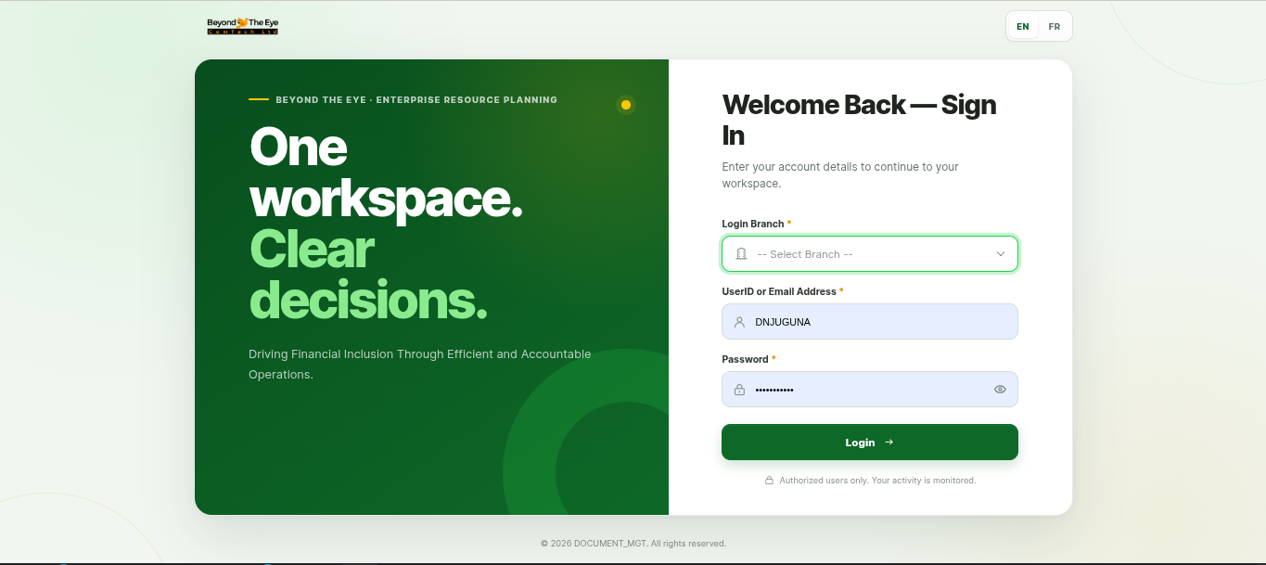
Important: After 5 unsuccessful login attempts your login is temporarily blocked. Wait for the time shown on screen and try again, or ask your administrator to reset your password.

Note: The system allows one active session per user. Signing in on another device may end your earlier session.

2.3 Resetting a forgotten password
Ask your administrator to send you a password-reset link. Open the link from your email, enter and confirm your new password, then log in as normal. You can also change your password yourself from your profile (section 2.6).

2.4 Screen layout
Area | Description
Side menu | Main navigation. Contains Document Management, User Management (if enabled) and Settings, each with sub-menus.
Top bar | Global search, language switch (English / French), notifications and your profile menu.
Breadcrumbs | Show where you are and let you jump back to a higher level.
Work area | The main content: lists, forms and document details.

2.5 Main menu reference
Menu item | Use it to…
Dashboard | See widgets and summaries of DMS activity.
Recent Documents | Return to documents you or others worked on lately.
Repository | Browse repositories and documents; upload, open and manage files.
Tags | Manage tags and automatic tagging rules; list documents by tag.
Bulk Upload | Upload many files at once with shared details.
Legal Hold | Create and manage legal holds.
Document Validation | Submit documents for approval/signing and act on requests.
Document Review | Handle review requests and annotate documents.
Registry | Physical files, storage locations, requests and check-outs.
Settings (DMS) | Signatures, Validation Types, Manage Registries, Linked-to Types, Document Types.
Trash | Restore or review deleted and archived documents.
Reports | Run and export DMS reports.

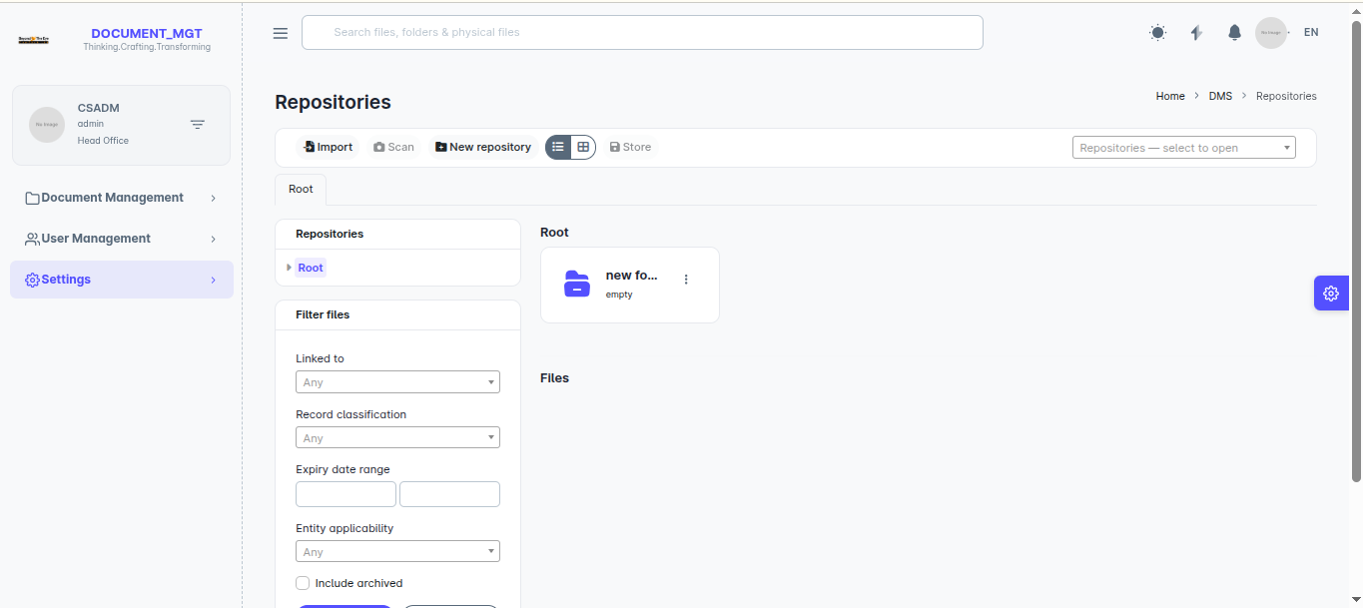

2.6 Your profile, password and two-factor authentication
Open your profile from the profile menu (top right).
- Update details – change your personal information and save.
- Profile picture – upload a new avatar image.
- Change password – enter your current password, then the new one twice.

Enabling two-factor authentication
- In your profile, open the Two-Factor section.
- Scan the QR code with your authenticator app.
- Enter the 6-digit code from the app to confirm.
- From now on you will be asked for a code each time you log in.
You can disable two-factor authentication from the same page.
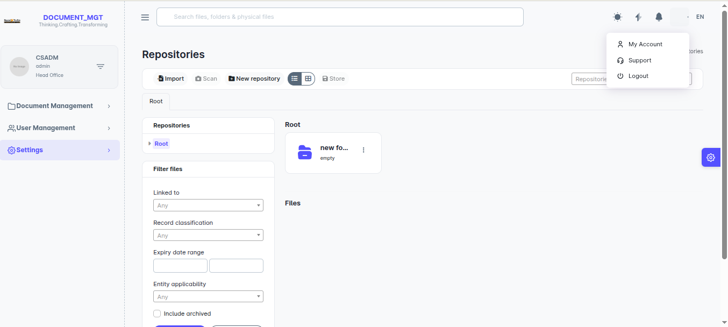
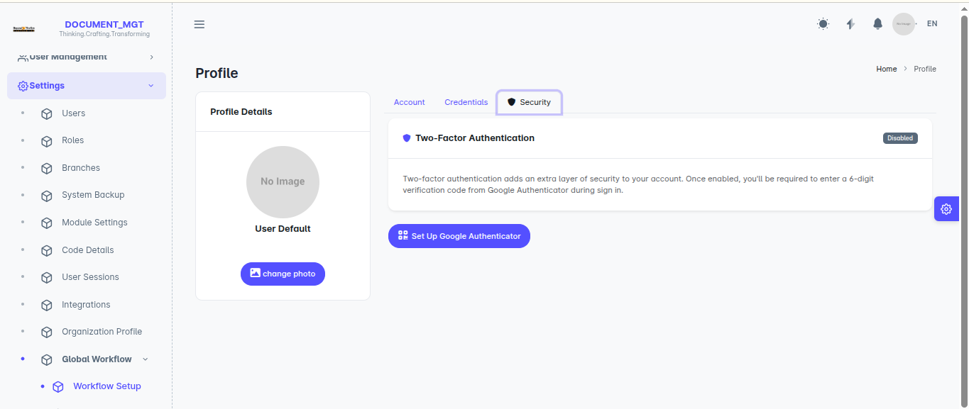

2.7 Language
Use the language switch to change between English and French. The choice is remembered for your session.

2.8 Session time-out and logging out
For security, an inactive session ends automatically (the default is 20 minutes). Shortly before this happens a warning appears; choose to stay signed in to extend the session. If the session ends you will be asked to sign in again. Always use Logout in the profile menu when you finish.

2.9 Notifications
The bell icon shows system notifications such as approval requests or review assignments. Open Notifications to see the full list, mark one notification as read, mark all as read, or clear the list.
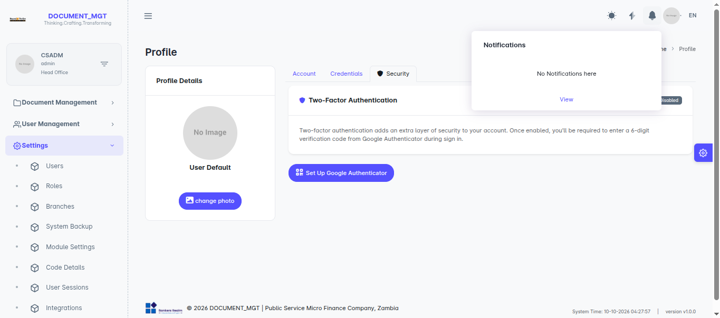

3. Working with Documents

3.1 Concepts
Term | Meaning
Repository | A folder-like container that holds documents. Repositories can contain sub-repositories.
Document | A file stored in the system, together with its details (type, tags, notes, dates), versions and history.
Document type | A category such as “Contract” or “Bank Statement”. It decides which file formats and maximum size are accepted and where the file is filed.
Folio (case) | An optional reference that groups several related documents together as one case.
Linked-to type | What the document relates to (for example a client or a loan). Chosen at upload.
Visibility | Public (visible to users who can access the location) or Private (visible only to people it is shared with).

3.2 Browsing repositories
- Go to Document Management > Repository.
- Click a repository to open it and see its documents and sub-repositories.
- Use the breadcrumbs to move back up.
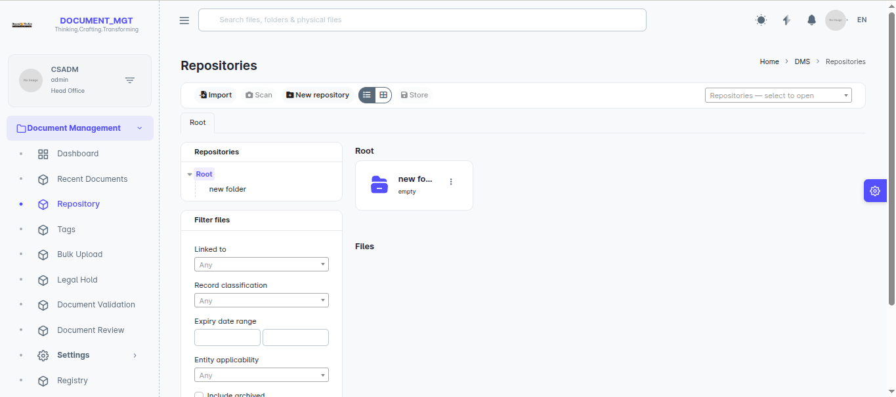

3.3 Creating a repository
- Open the location where the new repository should sit (or the root).
- Click the create/add repository button.
- Enter a Name (and description if requested) and choose the Visibility.
- Save.
From a repository you can also change its visibility, share it with users or teams, and move it under another repository.
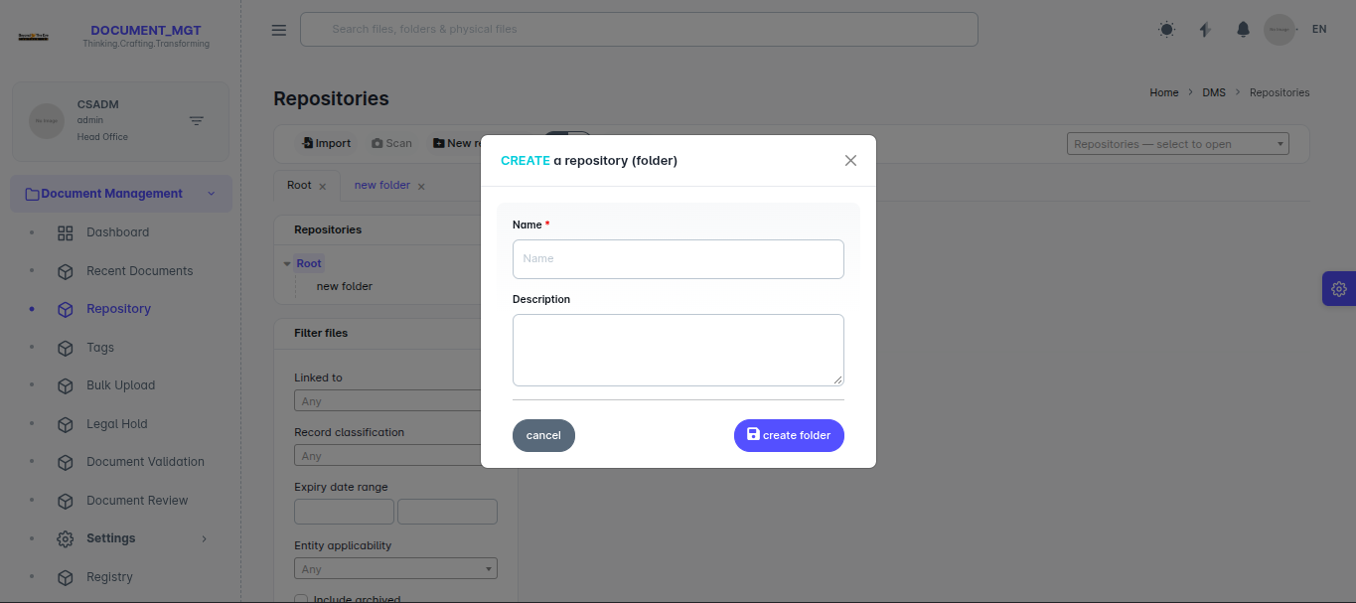
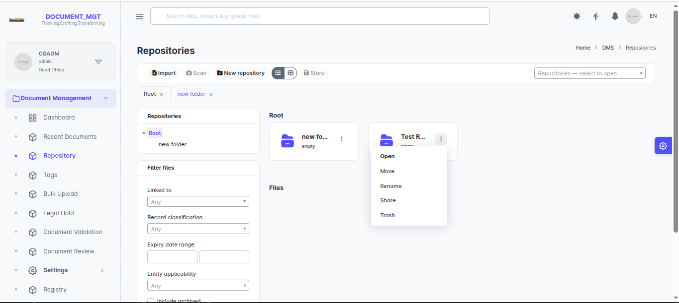
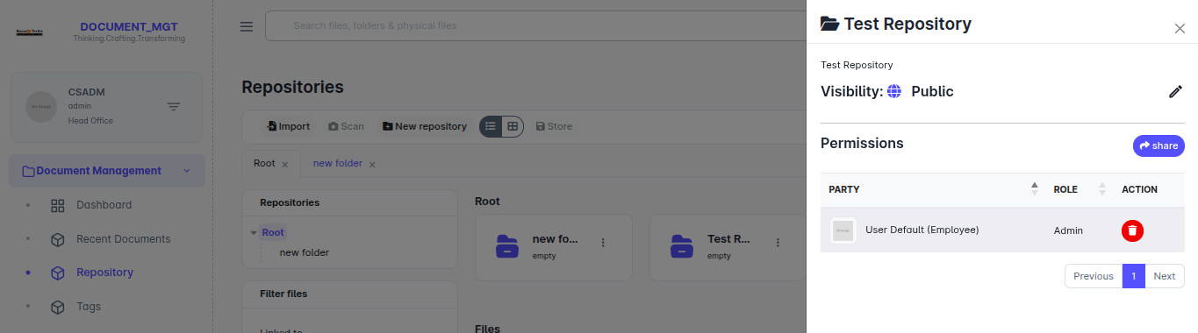

3.4 Uploading a document
- Open the target repository and choose to add a file, or use Bulk Upload (section 3.5).
- Select the Document type. The hint underneath explains which files are accepted.
- Choose the Linked to value and the Record it relates to, where requested.
- Optionally set the Folio: Standalone (no case), New case (a case reference is generated for you) or Existing case (pick an existing one).
- Optionally enter an Expiry date and Notes (up to 2000 characters).
- Drag files into the upload box, or click it to browse.
- Click upload/save and wait for each file to show as complete.
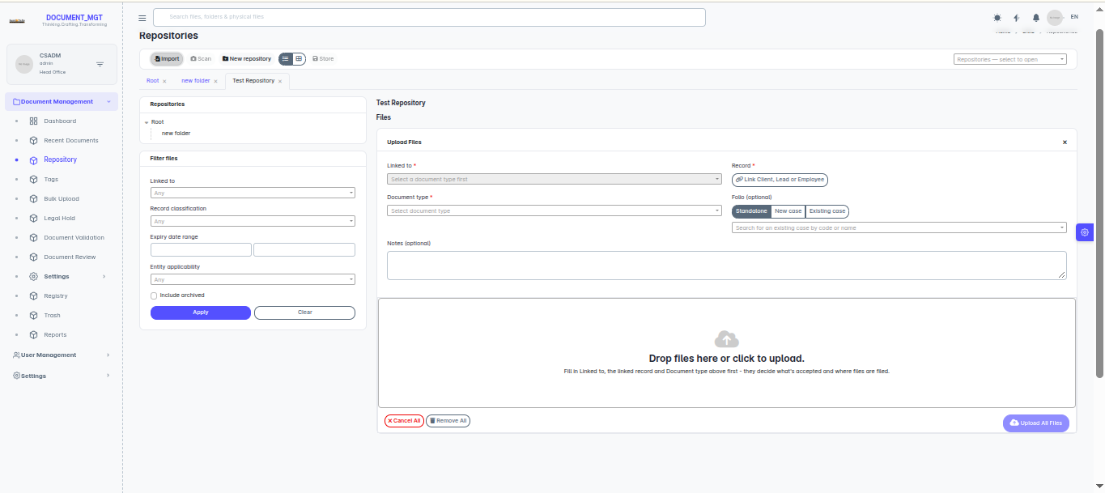
Important: Files larger than the size allowed for the document type (20 MB by default) or in a format the type does not accept are rejected. Contact your administrator if you need a different limit.

3.5 Bulk upload
Use Document Management > Bulk Upload to upload many files at once. Choose the document type and shared details first, then add all files. The same details are applied to every file, so group files of the same kind in one upload. You need the bulk-upload permission to see this menu.
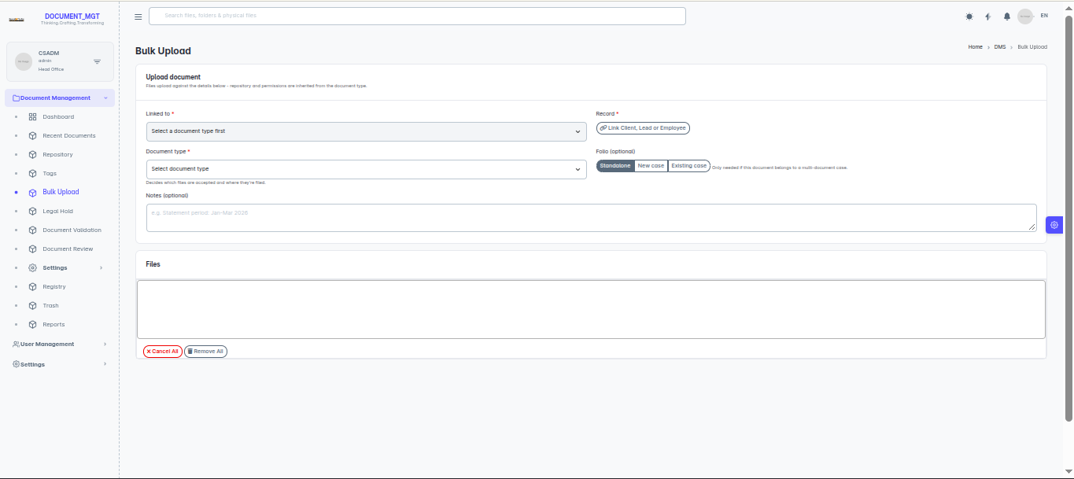

3.6 Opening and previewing a document
Click a document name to open its details page. The page shows a preview and the document information. Tabs and panels give access to versions, activity, permissions, tags, legal holds and related actions. Where a file cannot be previewed in the browser, use download.

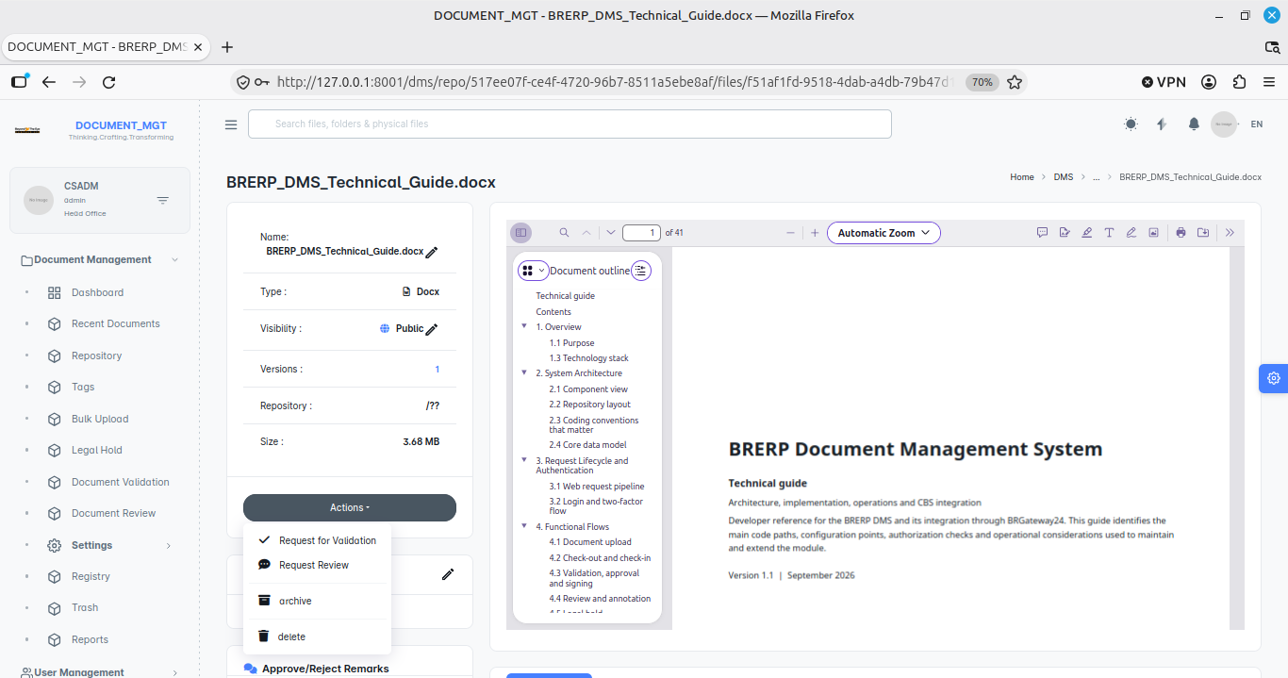

3.7 Searching
- Type your words into the global Search box in the top bar.
- Press Enter to see matching documents.
- Open a result to view it.
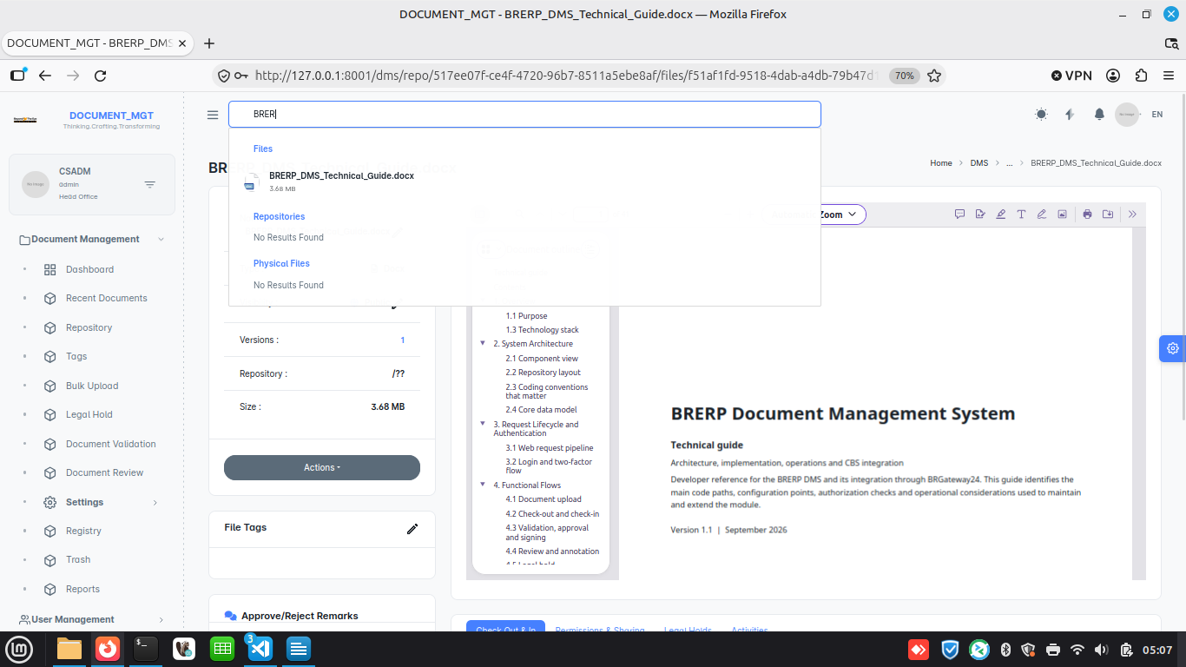
Tip: Combine searching with tags and document types to narrow results. Search results only include documents you have permission to see.

3.8 Recent documents
Document Management > Recent Documents lists documents recently added or changed, so you can pick up where you left off.

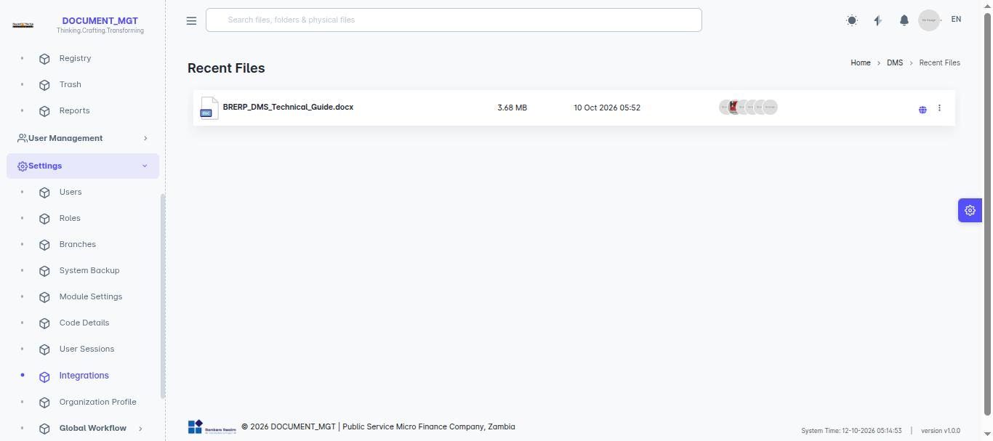

3.9 Downloading
Use the download action on the document page. Downloads are recorded in the document’s activity history.
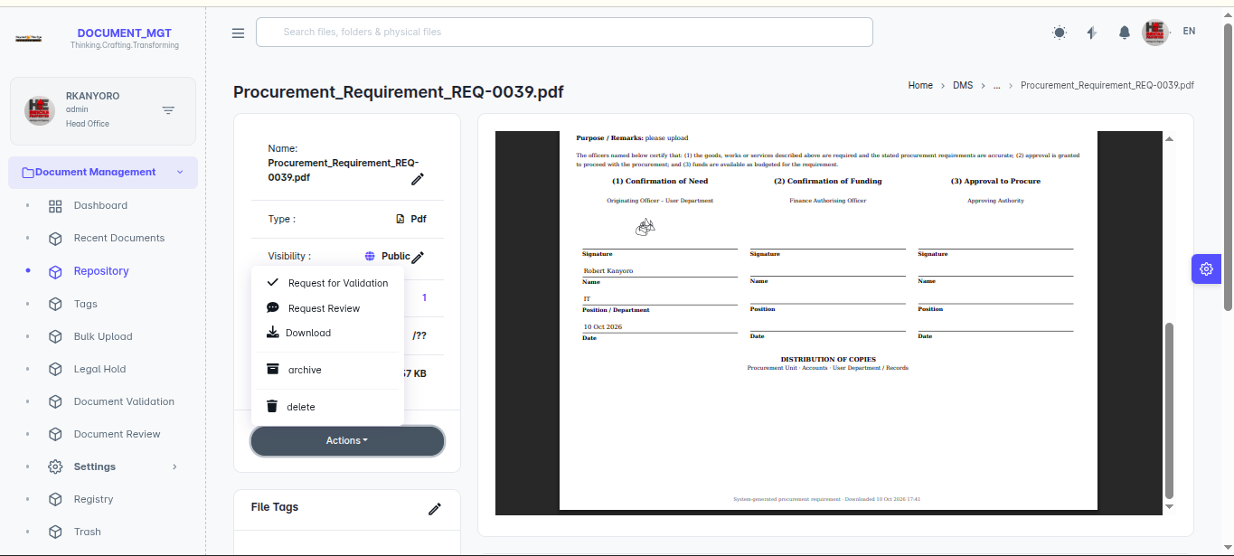

3.10 Versions
When a new file is checked in over an existing document, the previous file is kept as an earlier version. Open the Versions tab to list all versions, preview an older version, or download it.
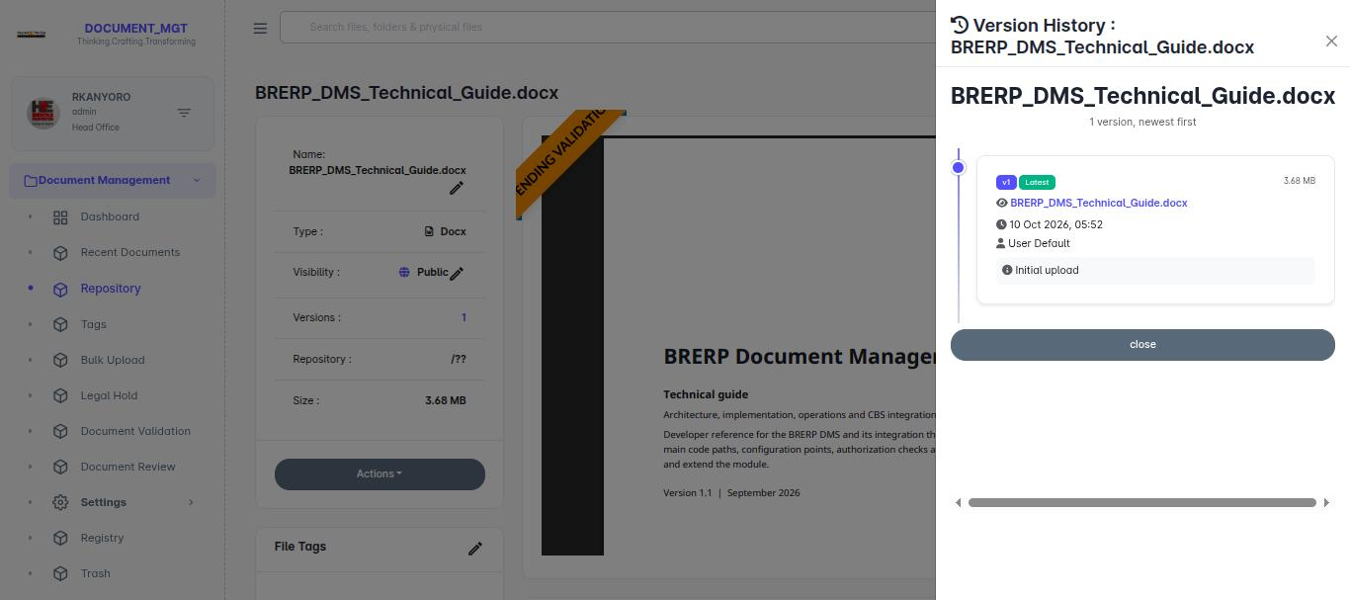

3.11 Check-out and check-in
Check-out reserves a document for you so nobody else can change it while you work on it. Others still see it marked as Checked Out.
- On the document page click Check Out, add a CheckOut Remark if you wish, and confirm.
- Download the document and edit it on your computer.
- When done, click Check Out & In/Check In, upload the updated file and add a CheckIn Remark describing what changed.
If you no longer need to edit the document, choose Cancel and give a Cancel Reason. This releases the document without creating a new version.
Note: Do not leave documents checked out longer than necessary. If someone else holds a document you need, ask them to check it in.

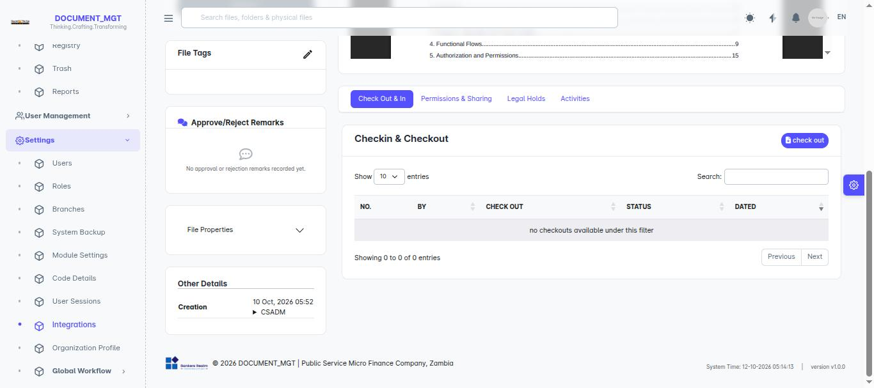

3.12 Editing details, moving and tagging
- Edit details – update name, notes, dates and similar information from the document page.
- Move – choose Move, select the destination repository and confirm.
- Tags – open the File Tags section and add tags (see chapter 4).
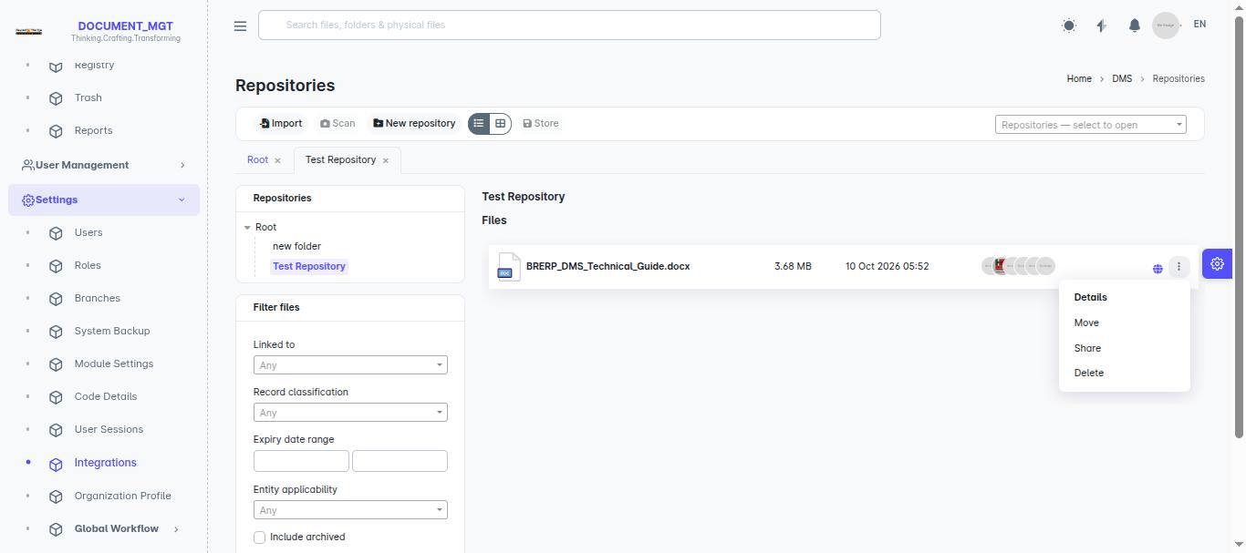

3.13 Sharing and permissions
Access to a document (or repository) can be granted to individual users or teams from the Permissions section. Choose the User/Team, choose a Role, and save.
Role | What it allows
Read | View and download only.
Write | Read, plus change the document (check-out/in, edit details).
Share | Write, plus share the document with others.
Admin | Full control including changing visibility, permissions and deleting.

To withdraw access click Remove beside the person or team and confirm. The Visibility setting switches the item between Public and Private.
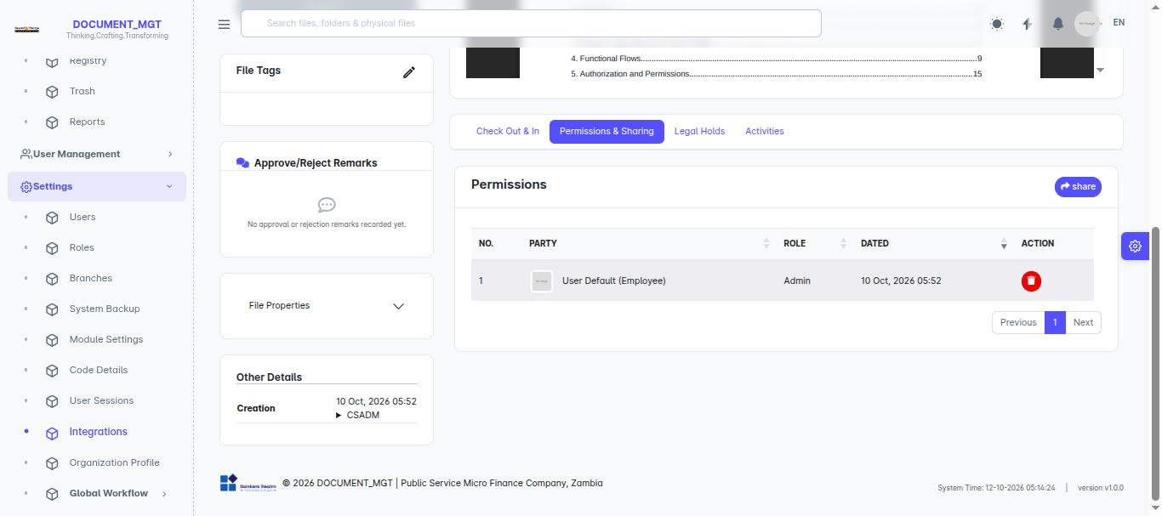

3.14 Archiving and unarchiving
Archive documents you no longer use day-to-day but must keep.
- Open the document and choose Archive Document.
- Enter the Reason and confirm.
Archived documents appear in the Archived tab of Trash. To bring one back, choose Unarchive Document and give a reason.
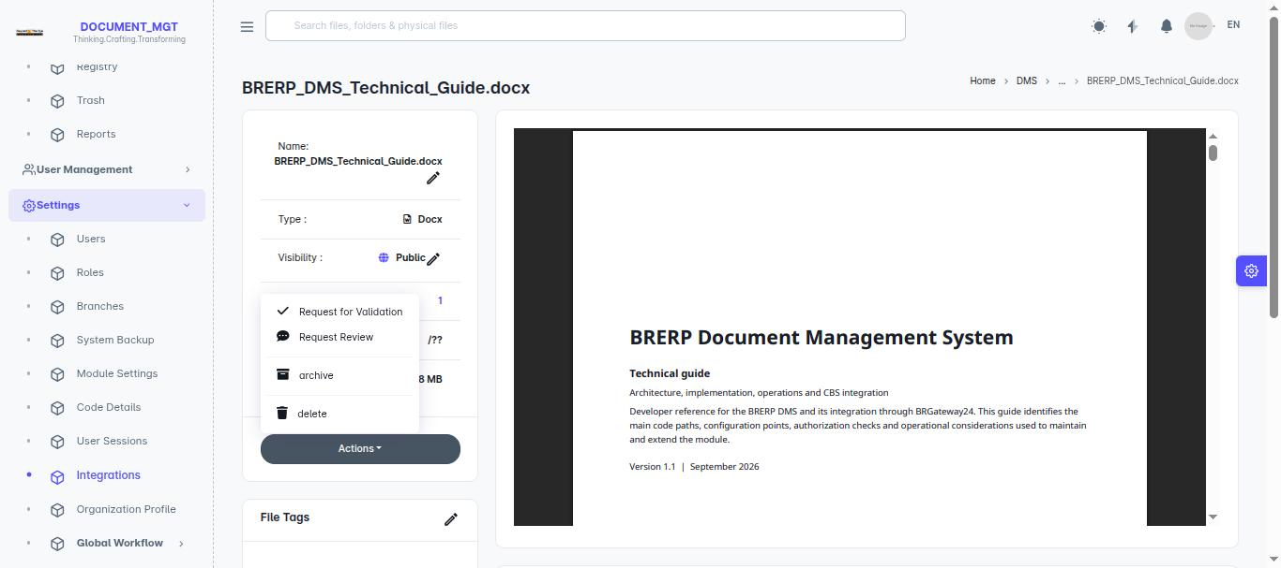

3.15 Deleting and restoring (Trash)
Deleting a document moves it to Trash, it is not destroyed immediately. Open Document Management > Trash to see deleted documents and archived documents on separate tabs, and restore what you need.
Important: Documents under an active legal hold cannot be deleted (chapter 6).

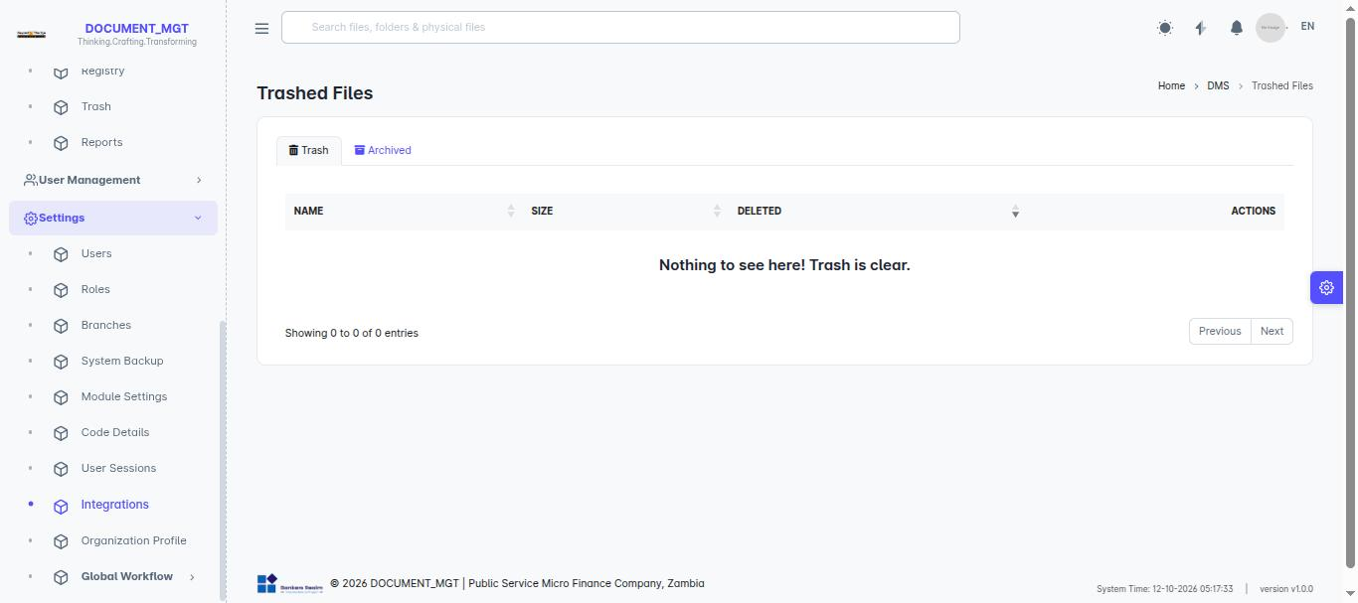

3.16 Activity history
Every document has an activity list showing who viewed, changed, moved, shared, downloaded, checked out or approved it, and when. Use it to answer “who did what”.
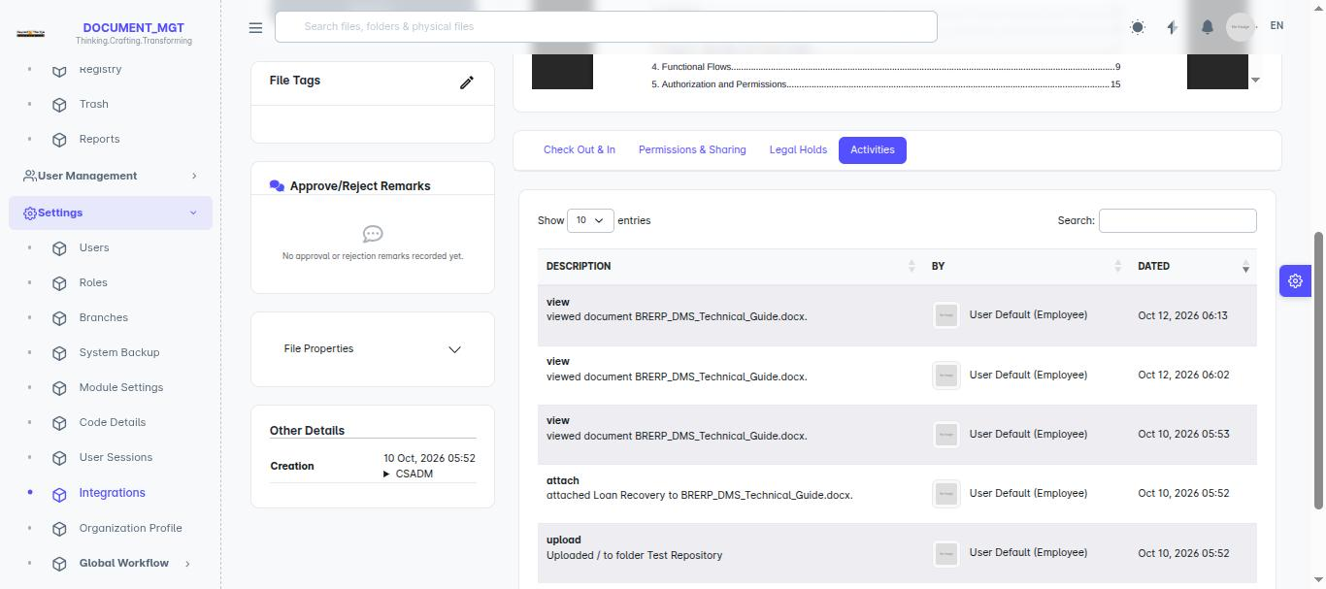

4. Tags
Tags are labels that group documents across repositories.

4.1 Viewing tags
Open Document Management > Tags to see all tags. Click a tag to list the documents that carry it.
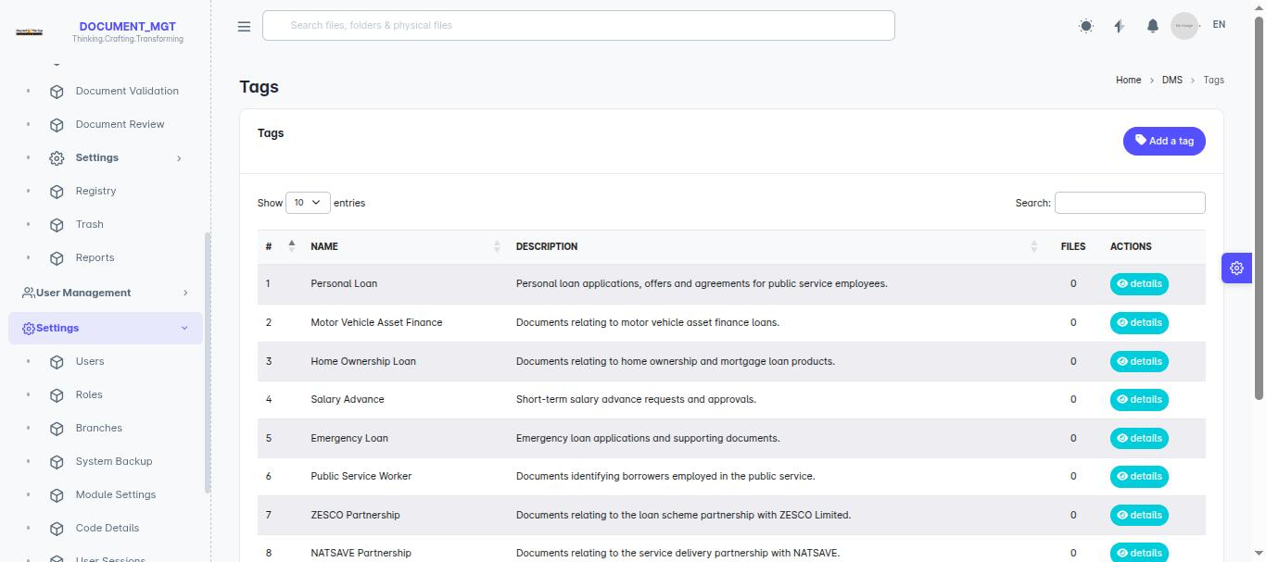

4.2 Creating a tag
- In Tags, click to add a new tag.
- Enter the tag Title and Description.
- Save.

4.3 Automatic tagging rules
A tag can have rules so matching documents are tagged automatically. Open a tag, go to its Tagging rules, and create a rule by choosing what to examine (document title or document content), a comparison (equal to, not equal to, contains, does not contain, starts with, ends with) and the text to compare.

4.4 Tagging a single document
Open the document, use File Tags, choose one or more tags and save.

5. Validation, Approval and Signing
Use Document Validation to get formal approval for a document, and optionally signatures from named approvers.

5.1 Submission modes
Mode | What happens
Submit for Validation | Requires approval and a signature from the assigned approvers.
Submit For Approval | Routes through the approval workflow only. No signature required.
Submit For Approval and Validation | First approved through the workflow, then signed by the added approvers.

5.2 Statuses
Status | Meaning
Pending | Created but not yet acted on.
Submitted for Approval | Sent to approvers and awaiting their decision.
Approved | All required approvals given.
Rejected | Turned down. The submitter may correct and resubmit.

5.3 Submitting a document
- Open the document and choose the validation/approval action (or start from Document Validation).
- Select the Validation type and the submission mode.
- Add a Name, notes and, where the mode needs them, the approvers/signers.
- Submit. The document is shown as Pending Validation and approvers are notified.

5.4 Approving or rejecting
You need the validation-approval permission to act on requests.
- Open Document Management > Document Validation and select the request.
- Read the document and any attached information.
- Enter Approve/Reject Remarks.
- Click Approve or Reject.
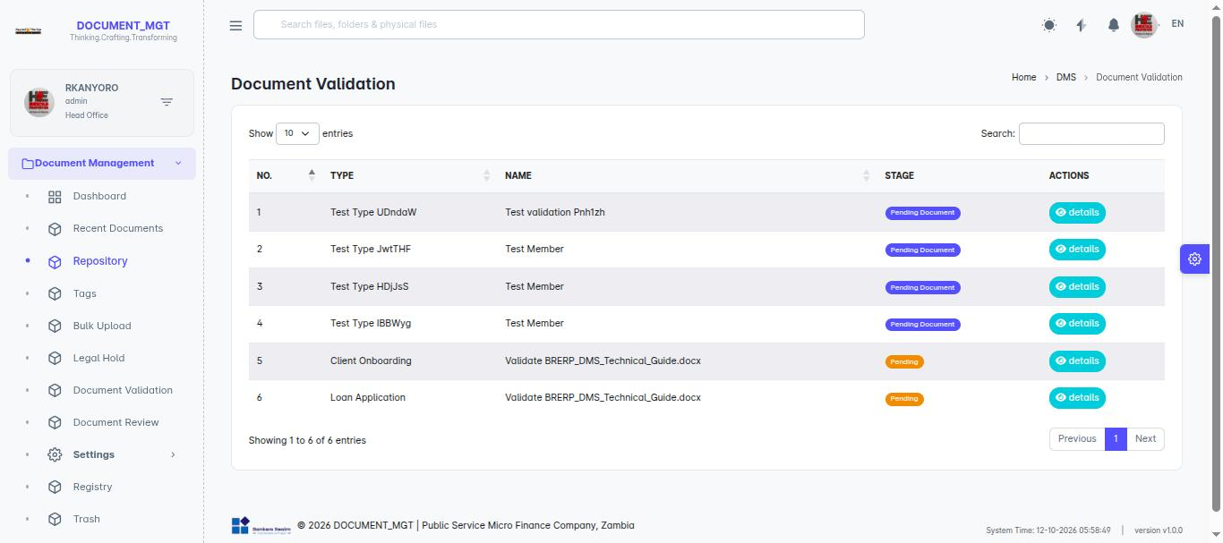
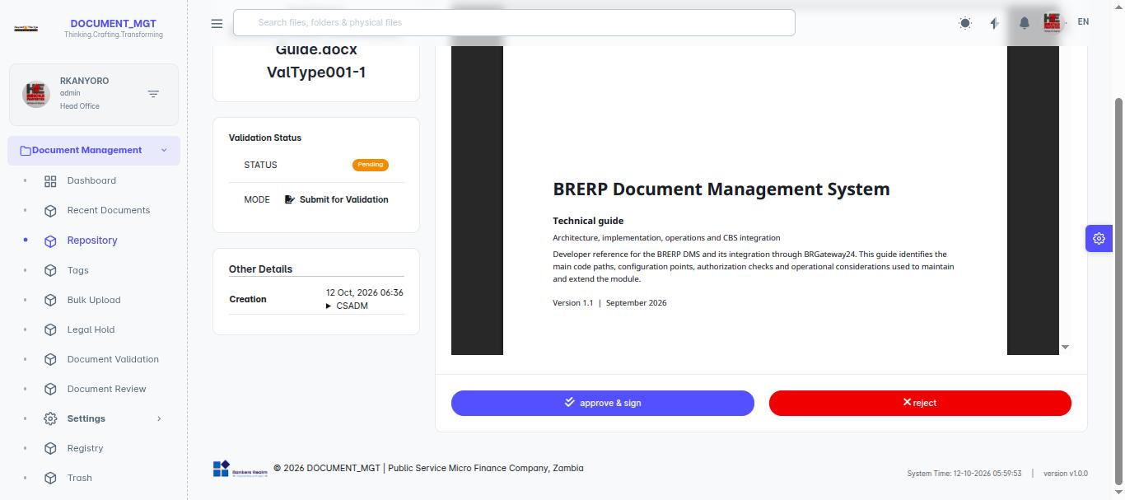
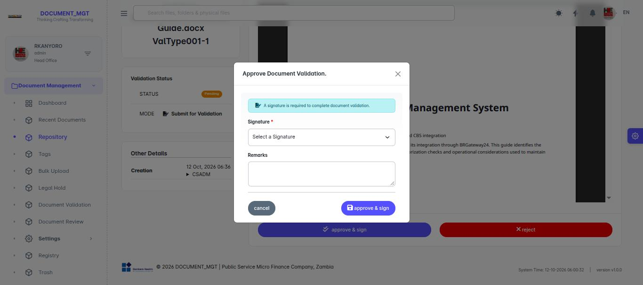
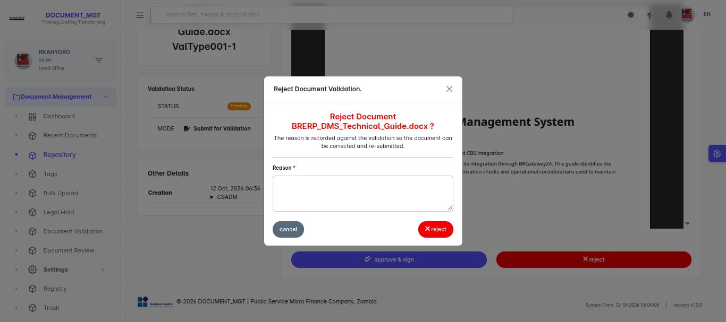

5.5 Resubmitting a rejected document
Open the rejected request, read the remarks, correct the document, and choose Resubmit.

5.6 Signatures
Under Settings > Signatures each person can maintain a signature that is applied to documents when they sign. Open a signature to see the documents it has been used on.
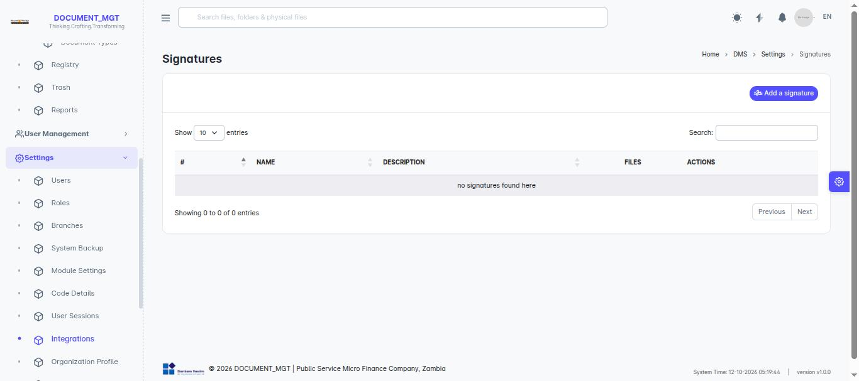

5.7 Document review and annotations
A review is a lighter request than approval: someone is asked to read a document and comment.
- On the document page choose the review request action, pick the reviewer(s) and add a note.
- Reviewers open Document Management > Document Review and select the item. Status is Pending until finished.
- The reviewer adds annotations directly on the document and saves. They can delete their own annotations.
- The reviewer marks the review done. Status changes to Reviewed.
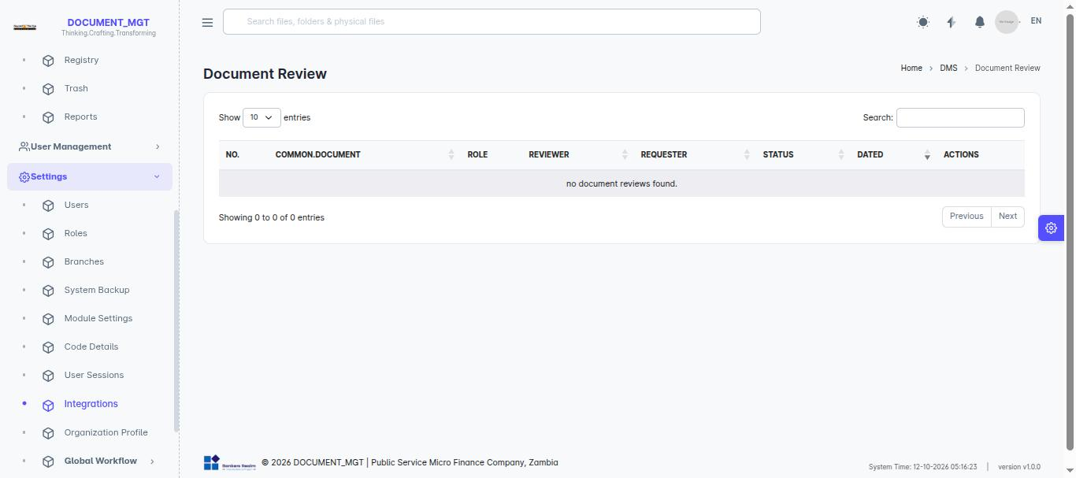

6. Legal Holds
A legal hold preserves documents needed for a legal matter, investigation or audit. While a document is on hold it is protected from deletion and disposal.
Status | Meaning
Active | Hold is in force; documents are protected.
Released | Hold has ended; documents return to normal handling.
Canceled | Hold was cancelled.

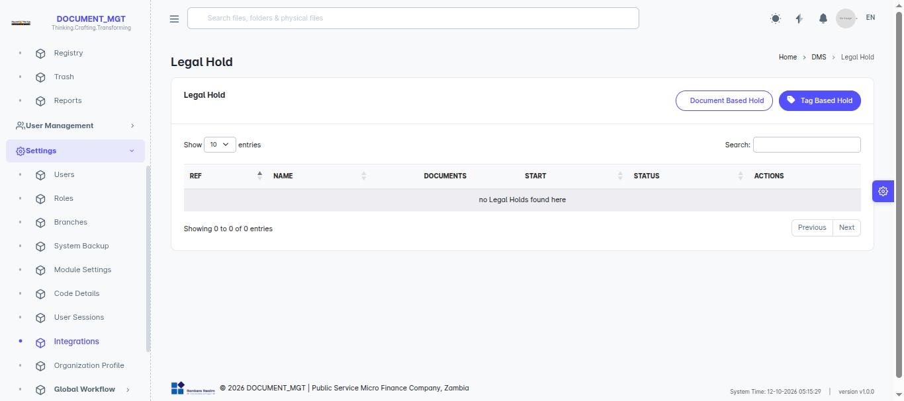

6.1 Creating a legal hold
- Open Document Management > Legal Hold and choose to create a new hold (requires the legal-hold create permission).
- Enter a clear Title and Description of the matter.
- Save.

6.2 Adding documents to a hold
Open the hold and use its documents list to add documents. A document’s own page shows the Legal Holds it belongs to, and displays it as locked.
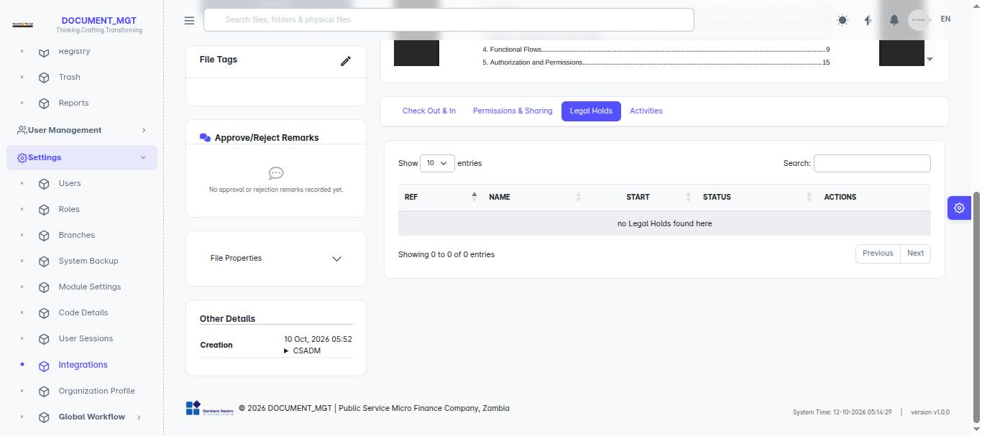

6.3 Releasing a hold
Only users with the release permission can end a hold. Open the hold, choose Release, confirm. Each hold keeps its own activity history.

7. Physical Registry
The registry tracks paper files: where each one is stored, who has it, and their electronic soft copies.

7.1 Storage locations
Open Registry to see the tree of storage locations (for example building > room > cabinet > shelf). Administrators create and arrange locations; users choose from them when filing.
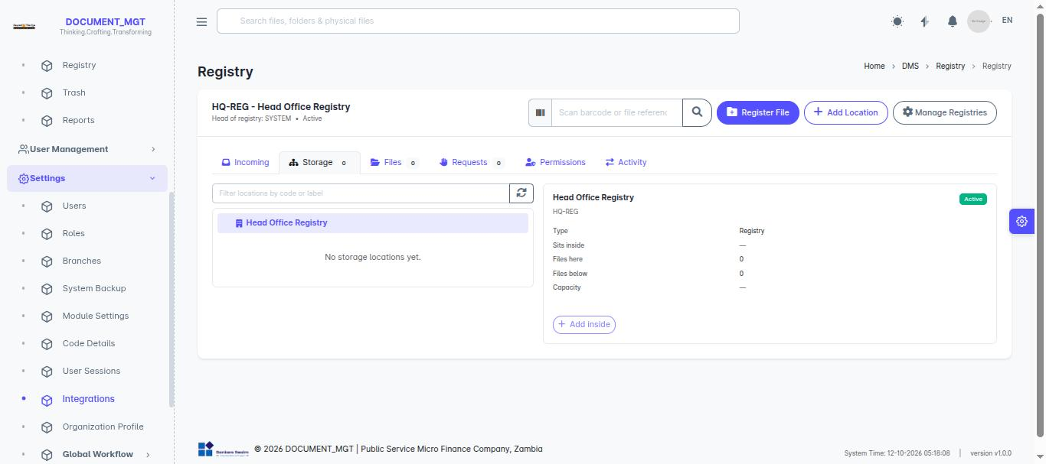

7.2 Registering a physical file
- Open Registry > Physical Files and choose to add a file.
- Enter the file details and select its storage location and registry.
- Choose what the file relates to, if requested.
- Save.
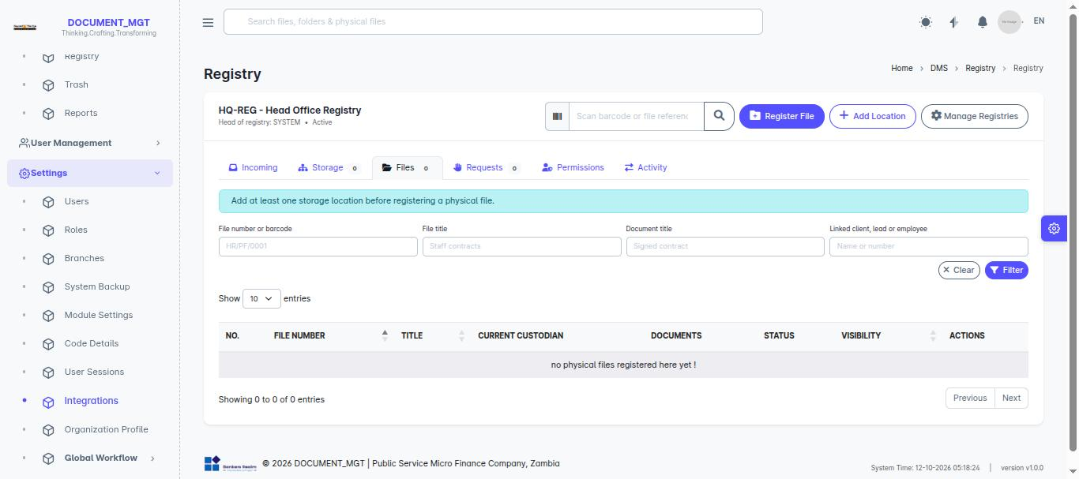
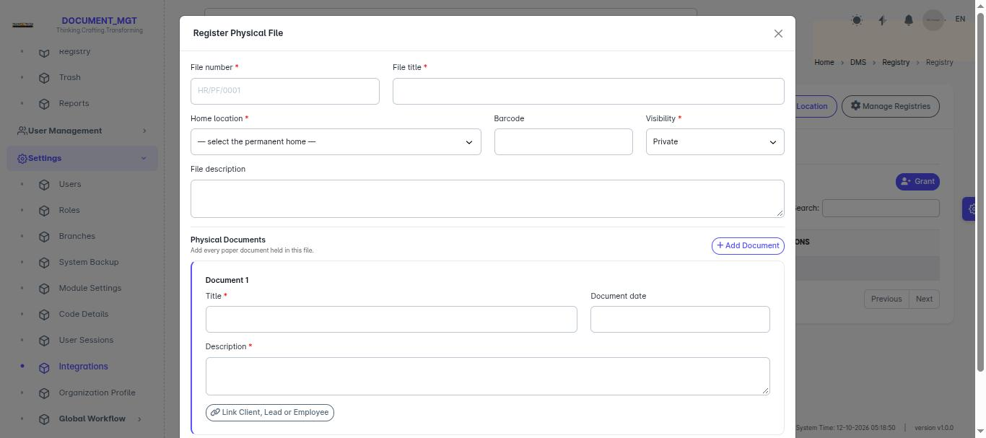

7.3 Documents inside a physical file
Open a physical file to see the paper documents it holds. You can add documents to it and upload a soft copy (scan) for each so the electronic copy is linked to the paper original.

7.4 Requesting a physical file
- Open the file (or Registry > Requests) and choose to request it.
- State the Purpose and the date you need it until.
- Submit. The registry officer is notified.
Registry officers approve or decline requests, then record the handover. Requesters can cancel a request before handover. Each request has a history of decisions.
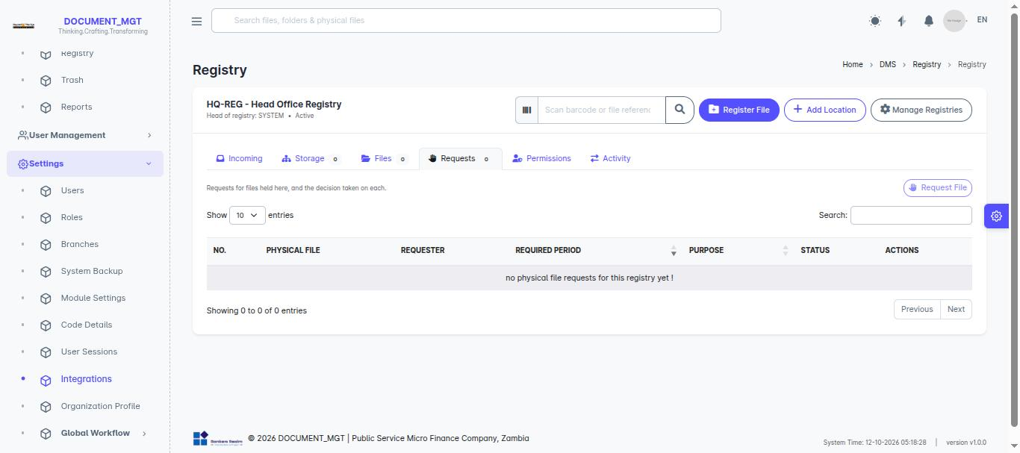

7.5 Check-in and movements
When a borrowed file is returned, the officer performs check-in. If a file is moved from one location to another, the movement is recorded and the receiving person confirms it with Receive. The Movements tab shows the full trail.

7.6 Permissions on physical files and registries
Like electronic documents, physical files and registries have their own sharing lists. Add a user or team with a role, or remove access from the Permissions tab.
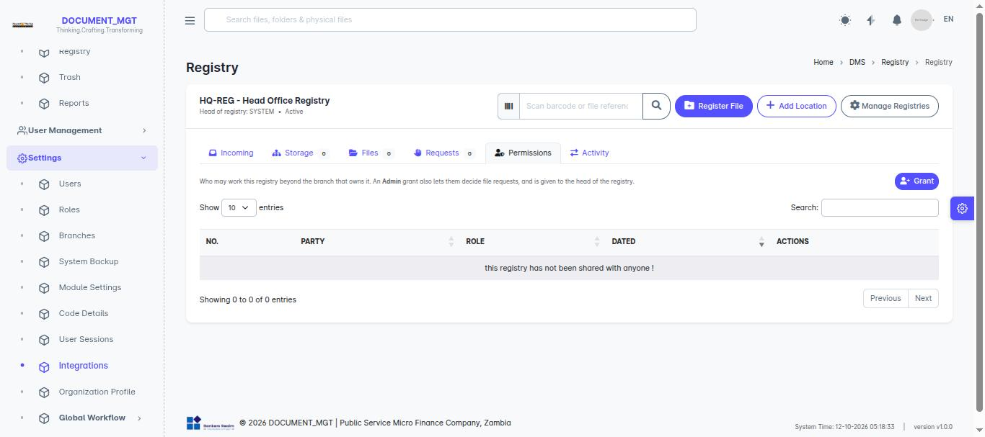

8. Dashboard and Reports

8.1 Dashboard
Document Management > Dashboard presents widgets showing key figures and charts. If you have the widget and layout permissions you can add, edit or remove widgets and save the arrangement.

8.2 Reports
- Open Document Management > Reports and choose a report.
- Set any filters offered and view the result.
- Use the export option to download it (for example to Excel or PDF, where available).
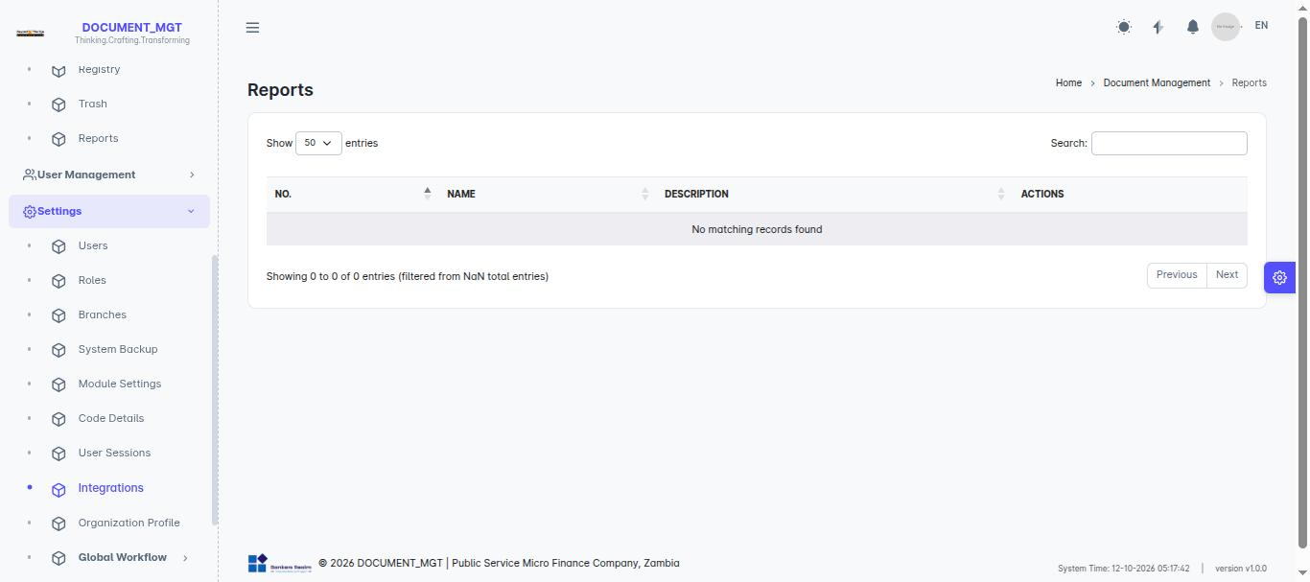

9. Administration
Note: This chapter is for administrators and users with the relevant permissions.

9.1 DMS settings
Setting | Purpose
Document Types | Define categories of documents, accepted file formats and maximum size, and how case references are generated.
Linked-to Types | Define what documents can relate to (e.g. client, loan).
Manage Registries | Create physical registries and set who may use them.
Validation Types | Define approval processes, their approvers and workflow.
Signatures | Manage stored signatures.
Source Systems / Event Types | Configure sources that send documents in and the events they record.

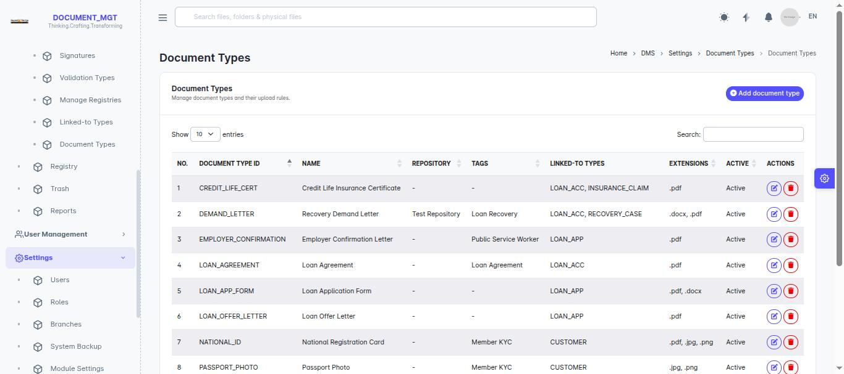
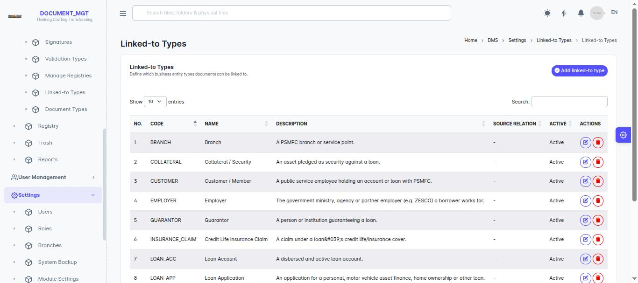
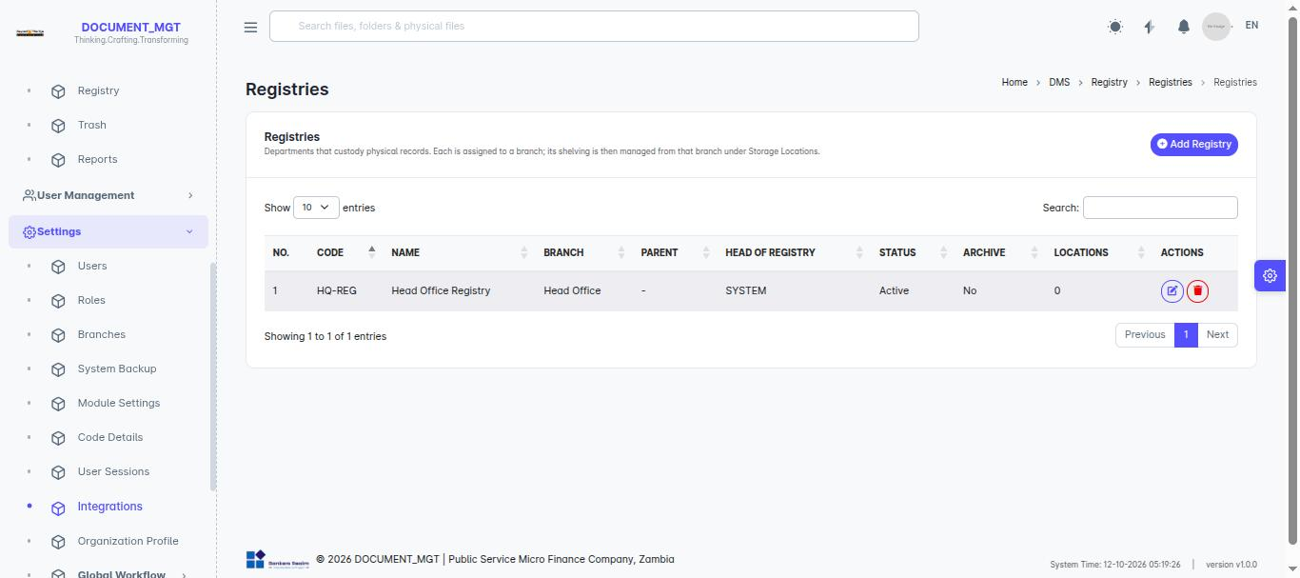
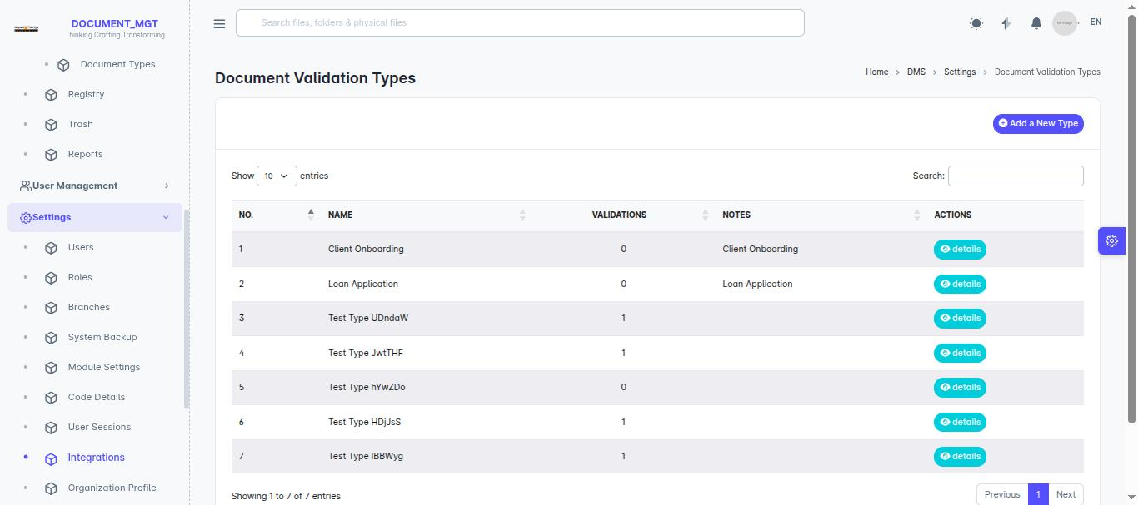
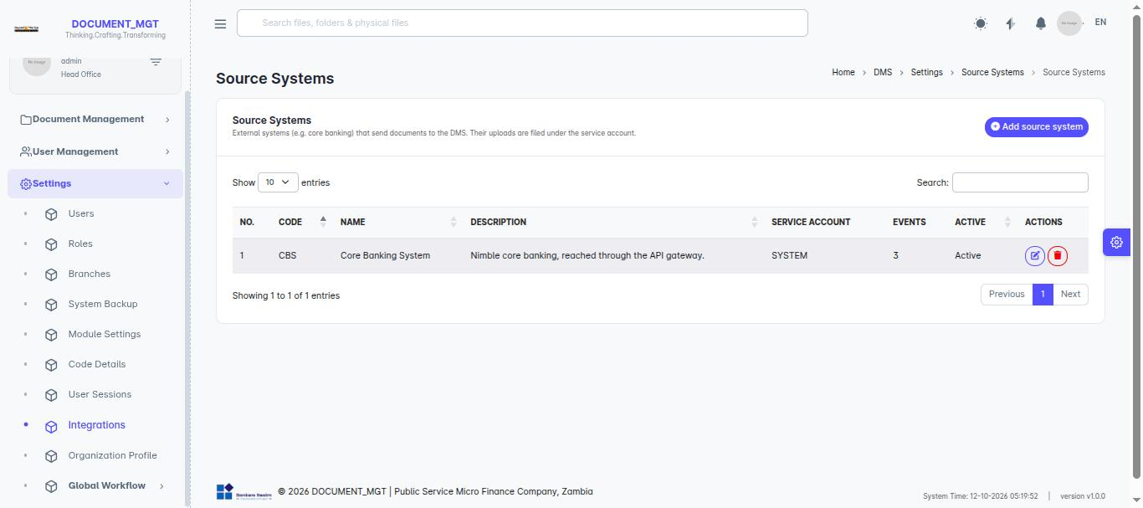

9.2 Users
- Open Settings > Users and choose to add a user.
- Enter the details and save.
- Assign one or more roles (section 9.3), optionally per branch.
- Use Send reset link if the user needs a new password.
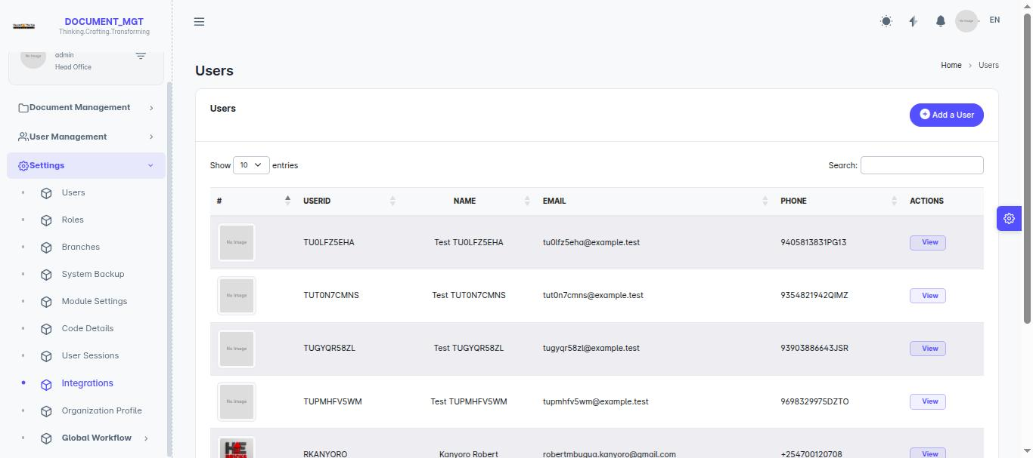

9.3 Roles and permissions
A role is a bundle of permissions. Open Settings > Roles to create or edit roles and tick the permissions each should have.
Permission | Allows
View documents (dms-view) | See the DMS menus, repositories and documents.
Bulk upload | Use Bulk Upload.
Legal hold create / view / release | Create, see, and release legal holds.
Validation approve | Approve or reject validation requests.
Registry manage | Administer the physical registry.
Widgets and layouts | View, create, update and delete dashboard widgets and layouts.

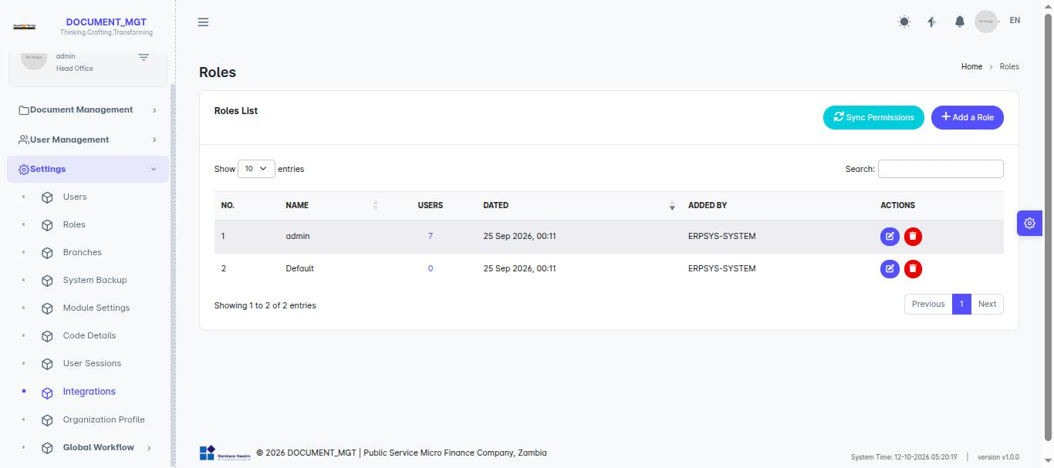

9.4 Teams, branches and organisation profile
- Teams – group users so they can be given access together.
- Branches – maintain branch records and synchronise them where configured.
- Organization Profile – update the organisation’s name and details.
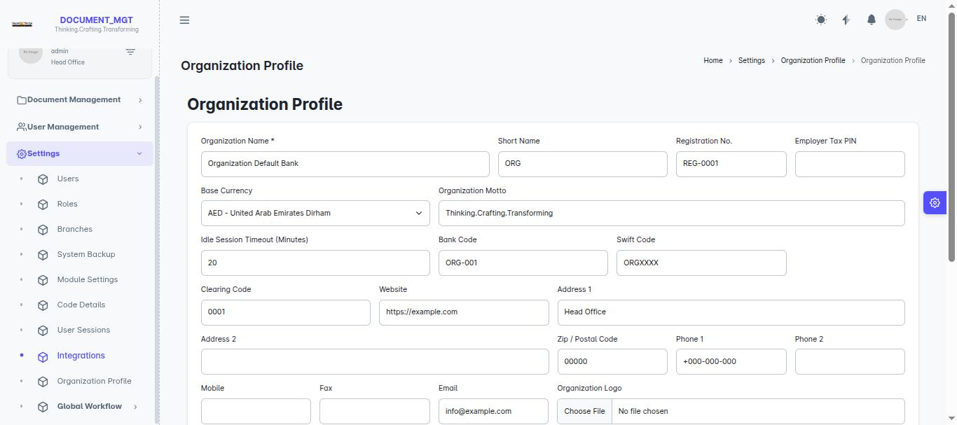

9.5 User sessions
Settings > User Sessions lists who is signed in. An administrator can end a specific session or all other sessions of a user.
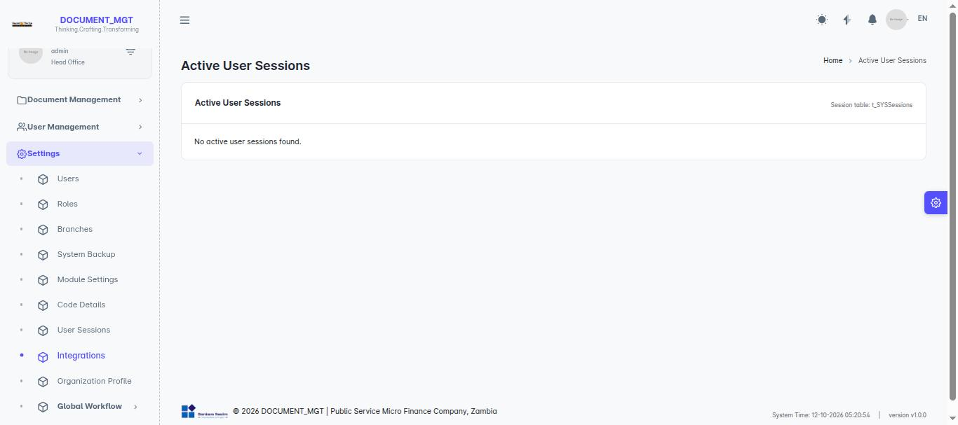

9.6 Workflows and limits
Global Workflow defines approval stages and who approves at each stage. Workflow Limits set amount limits per approver level. Stages can be enabled or disabled without deleting them.

9.7 System backups and modules
System Backup sets the backup schedule and lets an administrator run a backup immediately. Module Settings switches modules on or off.
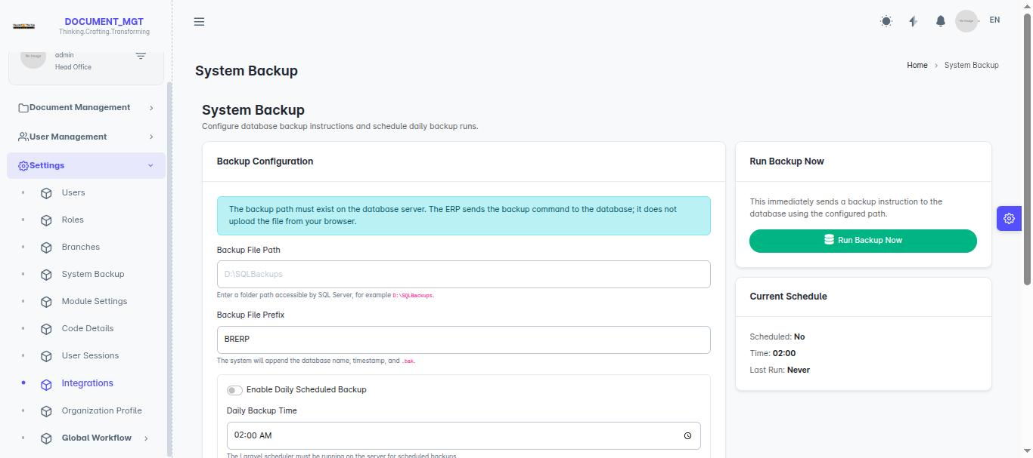
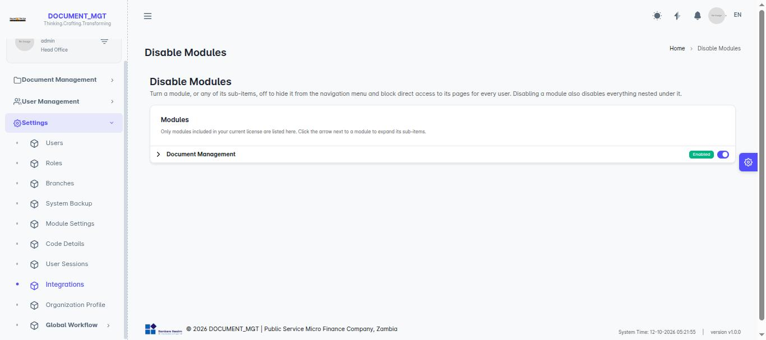

10. Troubleshooting and FAQ
Problem | What to do
I cannot log in | Check email and password. After 5 wrong attempts wait and retry. Otherwise ask for a reset link.
My two-factor code is rejected | Check your phone’s clock is automatic. Codes expire every 30 seconds; enter the current one. If your phone is lost, ask an administrator.
I was signed out suddenly | Sessions expire after inactivity, or another sign-in ended yours. Sign in again.
A menu or button is missing | You lack the permission. Ask your administrator.
“Forbidden” / 403 page | You do not have access to that item. Ask the owner or an administrator to share it with you.
Upload fails | Check the file format and size against the document type. Try a smaller or different file.
I cannot edit a document | It may be checked out by someone else, on legal hold, or you only have Read access.
I cannot delete a document | It may be under an active legal hold, or you lack Admin access.
I cannot find a document | Check spelling, try tags, look in Trash and Archived, and confirm you have access.
A page shows an error 419 | Your page expired. Refresh and try again.

Appendix A – Glossary
Term | Definition
Archive | Move a document out of everyday use while retaining it.
Check-out / check-in | Reserve a document for editing / return it with changes.
Folio | A case reference grouping related documents.
Legal hold | A protection that stops deletion of documents needed for legal reasons.
Repository | A container for documents, like a folder.
Soft copy | The scanned or electronic copy of a paper document.
Tag | A label used to classify documents.
Validation | A formal approval process, optionally with signatures.
Version | A saved state of a document at a point in time.

Appendix B – Quick Reference
I want to… | Go to…
Upload a file | Repository > open repository > add file
Upload many files | Bulk Upload
Edit a document safely | Document page > Check Out
Get a document approved | Document page > submit for validation
Approve a request | Document Validation
Preserve documents for a case | Legal Hold
Borrow a paper file | Registry > Requests
Recover a deleted file | Trash
Change my password / enable 2FA | Profile menu > Profile

For further help contact your system administrator or the support desk of your organisation.

