***Proposal***

***on***

***Doctor Finder App***

***Prepared*** ***for***

1. ***K. M. Ahsanul Hoque***

***Adjunct Professor and Consultant***

**Course Number: *CSE3224***

**Course Name: *Information System Design and Software Engineering Lab***

***Prepared by***

**Lab Section: B1**

**Group No: 06**

***Kanzud Saiyara 18.02.04.105***

***Nazifa Anjum 18.02.04.103***

***Mohammad Rakibul Hasan 18.02.04.102***

***Md Zahin Mobashshi 15.01.04.131***

***Jubayer Bin Jaman 17.01.04.125***

***Date: 22-02-2022***



***Ahsanullah University of Science and Technology***

***Department of Computer Science and Engineering***

**Table of Contents**

|  |  |
| --- | --- |
| **Contents** | **Page no** |
| **1.Activities of The Project** | **03** |
| **2.** **Main Processes** | **03** |
| **3.Sub Processes** | **03** |
| **4.Entity Names** | **04** |
| **5. Sequence Diagra** | **05** |
| **6. Collaboration Diagram** | **06** |
| **7. Data Flow Diagram** | **07** |
| **8. System Architecture** | **08** |

Activities of The Project:

* Easily download the apps by smartphone user and take advantage of them in times of need.
* if any family member develops some health condition and we will not aware of any doctor who could treat our relative, navigate through the apps to find out the most suitable doctors.
* Furthermore, we hope that we can also book appointments using the apps.
* Will be interacted with the leading doctors and ask them about any kind of your health related query.
* Can buy any kind of medicine by sitting home
* Will be contact with doctor via video call and send the medical reports of your previous treatment.
* will get notified in there’s any change in your appointment schedule or if it’s cancelled.
* This app search engine will be allow us to find doctors according to specialisation and location.
* Place all necessary information in one platform with ambulance service.

Main Processes:

* **Doctor**
* **Hospital**
* **Pharmacy**
* **Specialities**
* **Available doctor**
* **Prescribe medicine**

Sub Processes:

* **Home**
* **Review**
* **User**
* **LogIn**
* **Signup**
* **City**
* **Ambulance**

Entity Names:

* **Home**
* **Review**
* **User**
* **LogIn**
* **Signup**
* **City**
* **Doctor**
* **Hospital**
* **Pharmacy**
* **Specialities**
* **Available doctor**
* **Prescribe medicine**

**Sequence Diagram:**

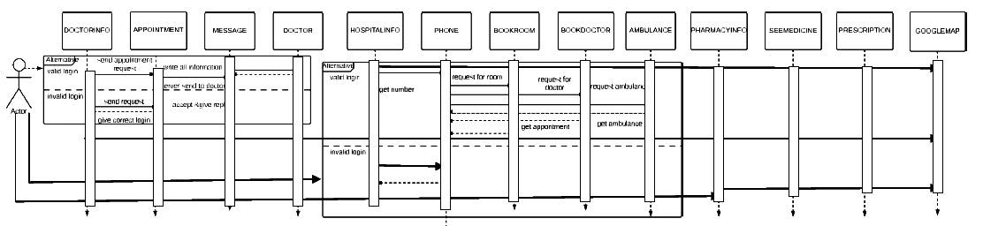

**Collaboration Diagram:**

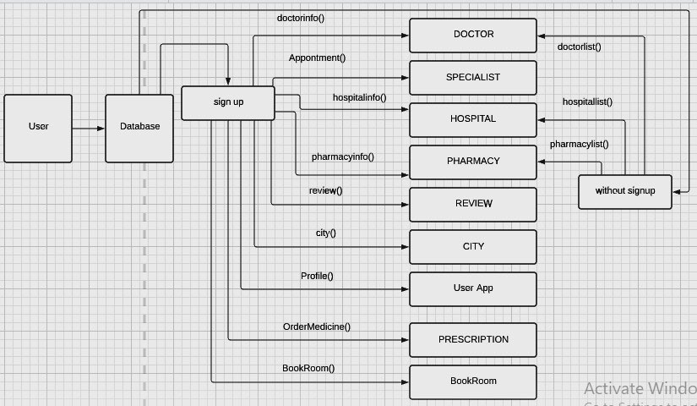

**Data Flow Diagram(PSPEC & CSPEC):**

LEVEL 0(Context Level Diagram):

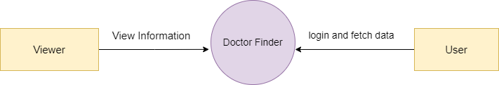

LEVEL 1 Diagram:

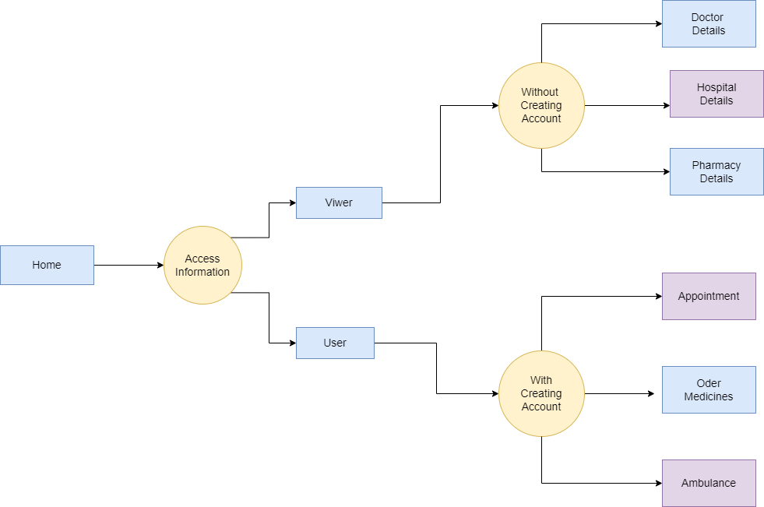

LEVEL 2 Diagram:

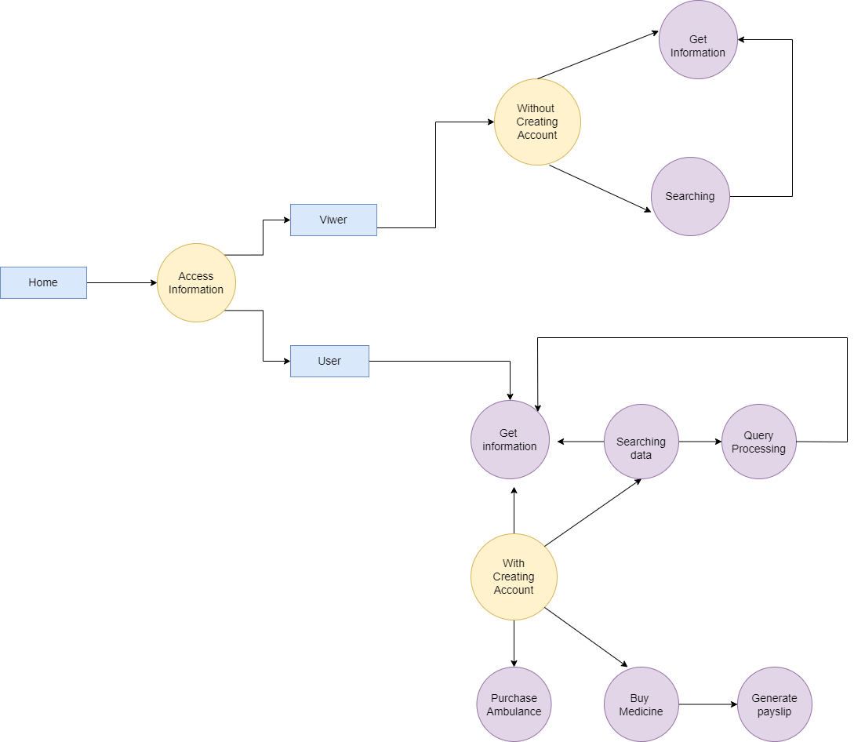

**System Architecture:**

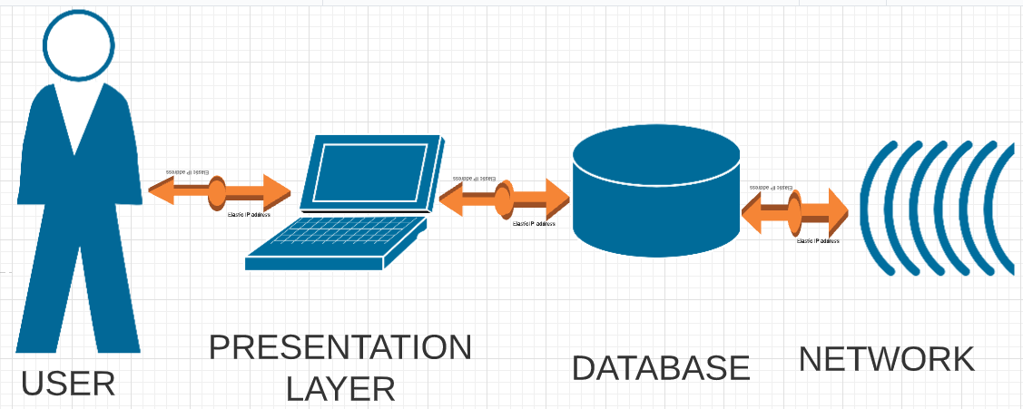

Conclusion:

We hope that this App will fulfill the needs of information and help people by providing useful health services.

We will try to develop the application for various platforms to reach out to as many people as possible.

By this App we are trying to build a media which will be able to fulfill all health related requirements .