***Report on***



***Prepared for***

A. K. M. Ahsanul Hoque, Adjunct professor

Tashreef Muhammad, Adjunct Faculty

**Course Number: *CSE3224***

**Course Name: *Information System Design and Software Engineering Lab***

Prepared by

|  |  |
| --- | --- |
| **Lab Section: B1** |  |
| **Group No: 06** |
| ***Kanzud Saiyara*** | ***18.02.04.105*** |
| ***Nazifa Anjum*** | ***18.02.04.103*** |
| ***Mohammad Rakibul Hasan*** | ***18.02.04.102*** |
| ***Md Zahin Mobashshi*** | ***15.01.04.131*** |
| ***Jubayer Bin Jaman*** | ***17.01.04.125*** |



***Date: 15-03-2022***

***Ahsanullah University of Science and Technology***

***Department of Computer Science and Engineering***

# Executive Summary:

Doctor Finder – Complete Medical Solution android application is combo app to find doctors, Pharmacies & Hospitals near you, you can find doctors within your city, check for pharmacy near you or even find list of hospitals and compare services.The mobile app will be easy to sign up.It will be available across all mobile platforms including all Android devices, tablets, laptops, and chrome- books.

The following are the services that the app will provide:

* **Sort doctors list by speciality (Urologist, Pulmonologist, Eye Care & more)**
* **Check Doctors Profile and distance from you**
* **Services Provided by doctors**
* **Health Care details**
* **Ratings for doctors by which you can decided which doctor is best for you**
* **You can also book appointment to the doctors by adding details like date, time and reason for visiting, all details will be send by mail to doctor.**
* **You can also upload prescription to Pharmacy by adding mobile number, prescription will be send by mail to pharmacy store.**
* **Cash on delivery is supported in Order Medicine**
* **Attractive and Informative Splash Slider**
* **Favourite list : you can bookmark doctors, pharmacies & Hospitals**
* **About app description**
* **Share doctors, Pharmacy and Hospitals on social media**
* **Share app on social media**
* **Add Ratings and Review**
* **Login with Facebook**
* **Login and Register with email**
* **Add your profile picture**
* **Sort list by Radius**
* **Sort list by City**
* **Easy to add New language**
* **Add speciality list from admin**
* **Easy Configuration of push notification from admin**
* **Send push notification from admin panel**
* **Google map to select easy location**

We hope that this App will fulfill the needs of information and help people by providing useful health services.

We will try to develop the application for various platforms to reach out to as many people as possible.

By this App we are trying to build a media which will be able to fulfill all health related requirements .

Contents

Letter Of Transmittal 04

Introduction… 05

Project Background 05

Objectives… 05

Process Model 06

The Project Survey 07

Gantt Chart / Time Chart… 09

Project Planning 09

Project Estimation… 09

Cost benefit Analysis… 10

Feasibility Study 11

Project Features… 12

Function Definitions… 13

Construction… 14

Conclusion… 15

**Letter of Transmittal:**

# Capture1.PNG DOCTOR FINDER

**49,Arjutpara,Mohakhali,Dhaka-1215 Phn:01921848321 Fax:123-123-123456**

[**Email:kanzud@gmail.com**](mailto:kanzud@gmail.com) **Website**[**:www.d**](http://www.dfinder.com/)**f**[**inder.com**](http://www.dfinder.com/)

**Kanzud Saiyara , System Analyst 1**

**Md Zahin Mobashshi , System Analyst 1 Nazifa Anjum , Programmer 1**

**Mohammad Rakibul Hasan , Programmer2**

***Jubayer Bin Jaman , Tester***

**A. K. M. Ahsanul Hoque, Lecturer,**

**Ahsanullah University of Science and Technology, Tejgaon, Dhaka.**

**Assalamualaikum Sir,**

**We the proposers would like to present the proposal of "Doctor Finder App" in compliance with your instructions, as per the requirements of the Information System Design and Software Engineering Lab. The goal of this article is to suggest a mobile app that we believe will be beneficial to all of us. This app will be able to build a media which will be fulfill all health related requirements .**

**We simply hope that you will approve of this suggestion. Yours Sincerely,**

|  |  |
| --- | --- |
| **Kanzud Saiyara** | **18.02.04.105** |
| **Nazifa Anjum** | **18.02.04.103** |
| **Mohammad Rakibul Hasan** | **18.02.04.102** |
| **Md Zahin Mobashshi** | **15.01.04.131** |
| ***Jubayer Bin Jaman*** | ***17.01.04.125*** |

**Date:15.03.2022**

# Project Introduction:

We know that the modern world is hit by the pandemic and for this we all are suffering. To mitigate this emerging situation people are trying to find solutions to save lives. We understand the battle is not easy and we all are into this together. In order to stand beside the mankind we have tried here to make a project which will be beneficial to all patients and doctors to fight this pandemic.”Doctor Finder App” – Complete Medical Solution android application is combo app to find doctors, Pharmacies & Hospitals near you, you can find doctors within your city, check for pharmacy near you or even find list of hospitals and compare services.The mobile app will be easy to sign up.It will be available across all mobile platforms including all Android devices, tablets, laptops, and chrome-books.

# Member Introduction:

“Doctor Finder App” project is done by a group of five people.We are – Kanzud Saiyara, Nazifa Anjum , Mohammad Rakibul Hasan,Jubayer Bin Jaman and Md Zahin Mobashshi.Login,signin are done by Jubayer,home,favourite are done by zahin.Rakib work on doctor details , suhi on hospital details and kanzud work for pharmacy.

# Background of Study:

Finding a good doctor can prove to be quite tricky, especially, if you are new in a city.When you are looking for a doctor, there are few crucial things that you need to take into account such as the specific care you need, doctor’s credentials, reviews from other patients. It is difficult to know about doctor ,hospital or pharmacy near you by searching google.As a responsible family member, you need to make informed health related decision, not only about yourself but for others in your family too.Helping people in this pandemic with necessary information to find Doctors , Pharmacy & Hospitals by sitting home is necessary.They need any kind of medicine by any time .By watching reviews of Doctors , Pharmacy & Hospitals anyone can easily chose the best one for them.We just want to direct people in the right path by helping to take appropriate decision at emergency situation.

# Objectives:

# a.Primary Objective:

* Easily download the apps by smartphone user and take advantage of them in times of need.
* if any family member develops some health condition and we will not aware of any doctor who could treat our relative, navigate through the apps to find out the most suitable doctors.
* Furthermore, we hope that we can also book appointments using the apps.
* Will be interacted with the leading doctors and ask them about any kind of your health related query.
* Can buy any kind of medicine by sitting home
* Will be contact with doctor via video call and send the medical reports of your previous treatment.
* will get notified in there’s any change in your appointment schedule or if it’s cancelled.
* This app search engine will be allow us to find doctors according to specialisation and location.
* Place all necessary information in one platform with ambulance service.

**b. Secondary Objectives**:

* try to include bloodbank service
* try to include ambulance service
* make it free for everyone

# Process Model:

**Incremental Model**

* In this project we are using **Incremental Model.**Because –
* It is easy to delivary
* Everythings is quick process
* It can fulfill customers demand
* Multiple independent deliveries are possible
* Always focus on productivity
* Customer can see it before finishing
* When time is too short it is best

We have clearly outlined the requirements of our project. Moreover, our project is under development. We assume that the incremental model will be a great choice for our project as it is of different small modules which we can build and develop individually. These will speed up the overall project development.

# The Project Survey:

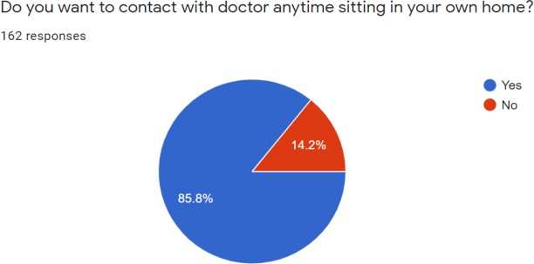

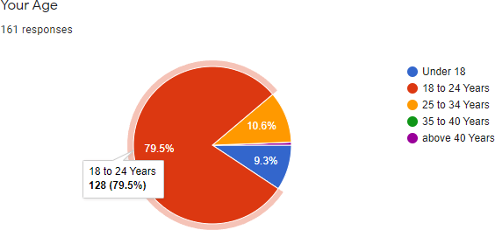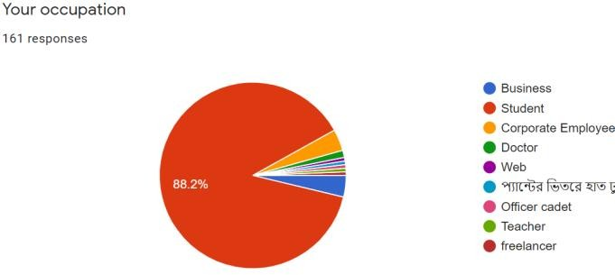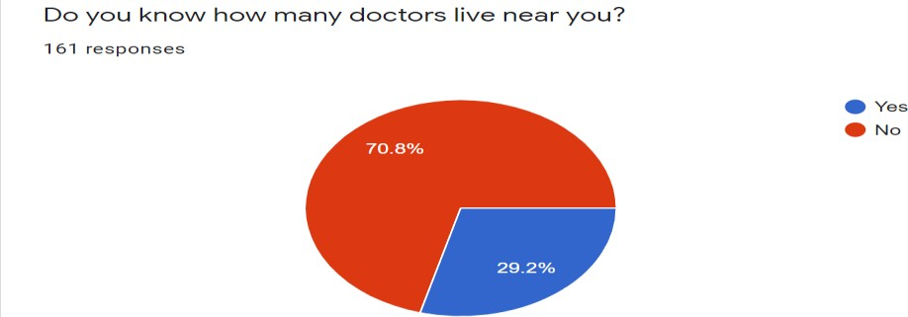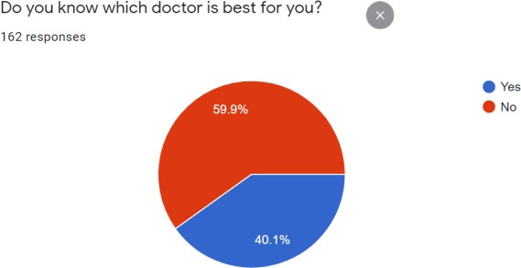

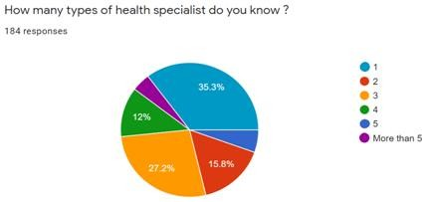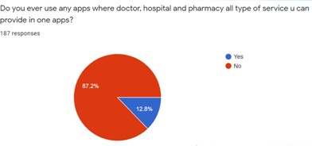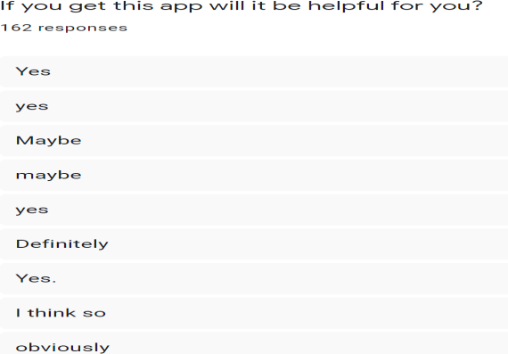

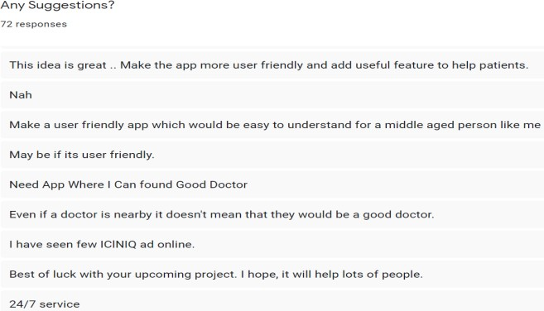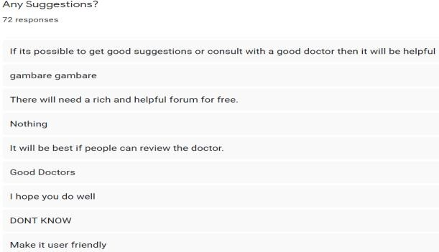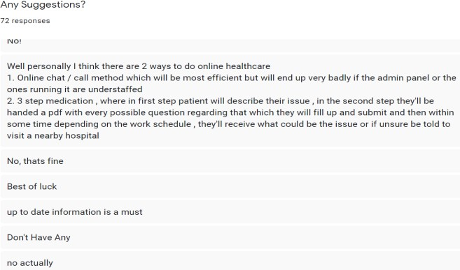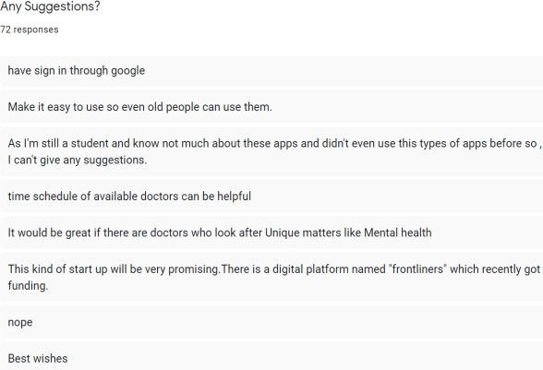

**Planning:**

**PERT:**

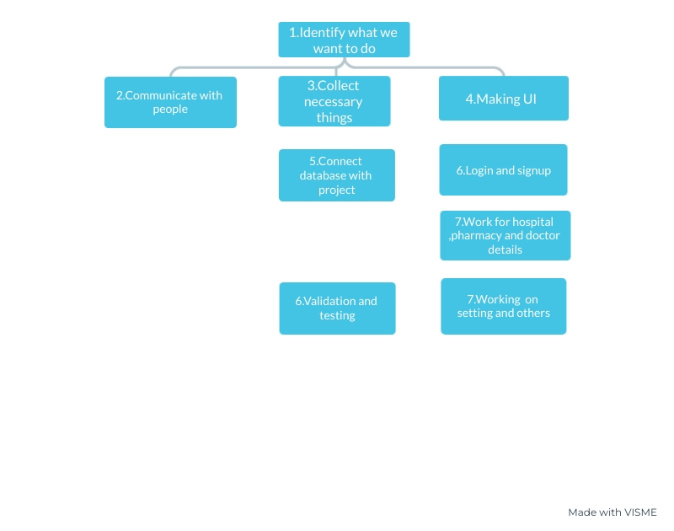

Unit:week

Slack:total slack

8.display project

8.Realise Customer requirement

**CPM:**

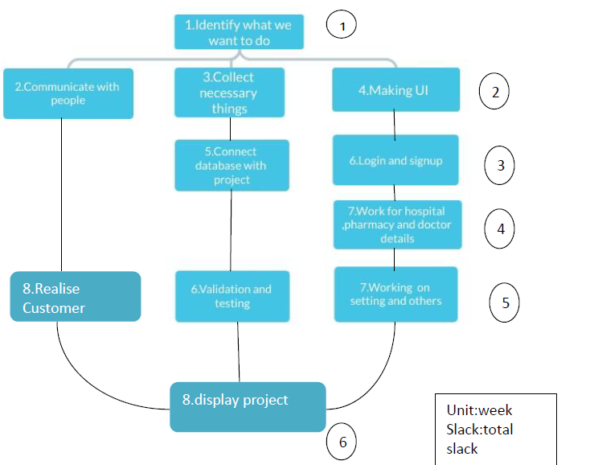

Critical Path:

1->4->6->7->7->8

**Time Plan:**



**Project Planning:**

We have to communicate with all our team members all the time which is in between 1st to 6th week. To complete our survey, we'll collect data and gather info within 2nd week. From 2nd to 5th week, we'll develop this application. But in 5th-6th week, we'll also design the user interface and complete our survey. We'll create a project report on our 6th week. We'll do our presentation in last two weeks.

# Project Estimation:

As the project requires a certain amount of cost to implement all the features properly,there is an estimation of cost decided to run all the task. here the estimated cost will be around :

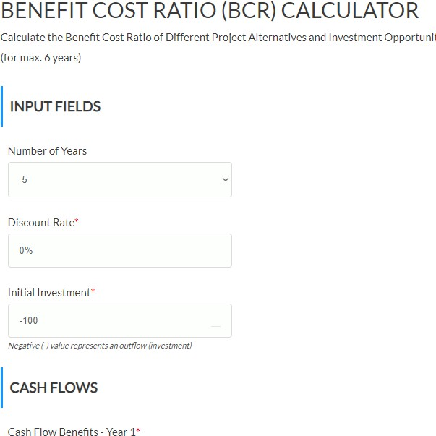

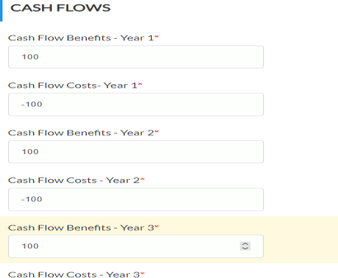

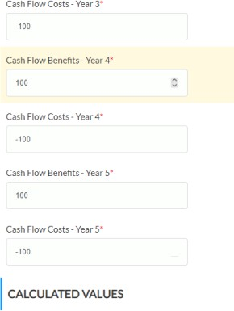

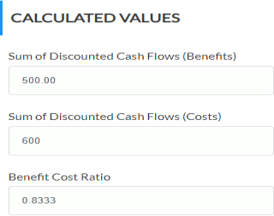

If we run our project with 0 discount for 6year will get 80% profit from it.

Process Based estimation:

The most common technique for estimating a project is to base the

estimate on the process that will be used.As we do our work according to process based so that we can finish it by time and we know that what our customer want.

Project Estimation:

We try to finish our project within 7weeks.It was very though bt we try our best.Some of our require is incomplete bt we will complete it future.

# Cost benefit analysis:

For my project cba= 0.8.

So Costs equal the benefits, which means the project should be allowed to proceed, but with little viability.

There is no risk in long term

We are not use vehicle so we can save the billing money

We can get 3in 1 solution by 1 apps by giving pay for 1 app

We can look nearest hospital so we don’t need to pay for ambulance

We can see map which save our time and sometimes life

# Feasibility Analysis:

## Technical Feasibility:

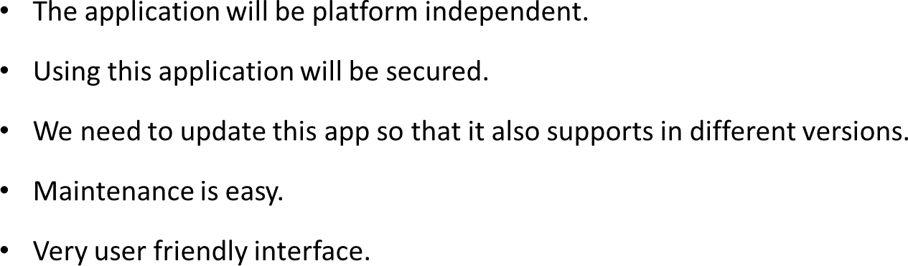

Economical Feasibility:

1. As android studio is an open source system software, so we don’t need to buy this app to develop.
2. A team of five members require to complete this risk.
3. Approximately seven weeks may required for developing this app.
4. Extra bills for phone call/ internet data is needed for communicating with the teammates.
5. The revenue for our app will come from the places which user will travel.

## Oprerational Feasibility:

1. As the data will be available which is controlled strictly.So, the data is secured.
2. It will be very difficult to gather correct data and info from filed level.
3. This app will be more flexible, if it supports on all devices.

# Project features:

* Find Doctors Near you,within your city
* Find Doctors sort by name
* Find Pharmacy Near you,
* Find Pharmacy within your city
* Find Pharmacy sort by name
* Find Hospitals Near you,
* Find Hospitals within your city
* Find Hospitals sort by name
* Sort doctors list by speciality (Urologist, Pulmonologist, Eye Care & more)
* Check Doctors Profile
* Doctor’s Address
* Contact Details
* Distance from you
* Services Provided by doctors
* Visiting Time
* Health Care details
* Map location
* Ratings for doctors
* Check Pharmacy Profile
* Pharmacy Address
* Contact Details
* Distance from you
* Services Provided by Pharmacy
* Open/Close Time
* Health Care details
* Map location
* Ratings for Pharmacy
* Check Hospitals Profile
* Hospitals Address
* Contact Details
* Distance from you
* Services Provided by Hospital
* Open/Close Time
* Health Care details
* Map location
* Ratings for Hospital
* You can also book appointment to the doctors by adding details like date, time and reason for visiting, all details will be send by mail to doctor.
* You can also upload prescription to Pharmacy by adding mobile number, prescription will be send by mail to pharmacy store.
* Cash on delivery is supported in Order Medicine
* Attractive and Informative Splash Slider
* Favourite list : you can bookmark doctors, pharmacies & Hospitals
* About app description
* Share doctors, Pharmacy and Hospitals on social media
* Share app on social media
* Add Ratings and Review
* Login with Facebook
* Login and Register with email
* Add your profile picture
* Admob Integration ( Banner & Interstitial both)
* Firebase Push Notification Supported
* Setting for application
* Sort list by Radius
* Sort list by City
* Sort list by ascending or descending
* On/Off Admob Advertising
* Easy to add New language
* RTL Supported
* PHP Admin Panel (Backend)
* Attractive & Informative Dashboard
* Separate List for doctors, Pharmacy & Hospitals
* Add Profiles of doctors, Pharmacy & Hospitals
* Add speciality list from admin

# Architech Flow Diagram:

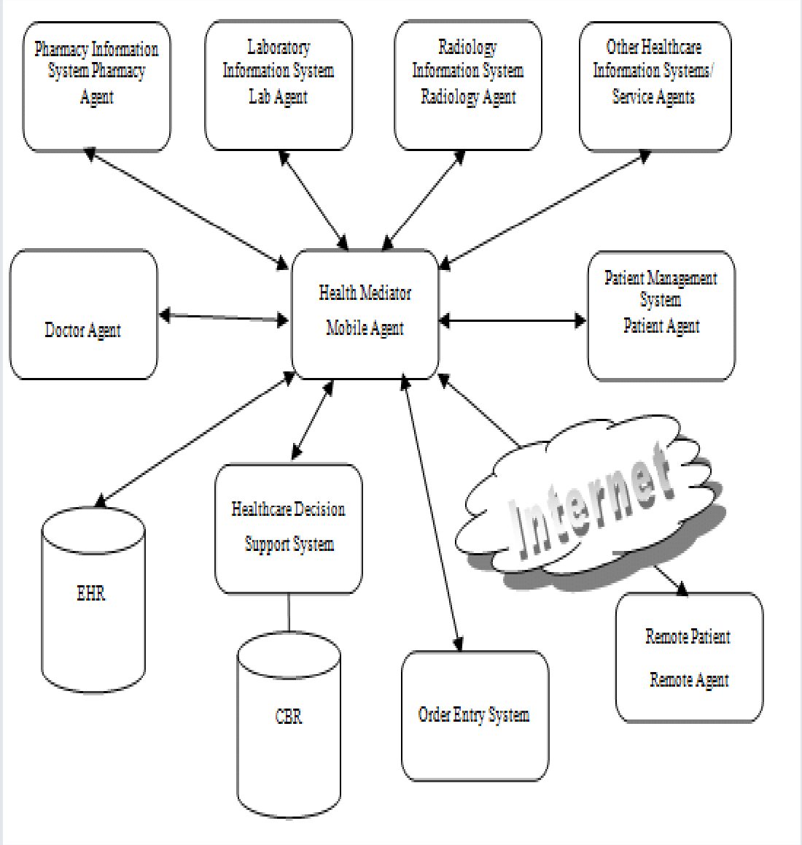

# Function Definitions:

**Login page:** Here, users and administrators both can login on this application.

**Register Page:** New users can register in this page The register fields are as follows:

* Name
* Email
* Password
* Confirm Password

**Doctors:**Find Doctors Near you,within your city,find Doctors sort by name,sort doctors list by speciality (Urologist, Pulmonologist, Eye Care & more),check Doctors Profile,doctor’s Address,contact Details,distance from you,services Provided by

doctors,visiting Time

**Hospital:** Find Hospitals Near you,Find Hospitals within your city,Find Hospitals sort by name,Health Care details,Map location,Ratings for Pharmacy,Check Hospitals Profile,Hospitals Address,Contact Details,Distance from you,Services Provided by Hospital,Open/Close Time

**Pharmacy:** Find it Near you,Find it within your city,Find it sort by name,all details,Map location,Ratings for Pharmacy,Check Profile, Address,Contact Details,Distance from you,Services Provided by it,Open/Close Time,giving prescription by taking photo

**About us page:** This page contains all types of information about Cholojai. Here, our email , phone number and facebook page are given for the help of the users. Our services are available for 24 hours.

**Receipt page:** Here, the users can see the total amount of cost for their travelling. Hotel costs,transportation costs and vat are included here.

**Favourite list :** you can bookmark doctors, pharmacies & Hospitals About app description

**Social Media:** Share doctors, Pharmacy and Hospitals on social media Share app on social media

**Setting:** Setting for application Sort list by Radius

Sort list by City

Sort list by ascending or descending On/Off Admob Advertising

Easy to add New language

**Review:** Add Ratings and Review

# Construction:

Development Environment

* 1. Development tools: Android Studio
  2. Language : Java
  3. Database : Firebase

# Conclusion:

We hope that this App will fulfill the needs of information and help people by providing

useful health services.

We will try to develop the application for various platforms to reach out to as many people as possible.

By this App we are trying to build a media which will be able to fulfill all health related requirements .