**National Taiwan University International Handball Invitational Tournament**

National Taiwan University International Handball Invitational Tournament is held every two years. In the last few years, Asian university handball teams and clubs are the main attenders. All games in the tournament are organized in the air conditioning indoor sport court. We cordially invite you to attend 2023 National Taiwan University International Handball Invitational Tournament in Taipei and enjoy the beautiful view in Taiwan.

**Date of the Tournament:**

Student group competition dates: June 20-25, 2023

Alumni group competition dates: June 23-25, 2023

Registration dates:

1. Intent to participate: March 30, 2023  
   Registration：<https://forms.gle/ZBtuWQ7Cyp2d3FR17>
2. Confirmation of team: Before April 10, 2023.
3. Submission of roster: April 30, 2023.

Place: NTU Sports Center

Groups:

1. Men: Male College Students
2. Women: Female College Students

(3) Alumni O45: Male alumnus, born before 1978/12/31.

(4) Alumni O35: Male alumnus, born before 1988/12/31.

(5) Alumni Men: Male alumnus

(6) Alumni Women: Female alumnus

Contact Information:

chunhen0331@ntu.edu.tw (Mr. Chun-Hen Hsu)；b08305017@ntu.edu.tw (Miss Kai-Ti Hu)

##### 臉書：[臺大手球聯盟 Taida Handball League](https://www.facebook.com/NTUHandball/)

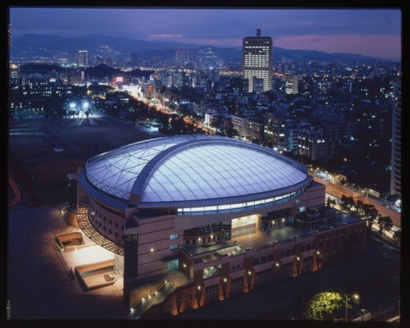 

NTU Sports Center