The Pokémon Team Building program is a fantastic program custom made for Pokémon enthusiasts around the world. With its main GUI made to resemble the Pokedex colors the community is so fond of.

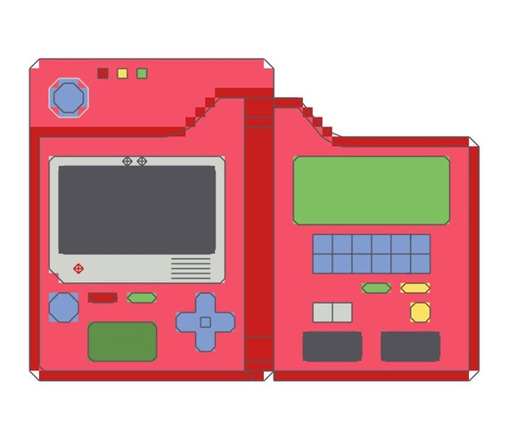

The Pokémon Team Builder started out using the PokeApi.Net external API before we converted the Open-Source Database into a more useable .NET friendly database.

To use the Pokémon Team Builder, you need to select what tab the function you are looking for is in. There are 4 main tabs in our program:

Teams: This tab grants you access to most innovative feature in the program called the Random Team Generator. This function allows you to randomly generate a 6 Pokémon Team based on recommended team compositions. You can also generate tabs, that way if you like the teams, you can then generate a new one and go back to the other one.

Moves: This tab allows you to access every Pokémon move to figure out what move is best suited for your teams.

Items: This tab allows you to access every Pokémon available held item, these items can also be recommended based on type. (To be implemented) By clicking on an item a message box with the in-game item id will appear.

Pokémon: This tab allows you to view every Pokémon ever created, which is a lot of Pokémon, we will also have a sorting feature to sort by region, and by type. By clicking on a Pokémon, a message box with the in-game item id will appear.

Language Combo Box: The language combo box is located at the top left of our application, the 3 implemented languages are English, French, Japanese, and Spanish(Not fully implemented)

File Combo Box: The combo box at the top left will have us about message box stating some stuff about the application and the exit button which you close the program with.