“WeRateDogs Data Analysis”

Kaori Ishikawa

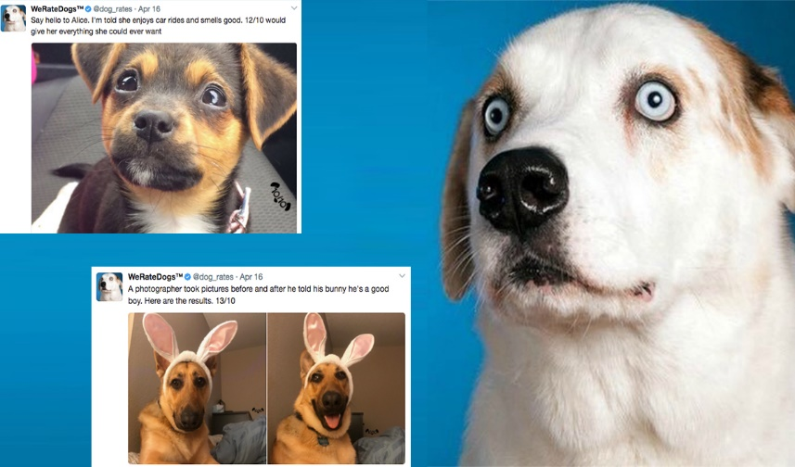

Image via  [***Boston Magazine***](http://www.bostonmagazine.com/arts-entertainment/blog/2017/04/18/dog-rates-mit/)

1. Introduction

WeRateDog is a Twitter account that rates people’s dog with a humorous comment about the dog. It has over 4 million followers and has received international media coverage. I gathered twitter archive data for all 5000+ of their tweets until August 1, 2017, which is provided by WeRateDog, additional twitter data from Twitter’s API and image predictions data for the images of dog in each tweet. There are 2,097 original tweet and I analyzed them.

2. Findings

There are various stages of dog such as doggo, pupper, puppo, and floof (er). While not all the dogs are categorized in the stage, 363 dogs are categorized in one or two of them. By far, pupper, a small and usually young doggo, is the most frequent stage; 220 out of 363.

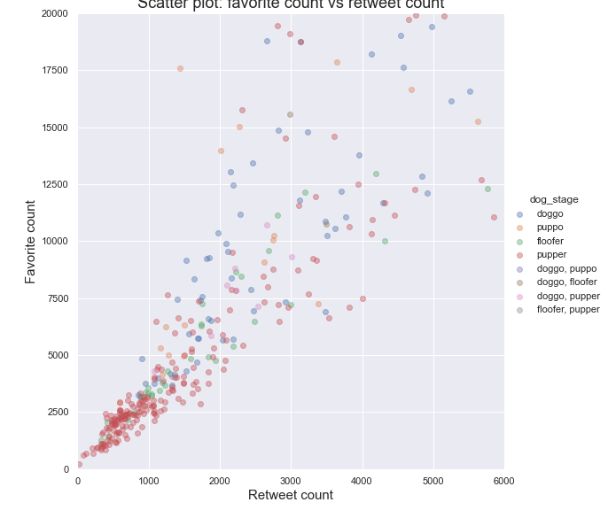

Chart 1: Scatter plot of favorite count vs retweet count

If you look at the count of favorite and retweet of each tweet, there is a strong correlation between them. Chart 1 shows the strong positive correlation.

As the account name speaks for itself, WeRateDog rates dogs based on the picture. The rating almost always have a denominator of 10, but the numerators is almost always greater than 10. Chart 2 is the box plot of rating ratio per stage of dogs. There is no significant difference of rating ratio between dog stages. However, pupper has more lower outliers compared to the other stages and the median is lower than doggo and puppo. Also, 25% is much more lower than the other stages and even lower than 1.0.

Based on the prediction, which is classified by a neural network, approximately 113 breeds of dogs are recognized. Retriever are the most popular breed. Golder retriever is appeared more than 156 times and Labrador retriever is 106, which are 1st and 2nd most frequently appeared breed respectively. The highest rating ratio per breed which is appeared more than 10 times is 1.256 and the breed is Pomeranian; its appearance is 41 times. This ratio is higher than the 75 percentile, which is 1.2.

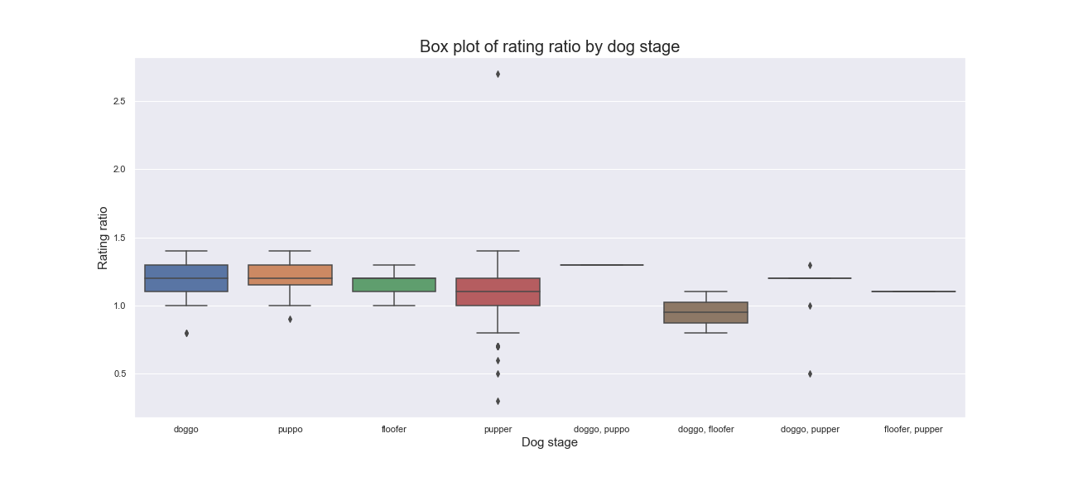

Chart 2: Box plot of rating ratio by dog stage

3. Conclusion

Overall, most of the dogs are rated over 10/10, while pupper has slightly lower rate in general compared to the other stages of dog. Also, pupper is the most common stage of dogs by far. And, there is difference in average rating ration per breed of dog. Pomeranian has significantly high rating ratio of 1.254, which is higher than the 75 percentile.