## CGRA151 Project Plan

Niamh Ferns

300 632 732

Pixel Chess

# Vision

## Game concept

A pixel-art chess game where the player is playing against either the computer or another player. The game will follow the standard rules of chess and will be made out of pixel-art. It will also have a menu at the beginning that allows the player to enable/disable a timer and select their colour.

## Gameplay

The game will, as said previously, follow the standard rules of chess. The player will control the game through the mouse. Clicking on a chess piece will give you an overlay of the board showing your possible move locations. Clicking one of these locations will move the piece to that location then the computer will take its turn. Repeat until forfeit or checkmate. The player will be able to enable a chess timer that will allow them to test themselves on speed.

## Visual Design

The game will be made out of simple pixel-art. Colours will be that of a wooden chess board with the normal white and black pieces. Visual interactions would ideally be shown entirely through subtle prompts, but there will be menus (with a pixel-art style) and tool tips for smaller, less obvious things.

# Timeline

## Core Working Program

The core program will consist of the menus, the movement of the pieces, and the multiplayer mode. Graphics will be shown by simple shapes for now as I’ll still be working through all the pixel art. There may be some initial pieces of art add at this stage. At this stage, the game will be playable with minor glitches. Each chess piece will implement it’s own “move checks” that will determine where they can move and at this point these should almost all be implemented with the exception of the queen and knight (as these will be more tricky).

## Reasonable Submission

The reasonable submission will consist of the core plus having all the art for the game finished. Multiplayer should be bug-less and all pieces should be able to move without hiccups. King-rook swap should be working properly at this stage as well. I plan on having very very basic AI finished by this point as well. That is... The AI should be able to make basic moves and should select a starting move at random.

## Well-polished Submission

The full submission will consist of the reasonable submission plus allowing the AI as a fully fleshed out option. Minor bugs will most likely still be present (usually around check mate or infinite-move-loop edge cases) but the AI should be able to make decent starting moves, and should actively try to achieve a checkmate.

# Appendix

## Chess-piece Art Inspiration

The style of art I’ll be going for. The menus and board will compliment it. I’m still deciding between a more intricate stylized game or a simpler look. (These are not final pieces or art and are purely for inspiration.)

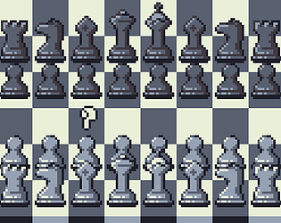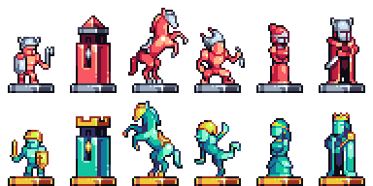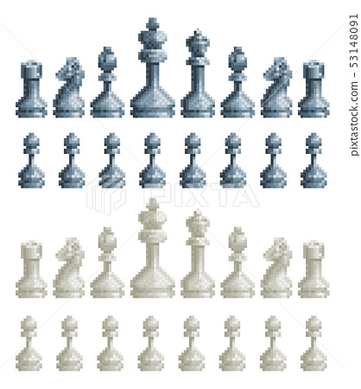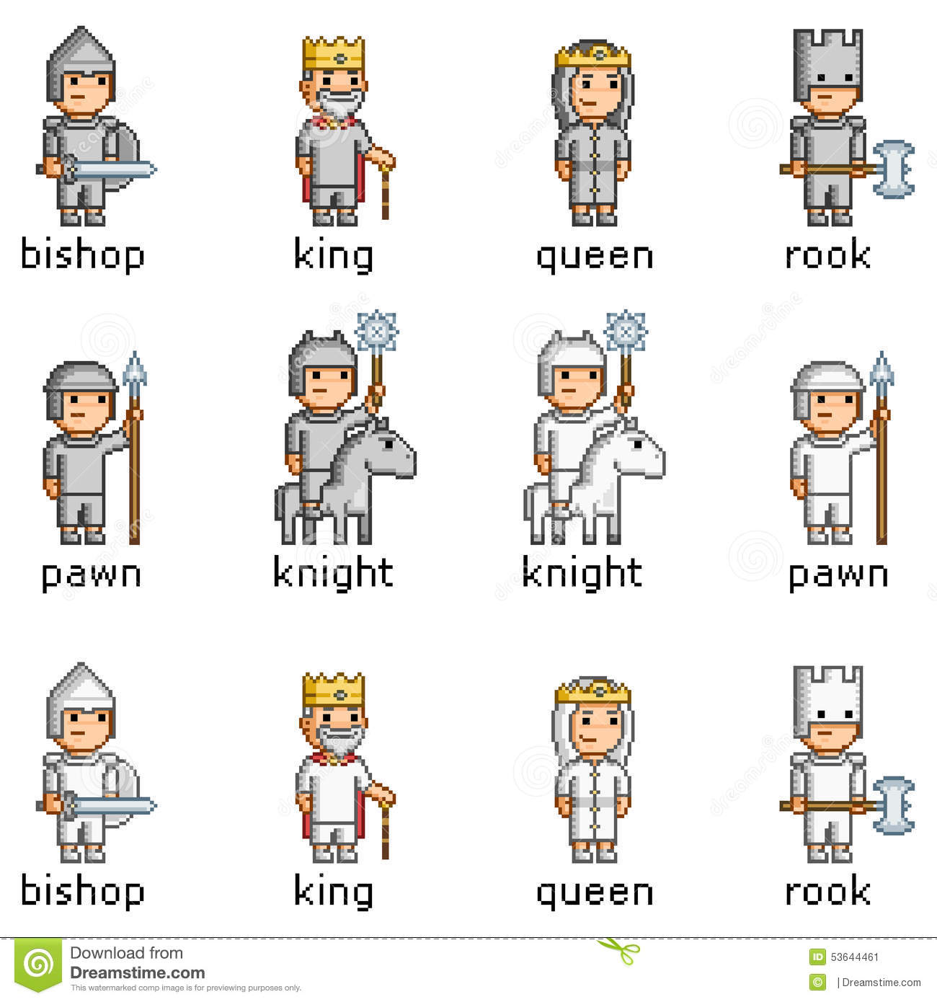

## Feature Examples

Notice how in this example the selected chess-piece is highlighted (at D2) and any possible moves that can be made are marked with a subtle circle (at D3 & D4).

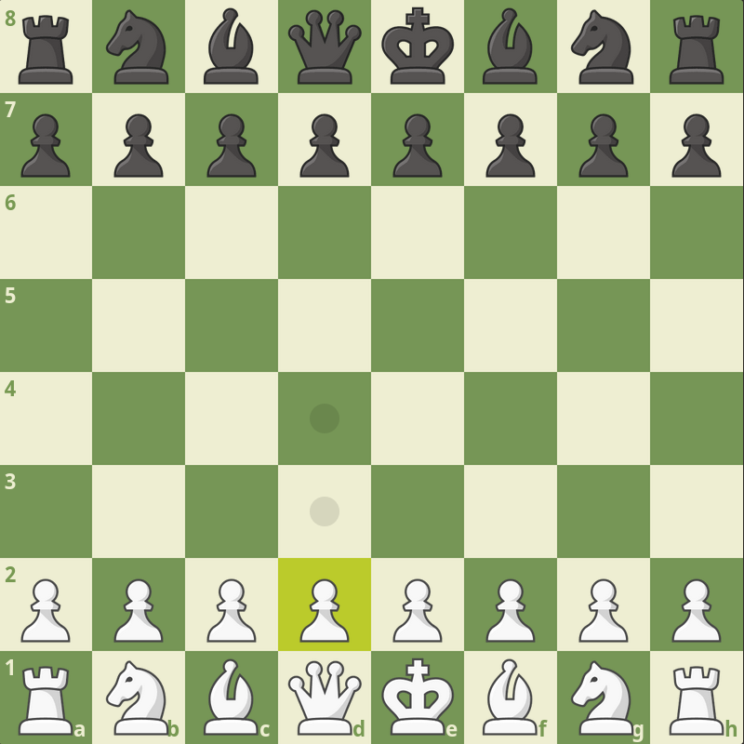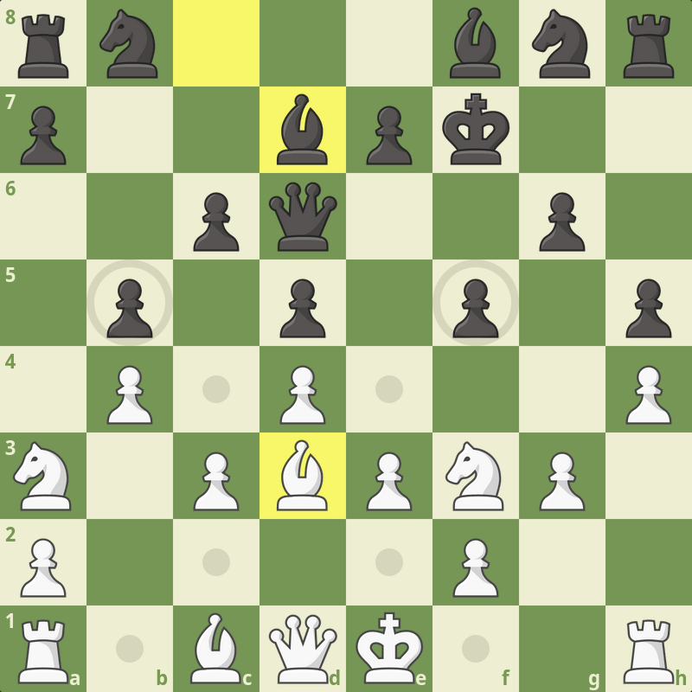

Now notice in this example how the chess piece I have highlighted (at D3) shows any pieces it can currently take.

Also notice how the board shows the previous move (Black Bishop: C8 → D7).