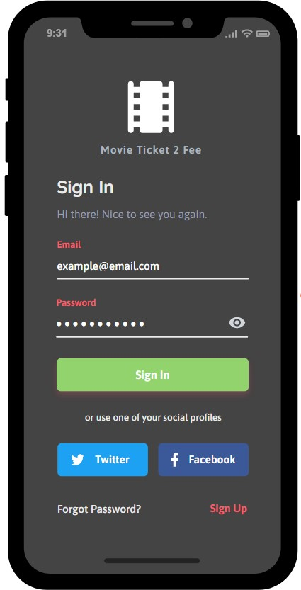

Figure1: The web application for sign in your account but

if you don’t have any account, you can click sign up to register the new account.

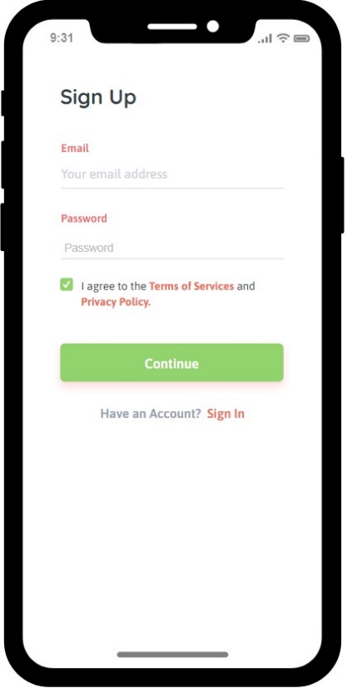

Figure2: After click sign up in Figure1, the web application for sign up new account will pop up for customer to register new account.

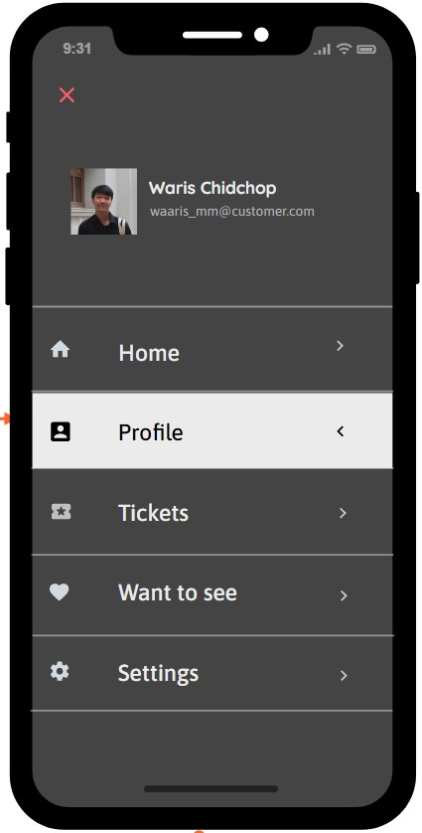

Figure3: After sign in at Figure1 or sign up new account in Figure2 the web application will showing your profile interface

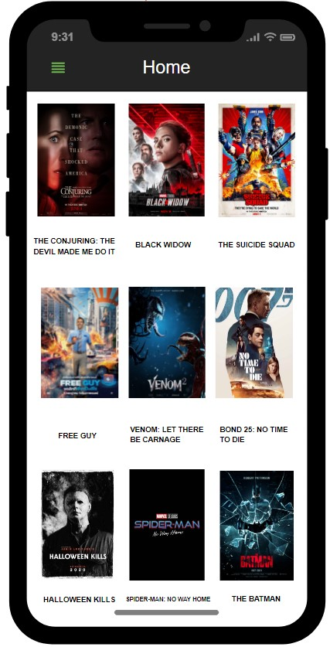

Figure4: After click “Home” in Figure3 the result showing Home page. This page will show the movie that now showing in the theater.

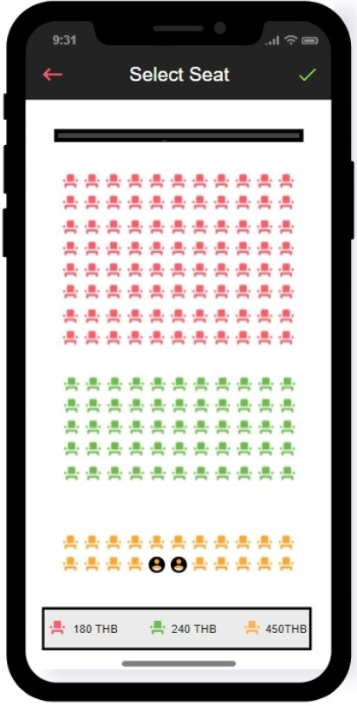

Figure5: When you selected movie that you want to watch in Figure4, you can select your seat at the seat icon.

This Figure will showing seat price and show available seat at the realtime.

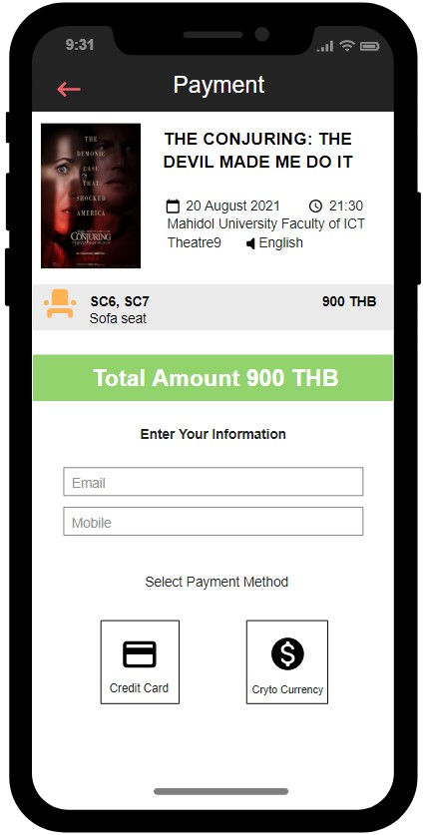

Figure6: After selected your seat and click check mark in Figure5 will go to the payment interface to select your payment method in this figure and fill your information for get tickets.

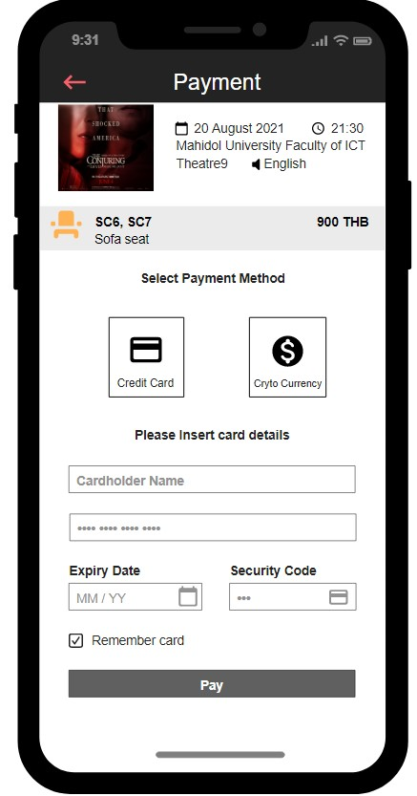

Figure7: If you choose payment by credit card in Figure6 the payment page will show up to fill your information.