MAIN GOAL OF GROUP 1 :

QR Service

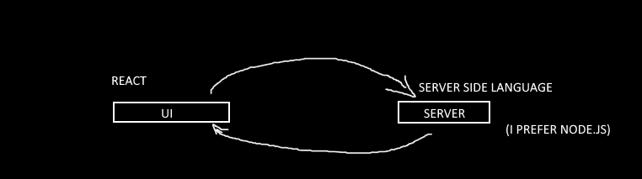

Build UI that:

* Asks for info about the QR code like size…
* Sends a QR code to the client.
* Make it possible to print it.
* Gives instruction on placing.
* Before you start write a **document** that explains everything you want to build.
* **Wait for our approval.**
* Start building.