MAIN GOAL OF GROUP 4:

Integration and Pipeline

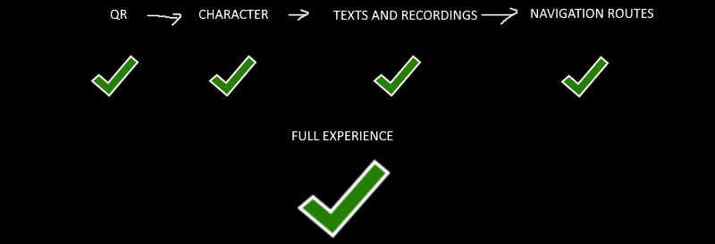

Build UI that:

* Takes all the files and information gathered from the previous steps.
* First check that the QR is readable and detects a some QR ID.
* Then Place the specifically designed character in a 3D Unity scene.
* Play each recording with the animations on time (“left” “right” “behind me” “behind you”) the timing is provided by the text to speech team.
* Display each route in 2d from above and with text.
* Client has to say everything works perfectly.
* Then upload the whole data to the server.
* Before you start write a **document** that explains everything you want to build.
* **Wait for our approval.**
* Start building.