MAIN GOAL OF GROUP 5:

Navigation

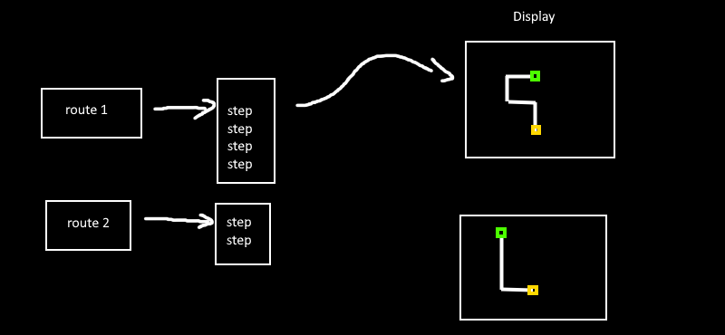

Build UI that:

* Ask the user if they want to make a navigation system in their AR experience.
* Button for creating new route.
* For each route make a button “Add step” a step consists of a direction and length on meters like so: {‘direction’ : ‘north’ , ‘length’:’50m’}
* A route is a collection of steps.
* Make it possible to have multiple routes.
* View each route in a 2d map from above.
* Before you start write a **document** that explains everything you want to build.
* **Wait for our approval.**
* Start building.