# Exercise 3

## Introduction

In this exercise the objective is to create a console application to run on the Hard-Core ARM processor of the Xilinx Zynq Programmable System (PS) on the ZYBO board.

The application has two core functionalities.

If it gets a ‘1’ as an input it is to read the value of the four DIP switches on the ZYBO board, and set the on-board LEDs accordingly.

If it gets a ‘2’ as an input it is supposed to count from 0 to 15 in binary on the on-board LEDs with an interval of 1 second.

This exercise will teach us how to setup a simple processing system on the PS, how to export the hardware system for use with the SDK and how write both hardware and software to the PS. Further this exercise will give insight into the use of the on-board USB-UART and the build-in *XscuTimer*. It will also show the learnings of earlier exercises where HW GPIO blocks where created in order to use the LEDs and switches as Memory-Mapped (MM) devices.

## Implementation

The HW system used here looks as shown in Figure 1.1. The BRAM Memory and controller that is shown at the bottom is left over from a previous exercise and is not used.

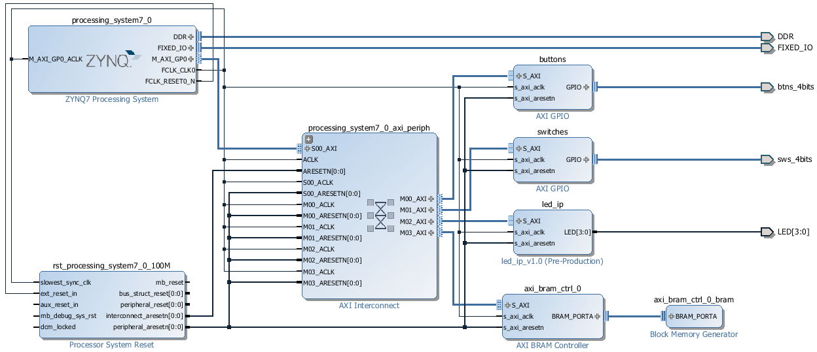

Figure 1.1 - Block Design for Exercise 3

The console input was implemented in a simple fashion using the *inbyte()* function to read characters from the console (See Snippet 1.1) . The function is run once to read the desired input, and twice more to discard of the following <CR> and <LF> characters. This crude implementation means that the system will behave unpredictably if presented with multi character inputs.

**while** (1) {

// Start console interpreter

xil_printf("CMD:> ");

value = inbyte(); // Read char from console

inbyte(); // skip CR

inbyte(); //skip LF

Snippet 1.1 - Console input

The first functionality is implemented by simply reading the MM switches as a register and writing to the MM LEDs as a register. A console output showing the read switch value is also produced (See Snippet 1.2).

**switch** (value) {

**case '1':**

// Read DIP's and display

dip_check = XGpio_DiscreteRead(&dip, 1);

LED_IP_mWriteReg(XPAR_LED_IP_S_AXI_BASEADDR, 0, dip_check);

xil_printf("LEDs set to: %d\r\n", dip_check);

**break**

Snippet 1.2 - DIP switches to LEDs handling

The second functionality is a bit more involved. First the timer must be created and initialized as shown in Snippet 1.3.

The program then runs a 1 second timer in a loop and updates the LEDs, when the second functionality is enabled (See Snippet 1.4). Although not expressly required in the exercise description, the program is set to *break* the loop if a push button is activated. This is implemented to stop the program from becoming stuck in the timer loop, requiring a HW reset to escape.

Finally a case for handling invalid single character inputs is implemented (See Snippet 1.3).

Snippet 1.3 - Invalid charater handling

**default** :

xil_printf("Invalid input: %c\n\r",value);

// Initialize Timer

XScuTimer Timer; /* Cortex A9 SCU Private Timer Instance */

// PS Timer related definitions

XScuTimer_Config *ConfigPtr;

XScuTimer *TimerInstancePtr = &Timer;

ConfigPtr = XScuTimer_LookupConfig(XPAR_PS7_SCUTIMER_0_DEVICE_ID);

**int** Status = XScuTimer_CfgInitialize(TimerInstancePtr, ConfigPtr,

ConfigPtr->BaseAddr);

**if** (Status != XST_SUCCESS) {

xil_printf("Timer init() failed\r\n");

**return** XST_FAILURE;

}

// Load timer with delay in multiple of ONE_SECOND

XScuTimer_LoadTimer(TimerInstancePtr, ONE_SECOND);

// Set AutoLoad mode

XScuTimer_EnableAutoReload(TimerInstancePtr)

Snippet 1.4 - Timer creation and initialization

**case '2':**

// Start the timer

xil_printf("Timer count started\r\n");

XScuTimer_Start(TimerInstancePtr);

count = 0;

**while** (1) {

// Check timer expired

**if** (XScuTimer_IsExpired(TimerInstancePtr)) {

// clear status bit

XScuTimer_ClearInterruptStatus(TimerInstancePtr);

// Code here

count = (count + 1) % 0x10;

LED_IP_mWriteReg(XPAR_LED_IP_S_AXI_BASEADDR, 0, count);

}

// If a Button is pushed go back to interpreter

**if**(XGpio_DiscreteRead(&push, 1)){

**break**;

}

}

// Stop the timer

XScuTimer_Stop(TimerInstancePtr);

**Break;**

Snippet 1.5 - Timer counter handling

## Results

Figure 1.2 shows the results of running the console application on the ZYBO Board. It is the result of the following sequence of inputs:

1. Set switches to *0b0000*
2. Input ‘1’ ↵
3. Set switches to *0b0101*
4. Input ‘1’ ↵
5. Input ‘2’ ↵
6. Waiting and observing the LEDs count up at regular intervals
7. Pressing *BTN0*
8. Input ‘1’ ↵

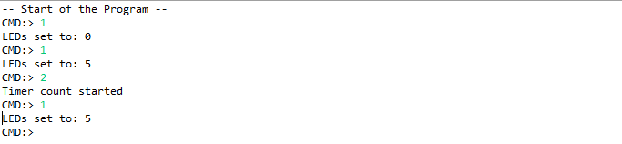

Figure 1.2 - Results of running console application

As is visible from Figure 1.2, the application behaves as intended.

## Discussion

As was intened this exercise was a good stepping stone into the development of SW applications on custom HW. The use of MM HW devices and build-in timers and UART made the exercise relative easy to handle.