# Assignment 4 | HY-487

## Stivaktakis Giorgos | csd4300

### **Exercise 1**

No we cant use just 1 rule. We will have an infinite loop because we dont have a ‘stop’ condition. It could work sometimes if we predefine all connections with interconnected/2 rather connected/2.

### **Exercise 2**

Exist_path code :

exists_path(X, Y) :- connect(X, Y).

exists_path(X, Y) :-

connect(X, Z),

exists_path(Z, Y).

Example using it in the following graph :

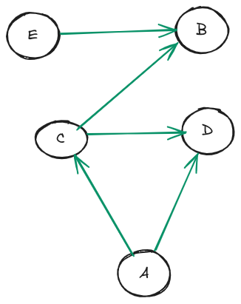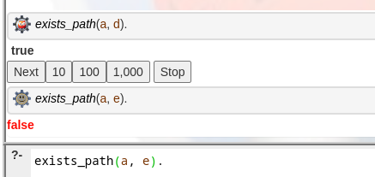

### **Exercise 3**

Code for path (we add each visited node to a list in order to prevent cycles) :

path(Start, End, Path) :-

path(Start, End, [Start], Path).

path(Start, End, Visited, [End|Visited]) :-

connect(Start, End),

\+ member(End, Visited).

path(Start, End, Visited, Path) :-

connect(Start, Mid),

Mid \== End,

\+ member(Mid, Visited),

path(Mid, End, [Mid|Visited], Path).

Results using it in graph from Exercise 2 :

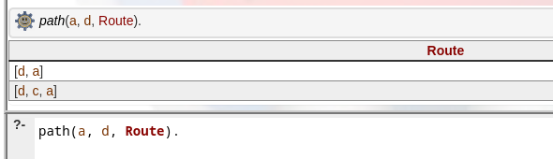

### **Exercise 4**

Same idea as exercise 3 ,although this time using the interconnected Rule (directed graph) and also calculate the current cost after visiting each node :

cost_path(Start, End, Path, Cost) :-

cost_path(Start, End, [Start], 0, RevPath, Cost),

reverse(RevPath, Path).

cost_path(Start, End, Visited, CurrCost, [End|Visited], TotalCost) :-

interconnected(Start, End, Cost),

TotalCost is CurrCost + Cost.

cost_path(Start, End, Visited, CurrCost, Path, TotalCost) :-

interconnected(Start, Mid, Cost),

Mid \== End,

\+ member(Mid, Visited),

NewCost is CurrCost + Cost,

cost_path(Mid, End, [Mid|Visited], NewCost, Path, TotalCost).

Results example :

