Yet another espionage game set in 80’s  
One Page Design Document

| Platforms | PC |
| --- | --- |
| Price | Free |
| Playtime | 15 minutes or less |
| Age Rating | M |
| Planned Release | Yes |

# 

# Game Pitch

Side Scrolling horror-esque espionage game with paranormal activities as main antagonist/(?). The player operates as a spy during the Cold War and using the original way spies operated (shortwave radio stations passing them instructions on how to proceed).

# Game Systems

* A mouse operated system for flashlight shining small part of the screen
* A system for movement for a character
* A system for interactivity to certain objects e.g. radios, doors
* A system for jumpscares and/or other paranormal events

# Gameplay

The player respawns in a dimly lit room with a card providing instructions (written as instructions to a newbie spy in the Era on his training mission. (maybe a bit encoded message?). Then the player has to move further to the next room and find a shortwave radio station, where he must set the correct frequency to receive instructions (that is numbers that are used to unlock the doors before him) - different frequencies will play different numbers.

Using the wrong code for the doors will result in radio noise/ some kind of paranormal activity starting to occur (something along the lines of slenderman’s noise), until the player makes three mistakes, resulting in death (not instant, would be nice if some kind of a monster spawned with an audio cue).

The correct code will open the doors and here the player will encounter another set of doors and probably another radio, and a different hint on how to get the correct radio frequency. The radio part here repeats the same way as last time. Plan is to make the player pass through three sets of doors, before getting the desired briefcase/documents and here the game ends in success.

# Story Cold War era espionage behind the Iron Curtain of communist bloc (with paranormal activities for the sake of it).

# Objectives

# Pass through the riddles using the received messages through the radio, the correct radio message will only be after the right audio cue (see E.g. “Three Note oddity” in The Conet Project on Youtube). The player might set the radio on the wrong radio frequency.

# Unique Selling Points The flashlight system in a side scrolling game. Interaction with a basic radio to receive instructions and hints on how to pass the level.

# Target Audience

# Mature audiences with interests in espionage, cold war and people interested in 80’s shortwave number stations. (The Conet Archive/Project: Recordings of Shortwave Numbers Stations)

# Competitive Products

# Signalis - similar in radio cues usage of The Conet Archive. Different gameplay. Cold War inspired setting, although set in a dystopian future with retro futurism (as in - what’s old is now new/futuristic - the big old console buttons and such). Main inspiration in the radio aspect.

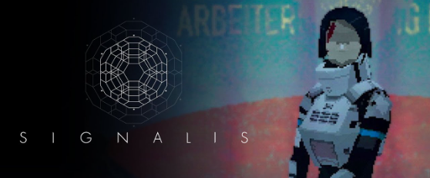

# 

# Asleep - pixel horror game with monsters and low visibility that causes a sense of dread. Flashlight gives a small cone of light in front of the character and as you progress, you encounter different monsters and paranormal events.

# Supplemental Art



