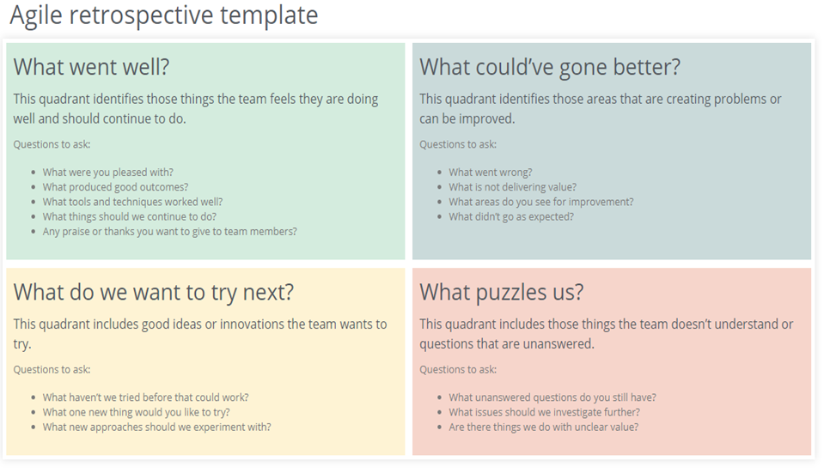

Sprint 1

| What went well?   * The team had time to get used to each other * Working all on user stories put us all on the same page * Setting up drive, git, discord, whatsapp * Remote working and communication * Getting used to a scrum and agile work environment |  | What could’ve gone better?   * TAs give different answers to the same question. We need one person to rely on when answering a question. |
| --- | --- | --- |
|  |  |  |
| What do we want to try next?   * Avoid asking multiple TAs, asking only Serkan or teacher of the topic in question. |  | What puzzles us?   * Unclarities about difference between user stories and requirements. * Moscow priority. * Formulating user stories. |

Sprint 2

| What went well?   * The use of Trello as a project management tool allowed for well-documented tasks and efficient division of work among team members. This helped in organising and tracking progress effectively. * We saw that dividing the tasks efficiently resulted in a productive distinct team work. Each person knew what to do at any given time. * Sitting together in one room was useful for sharing ideas and thoughts. * Communication has been going well in the group. Many ideas are discussed democratically. * The amount of work done is good. There is a good balance between quality and quantity. * The team members worked well together, fostering a positive and supportive environment. This contributed to a sense of camaraderie and enhanced teamwork. |  | What could’ve gone better?   * The situation where someone went overdue on a non-existing deadline and another person losing patience indicates a lack of clear communication and expectations. It would be beneficial to establish clear deadlines and ensure everyone is on the same page to prevent such conflicts from arising in the future. * Although most of the communication is effective, some of it is still redundant and in some cases cluttering. For instance, sometimes a question is asked what the best design choice is – this is good. Other times, sometimes it is asked why the colour of a navbar is blue? – This is a design choice, which has been made at the time. The question is trivial and therefore not that efficient. * When it comes to task division, people like to be in their comfort zones. Although, you could learn a lot from it, but you might not learn from the stuff you don’t do. E.g. back-end programmers don’t learn that much about front-end. |
| --- | --- | --- |
|  |  |  |
| What do we want to try next?   * We want to try to work with deadlines in trello, to set out a more strict way to enforce people to finish their work? * This is very implementation specific, but how to set out generalised designs? How to make our code maintainable to ensure we don’t reinvent the wheel later? * We want to work with different designs and structures to allow us to learn with new ideas. For instance, working with a servlet interface which acts as middleware can help us to produce better code. Or use a different existing pattern to tackle a new problem. * Switching up the work. People who work on the front-end will do the back-end and the other way around. We might try this, but depending on the page or context, we might not. |  | What puzzles us?   * What is the best team balance? Which people work on the front-end, back-end and database? What is the best way to divide tasks? * What is the best database design? What is the right balance between functionality/theoretical correctness and time? Constraints versus freedom? * What is the ideal design for the front-end? * What to do if people have problems with implementation? * How to help the team if they are ‘too distracted’ about future details? e.g. how to keep focus on current implementation? It’s good to think about general design which still works later, but sometimes it’s too specific. |

Sprint 3

| What went well?   * Much progress has been made with the code. There is a clear vision for the design and only needs some work to finalise it to be connected to the back end. The back end for the calendar and client side is also done. The DB is all set up, only needing stored procedures for efficiency. * Healthy conversation with Serkan as mediator with some of the team members. * Git branches are very effective and we talk to each other to not edit certain files that the other person is working on in another branch. This prevents merge conflicts in the future, as last sprint Raphael spent a few hours just with the merge conflicts. * The design (e.g., navbar) is consistent on each page of the website. |  | What could’ve gone better?   * Resolving prior conflicts hasn’t been the easiest, but on the day of the presentation we did have a conversation to talk about it and it w * Sometimes Trello is outdated, it should be updated more frequently. |
| --- | --- | --- |
|  |  |  |
| What do we want to try next?   * Be more committed, since there are no more exams to do assuming no resits. |  | What puzzles us? |

Sprint 4

| What went well? |  | What could’ve gone better? |
| --- | --- | --- |
|  |  |  |
| What do we want to try next? |  | What puzzles us? |