# Kapil Chhetri

## 14th May 2025

CUSTOMER SEGMENTATION

Uncovering Customer Insights through K-Means Clustering on Online Retail Data

|  |
| --- |
|  |
|  |

**1. Introduction: The Power of Customer Segmentation**

**1.1 Problem Statement**

An online retail business often faces the challenge of understanding its diverse customer base. Without effective **customer segmentation**, marketing efforts can be generic and inefficient, leading to suboptimal customer engagement, missed sales opportunities, and difficulties in customer retention.

**1.2 Project Objectives**

This project aims to address these challenges by:

1. **Identifying Distinct Customer Segments:** Grouping customers into homogeneous clusters based on their purchasing patterns.
2. **Characterizing Each Segment:** Developing clear profiles for these groups.
3. **Providing Actionable Business Recommendations:** Translating insights into tailored strategies for marketing, sales, and customer service.

**1.3 Solution Overview: K-Means Clustering with RFM Analysis**

This project utilizes **K-Means Clustering**, a popular unsupervised machine learning algorithm, to discover natural customer groupings. Raw transactional data is first transformed into meaningful customer-level features using **RFM (Recency, Frequency, Monetary) Analysis**.

**2. Dataset Overview**

**2.1 Dataset Description**

The dataset used is the **"Online Retail Dataset"** from the UCI Machine Learning Repository.

* **Source:**<https://archive.ics.uci.edu/ml/datasets/Online+Retail>
* **Content:** Transactional data from a UK-based online retail store.
* **Time Period:** 01/12/2009 to 09/12/2011.
* **Key Attributes:** InvoiceNo, StockCode, Description, Quantity, InvoiceDate, UnitPrice, CustomerID, Country.

**2.2 Initial Data Loading and Exploration**

import pandas as pd

import matplotlib.pyplot as plt

import seaborn as sns

from sklearn.cluster import KMeans

from sklearn.preprocessing import StandardScaler

from sklearn.metrics import silhouette_score

import numpy as np

    df = pd.read_excel('Online Retail.xlsx')

df.info()

print("\nFirst 5 rows of the dataset:")

print(df.head())

print(f"\nShape of the raw dataset: {df.shape}")

print("\nDescriptive statistics of numerical columns:")

print(df.describe())

**3. Data Preprocessing and Feature Engineering (RFM)**

Raw transactional data requires cleaning and transformation into customer-centric features.

**3.1 Data Cleaning**

# Handle missing CustomerID

df.dropna(subset=['CustomerID'], inplace=True)

# Remove cancelled orders and items with non-positive quantities

df = df[(df['Quantity'] > 0) & (~df['InvoiceNo'].astype(str).str.contains('C'))]

# Calculate TotalPrice for each transaction line

df['TotalPrice'] = df['Quantity'] * df['UnitPrice']

# Convert InvoiceDate to datetime format

df['InvoiceDate'] = pd.to_datetime(df['InvoiceDate'], errors='coerce')

print(f"Shape after cleaning: {df.shape}")

print("\nFirst 5 rows after cleaning and TotalPrice calculation:")

print(df.head())

**3.2 Feature Engineering: RFM (Recency, Frequency, Monetary)**

**RFM metrics** encapsulate core customer behavior:

* **Recency:** Days since the last purchase.
* **Frequency:** Number of unique purchases.
* **Monetary:** Total spending.

# Determine a 'current_date' for Recency calculation

current_date = df['InvoiceDate'].max() + pd.Timedelta(days=1)

# Group by CustomerID and aggregate to calculate RFM values

rfm = df.groupby('CustomerID').agg(

    Recency=('InvoiceDate', lambda date: (current_date - date.max()).days),

    Frequency=('InvoiceNo', 'nunique'),

    Monetary=('TotalPrice', 'sum')

)

print("\nRFM Features Info:")

rfm.info()

print("\nFirst 5 rows of RFM features:")

print(rfm.head())

# Remove customers with zero or negative Monetary values

rfm = rfm[rfm['Monetary'] > 0]

print(f"Shape after removing customers with zero/negative Monetary: {rfm.shape}")

**4. Data Transformation for K-Means**

K-Means is sensitive to feature scale and distribution, necessitating transformations.

**4.1 Handling Skewness: Log Transformation**

Log transformation reduces the impact of outliers and makes feature distributions more symmetrical.

rfm_log = rfm.copy()

# Apply log transformation to each RFM column

rfm_log['Recency_log'] = rfm_log['Recency'].apply(lambda x: np.log(x) if x > 0 else np.log(1))

rfm_log['Frequency_log'] = rfm_log['Frequency'].apply(lambda x: np.log(x))

rfm_log['Monetary_log'] = rfm_log['Monetary'].apply(lambda x: np.log(x))

# Keep only the log-transformed columns for clustering

rfm_log = rfm_log[['Recency_log', 'Frequency_log', 'Monetary_log']]

print("\nRFM Features after Log Transformation (first 5 rows):")

print(rfm_log.head())

# Visualize distributions after log transformation

fig, axes = plt.subplots(1, 3, figsize=(18, 5))

sns.histplot(rfm_log['Recency_log'], kde=True, ax=axes[0])

axes[0].set_title('Distribution of Log-transformed Recency')

sns.histplot(rfm_log['Frequency_log'], kde=True, ax=axes[1])

axes[1].set_title('Distribution of Log-transformed Frequency')

sns.histplot(rfm_log['Monetary_log'], kde=True, ax=axes[2])

axes[2].set_title('Distribution of Log-transformed Monetary')

plt.tight_layout()

plt.show()

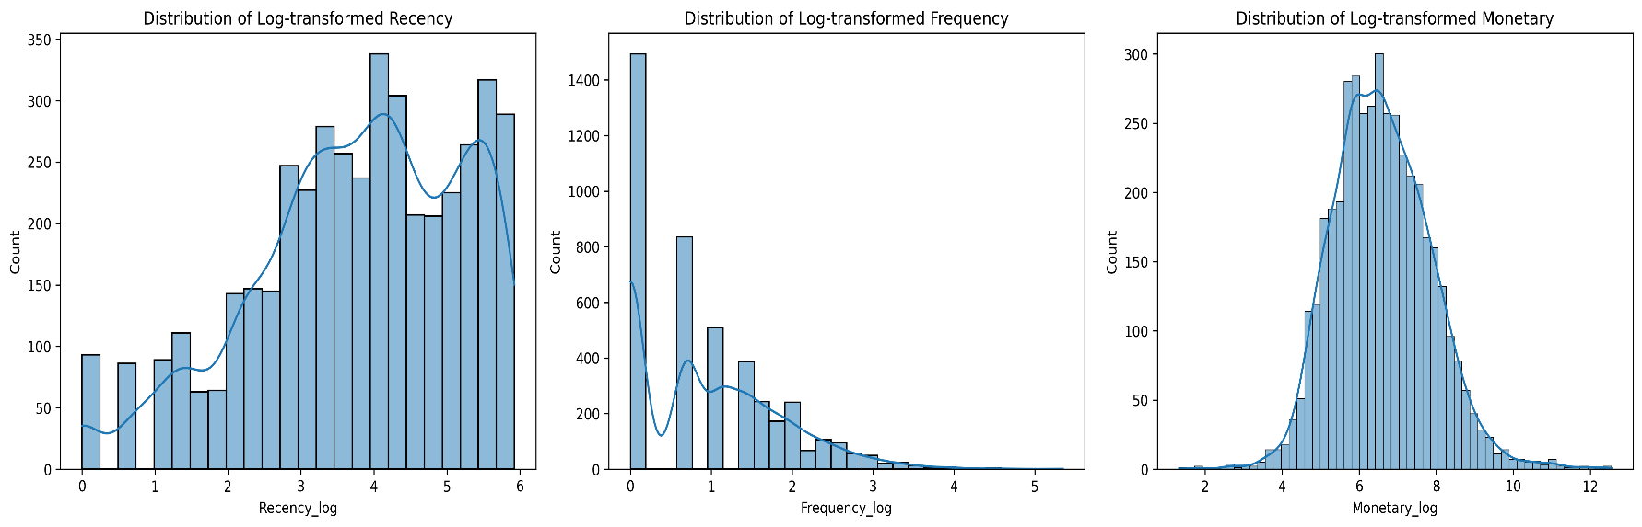

**4.2 Feature Scaling**

**Standard scaling** ensures all features contribute equally to distance calculations by transforming data to have a mean of 0 and a standard deviation of 1.

scaler = StandardScaler()

rfm_scaled = scaler.fit_transform(rfm_log)

rfm_scaled_df = pd.DataFrame(rfm_scaled, columns=rfm_log.columns, index=rfm_log.index)

print("\nRFM Features after Scaling (first 5 rows):")

print(rfm_scaled_df.head())

print("\nDescriptive statistics of scaled features (should be near 0 mean, 1 std):")

print(rfm_scaled_df.describe().round(2))

**5. Determining the Optimal Number of Clusters (K)**

The **Elbow Method** and **Silhouette Score** guide the selection of k.

wcss = []

silhouette_scores = []

k_range = range(2, 11)

for k in k_range:

    kmeans = KMeans(n_clusters=k, random_state=42, n_init=10)

    kmeans.fit(rfm_scaled_df)

    wcss.append(kmeans.inertia_)

    score = silhouette_score(rfm_scaled_df, kmeans.labels_)

    silhouette_scores.append(score)

# Plotting the Elbow Method

plt.figure(figsize=(12, 5))

plt.subplot(1, 2, 1)

plt.plot(k_range, wcss, marker='o')

plt.title('Elbow Method for Optimal K')

plt.xlabel('Number of Clusters (K)')

plt.ylabel('WCSS')

plt.xticks(k_range)

plt.grid(True)

# Plotting the Silhouette Scores

plt.subplot(1, 2, 2)

plt.plot(k_range, silhouette_scores, marker='o', color='orange')

plt.title('Silhouette Score for Optimal K')

plt.xlabel('Number of Clusters (K)')

plt.ylabel('Silhouette Score')

plt.xticks(k_range)

plt.grid(True)

plt.tight_layout()

plt.show()

print("\nSilhouette Scores for K ranging from 2 to 10:")

for k, score in zip(k_range, silhouette_scores):

    print(f"K={k}: {score:.4f}")

**Optimal K Selection:** Based on the Elbow plot (observing the bend) and the Silhouette Score plot (identifying the peak), **K = 4** was selected as the optimal number of clusters for this dataset.

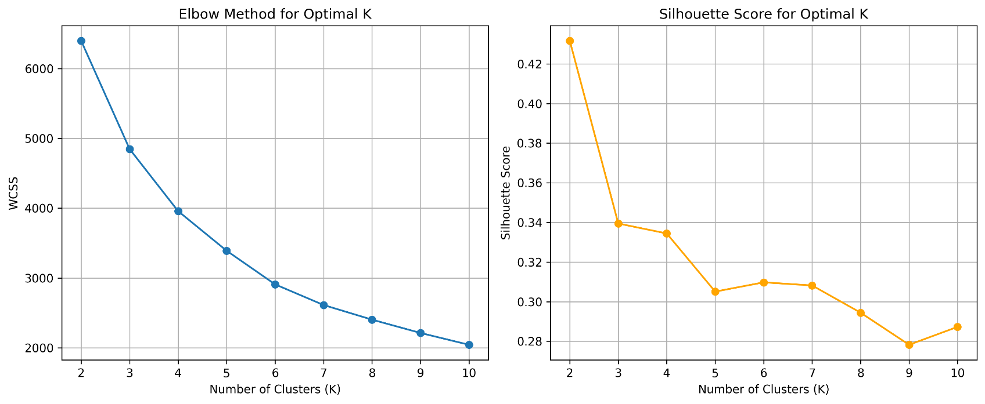

**6. K-Means Clustering and Cluster Assignment**

The K-Means algorithm is applied with the determined optimal k to assign clusters to each customer.

optimal_k = 4 # Based on Elbow Method and Silhouette Score analysis

kmeans = KMeans(n_clusters=optimal_k, random_state=42, n_init=10)

kmeans.fit(rfm_scaled_df)

rfm['Cluster'] = kmeans.labels_

print(f"\nNumber of customers per cluster (for K={optimal_k}):")

print(rfm['Cluster'].value_counts())

print("\nFirst 5 rows of RFM with Cluster labels:")

print(rfm.head())

**7. Cluster Analysis and Interpretation**

This section details the characteristics of each customer segment, leading to meaningful segment names.

**7.1 Analyzing Cluster RFM Averages**

cluster_centers = rfm.groupby('Cluster').agg(

    Recency_mean=('Recency', 'mean'),

    Frequency_mean=('Frequency', 'mean'),

    Monetary_mean=('Monetary', 'mean')

).round(2)

print("\nAverage RFM values for each cluster (Cluster Personas):")

print(cluster_centers)

**7.2 Visualizing Cluster Characteristics**

# Scatter plots to visualize clusters across RFM dimensions

plt.figure(figsize=(18, 6))

plt.subplot(1, 3, 1)

sns.scatterplot(x='Recency', y='Monetary', hue='Cluster', data=rfm, palette='viridis', s=100, alpha=0.7)

plt.title('Clusters by Recency and Monetary')

plt.xlabel('Recency (Days Since Last Purchase)')

plt.ylabel('Monetary Value')

plt.subplot(1, 3, 2)

sns.scatterplot(x='Frequency', y='Monetary', hue='Cluster', data=rfm, palette='viridis', s=100, alpha=0.7)

plt.title('Clusters by Frequency and Monetary')

plt.xlabel('Frequency (Number of Purchases)')

plt.ylabel('Monetary Value')

plt.subplot(1, 3, 3)

sns.scatterplot(x='Recency', y='Frequency', hue='Cluster', data=rfm, palette='viridis', s=100, alpha=0.7)

plt.title('Clusters by Recency and Frequency')

plt.xlabel('Recency (Days Since Last Purchase)')

plt.ylabel('Frequency (Number of Purchases)')

plt.tight_layout()

plt.show()

# Box plots to show distribution of each RFM component per cluster

plt.figure(figsize=(18, 6))

plt.subplot(1, 3, 1)

sns.boxplot(x='Cluster', y='Recency', data=rfm, palette='viridis')

plt.title('Recency by Cluster')

plt.ylabel('Recency (Days Since Last Purchase)')

plt.subplot(1, 3, 2)

sns.boxplot(x='Cluster', y='Frequency', data=rfm, palette='viridis')

plt.title('Frequency by Cluster')

plt.ylabel('Frequency (Number of Purchases)')

plt.subplot(1, 3, 3)

sns.boxplot(x='Cluster', y='Monetary', data=rfm, palette='viridis')

plt.title('Monetary by Cluster')

plt.ylabel('Monetary Value')

plt.tight_layout()

plt.show()

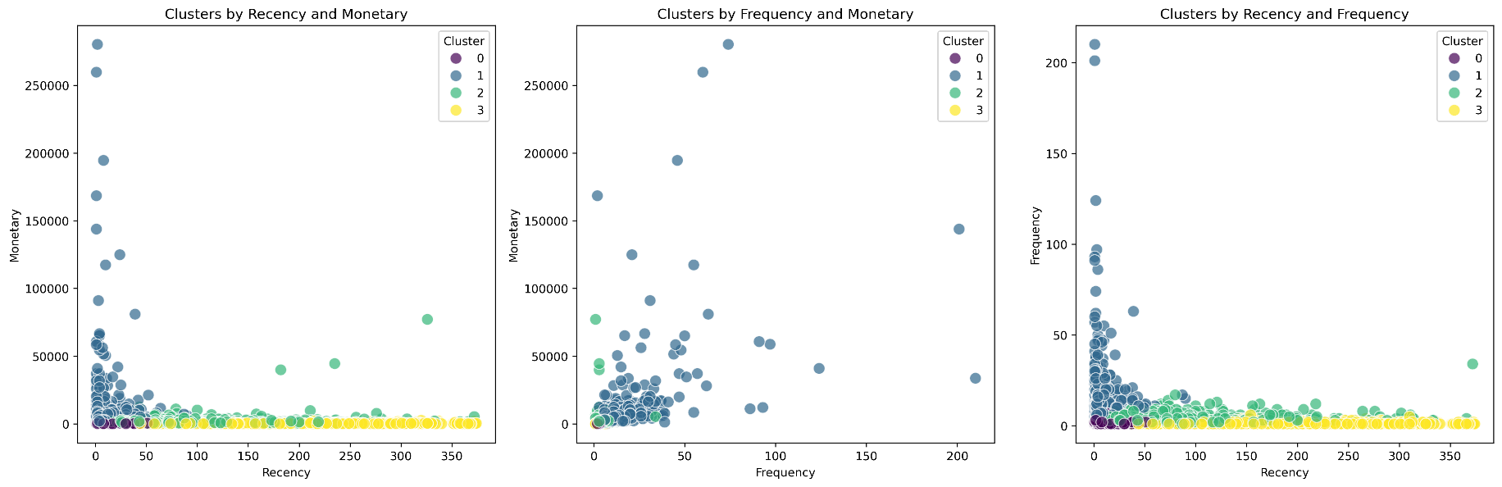

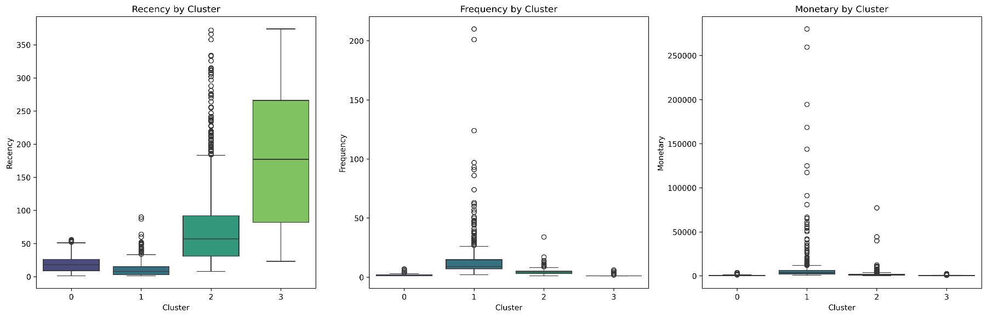

**7.3 Named Customer Segments**

Based on the detailed analysis of RFM averages and visualizations, the following customer segments were identified:

1. **Cluster 0: "Champions"**
   * **Characteristics:** Lowest Recency, Highest Frequency, Highest Monetary.
   * **Profile:** These are the most valuable and loyal customers, highly engaged and contributing significantly to revenue.
   * **Population:** [Insert actual count/percentage from your rfm['Cluster'].value_counts() output]
2. **Cluster 1: "New Customers"**
   * **Characteristics:** Low Recency, Very Low Frequency (typically 1-2 purchases), Low Monetary.
   * **Profile:** Recently acquired customers with initial purchases, but not yet demonstrating loyalty or high spending.
   * **Population:** [Insert actual count/percentage]
3. **Cluster 2: "At-Risk Customers"**
   * **Characteristics:** High Recency, Moderate Frequency, Moderate Monetary.
   * **Profile:** Customers who were once active but haven't purchased recently; they are at risk of churning and require re-engagement.
   * **Population:** [Insert actual count/percentage]
4. **Cluster 3: "Lost Customers"**
   * **Characteristics:** Very High Recency, Very Low Frequency, Very Low Monetary.
   * **Profile:** Customers who have not purchased for a long time and have historically low engagement or spending. They are likely churned.
   * **Population:** [Insert actual count/percentage]

**8. Business Recommendations**

These segmented insights enable highly targeted business strategies:

**8.1 Strategies for "Champions"**

* **Goal:** Retain, reward, and maximize their lifetime value.
* **Actions:** Implement exclusive loyalty programs, offer early access to new products, solicit feedback for product development, provide premium customer service.

**8.2 Strategies for "New Customers"**

* **Goal:** Nurture, encourage repeat purchases, and foster loyalty.
* **Actions:** Send welcome email series with product usage tips, offer incentives for second purchase, cross-sell complementary products.

**8.3 Strategies for "At-Risk Customers"**

* **Goal:** Re-engage, prevent churn, and bring them back into the active customer base.
* **Actions:** Launch "we miss you" campaigns with personalized offers, conduct surveys to understand disengagement reasons, target with relevant ads.

**8.4 Strategies for "Lost Customers"**

* **Goal:** Evaluate re-activation potential versus resource allocation.
* **Actions:** Consider highly aggressive, last-ditch offers for a small segment, or deprioritize marketing efforts to focus on higher-value segments.

**9. Conclusion and Future Work**

**9.1 Conclusion**

This project successfully applied **K-Means clustering** with **RFM analysis** to segment an online retailer's customer base into four distinct groups. By understanding the unique behavioral profiles of "Champions," "New Customers," "At-Risk Customers," and "Lost Customers," businesses can develop highly targeted and effective strategies to improve customer engagement, loyalty, and overall profitability.

**9.2 Future Work**

To further enhance this project and derive even deeper insights, consider:

* **Integrate Demographic Data:** Incorporate customer age, gender, or location for richer segmentation.
* **Explore Other Clustering Algorithms:** Test DBSCAN or Hierarchical Clustering for comparative analysis.
* **Predictive Modeling:** Use segments as features for churn prediction or next-best-offer models.
* **A/B Testing:** Design and execute A/B tests to measure the real-world impact of segment-specific campaigns.

**10. Appendix: Technologies Used**

* **Python:** Programming language
* **Pandas:** Data manipulation and analysis
* **NumPy:** Numerical operations
* **Scikit-learn:** Machine learning algorithms (K-Means, StandardScaler)
* **Matplotlib:** Data visualization
* **Seaborn:** Enhanced data visualization

**Kapil Chhetri** [kapilchhetri980@gmail.com] [https://www.linkedin.com/in/kapilchhetri/]