Title
(Title Goes Here, Times New Roman, 14pt, Bold, Centered, Capitalize Each Word)
Presenting Author¹, Second Author², Corresponding Author³* (Times New Roman, 12pt)

¹Replace this text with authors affiliation, (use complete addresses) (Times New Roman, 12pt, italic, centered)
*Corresponding authors E-mail address Email: abc@xxx.co.in (Times New Roman, 12pt, italic, centered)

A one-page abstract should be prepared in the following format: (1) Use a sheet of A4 size paper. (2) Use 12 points Times New Roman for the main text and 11 points for figure captions. (3) The width of each line should not exceed 17.5 cm or 7.0 inch. (4) Start the first line leaving the space of 2.5 cm or 1.0 inch on the upper side. (5) Title, author's names, and affiliations should be centred. (6) Insert one blank line between the affiliations and the main text. (7) Main text should be fully justified with a single spacing. (8) Use bold face with 14 points fonts for title but not for authors, affiliations, and the main text. (9) Underline the presenting author. (10) Leave the space of 2.5 cm or 1.0 inch at lease on the bottom of the text. Page number will be printed there.
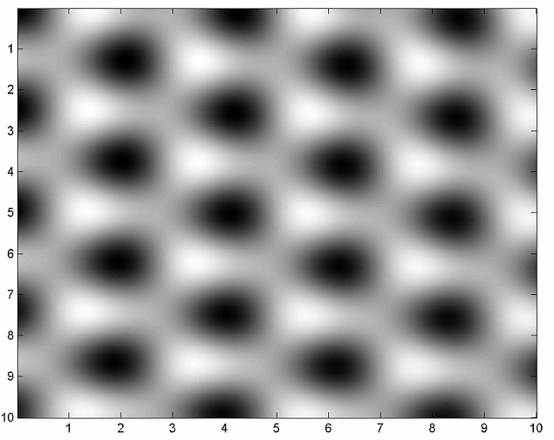
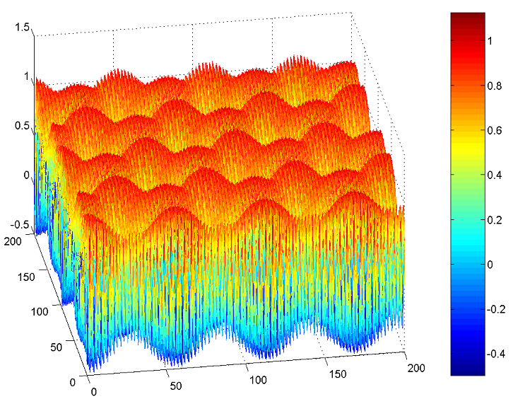

Fig.1 – All images must have a caption. The text “Fig.1” which labels the caption, should be bold and first letter in upper case.
Fig.2 – All images must have a caption. The text “Fig.2” which labels the caption, should be bold and first letter in upper case.

*Figures are optional.

References
[1] XXXX, T.P. XXXX., Science 251 (1991) 640
[2] M. P. XXXX, C. J. XXX, “Title of Chapter,” in Classic Physiques, edited by XXXXX,
Publisher name (2023) 211–232
[3] W.T. XXX, C. XXXX, J. XXX, “Observation of Large-Scale Features on Graphite under Scanning Tunnelling Microscope” 12th International Colloquium on Scanning Probe Microscopy in Shizuoka, Japan 2004.

