Title of the Research Paper (Times New Roman, 16 pt, Bold, Centered)
First Author¹, Second Author^{2,3} Third Author^{1,3}* (Times New Roman, 12 pt)
¹Affiliation of 1 with complete address and pin code (TNR, 12 pt, italic, centered)
²Affiliation of 2 with address and pin code
³Affiliation of 3 with address and pin code
*Corresponding author: e-mail of corresponding author (Italic, TNR 12 pt, centered)
We advise you to strictly follow the template and submit your abstract in MS Word format through the abstract submission portal. Use a Times New Roman font with a size of 12, leaving 1.0 spacing between lines. Authors' names, affiliations, and addresses as provided in the uploaded abstract will appear in the abstract book. The name of the presenting author should be underlined (assumed to be the first author in this template). The maximum size of the abstract is limited to one page, including text, image, and bibliography. What extends over the first page will be automatically deleted.
Please leave space between paragraphs. Abstracts submitted in other formats and/or does not follow the template may not be included in the abstract book. All the texts should be centered and justified.
Leave a space of 2.5 cm or 1.0 inch at the bottom of the page. The page number of the abstract booklet will be printed there. The abstract must be uploaded on the PHYCON-2026 website (https://iitrpr.ac.in/phycon26/abstract.html) with file size < 10 MB.
Fig.1 – All images must have a caption. The text “Fig.1” which labels the caption, should be bold and first letter in upper case with font size of 10 (Times New Roman)
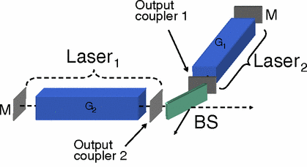
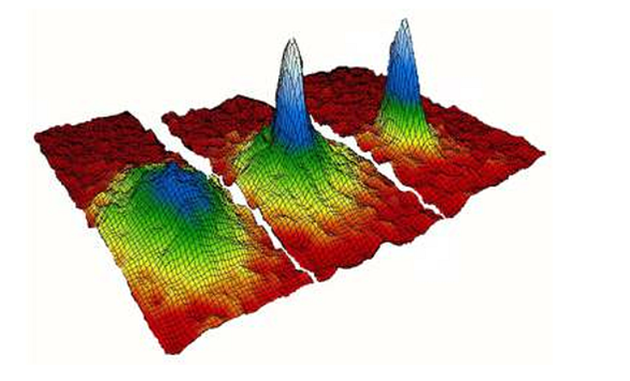
Fig.2 – Evolution of the Bose-Einstein condensate….

References
[1] A. Mehta, B. Pal, and C. Sharma, Nano Lett. 22, 29–35 (2021).
[2] A. Sen et al., Phys. Rev. Lett. 118, 123456 (2017).
[3] A. Einstein, Ann. Phys. 49, 769 (1916).

