SQLAnalyst AI
Ask your databases questions in plain English

Complete project documentation
Architecture · flowcharts · features · security · setup · API · operations
Version 1.0 · 8 October 2026
FastAPI · Next.js 14 · sqlglot · Groq LLM
Contents

If the page numbers above are missing, right-click the contents list in Word and choose Update Field → Update entire table.

1. Overview
SQLAnalyst AI is a web application that lets people ask questions about their business data in plain English. It turns each question into a safe SQL query, runs it on the database the user has chosen, and answers with a table, an automatic chart and a short explanation that streams in as it is written.
It is built for two kinds of people:
- Users (analysts, managers) — ask questions, look at charts, run read-only SQL, upload CSV/Excel files and analyse them.
- Admins — everything users can do, plus connecting new databases, managing users, reading the audit log and, with confirmation, changing data.

1.1 Key features
Feature | What it does
Chat with your data | Questions become SQL through the Groq LLM (llama-3.3-70b-versatile). Results stream back with a chart: line for dates, pie for a few categories, bar otherwise.
Several databases | The default database (TARGET_DB_URL) plus any PostgreSQL, MySQL, SQLite, SQL Server or Oracle database added by an admin. Users switch in the top bar.
11-check SQL safety engine | Every query is parsed with sqlglot: one read-only SELECT, no system tables, only tables of the selected database, enforced row cap, always rolled back.
SQL console | Type SQL directly with the same checks. Admins can turn on Write mode.
Admin changes with confirmation | Admins can ask the chat to "delete order 12". The SQL is shown first and runs only after Run change is clicked.
File analysis | Upload a CSV or Excel file (≤ 10 MB) and ask questions about it.
Conversation memory | Earlier answers in the same chat help answer follow-up questions (sentence-transformers + FAISS).
Accounts | Email + 6-digit code verification, Google sign-in, password reset links, silent token refresh, profile pictures from Google or Gravatar.
Admin panel | Usage statistics, user management, full audit log, data-source management with connection testing.
Hardened | Rate-limited login, encrypted data-source passwords, production start-up checks.

1.2 Technology stack
Layer | Technology
Frontend | Next.js 14 (App Router), React 18, TypeScript 5, Tailwind CSS 3.4, Chart.js 4
Backend | Python 3.11–3.13, FastAPI, SQLAlchemy 2 (async), Pydantic v2, slowapi
SQL safety | sqlglot 30 (parser for every supported dialect)
AI | Groq API — SQL generation and result explanations
Chat memory | sentence-transformers embeddings + FAISS index, in memory
App database | SQLite (development) or PostgreSQL (production)
Cache | Redis (optional)
Email | SMTP (e.g. Gmail with an App Password)
Quality | pytest (58 tests), mypy, Ruff, TypeScript, ESLint, Prettier

2. System architecture
The browser talks only to the FastAPI backend. The backend owns every connection: its own app database, the databases users query, the LLM, the mail server and the optional Redis cache. No database credentials ever reach the browser.
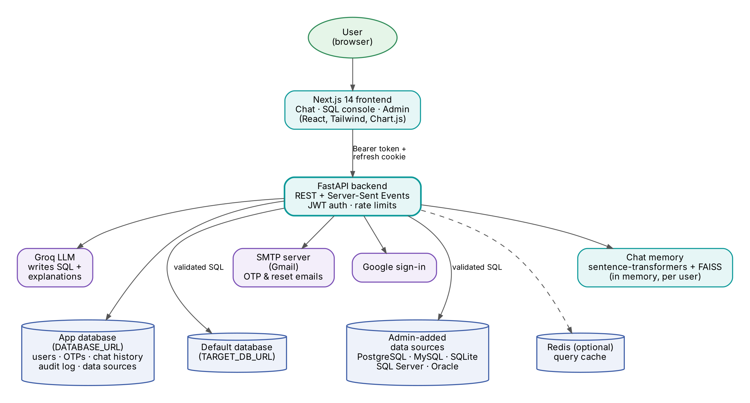
Figure 1. System architecture
Component | Role
Next.js frontend | Login, chat dashboard, SQL console, admin panel. Stores the short-lived access token; the refresh token lives in an httpOnly cookie.
FastAPI backend | REST + Server-Sent Events API. Authentication, rate limiting, SQL generation, validation, execution, audit logging.
App database (DATABASE_URL) | Users, OTP codes, chat history, audit log and saved data sources (passwords encrypted).
Default database (TARGET_DB_URL) | The database questions go to unless the user picks another one. Its table list is cached in backend/data/schema_cache.json.
Data sources | Extra databases added by admins. Each has its own schema, cached in memory.
Groq LLM | Writes SQL from the schema and explains results in business language.
Chat memory | Recalls the 3 most relevant earlier Q&A pairs of the same conversation.
Redis | Optional 5-minute cache for admin data-source queries. The app runs without it.
SMTP server | Sends verification codes and password-reset links.

2.1 Project structure
sqlanalyst/
├── backend/
│ ├── app/
│ │ ├── api/routes/ HTTP endpoints, one file per area
│ │ ├── core/ JWT, passwords, email, rate limits, avatars
│ │ ├── db/ default-database engine, executor, schema cache
│ │ ├── langchain_chains/ LLM prompts, conversation memory
│ │ ├── models/ SQLAlchemy tables
│ │ ├── schemas/ Pydantic request/response models
│ │ ├── services/ query pipeline, connections, files, cache
│ │ ├── sql_safety/ validator.py (11 checks), admin_writes.py
│ │ ├── config.py settings from environment variables
│ │ └── main.py app entry point, start-up tasks
│ ├── tests/ pytest suite (58 tests)
│ ├── test_smtp.py checks the email settings
│ ├── .env.example
│ └── requirements.txt
├── frontend/
│ ├── app/ auth/, dashboard/ (chat, sql/), admin/
│ ├── components/ Navbar, Sidebar, ChartBlock, Avatar
│ └── lib/api.ts API client: tokens, silent refresh
├── docs/ Markdown documentation
├── docker-compose.yml
├── check_errors.bat runs every check on Windows
└── mypy.ini
Route files: auth, google_auth, ask, ask_stream, sources, schema, file_analysis, chat_history, admin, admin_sql and data_sources.

3. Using the application

3.1 Signing in
- Open the app (http://localhost:3000 in development).
- Sign in with email and password, or with Google. The default admin can type just admin as the email.
- New users register with name, email and password, then enter the 6-digit code sent by email.
- Forgot your password? Use the link on the sign-in page; a single-use reset link is emailed.

3.2 The chat dashboard
- Top bar — the Database switcher, links to the SQL console and Admin panel (admins), and your profile picture.
- Sidebar — the tables and columns of the selected database, with example questions you can click.
- Chat — type a question such as "Top 5 customers by revenue last year". You get the SQL, a table, a chart and an explanation.
- Follow-ups — "only for 2025" or "as a pie chart" work, because the chat remembers the conversation.
- History — your saved questions; clear them any time.

3.3 Choosing a database
Pick a database in the switcher at the top. The sidebar loads that database’s own tables, the conversation restarts, and every question afterwards goes only to that database. A green dot means it is reachable; a red dot means the connection failed, with the reason shown.

3.4 SQL console
Type a SELECT query and run it. The same 11 safety checks apply. Admins see a Write mode switch that allows INSERT, UPDATE, DELETE and table changes, always with confirmation.

3.5 Analysing a file
Upload a CSV or Excel file (up to 10 MB and 50,000 rows). You get a summary and a preview, then you can ask questions about the file just like a database.

3.6 Admin panel
Tab | What you can do
Statistics | Number of users, queries, successes and failures.
Users | Activate or deactivate users, promote users to admin.
Audit log | Every question and change: SQL, rows, time taken, success or error.
Data sources | Add, test, edit, activate/deactivate and delete databases.

4. Flow: asking a question
This is the main flow of the application. The dashboard calls POST /ask/stream; the answer comes back as a stream of Server-Sent Events so the table appears first and the explanation types itself out afterwards.
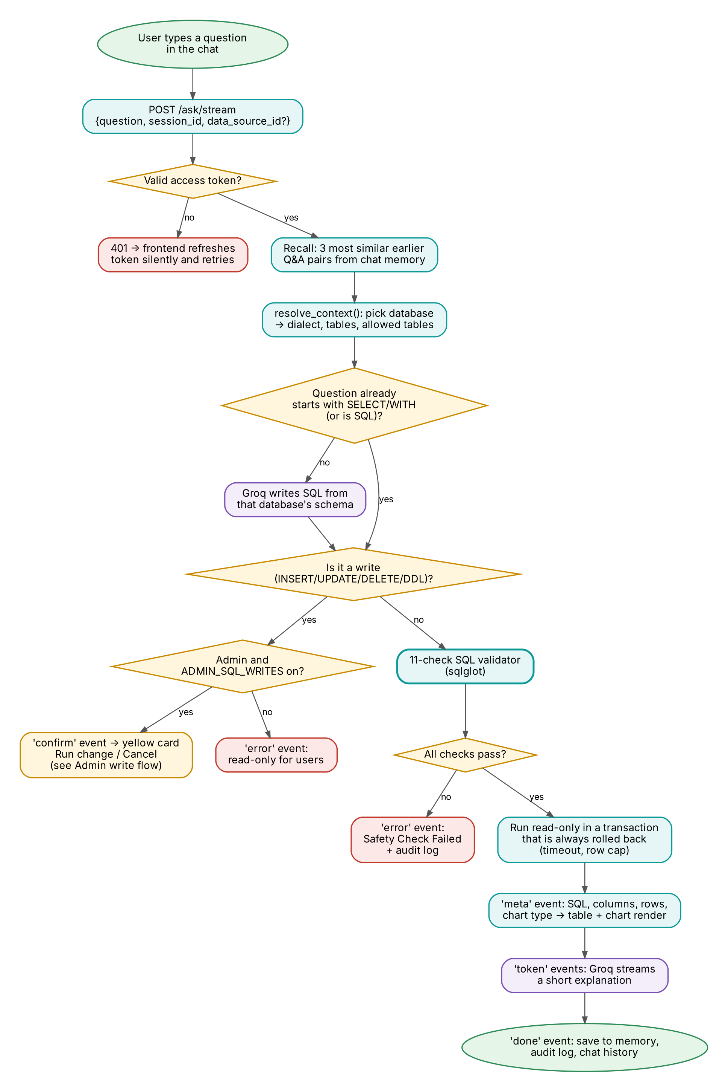
Figure 2. What happens when a user asks a question

4.1 Step by step
- Authenticate — the Bearer token is checked and the user loaded. An expired token gets 401 and the frontend refreshes it silently, then retries.
- Recall — chat memory returns the 3 most similar earlier question/answer pairs from this conversation.
- Pick the database — resolve_context() returns the SQL dialect, table list and allowed tables of the default database or of the chosen data source.
- Write SQL — if the question is already SQL it is used as-is; otherwise Groq writes it from that database’s schema in the right dialect.
- Write or read? — if the SQL changes data and the user is an admin (with ADMIN_SQL_WRITES on), a confirm event shows a Run change / Cancel card. Nothing runs automatically. Regular users get an error.
- Validate — the 11-check validator (chapter 5) must pass. Failures are reported and audited.
- Run — read-only, in a transaction that is always rolled back, with a timeout and a row cap.
- `meta` event — SQL, columns, rows and a suggested chart: table and chart appear immediately.
- `token` events — Groq streams a short business explanation.
- `done` event — the turn is saved to memory, the audit log and chat history.

4.2 Stream events
Event | Contents | Frontend action
meta | sql_query, columns, rows, row_count, truncated, timing_ms, chart, engine_used | Render SQL, table and chart
token | Next piece of the explanation | Append text
confirm | sql, kind, full_table, database, data_source_id | Show the Run change / Cancel card (admins only)
done | session_id | Save the turn to chat history
error | Message | Show the error

5. SQL safety engine
Every query — written by the AI, typed in the console or generated for an uploaded file — goes through sql_safety/validator.py before it reaches any database. Checks run in order and the first failure stops the query with a message such as “[Check 10] Table not in whitelist”.
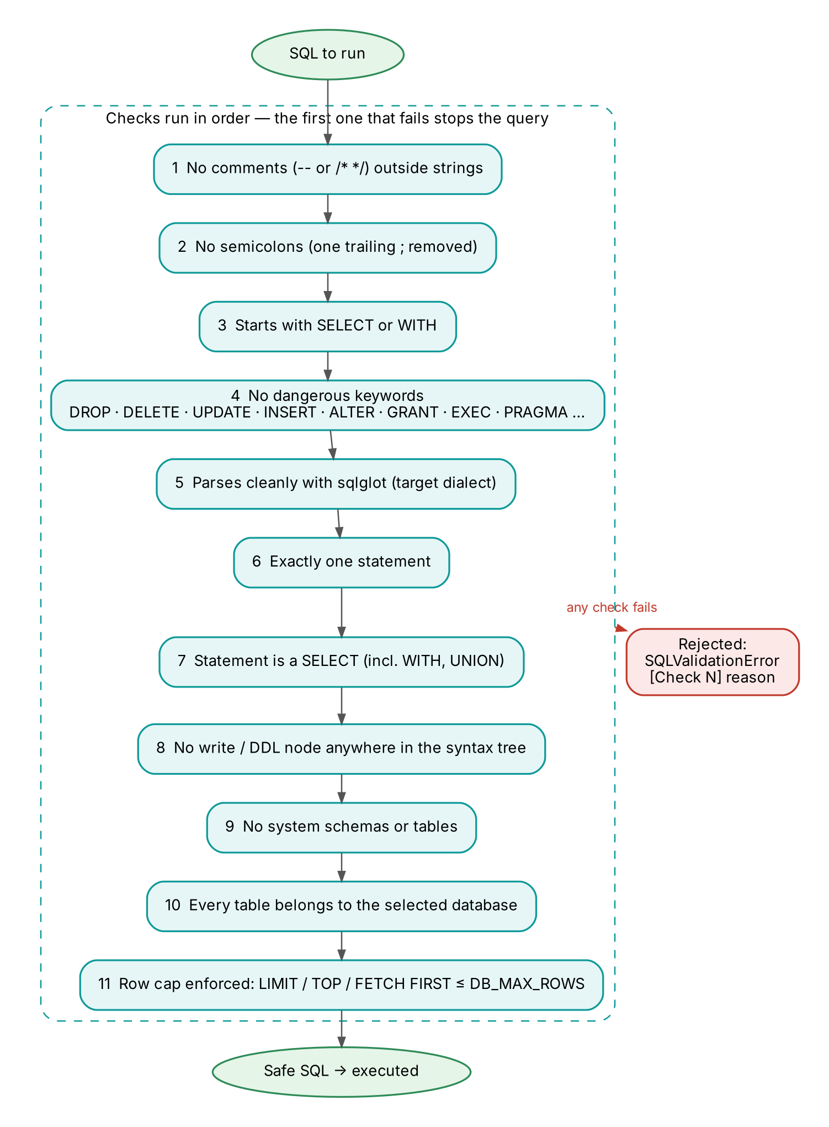
Figure 3. The 11 checks
Checks 1–4 ignore text inside quotes, so WHERE status = 'open -- now' or a column called close is fine. On top of the validator, queries run in a transaction that is always rolled back, with a statement timeout; uploaded files live in a SQLite database switched to read-only.
Defence in depth: even with the validator, use database accounts that can only SELECT. The validator stops mistakes; database permissions are the final safety net.

6. Flow: admin changes to data
Regular users are always read-only. Admins can change data from the chat (“delete the order with id 12”) or from the SQL console in Write mode. Both go through the same path, POST /admin/sql/execute, with its own validator sql_safety/admin_writes.py.
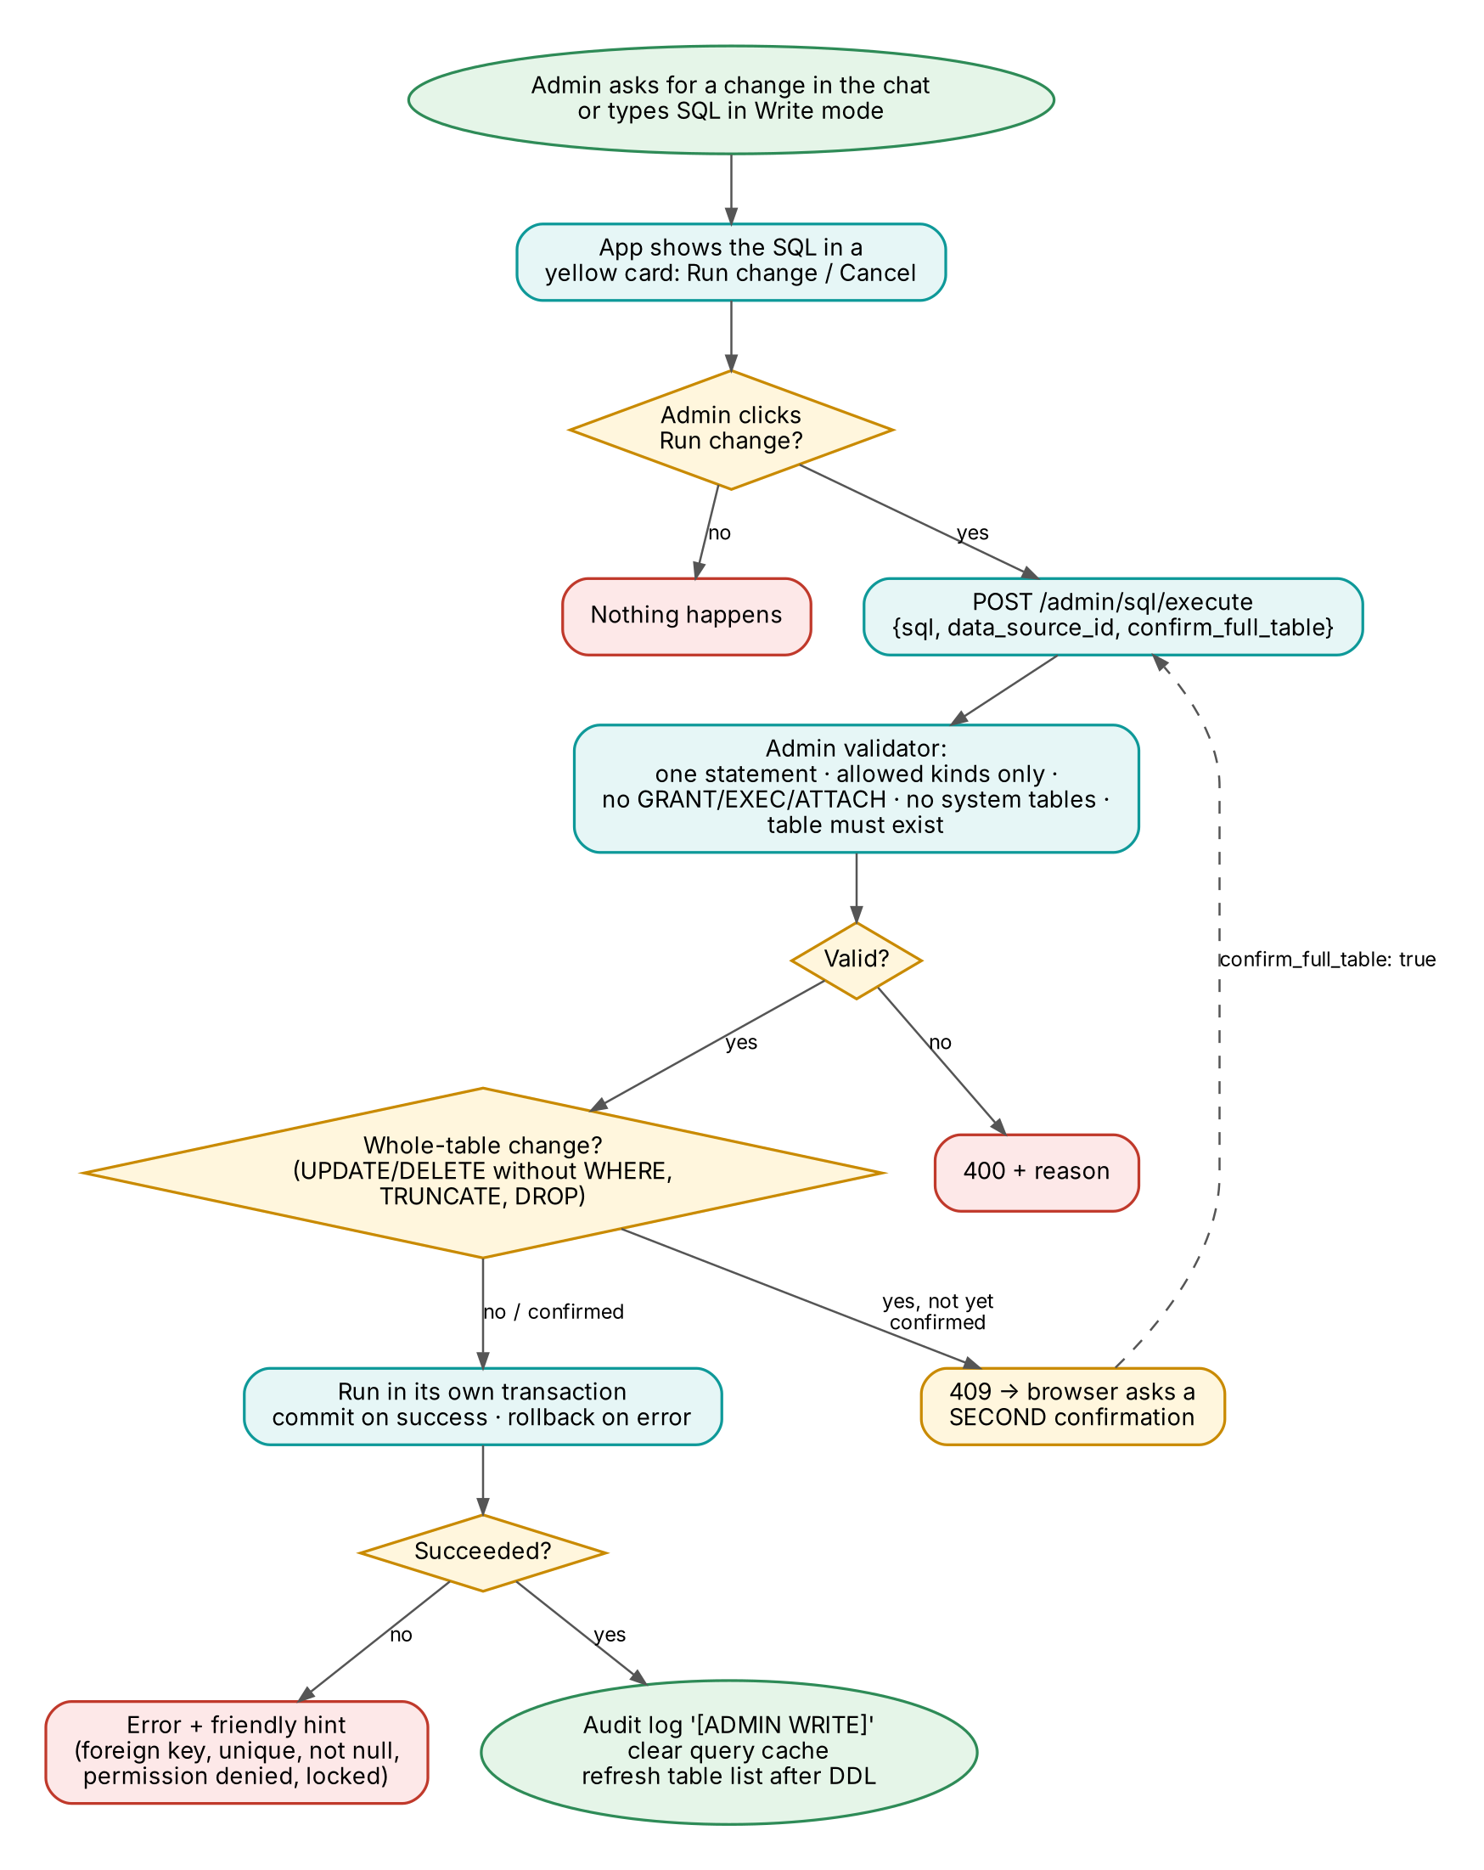
Figure 4. Admin write flow with confirmations
Allowed for admins | Never allowed, even for admins
INSERT, UPDATE, DELETE, MERGE | GRANT / REVOKE
CREATE / DROP TABLE, VIEW, INDEX | CREATE / DROP DATABASE or SCHEMA
ALTER TABLE, TRUNCATE TABLE | EXEC / CALL, ATTACH / PRAGMA, COPY, file access, SLEEP
One statement at a time | Comments, several statements chained with ;, system tables, tables that do not exist

- Second confirmation — UPDATE/DELETE without WHERE, TRUNCATE and DROP return 409 until the admin confirms again.
- Transaction — committed on success, rolled back on error (60-second timeout on PostgreSQL).
- Afterwards — written to the audit log as [ADMIN WRITE], query cache cleared, table list refreshed after CREATE/DROP/ALTER.
- Friendly errors — foreign key, unique, not-null, permission and lock errors come with a hint on how to fix them.
- Switch off — set ADMIN_SQL_WRITES=false to disable changes completely.

7. Flow: accounts, login and sessions
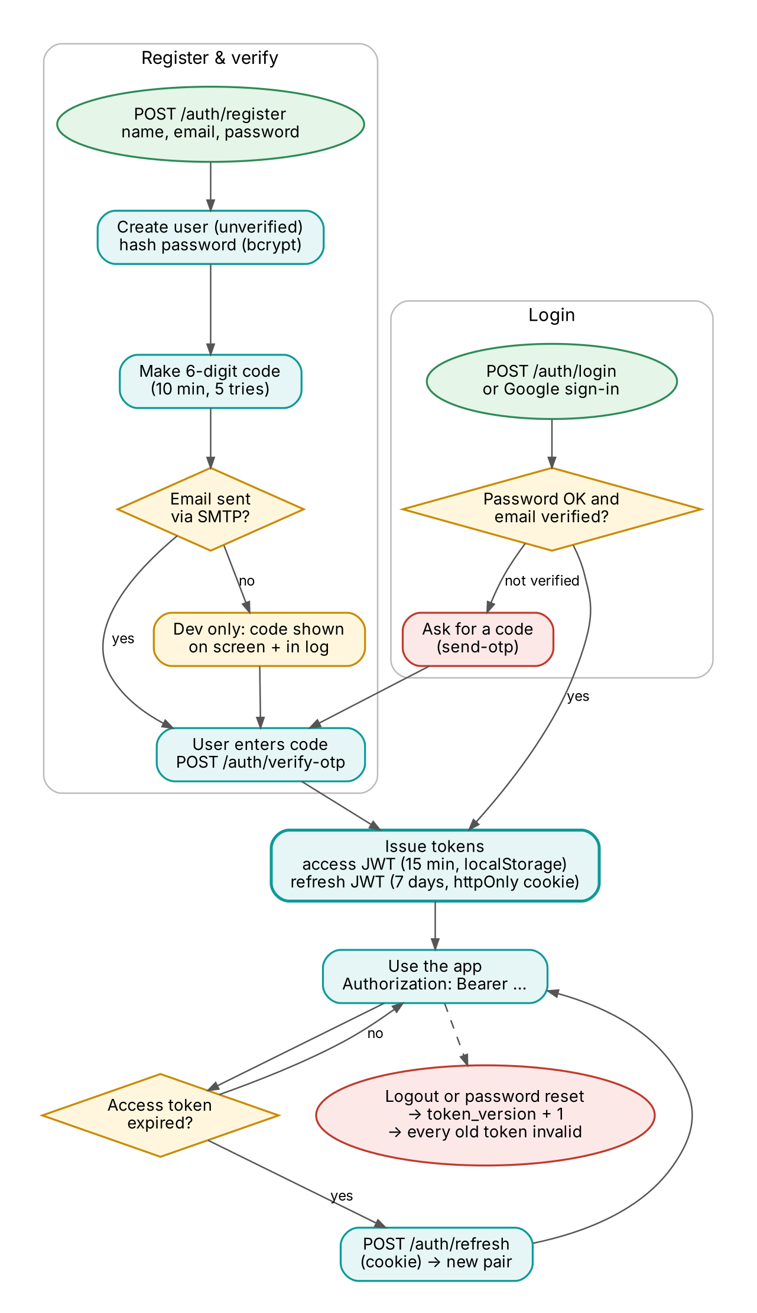
Figure 5. Registration, login and token refresh
Item | Detail
Passwords | At least 8 characters, one uppercase letter, one digit. Stored with bcrypt (cost 12).
Verification code | 6 digits from Python’s secrets module, valid 10 minutes, burned after 5 wrong tries.
Access token | JWT (HS256), 15 minutes, sent as Authorization: Bearer, kept in localStorage.
Refresh token | JWT, 7 days, httpOnly SameSite=Lax cookie (Secure in production).
Revocation | Logout and password reset increase token_version, which invalidates every older token on all devices.
Google sign-in | Popup (ID token) or redirect flow; only Google-verified emails are accepted.
Rate limits | register / send-otp / forgot-password 5 per minute; login / verify-otp / reset 10 per minute; refresh 30 per minute.
Roles | user: chat, console, files, own history. admin: everything plus admin panel and data sources. Admins cannot be demoted.

8. Flow: adding and using a database
Adding a database does not create tables or copy data. The app saves the connection, reads the tables that already exist in that database, and then sends every question for it straight to that database.
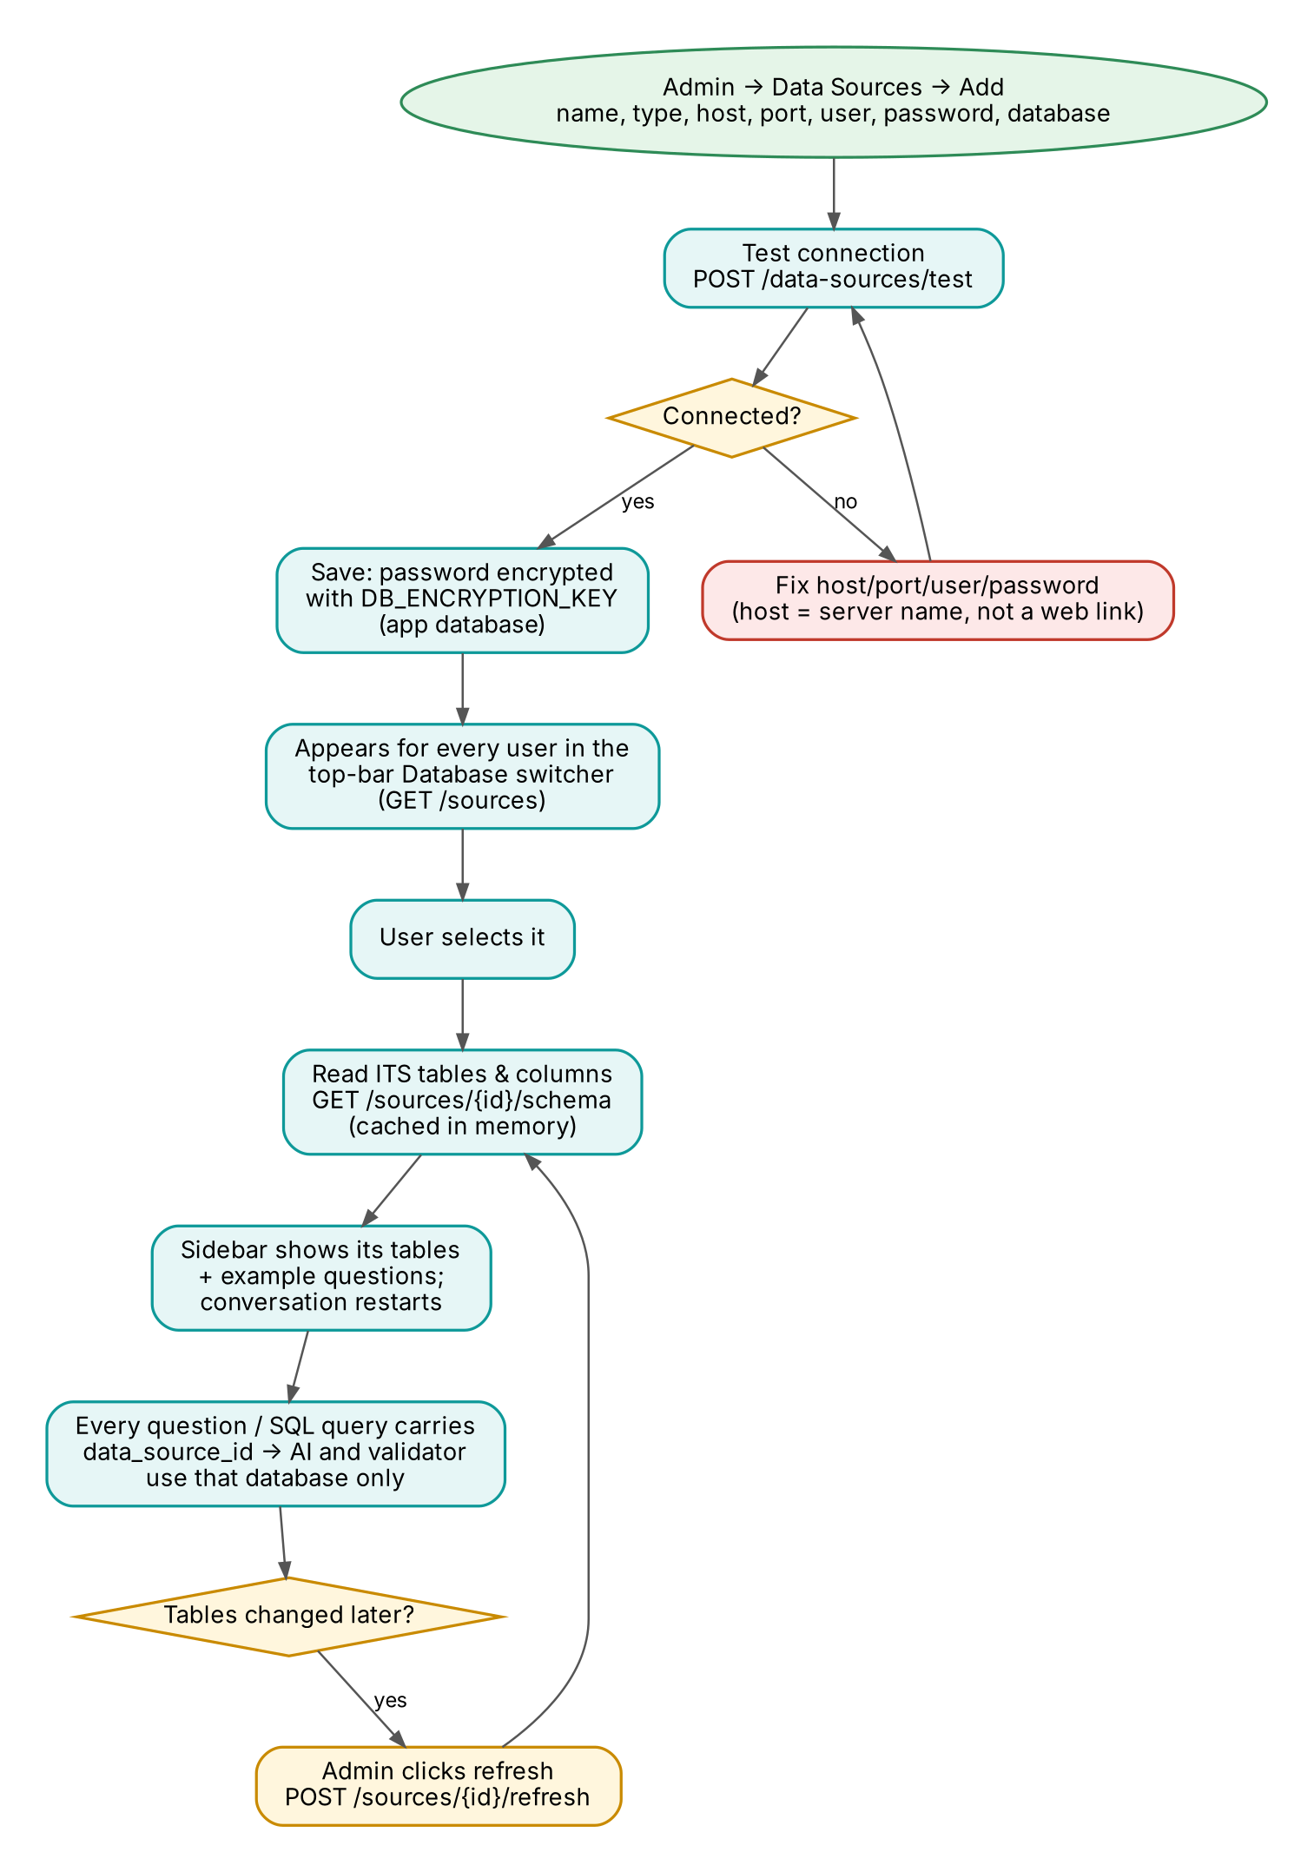
Figure 6. Adding a data source and using it from the chat
Field | PostgreSQL / MySQL / SQL Server / Oracle | SQLite
Name | Any label users will recognise | Same
Type | postgresql, mysql, sqlserver, oracle | sqlite
Host / Port | Server address and port (5432, 3306, 1433, 1521) | –
Username / Password | A read-only user, unless admins need write mode | –
Database name | Database (Oracle: service name) | Path to the .db file on the backend machine

The host is a server name such as db.example.com — never a web link. For Supabase use the pooler host from Project → Connect (e.g. aws-0-ap-south-1.pooler.supabase.com), port 5432, user postgres.<project-ref>, database postgres.
 | Default database | Data sources
Set up by | TARGET_DB_URL in backend/.env | An admin in Admin → Data Sources
Tables read | At start-up, saved to schema_cache.json | First time someone selects it, kept in memory
When tables change | Admin clicks refresh | Admin clicks refresh, edits the source, or restarts the backend
Who can query | Every logged-in user | Every logged-in user while the source is active

9. Flow: file analysis
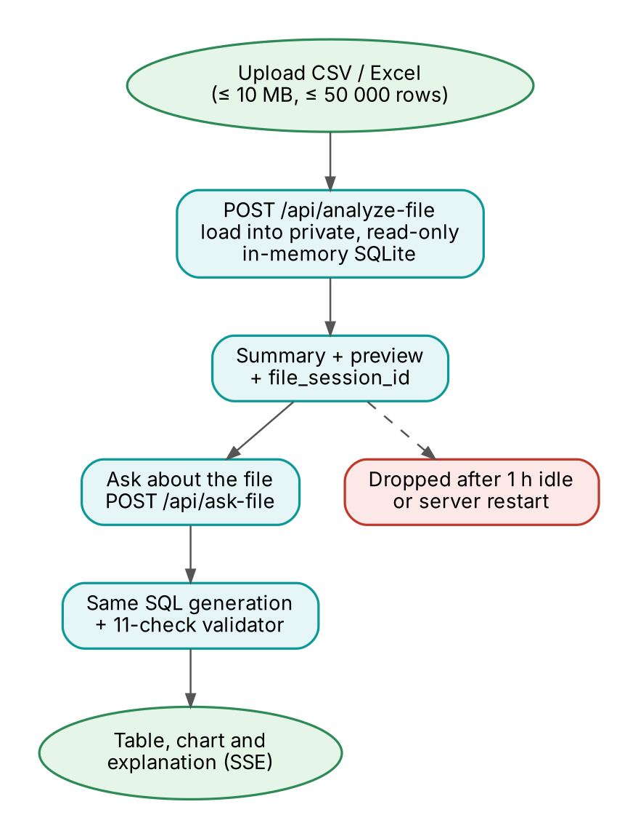
Figure 7. Uploading and questioning a CSV or Excel file
The file is loaded into a private, read-only, in-memory SQLite database owned by the uploading user. Questions use the same SQL generation and the same 11 checks. The file session disappears after one hour without use or when the server restarts.

10. Flow: email (verification codes and reset links)
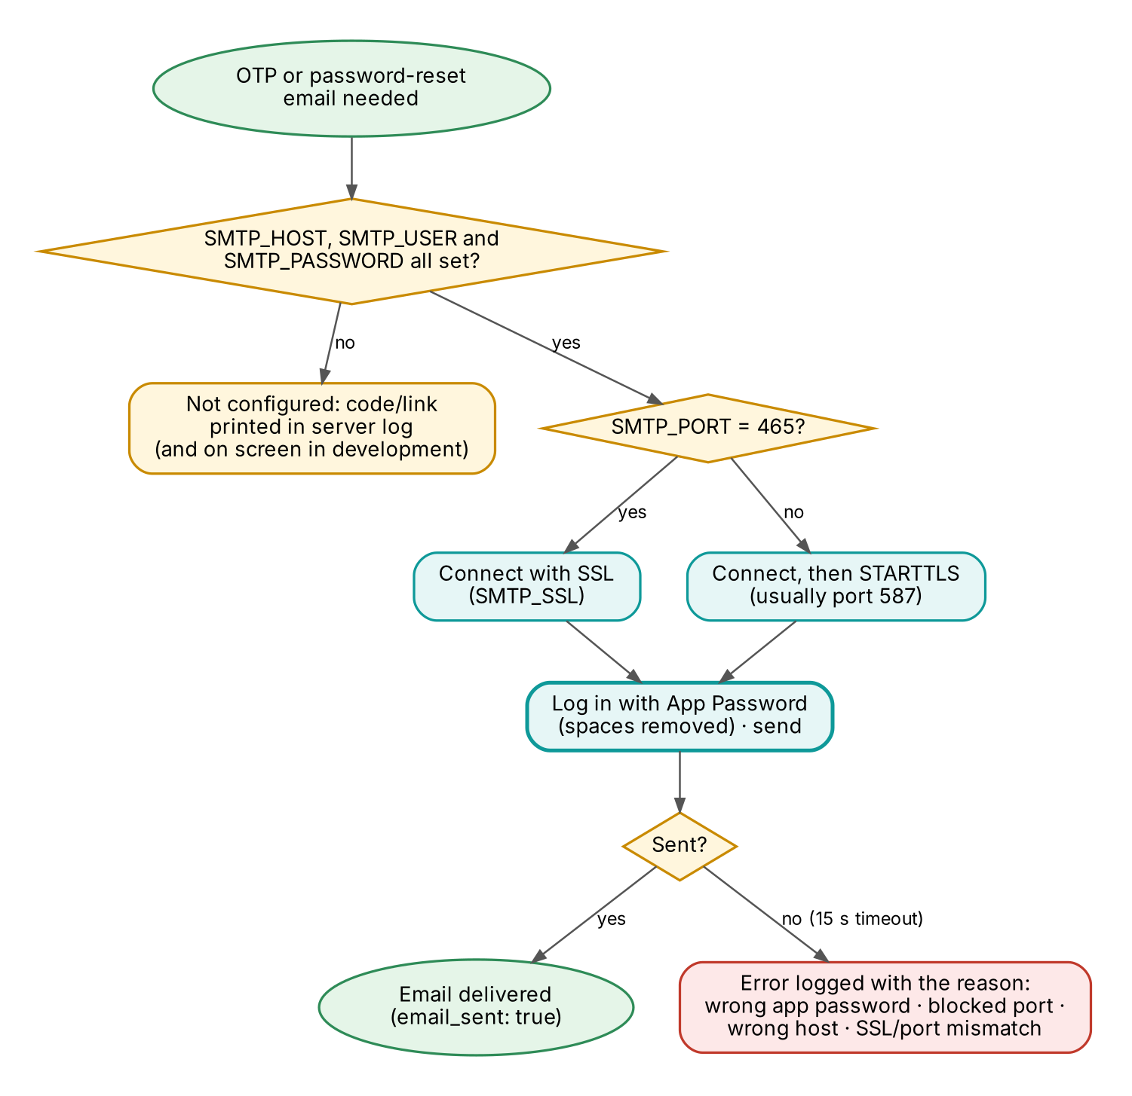
Figure 8. How emails are sent and what happens when they fail
Setting | Gmail value | Notes
SMTP_HOST | smtp.gmail.com
SMTP_PORT | 465 | 465 = SSL. 587 = STARTTLS. Both work.
SMTP_USER | your Gmail address
SMTP_PASSWORD | 16-letter App Password | Needs 2-Step Verification. Your normal password will not work. Spaces are ignored.
SMTP_FROM | same as SMTP_USER | Gmail refuses other From addresses.
SMTP_TIMEOUT | 15 | Seconds before giving up.

Testing the email settings
cd backend
..\.venv\Scripts\python test_smtp.py you@example.com
The script prints the settings it found, sends one test email, and on failure prints the exact reason and fix. The same explanation appears in the server log whenever a code or reset email fails.
Message | Fix
mail server rejected SMTP_USER / SMTP_PASSWORD | Create a new App Password at myaccount.google.com/apppasswords and paste it into SMTP_PASSWORD.
could not reach smtp.gmail.com:465 | A firewall or antivirus blocks the port. Try SMTP_PORT=587.
SSL handshake failed | Port and mode do not match: 465 is SSL, 587 is STARTTLS.
cannot find mail server | Check SMTP_HOST spelling and the internet connection.
SMTP_FROM is not allowed to send | Set SMTP_FROM to the same address as SMTP_USER.

11. Data model (app database)
Table | Contents
users | Accounts: email, name, password hash, role (user/admin), active, email_verified, avatar_url, token_version, timestamps
otp_codes | Current 6-digit code per email, expiry, wrong-attempt count
chat_messages | Saved Q&A turns per user: question, SQL, explanation, engine, session id
audit_logs | Every question and admin change: user, SQL, rows, timing, success or error
data_sources | Databases added by admins: type, host, port, username, encrypted password, database, active flag

Tables are created at start-up. New columns are added automatically by the migration list _COLUMN_MIGRATIONS in main.py.

12. API reference
Base URL http://localhost:8000. Interactive documentation is at /docs (Swagger) and /redoc. Auth: — public, User = any logged-in user, Admin = admin role.

12.1 Authentication
Method | Path | Auth | Description
POST | /auth/register | — | Create an account and email a 6-digit code
POST | /auth/send-otp | — | Send a fresh code
POST | /auth/verify-otp | — | Verify the code → tokens
POST | /auth/login | — | Email + password → tokens
POST | /auth/refresh | cookie | New access token
POST | /auth/logout | cookie | Revoke all tokens
POST | /auth/forgot-password | — | Email a reset link
POST | /auth/reset-password | — | Set a new password
GET | /auth/me | User | Current profile
POST/GET | /auth/google/* | — | Google sign-in (token, redirect, callback)

12.2 Questions, databases, files, history
Method | Path | Auth | Description
POST | /ask/stream | User | Question → Server-Sent Events
POST | /ask | User | Question → single JSON response
POST | /api/query | User | Run a SELECT directly (SQL console)
GET | /sources | User | Default database + active data sources
GET | /sources/{id}/schema | User | Tables, columns and example questions
POST | /sources/{id}/refresh | Admin | Re-read the tables
POST | /api/analyze-file | User | Upload CSV/Excel → summary + file_session_id
POST | /api/ask-file | User | Ask about an uploaded file (SSE)
GET / DELETE | /chat/history | User | Read or clear saved turns
POST | /chat/save | User | Save a turn

12.3 Administration
Method | Path | Description
GET | /admin/stats | User and query totals
GET / PATCH | /admin/users | List users; change role or active state
GET | /admin/audit-logs | Audit trail, filter by status
POST | /admin/sql/execute | Write mode: {sql, data_source_id?, confirm_full_table?}; 409 = needs second confirmation
GET / POST | /data-sources | List or create data sources
GET / PATCH / DELETE | /data-sources/{id} | Read, edit or delete one
POST | /data-sources/test | Test connection settings without saving
GET | /data-sources/{id}/schema | Full schema with types and defaults
POST | /data-sources/{id}/query | Paginated, validated query (cached 5 min)
GET | /health | Public: backend and default database status

13. Configuration
All backend settings are environment variables in backend/.env (copy .env.example). The frontend uses frontend/.env.local.
Variable | Default | Purpose
APP_ENV | development | production enables strict start-up checks and hides driver errors
SECRET_KEY | — | Signs login tokens. 32+ random characters in production
DATABASE_URL | sqlite+aiosqlite:///./data/app.db | App database
TARGET_DB_URL | sqlite:///./data/analytics.db | Default database users ask about
DB_ENCRYPTION_KEY | auto in dev | Encrypts data-source passwords. Set once, back up, never change
DB_MAX_ROWS | 10000 | Maximum rows a query may return
GROQ_API_KEY | — | Enables AI SQL generation and explanations
ADMIN_SQL_WRITES | true | Allow admins to change data (always with confirmation)
SMTP_HOST / PORT / USER / PASSWORD / FROM / TIMEOUT | see chapter 10 | Email for codes and reset links
DEFAULT_ADMIN_EMAIL / PASSWORD | admin@sqlanalyst.com / Admin1234 | First admin. Change the password
FRONTEND_URL, CORS_ORIGINS | http://localhost:3000 | Where the frontend runs
REDIS_URL | redis://localhost:6379 | Optional cache
RATE_LIMIT_ENABLED | true | Turn off only for load tests
SQL_ECHO | false | Print every SQL statement (debugging only)
NEXT_PUBLIC_API_URL (frontend) | http://localhost:8000 | Backend address
NEXT_PUBLIC_GOOGLE_CLIENT_ID (frontend) | — | Google sign-in button

14. Installation and running

14.1 Requirements
- Python 3.11 – 3.13, Node.js 18 or newer, Git.
- A Groq API key (free at console.groq.com). Without it you can still type SQL directly.
- Optional: PostgreSQL for the app database, Redis for caching.

14.2 Backend (Windows PowerShell)
python -m venv .venv
.\.venv\Scripts\Activate.ps1
pip install -r backend\requirements.txt
cd backend
copy .env.example .env # then edit .env
..\.venv\Scripts\uvicorn app.main:app --reload --host 0.0.0.0 --port 8000
Always start the backend from the backend folder, because paths such as ./data/analytics.db are relative to it. On first start it creates the app tables, reads the default database’s tables, loads the chat-memory model and creates the default admin.

14.3 Frontend
cd frontend
npm install
npm run dev # http://localhost:3000
Create frontend/.env.local with NEXT_PUBLIC_API_URL=http://localhost:8000. Use localhost for both apps (not 127.0.0.1 for one of them), or the login cookie is not sent.

14.4 Docker
docker compose up --build -d
Starts PostgreSQL (app database), Redis, the backend on port 8000 and the frontend on port 3000.

15. Testing and code quality
Check | Command
Everything (Windows) | double-click check_errors.bat → check_results.txt
Backend tests | cd backend, then ..\.venv\Scripts\python -m pytest -q
Type check (backend) | VS Code Mypy extension, configured by mypy.ini
Format + lint (backend) | cd backend, then ruff format . and ruff check .
Type check (frontend) | cd frontend, then npx tsc --noEmit
Lint (frontend) | npm run lint
Format (frontend) | npm run format (Prettier)
Email settings | cd backend, then python test_smtp.py you@example.com

Test file | Covers
test_sql_validator.py | The 11 checks, blocked statements, comments, system tables, CTEs, UNION, row caps per dialect
test_auth_flow.py | Register → code → login → refresh → logout, code lockout, reset links, Google fallback, avatars
test_sources.py | Database picker, per-source schema, admin refresh, queries against a data source
test_data_sources.py | Data-source CRUD, encryption, connection URLs, query cache
test_chat_changes.py | Admin change requests are confirmed, never auto-run; users are refused
test_admin_sql.py | Write mode, confirmations, DDL refresh, blocked statements, error hints

16. Troubleshooting
Symptom | Fix
Logged out every ~15 minutes | Use localhost for both frontend and backend; check CORS_ORIGINS
“Groq LLM API key is not configured” | Set GROQ_API_KEY, or type the question as SQL
“Table not in whitelist” | The table is not in the selected database, or tables changed — admin: click refresh
“Stored password cannot be decrypted” | DB_ENCRYPTION_KEY changed — re-enter the data source password
Verification email never arrives | Run test_smtp.py and follow the message (chapter 10)
429 Too Many Requests | Rate limit — wait a minute
Red dot / “Could not connect to the database” | Fix host, port, user, database or password with Edit in Admin → Data Sources
Admin change fails with “permission denied” | The database account is read-only — give it write rights
“Other rows still point to this row” | Foreign key: delete or update the referencing rows first
Excel upload fails | pip install -r backend\requirements.txt (openpyxl / xlrd)
Terminal full of SQL statements | Set SQL_ECHO=false (the default) and restart

17. Production checklist
☐ APP_ENV=production
☐ SECRET_KEY — 32+ random characters
☐ DB_ENCRYPTION_KEY set, backed up, never rotated casually
☐ Default admin password changed
☐ HTTPS in front of frontend and backend; COOKIE_SECURE=true
☐ FRONTEND_URL, APP_URL and CORS_ORIGINS set to the real domains
☐ SMTP configured and tested with test_smtp.py
☐ Read-only database accounts for TARGET_DB_URL and every data source (or a separate limited write account if admins need write mode)
☐ ADMIN_SQL_WRITES=false if admins should never change data from the app
☐ PostgreSQL for DATABASE_URL, with backups
☐ Run without --reload

