Public, private, protected, default access modifier and package

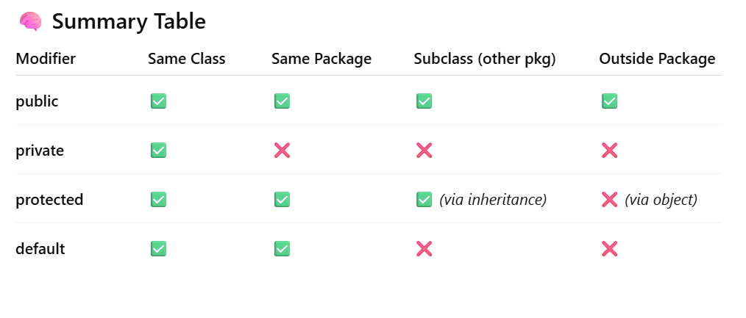

- Geeting data from outside of a package then only public, protected(through inheritance in subclass only)
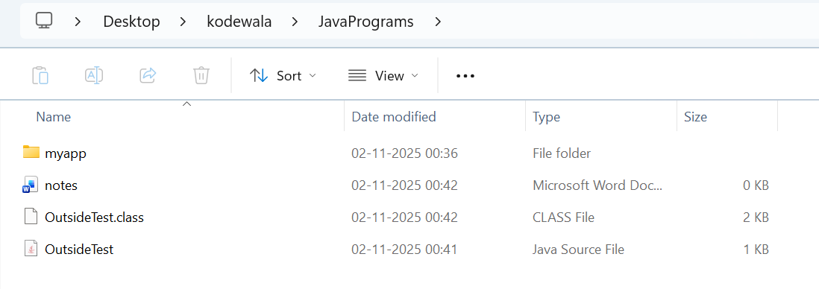

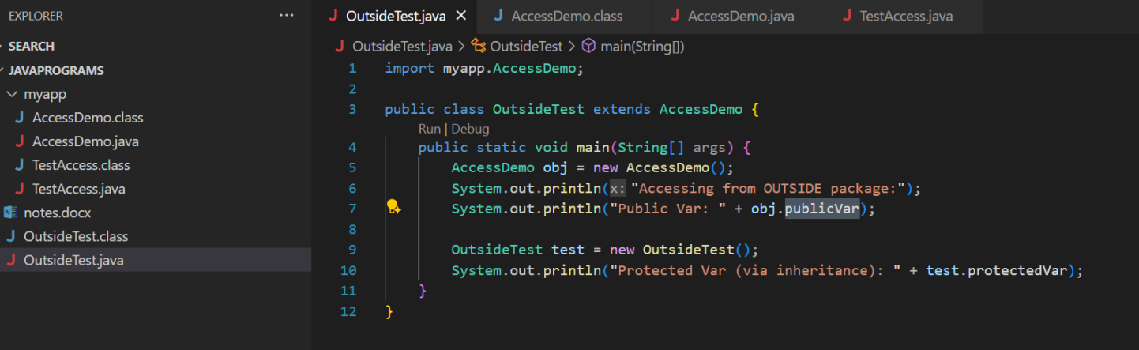

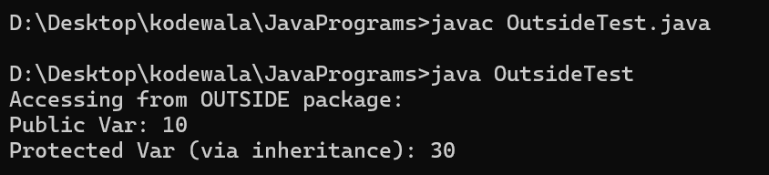

2.Getting data from inside of a package then
private can go only for same class only not outside of that class.
Public can go to anywhere.
Protected can also get within same package having multiple class.
Default can go within that package if have two class then we can access.

