INTELLIGENT OBSTACLE AVOIDING HELMET FOR THE VISUALLY DISABLED

ABSTRACT
The main aim of this project is to assist the blind persons without the human need. It is well known that the blind people carry a hand stick with them whenever they need a support. Sometimes even when they use this stick, there is no guarantee that the blind persons are safe and secured in reaching their destinations. There may be an obstacle in their path but is not encountered by the person with the help of the stick. Thus, the people may be injured if the obstacle is big enough or dangerous. Thus, a Intelligent Helmet with ultrasonic sensor has been developed to assist the blind and provide them a clear path.

AIM
To develop an intelligent helmet to assist visually disabled to identify the presence of obstacles in the navigation path

COMPONENTS REQUIRED
Sl No. | ITEM | SPECIFICTION | QUANTITY
1 | Arduino Microcontroller | UNO | 1
2 | Ultrasonic sensor | HC – SR04 | 1
3 | Resistor |  | 1
4 | Vibrating Motor | - | 1
5 | Battery | 9 V | 1
6 | Toggle Switch | - | 1

SOFTWARE AND HARDWARE TOOLS:

Software Tools:

- Arduino IDE

Hardware tools:

- Arduino Uno
- |Ultrasonic sensor
- Vibrating Motor

BLOCK DIAGRAM
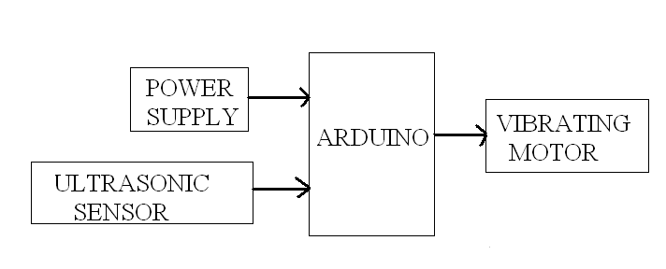
CIRCUIT DIAGRAM

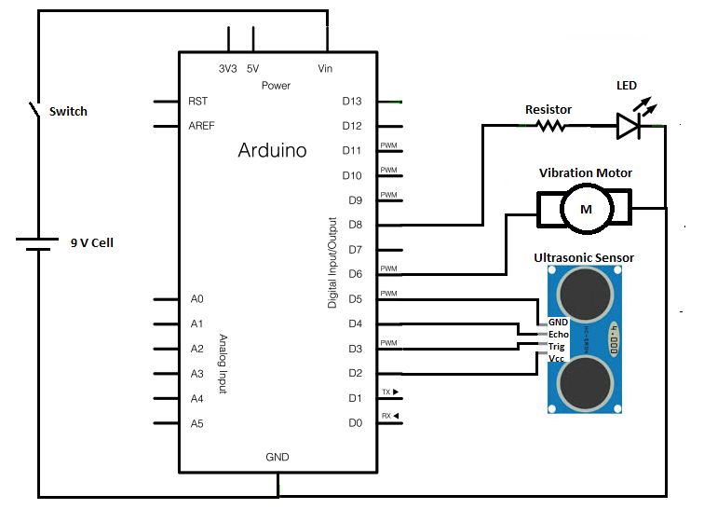
WORKING PRINCIPLE
A Vibrating motor is attached with the device which vibrates faster if the distance between the obstacle and device decreases and vibration decreases as distance increases.
Device currently uses Arduino Uno, Ultrasonic sensor and vibrating motor. Micro-controller is used to measure the distance of the forth coming object by measuring time of flight of Ultrasonic waves emitted by Ping sensor. Depending on the distance, controller changes the vibration of the vibrating motors. Hence, if the distance is decreasing vibration of the motor increases and if distance increases vibration decreases.

ARDUINO PROGRAM:
void setup()
{
pinMode (2,OUTPUT);
pinMode (5,OUTPUT);
pinMode (8,OUTPUT);
}

void loop()
{
digitalWrite(2, HIGH);
digitalWrite(8, HIGH);
long duration, inches, cm;
pinMode(3, OUTPUT);
digitalWrite(3, LOW);
delayMicroseconds(2);
digitalWrite(3, HIGH);
delayMicroseconds(5);
digitalWrite(3, LOW);
pinMode (4, INPUT);
duration = pulseIn(4, HIGH);
inches = microsecondsToInches(duration);
cm = inches*2.54 ;

if (cm < 10 )
{
analogWrite(6,255);
}
else if (cm < 50)
{
analogWrite(6,200);
}
else if (cm < 100)
{
analogWrite(6,150);
}
else
{
analogWrite(6,0);
}
}
long microsecondsToInches(long microseconds)
{
return microseconds / 74 / 2;
}

