## Day 1

1. Create a database (<your_name>day_1)
2. Create tables with the following schema

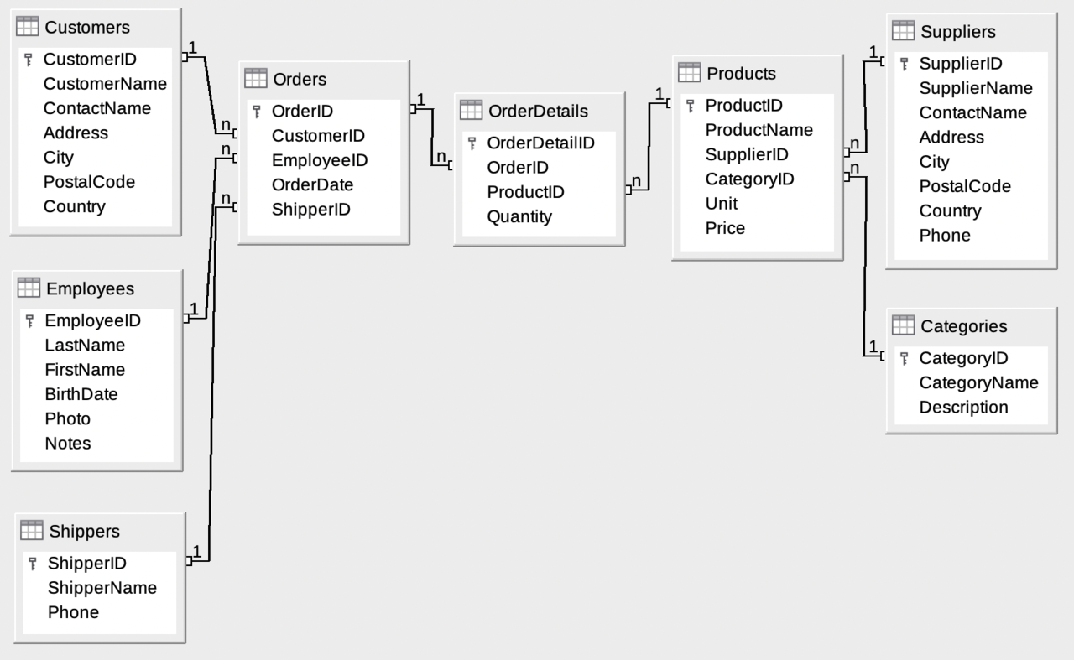

1. Insert sample data for the tables (<https://docs.google.com/spreadsheets/d/1qOoOs7_DxSbI779ALyggutxWmmrNI8pWbDzM06UkdoM/edit#gid=0> )

Folder structure for submission:

sql/

migrations/

<table_name_1>.sql –Create Scripts

<table_name_2>.sql

seeds/

<table_name_1>.sql – Insert Scripts

<table_name_2>.sql