Forecasting NSW electricity demand and price direction under drift

1 Introduction
Operators in the power system sector rely on demand forecasts to plan and schedule generation in advance. If these predictions are too low, supply may have to be interrupted. The demand and price of power changes with factors like the time of day, weather, and season – but also with structural changes, like the growth of rooftop solar panels. As a result, accurate forecast models trained on early data can become unreliable with market changes over time.

Our study has been provided with over 290 thousand entries from January 2010 to October 2026 containing demand (in MW) and price (in $/MWh) for Sydney, Melbourne, and Brisbane along with the temperature, humidity, cloud cover, and shortwave solar radiation (intensity of sunlight) for the three cities ^{[1]}. Using this data, we aim to train a regression model capable of predicting the demand for all 48 half hours of the next day and a classification model capable of predicting whether the price during a given 30-minute interval will be greater than the previous day’s mean price – i.e. predicting price direction. Our models will need to beat the baseline of simply predicting yesterdays and last week’s demand and price direction at the same time.

2 Data Analysis
Table 1. NSW summary statistics over the released dataset. Demand and prices are half-hour averages.
Variable | Mean | Std dev | Median | Minimum | Maximum
Demand (MW) | 7,918.31 | 1,361.22 | 7,838.61 | 2,581.84 | 14,579.86
Price ($/MWh) | 76.17 | 241.77 | 53.11 | -587.71 | 17,500.00
Every timestamp is present, unique and ordered, with no missing values; no imputation was required. Negative prices and extreme spikes were retained as genuine observations. Price standard deviation substantially exceeds its mean (Table 1), so averages can be dominated by rare events. NSW average demand declined from 8,807 MW in 2010 to 7,497 MW in 2025. Negative prices increased from 0.04% to 13.07% of intervals over those years. The 2026 observations cover January to October only and are not a full-year comparison.
The positive price class depends on the previous day's price threshold. Its annual share was 38.67% in 2020, 46.40% in 2025 and 51.91% in January to October 2026. A large preceding-day spike raises that threshold and can make almost all following-day labels zero. High raw accuracy can therefore conceal weak recall for one class. Calendar and weather features represent within-day and seasonal variation; the fixed-reference analysis below examines changes in daily demand shape.

2 Data Analysis continued
Each market day was represented by its 48 NSW demand values divided by that day's mean. This normalization focuses on shape rather than level, separating changes in daily profiles from a general decline in demand. PCA and k-means were fitted once on 2010–2013 only, then applied unchanged to later days [5]. Day types are retrospective analysis variables and are not used to forecast the unknown next-day type.
Retaining at least 95% of training variance produced five principal components explaining 96.24%. Candidate cluster counts were 2–6, with 20 k-means initializations and seed 9417. Silhouette scores on a fixed 800-day training sample were 0.408, 0.343, 0.315, 0.335 and 0.317 respectively, supporting two clusters. This favours separation in the retained space; it does not establish that the market has exactly two natural regimes.
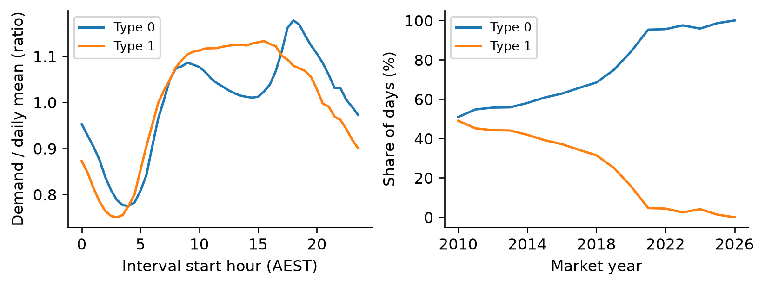
Figure 1. Training-period normalized demand profiles and annual assignments to fixed clusters. The 2026 shares cover January to October. Hours use AEST without daylight saving.
Type 0 has a pronounced evening peak and a lower midday level relative to its daily mean. Type 1 has a broader daytime plateau. In the training years, weekends account for 38.3% of Type 0 and 17.1% of Type 1, making a weekday working pattern a plausible interpretation of Type 1 rather than a deterministic label. Type 0 increases from 51.0% of days in 2010 to 98.6% in 2025 and 100% in partial 2026 (Figure 1).
A day is unusual when its distance to the nearest fixed centre exceeds the training 99th percentile, 0.586 in PCA coordinates. Later days are always assigned a cluster, even when far from both centres, so shares alone are insufficient evidence of similarity. Across simulation months, unusual-day share correlates 0.789 with frozen boosted-demand MAPE and 0.395 with the input statistic. These descriptive associations connect shape change, monitored inputs and error; common trends and seasonality prevent a causal interpretation.

3 Methodology
A timestamp denotes interval end in AEST. Subtracting 30 minutes assigns each interval to its market day: day D runs from D 00:30 through D+1 00:00. At the end of D, the model forecasts the 48 intervals of D+1. The demand target is NSW MW; the price label is one exactly when that interval's NSW price exceeds the mean NSW price of D. Labels and baselines were checked against the authoritative harness [1].
Stage 1 fits on 2010–2013, selects settings and a family per task using 2014, then refits each chosen family on 2010–2014. Stage 2 freezes those versions and simulates daily deployment from January 2015 to October 2026. Adaptation is compared separately; only 2015–2024 scores select policies, with 2025–October 2026 reserved as a subsequent check. Stage 3 refits final models on released data using the selected window rule. The live week is genuinely unseen; simulation scores used for selection are not unbiased future estimates.
The shared training/inference function creates 78 features: 12 target-day weather variables; sine/cosine encodings of half-hour and annual position; weekday and NSW holiday indicators; same-half-hour market lags of 1, 2 and 7 days for all three states; previous-day mean, standard deviation, minimum and maximum for each market variable; seven-day means of completed daily averages; and weather changes from yesterday. Calendar information is the only external feature exception. Future market values are excluded. The first seven days lack sufficient context and are omitted from fitting.
Ridge and logistic regression provide regularized linear references, using training-fitted standardization [2,3]. LightGBM regression and classification model nonlinear weather, calendar and lag interactions without scaling [4]. All use the full eligible training set; subsampling is unnecessary. The limited search tests ridge alpha 10 or 1,000, logistic C 0.01 or 1, and 15 or 31 leaves per boosted model. Boosting uses 180 trees, learning rate 0.05, minimum leaf sample count 80 and L2 penalty 2. Seed is 9417. Lower demand MAPE and higher price balanced accuracy select settings, fixed thereafter.
Both baselines copy the same half-hour yesterday or seven days earlier. Both price baselines compare the copied price with day D's mean, not the source day's own mean. Yesterday is competitive because recent demand and price structure persist. Weekly copying preserves weekday patterns but can miss rapid changes.
MAPE averages absolute error divided by actual demand for each half-hour, times 100; MAE averages absolute errors in MW. Demand stays well above zero. Price metrics are accuracy and balanced accuracy, the mean recall across classes present; a single-class period uses its sole recall. Balanced accuracy is preferred for selection and live scoring because class shares change. Monthly uncertainty is reported for MAPE and raw accuracy, as specified [1].

4 Results

4 Results validation and feature choices
Table 2. Stage 1 results on 2014 only. Lower demand errors and higher classification percentages are better. A dash denotes a different task.
Model | Setting | MAPE % | MAE MW | Accuracy % | Bal acc %
Yesterday | — | 4.935 | 394.42 | 73.90 | 73.99
Last week | — | 4.934 | 401.26 | 74.25 | 74.28
Ridge | α 10 | 3.723 | 292.10 | — | —
Ridge | α 1000 | 3.570 | 280.68 | — | —
Boost demand | Leaves 15 | 2.618 | 207.59 | — | —
Boost demand | Leaves 31 | 2.486 | 197.67 | — | —
Logistic | C 0.01 | — | — | 76.23 | 76.40
Logistic | C 1 | — | — | 76.08 | 76.27
Boost price | Leaves 15 | — | — | 79.94 | 80.12
Boost price | Leaves 31 | — | — | 80.25 | 80.40
Boosted models with 31 leaves were selected for both tasks (Table 2). Their validation gains over yesterday were 49.6% relative demand MAPE reduction and 6.42 percentage points of balanced accuracy. More ridge shrinkage improved MAPE; stronger logistic regularization slightly improved balanced accuracy. A two-value search tests a small, reproducible design rather than locating a global optimum.
Table 3. Controlled 2014 ablations of the selected boosted settings. All other settings are unchanged; these follow-up checks do not revise selection.
Feature variant | Feature count | Demand MAPE % | Price bal acc %
All features | 78 | 2.486 | 80.40
No other states | 30 | 2.561 | 79.73
No weather | 54 | 2.869 | 79.69
No market lags | 30 | 6.504 | 77.04
Market history provides the largest benefit (Table 3). Weather contributes more to demand than price, while neighbouring-state features offer smaller gains. The other-states ablation removes market and weather features together, so their individual effects are not identified. Class-balanced boosting achieved 79.97% balanced accuracy versus 80.40% unweighted, offering no validation improvement.
Split-count importance ranks Sydney temperature (569), weekday (461) and half-hour sine (332) highest for demand, followed by yesterday's demand (311). Price importance is led by previous-day mean price (328), yesterday's price (280), and half-hour sine (191). Counts indicate use, not effect direction or causality, and can favour variables with many splits. Correlated lags share importance; controlled ablations provide complementary evidence [4].

4 Results frozen model degradation
Figure 2 compares every frozen family with both baselines month by month. Frozen boosted demand MAPE rises from 2.52% in 2015 to 6.67% in January–October 2026; ridge rises from 3.80% to 7.12%. Across the full simulation, boosting retains lower MAPE than ridge, 4.61% versus 5.65%, but its October 2026 MAPE of 10.33% exceeds both ridge (8.08%) and yesterday (8.77%). Flexibility improves initial fit without guaranteeing resistance to drift.
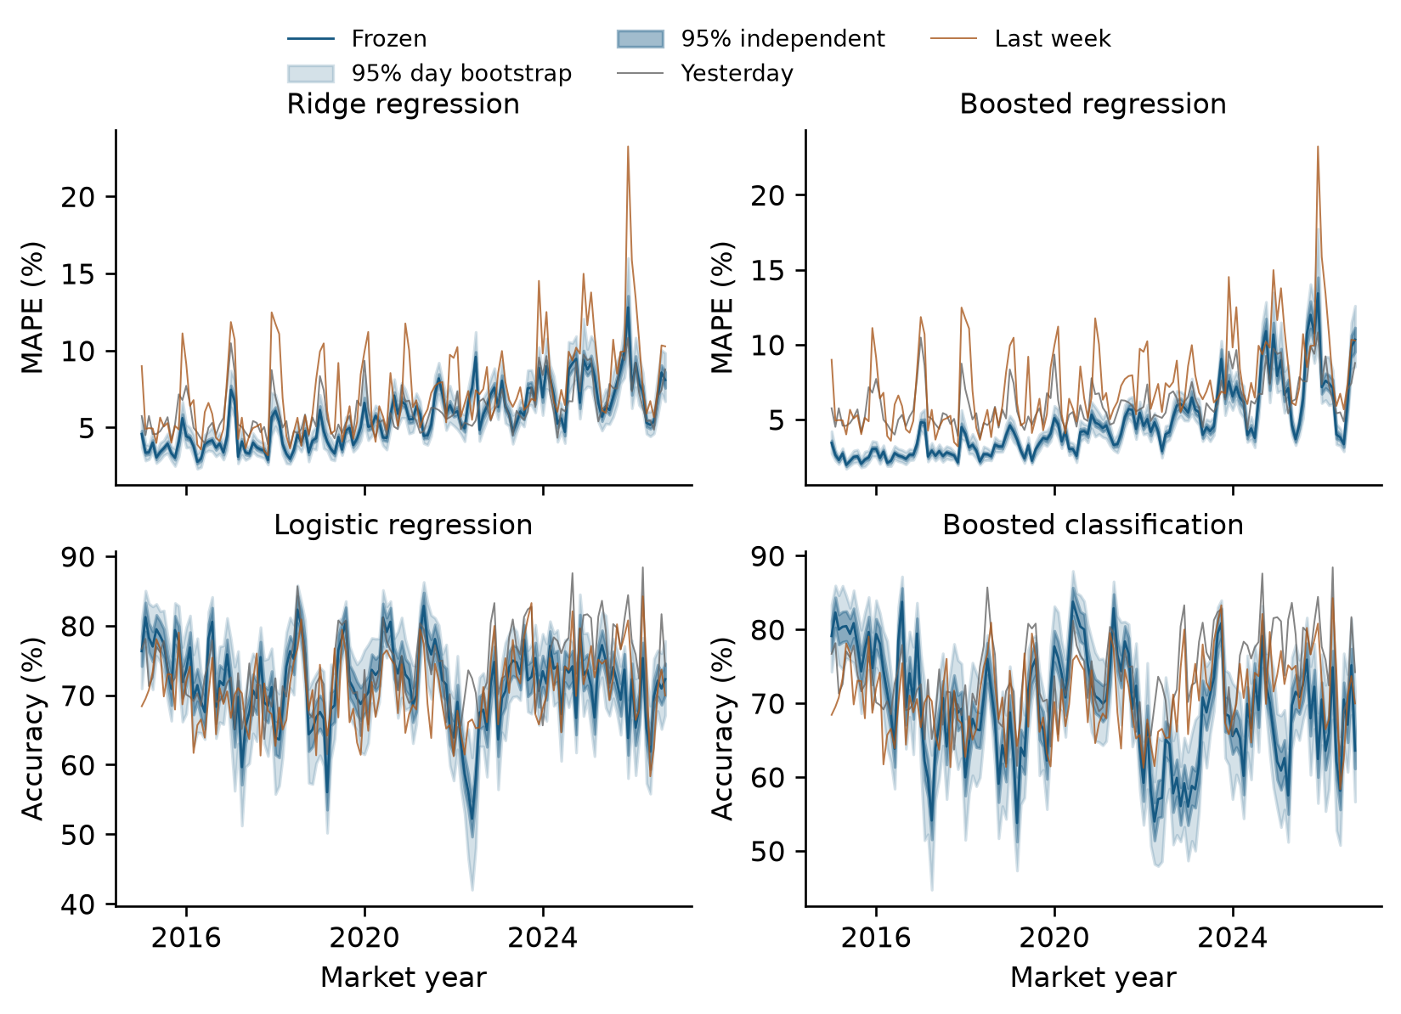
Figure 2. Monthly frozen-model MAPE and price accuracy, January 2015–October 2026. Light bands are 95% whole-day bootstrap intervals; dark bands assume independent half-hours. Both copying baselines are shown. All four families are evaluated without updates.
Frozen boosted classification falls from 78.58% balanced accuracy in 2015 to 68.01% in partial 2026. Over the full simulation, logistic regression has higher balanced accuracy than frozen boosting, 69.68% versus 66.18%; both lose to yesterday at 73.42%. The 2014 winning classifier therefore ages less well than the simpler reference. Changes in prices, class proportions and market relationships are plausible contributors, but average error alone does not establish conditional concept drift.
Across the full simulation, yesterday and last week achieve demand MAPE of 6.15% and 7.42%, with MAE of 470.64 and 569.73 MW. Their price accuracy is 73.81% and 70.81%, and balanced accuracy 73.42% and 70.42%. Monthly curves reveal seasonal variation and abrupt episodes hidden by a single average. Appendix A supplies annual metrics for every frozen family; the main-text adaptation comparison below also reports each simulation year.

4 Results uncertainty of monthly performance
A completed month's observed score is known exactly. Intervals instead describe expected performance under conditions like that month, assuming reasonable within-month stability. For demand, per-half-hour percentage errors have mean MAPE and sample standard deviation s. For price, correctness indicators have mean p. The independent approximations are [1]:
MAPE ± 1.96 s / sqrt(n) and p ± 1.96 sqrt[p(1 - p) / n]
The price formula is on the 0–1 scale and is multiplied by 100 for percentage-point reporting. It assumes independent Bernoulli outcomes with a common probability and uses a normal approximation. A distribution-free Hoeffding accuracy bound is also saved. Neither independent calculation accounts for shared weather or market shocks across intervals.
The alternative draws the month's number of whole days with replacement 1,000 times, preserves each selected day's 48 intervals, and uses the 2.5th and 97.5th percentiles. With equal complete days, resampling daily means is exactly equivalent for these statistics. Both methods are applied to every monthly baseline, frozen model and adapted model.
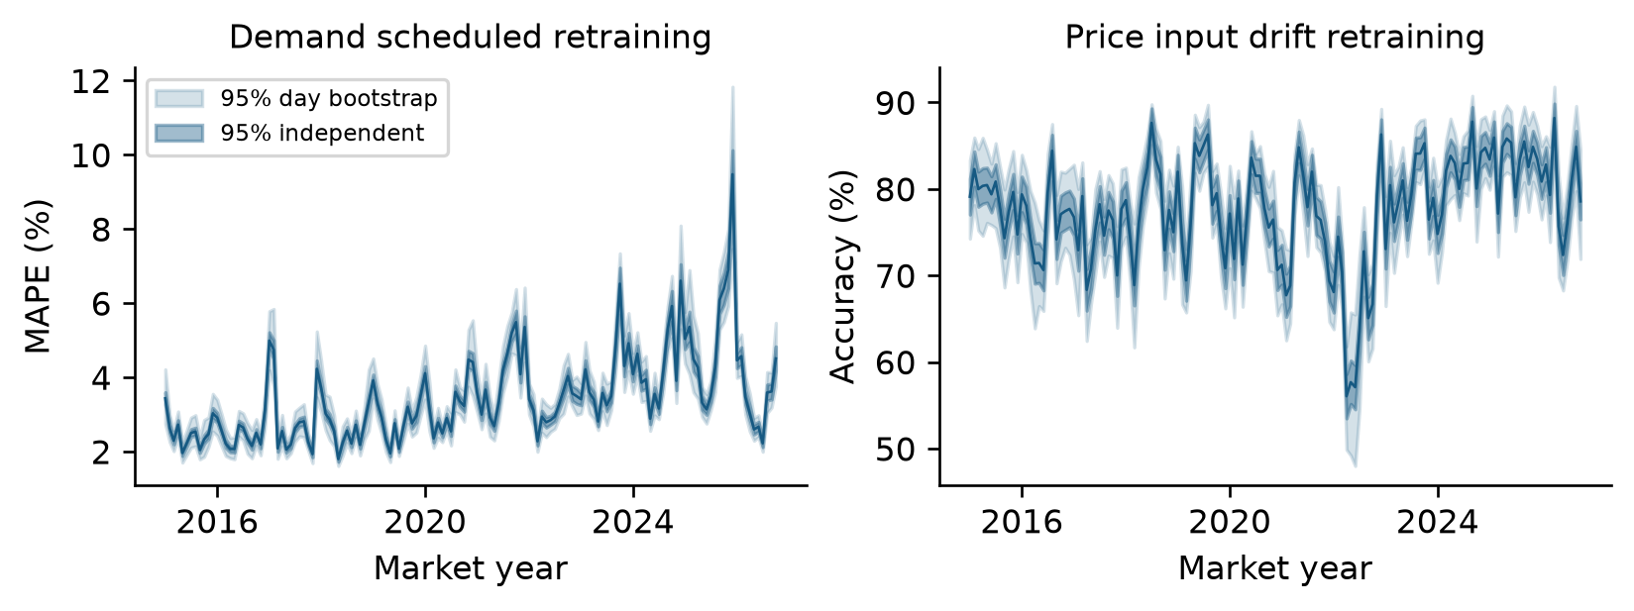
Figure 3. Monthly performance of the selected adaptation policies. Light bands resample whole days; dark bands assume independent half-hours. Scheduled retraining is shown for demand and input-triggered retraining for price. Appendices B and C show other policies with both intervals.
For frozen boosted demand, mean interval width is 0.54 percentage points under independence and 1.51 under day resampling. For frozen boosted price accuracy, widths are 4.66 and 12.05 points. Mean within-month lag-one half-hour loss correlations are 0.919 and 0.623, explaining wider day-bootstrap intervals. Daily lag-one correlations average 0.158 and 0.025: day independence remains approximate, especially during prolonged events. Weekly blocks retain more dependence, but a month supplies only four or five blocks. Overlap of monthly intervals is not a formal test of degradation; a direct interval for a difference is needed.

4 Results online drift detection
The input detector standardizes five daily observations against month-specific 2010–2013 means and standard deviations: NSW demand mean and range, mean asinh(price/100), and Sydney mean temperature and solar radiation. It averages their absolute z-scores, then takes a trailing 28-day mean. The price transform retains negative values while reducing spike dominance. Month matching reduces ordinary seasonal alarms; the reference stays fixed.
The error detector uses daily MAPE for demand and percentage classification error for price. A selected model trained through 2013 supplies out-of-sample 2014 losses. Each loss is centered by its 2014 calendar-month mean and divided by the standard deviation of centered daily losses; the trailing 28-day mean is monitored. Thresholds are the 99th percentiles of 2014 rolling statistics: 1.1546 for inputs, 0.2504 for demand error and 0.2648 for price error. These are empirical calibration rules, not formal 1% false-alarm guarantees.
All detectors require seven consecutive exceedances and a 540-day cooldown. Each observes D only after day end; a triggered replacement first predicts D+1. Error buffers reset after a triggered replacement; references and thresholds remain unchanged. No simulation outcomes choose thresholds. Detectors continue signalling after the six-retrain budget is exhausted.
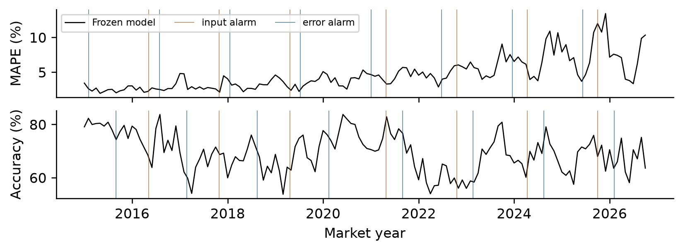
Figure 4. Alarm dates on frozen boosted-model trajectories. Input alarms are shared across tasks; error alarms depend on each task's losses. The cooldown limits repeated signals, so nearby events need not produce separate alarms.
Input alarms occur on 7 May 2016, 29 October 2017, 22 April 2019, 27 April 2021, 19 October 2022, 11 April 2024 and 3 October 2025. Demand error first signals on 3 February 2015; price error first signals on 1 September 2015. In 28-day before/after comparisons of frozen-model input alarms, loss increases at only 3 of 7 dates per task. Changed inputs do not consistently imply worsening average predictions.
Five-minute settlement began on 1 October 2021 [6]; the nearest frozen price-error alarm precedes it by 31 days. The 15 June 2022 market suspension [7] precedes a demand-error alarm by 11 days, whereas the nearest input alarm is 126 days later. These comparisons provide context, not causal attribution. Input shift can move observations into regions a model handles poorly; error can change without a changed conditional relationship. Neither detector alone identifies a change in P(Y | X).

4 Results adaptation and final strategy
Each selected boosted family compares four policies: frozen; scheduled replacements on 1 January of 2016, 2018, 2020, 2022, 2024 and 2026; input-triggered replacements; and error-triggered replacements. Replacements fit the latest 1,095 completed days with fixed 2014 hyperparameters. Fitted preprocessing changes occur on the same replacement occasion. Each nonfrozen policy uses six replacements per task; forecasts always precede observing targets.
Table 4. Full 2015–October 2026 simulation. Nonfrozen policies each use six retrains per task; frozen uses zero. Classification columns refer to price direction.
Policy | MAPE % | MAE MW | Accuracy % | Bal acc %
Frozen | 4.61 | 327.7 | 69.45 | 66.18
Scheduled | 3.41 | 253.4 | 76.97 | 75.99
Input trigger | 3.46 | 255.7 | 77.70 | 76.89
Error trigger | 3.67 | 266.1 | 77.43 | 76.56
On 2015–2024, scheduled demand MAPE is 3.228% versus input-triggered 3.230%, a negligible lead used without retuning. Input-triggered price balanced accuracy is 75.77% versus scheduled 74.75%. Choices remain unchanged after the holdout: selected-policy demand MAPE is 4.40% and price balanced accuracy 81.86% in 2025–October 2026. Table 5 compares annual selected-policy scores with both baselines.
Table 5. Annual selected-policy MAPE and balanced accuracy versus both baselines. Y and W mean yesterday and last week; 2026 ends in October.
Year | Y MAPE % | W MAPE % | Model MAPE % | Y BA % | W BA % | Model BA %
2015 | 5.35 | 5.76 | 2.52 | 74.72 | 72.06 | 78.58
2016 | 5.46 | 5.84 | 2.46 | 69.83 | 67.56 | 73.69
2017 | 5.95 | 6.23 | 2.93 | 68.71 | 68.30 | 72.97
2018 | 5.20 | 6.34 | 2.66 | 72.26 | 69.10 | 77.54
2019 | 5.75 | 6.53 | 2.86 | 71.53 | 69.10 | 77.52
2020 | 5.89 | 7.15 | 3.28 | 72.26 | 69.94 | 75.47
2021 | 5.73 | 7.17 | 4.02 | 72.85 | 69.26 | 74.59
2022 | 5.89 | 7.28 | 3.20 | 70.82 | 67.41 | 67.25
2023 | 6.46 | 7.90 | 4.03 | 76.00 | 73.31 | 79.38
2024 | 7.30 | 9.29 | 4.33 | 76.39 | 72.48 | 81.78
2025 | 8.07 | 10.55 | 5.19 | 79.42 | 75.40 | 83.51
2026 | 6.89 | 9.35 | 3.47 | 73.87 | 70.20 | 79.82
Error-triggered demand exhausts its budget in June 2022 and has 5.79% holdout MAPE versus scheduled 4.40%. Input drift helps price but does not beat scheduled demand retraining. Final models refit on 2 November 2023–31 October 2026, outside the historical budget.

5 Live Week Forecast
For 7–13 December 2026, the forecast is 5.31% demand MAPE and 85.35% price balanced accuracy (Table 6). These are estimates, not measured live results. Each point is the mean of that December week in 2023, 2024 and 2025, using the chosen boosted settings, a preceding 1,095-day fitting window ending 31 October, and frozen parameters throughout the week. This matches the 37-day gap between the last training day and the first live target day.
Table 6. Live-week estimates and empirical scenario ranges, in percent. Ranges are not formal 95% confidence intervals and have no guaranteed future coverage.
Metric | Point estimate | Scenario range
Demand MAPE (%) | 5.31 | 2.19–8.40
Price balanced accuracy (%) | 85.35 | 69.30–92.20
Ranges span all six matching December weeks from 2020–2025 and the central 95% of rolling seven-day holdout scores from 2025–October 2026. Windows crossing a replacement are excluded. Overlapping windows are dependent; older matching weeks reuse development history, and only the 2025 matching week follows strategy selection. This gives a transparent stress range, not calibrated probabilistic coverage.
Table 7. Historical 7–13 December frozen-week checks and marks under the live formula. Models train only through that year's October. Marks exclude runtime penalties.
Year | Model MAPE % | Y MAPE % | Model BA % | Y BA % | Demand marks | Price marks
2020 | 3.42 | 5.68 | 70.42 | 76.26 | 4/5 | 0/5
2021 | 3.19 | 5.90 | 71.28 | 73.28 | 5/5 | 0/5
2022 | 3.98 | 8.78 | 87.50 | 80.40 | 5/5 | 4/5
2023 | 5.26 | 8.13 | 82.78 | 74.13 | 4/5 | 5/5
2024 | 4.93 | 8.44 | 87.33 | 83.25 | 5/5 | 3/5
2025 | 5.73 | 11.14 | 85.93 | 88.53 | 5/5 | 0/5
The 2025 demand improvement is 48.6%, but price balanced accuracy trails yesterday by 2.60 percentage points despite an absolute score of 85.93%. It earns 5/10 under the historical formula. Absolute classifier quality and improvement against a strong baseline are different questions. Six totals range from 4/10 to 9/10, giving no basis to promise full live marks.
Extreme heat, a preceding-day price spike, unusual class proportions or new market conditions could move performance outside the ranges. The same dates fall on different weekdays across years, and only three recent matching weeks determine each point. Weather is treated as known reanalysis, so deployment weather uncertainty is absent. No fitted parameters or persistent state may change during the live week.

6 Discussion
Market lags explain much of the demand advantage. Boosting wins initial selection, but its advantage weakens as demand shapes leave the training reference. Logistic classification ages better when frozen. Adaptation recovers boosted-classifier performance, although December backtests show it can still lose to yesterday.
MAPE compares errors across demand levels; MAE expresses their MW size. Balanced accuracy reveals unequal class recalls; accuracy supports the specified mean-based intervals. Neither measures trading profit, tail risk or calibration. Feature importance and day-type correlations do not establish causes.
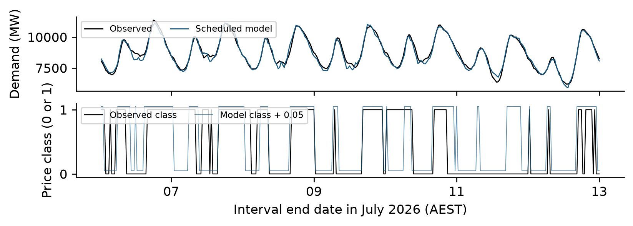
Figure 5. Observed and selected-policy forecasts for 6–12 July 2026. Predicted price class is offset upward by 0.05 only to separate lines. This fixed illustrative week was not selected by best or worst error.
Figure 5 shows remaining interval errors and classification disagreements. Cooldowns and six-retrain budgets make delay consequential. Thresholds use one calibration year; fixed references can repeatedly signal long-term change. More selective triggers or validation of remaining-budget allocation require a new chronological evaluation, not holdout tuning.
Future work should validate window lengths using past data, assess classifier calibration and test forecast-weather sensitivity. Longer blocks and paired intervals need enough independent periods. Operational deployment also needs monitoring, fallbacks and Linux resource-limit testing.
The final package rebuilt byte-identical fitted artifacts locally and passed all 14 days of the supplied ZIP checker. Artifacts total about 1.18 MB; loading and prediction stayed within 60 and 20 seconds. Checker days were in final training, so 2.86% MAPE and 92.9% balanced accuracy are execution checks, not future-generalization evidence. Linux sandbox enforcement has not been tested here.

7 Conclusion
Chronological evaluation supports boosted models with recent-data replacement, scheduled for demand and triggered by input drift for price. Fixed daily-shape clusters reveal structural change; wider day-bootstrap intervals expose dependence hidden by independent half-hour calculations. Input drift helps one task but does not universally determine replacement timing. The historical comparisons, limited retraining budget and genuinely unseen live week must remain distinct.

8 References
[1] UNSW COMP9417. Machine Learning Project Forecasting Electricity Demand and Price Direction under Drift. 26T3 specification, Appendix A, released dataset and project kit, 2026. Market data acknowledged to AEMO; weather data to Open-Meteo, CC BY 4.0.
[2] Scikit-learn developers. Ridge estimator documentation. Version 1.9.1.
https://scikit-learn.org/stable/modules/generated/sklearn.linear_model.Ridge.html
[3] Scikit-learn developers. LogisticRegression estimator documentation. Version 1.9.1.
https://scikit-learn.org/stable/modules/generated/sklearn.linear_model.LogisticRegression.html
[4] LightGBM developers. Parameters and LGBMModel API documentation. Version 4.7.0.
https://lightgbm.readthedocs.io/en/stable/Parameters.html
https://lightgbm.readthedocs.io/en/stable/pythonapi/lightgbm.LGBMModel.html
[5] Scikit-learn developers. PCA, KMeans and silhouette_score documentation. Version 1.9.1.
https://scikit-learn.org/stable/modules/generated/sklearn.decomposition.PCA.html
https://scikit-learn.org/stable/modules/generated/sklearn.cluster.KMeans.html
https://scikit-learn.org/stable/modules/generated/sklearn.metrics.silhouette_score.html
[6] Australian Energy Market Operator. Five Minute Settlement. Commencement on 1 October 2021.
https://www.aemo.com.au/initiatives/major-programs/past-major-programs/five-minute-settlement
[7] Australian Energy Market Operator. AEMO suspends NEM Wholesale Market. 15 June 2022.
https://www.aemo.com.au/newsroom/media-release/aemo-suspends-nem-wholesale-market
Online sources accessed 5 November 2026. Background sources are not training data; numerical experiments use only the released CSV and permitted calendar information.

Appendix A Annual frozen model metrics
These models remain fixed after refitting on 2010–2014. The 2026 rows cover January to October. Tables supplement the main monthly curves and annual selected-policy comparison.
Table A1. Annual frozen regression MAPE (%) and MAE (MW).
Year | Ridge MAPE % | Ridge MAE MW | Boost MAPE % | Boost MAE MW
2015 | 3.80 | 304.8 | 2.52 | 201.8
2016 | 3.83 | 312.1 | 2.63 | 214.6
2017 | 4.28 | 358.4 | 3.14 | 259.0
2018 | 4.20 | 340.9 | 3.10 | 251.1
2019 | 4.40 | 356.3 | 3.43 | 275.8
2020 | 5.71 | 435.3 | 4.05 | 310.6
2021 | 6.04 | 442.8 | 4.55 | 331.9
2022 | 6.49 | 490.1 | 4.73 | 339.4
2023 | 6.60 | 469.4 | 5.84 | 394.0
2024 | 7.52 | 526.6 | 6.97 | 448.7
2025 | 8.12 | 557.0 | 8.07 | 495.1
2026 | 7.12 | 498.8 | 6.67 | 427.5
Table A2. Annual frozen classification accuracy and balanced accuracy, both in percent.
Year | Logistic acc % | Logistic BA % | Boost acc % | Boost BA %
2015 | 76.82 | 76.93 | 78.84 | 78.58
2016 | 72.90 | 70.91 | 74.29 | 70.20
2017 | 68.63 | 63.58 | 65.83 | 59.72
2018 | 71.36 | 65.64 | 66.42 | 58.97
2019 | 70.33 | 64.17 | 66.88 | 60.00
2020 | 74.79 | 71.59 | 76.72 | 74.55
2021 | 74.08 | 71.88 | 73.35 | 70.39
2022 | 63.97 | 62.98 | 59.56 | 58.23
2023 | 72.45 | 71.76 | 68.07 | 65.89
2024 | 73.19 | 72.03 | 68.69 | 64.99
2025 | 71.95 | 71.61 | 67.21 | 65.31
2026 | 69.39 | 69.68 | 67.16 | 68.01

Appendix B Monthly adapted demand uncertainty
Each panel evaluates the selected regression family with a different policy. Intervals use the two main-text procedures; uncertainty does not remove strategy-selection bias.
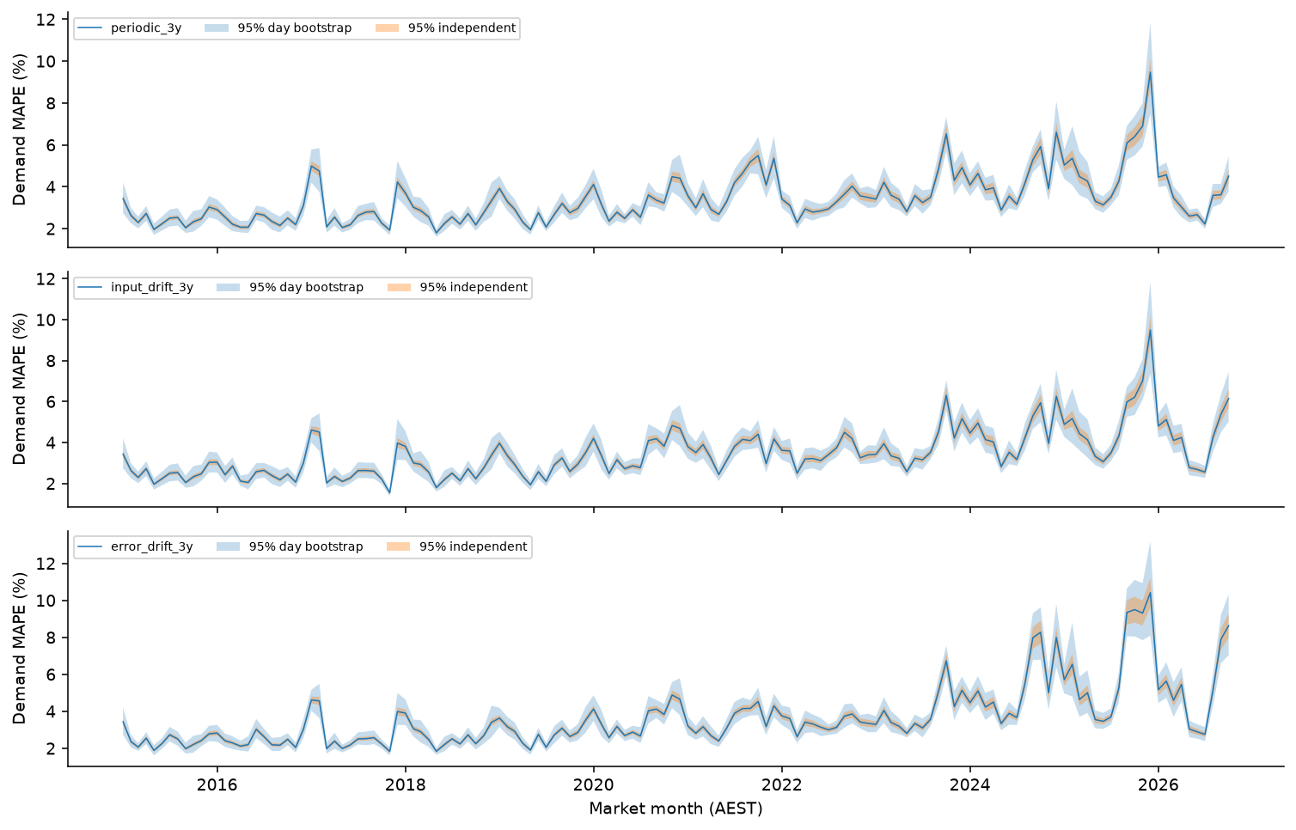
Figure B1. Monthly demand MAPE under scheduled, input-triggered and error-triggered replacement, with independent half-hour and whole-day bootstrap 95% intervals. Each policy uses at most six replacements.
The complete monthly and yearly values, including MAE, are in stage2_period_metrics.csv. Retraining dates, cutoffs and effective days are in retraining_log.csv. Error-triggered demand spends its budget earlier than the schedule, leaving a long period without further fitted updates.

Appendix C Monthly adapted price uncertainty
Panels show accuracy for compatibility with the specified mean-based intervals. Balanced accuracy remains the selection and live-evaluation metric and is reported separately.
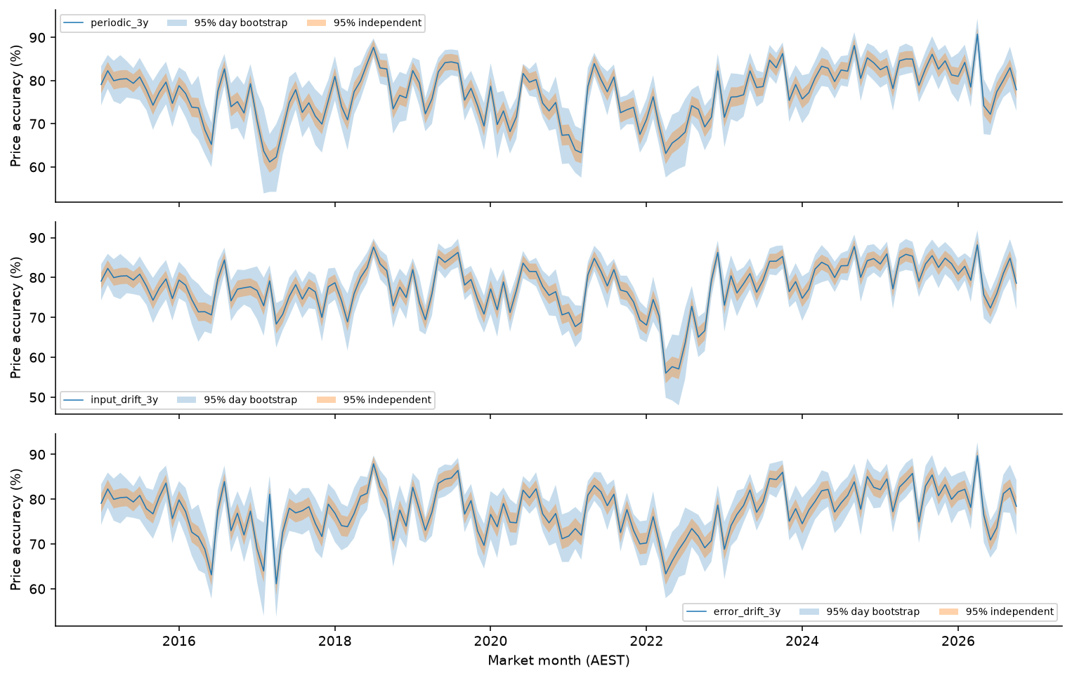
Figure C1. Monthly price accuracy under scheduled, input-triggered and error-triggered replacement. Shading compares independent half-hour and whole-day bootstrap 95% intervals. Thresholds are calibrated before 2015.
Reproduction uses Python 3.11 and exact requirements.txt versions. run_all.py reruns the analysis, final training, exact-artifact reproduction and original ZIP checker. Inference shares the training feature function, uses only the last 14 days of supplied history and permitted next-day weather, and never changes fitted parameters. No external market or weather records enter training, tuning or features.

Appendix D Annual adaptation metrics
F denotes frozen, S scheduled, I input-triggered and E error-triggered. MAPE and classification scores are percentages; MAE is MW. The 2026 rows end in October.
Table D1. Annual demand metrics for each replacement policy.
Year | F MAPE % | F MAE MW | S MAPE % | S MAE MW | I MAPE % | I MAE MW | E MAPE % | E MAE MW
2015 | 2.52 | 201.79 | 2.52 | 201.79 | 2.52 | 201.79 | 2.43 | 195.74
2016 | 2.63 | 214.61 | 2.46 | 200.97 | 2.49 | 202.32 | 2.45 | 201.15
2017 | 3.14 | 259.02 | 2.93 | 245.93 | 2.78 | 232.13 | 2.77 | 231.14
2018 | 3.10 | 251.10 | 2.66 | 216.06 | 2.67 | 216.20 | 2.68 | 217.45
2019 | 3.43 | 275.79 | 2.86 | 230.58 | 2.86 | 230.71 | 2.79 | 224.70
2020 | 4.05 | 310.59 | 3.28 | 253.40 | 3.60 | 274.64 | 3.58 | 272.95
2021 | 4.55 | 331.89 | 4.02 | 294.33 | 3.64 | 269.02 | 3.47 | 257.55
2022 | 4.73 | 339.37 | 3.20 | 235.45 | 3.47 | 254.42 | 3.36 | 246.66
2023 | 5.84 | 393.96 | 4.03 | 278.62 | 3.89 | 269.93 | 4.00 | 275.90
2024 | 6.97 | 448.70 | 4.33 | 297.73 | 4.40 | 301.88 | 5.33 | 351.44
2025 | 8.07 | 495.13 | 5.19 | 337.66 | 5.13 | 335.38 | 6.36 | 396.54
2026 | 6.67 | 427.47 | 3.47 | 247.42 | 4.20 | 284.42 | 5.11 | 332.46
Table D2. Annual price accuracy and balanced accuracy for each policy.
Year | F Acc % | F BA % | S Acc % | S BA % | I Acc % | I BA % | E Acc % | E BA %
2015 | 78.84 | 78.58 | 78.84 | 78.58 | 78.84 | 78.58 | 79.71 | 79.51
2016 | 74.29 | 70.20 | 74.89 | 71.28 | 76.34 | 73.69 | 74.53 | 70.59
2017 | 65.83 | 59.72 | 70.37 | 65.66 | 74.84 | 72.97 | 73.73 | 70.61
2018 | 66.42 | 58.97 | 78.91 | 77.74 | 78.22 | 77.54 | 78.08 | 75.69
2019 | 66.88 | 60.00 | 78.49 | 76.92 | 78.76 | 77.52 | 79.08 | 77.48
2020 | 76.72 | 74.55 | 74.43 | 74.44 | 76.95 | 75.47 | 76.94 | 75.76
2021 | 73.35 | 70.39 | 73.64 | 73.61 | 75.98 | 74.59 | 76.34 | 75.21
2022 | 59.56 | 58.23 | 70.88 | 70.09 | 68.10 | 67.25 | 70.79 | 70.02
2023 | 68.07 | 65.89 | 79.08 | 78.44 | 79.47 | 79.38 | 78.76 | 78.62
2024 | 68.69 | 64.99 | 81.85 | 82.02 | 81.97 | 81.78 | 80.18 | 80.78
2025 | 67.21 | 65.31 | 82.89 | 83.17 | 83.40 | 83.51 | 81.93 | 82.40
2026 | 67.16 | 68.01 | 79.87 | 79.95 | 79.92 | 79.82 | 79.45 | 79.26

