A

Project SRS Report

On

**ONLINE HOTEL BOOKING STSTEM**

Developed by

**GOHIL KAPIL S.(CE049) - Department of CE, DD University**

**CHUDASAMA AKSHAYRAJSINH (CE007)- Department of CE, DD University**

**Guided By:**

**Prof. Ankit P. Vaishnav**



**Department of Computer Engineering**

**Faculty of Technology, Dharmsinh Desai University**

**College Road, Nadiad-387001**

**INDEX**

**1.INTRODUCTION………………………………………………………………………………………………………………. 1**

1.1 PURPOSE.................................................................................................................. 1

1.2 INTENDED AUDIENCE..………………………………………………………………………………………… 1

1.3 PROJECT SCOPE.…………………………………………………………………………………………….……. 1

1.4 DEFINITIONS AND ACRONYMS……………………………………………………………………….……. 2

1.5 REFRENCES…………………………………………………………………………………………………….……. 2

**2.OVERALL DISCRIPTION....................................................................................................... 3**

2.1 PRODUCT PERSPECTIVE………………………………………………………………………………….……. 3

2.2 PRODUCT FUNCTIONS…………..……………………………………………………………………….……. 3

2.3 USER CLASSES AND CHARACTERISTICS.………………………………………………………….……. 4

2.4 OPERATING ENVIRONMENT….……………………………………………………………………….……. 5

2.5 DESIGN AND IMPLEMENTATION CONSTRAINTS.…………………………………………….……. 5

2.6 ASSUMPTIONS AND DEPENDENCIES..…………………………………………………………….……. 5

2.7 USECASE DIAGRAM………………………….…………………………………………………………….……. 6

2.8 E-R DIAGRAM…………………………………..…………………………………………………………….……. 7

**3. EXTERNAL INTERFACE REQUIREMENTS............................................................................. 8**

3.1 USER INTERFACES……………..….……………………………………………………………………….……. 8

3.2 HARDWARE INTERFACES…..….……………………………………………………………………….……. 8

3.3 SOFTWARE INTERFACES……….….…………………………………………………………………….……. 8

3.4 COMMUNICATION INTERFACES.…………………………………………………………………….……. 8

**4. SYSTEM FEATURES….......................................................................................................... 9**

4.1 FUNCTIONAL REQUIRENMENTS.…………………………………………………………………….….…. 9

R.2 : MANAGING ROOM DETAILS..……………………………………………………………………….….…. 9

R.3: REGISTRATION………………….….……………………………………………………………………….….…. 9

R.4 : LOGIN………………………………….……………………………………………………………………….….…. 10

R.5 : VIEW THE ROOM DETAILS.….……………………………………………………………………….….…. 10

R.6 : ROOM BOOKING……………..….……………………………………………………………………….….…. 11

**5. OTHER NONFUNCTIONAL REQUIREMENTS......................................................................... 12**

5.1 PERFORMANCE REQUIREMENTS…………………………………………………………………….….…. 12

5.2 SAFETY REQUIREMENTS………..……………………………………………………………………….….…. 12

5.3 SOFTWARE QUALITY ATTRIBUTES.………………………………………………………………….….…. 12

5.4 GOAL OF IMPLIMENTATION.….……………………………………………………………………….….…. 13

**1. INTRODUCTION:**

**1.1 PURPOSE:**

* The software should be useful for the hotel manager to manage the hotel in online mode and also for the growing business.
* The purpose of the online hotel booking system is to allow the customers to self book the hotel rooms.
* The software should be used for securely storing and managing the data.
* Through the help of the software the customer can do emergency booking.
* This software saves the time from both sides(Hotel and Customer side).

**1.2 INTENDED AUDIENCE :**

* This system is intended for providing room facility in online mode so that the peoples having the online banking or online payment options can do booking in online mode.

**1.3 PROJECT SCOPE:**

* The online hotel booking system project is intended for the online reservation of the rooms.
* It will be able to do various operation of the hotel booking automatic and in online mode like bill generation, room availability, data management etc.
* There are two user levels in hotel booking system: Customer, and Hotel Manager
* This software is consist of the booking management system and DBMS server.
* Customer will be able to check for room’s availability, select the rooms, and pay for the room.
* Manager will able to update room information such as cost and category.
* Hotel booking system is able to resolve the drawbacks of the reservation of room in offline mode.
* In future updates, software should be able to perform more tasks automatically like financial report generation, growth chart of the system, no of customers visited, shows the regular customer etc.

**1.4 DEFINITIONS AND ACRONYMS:**

|  |  |
| --- | --- |
| SRS | Software Requirement Specifications |
| HBS | Hotel Booking System |
| DBMS | Database Management System |
| FR | Functional Requirements |
| NFR | Non-Functional Requirements |

**1.5 REFRENCES:**

(1)7th_ed_software_engineering_a_practitioners_approach_by_roger_s._pressman.

(2) Fundamentals of Software Engineering by Rajib Mall, PHI Learning (3)<https://www.researchgate.net/publication/275097517_documentation_of_online_booking_system>

(4)<https://www.academia.edu/34451441/software_requirements_specification_for_hotel_reservation_software_requirements_specification_for_hotel_reservation>

**2.OVERALL DISCRIPTION**

**2.1 PRODUCT PERSPECTIVE:**

* The “Online Hotel Booking System” is a web application used for the book the room using internet via website.
* There manual method for the room booking has so many constrain and issues like more time Consumption, delay in processing , maintaining data(requires all the records of booking ,recourses etc.. Are maintained in books)etc..
* Hence sometime it is very difficult to book the room in emergency situation
* The purpose of this project is to develop and implement an online hotel booking system for hotels, that will replace the manual method of booking for hotel rooms.
* We are creating application that will used for the processing the online room booking.
* With the help of this web application hotel manager should be able to maintain the hotel with less time and also maintain and store data of the customer and hotel in proper manner without any time consuming process.

**2.2 PRODUCT FUNCTIONS:**

* Registration
* log in
* display the available rooms
* Book a room
* Update Room Details
* Manage Booking Details
* Generate bill
* Store the details of the user in database

**2.3 USER CLASSES AND CHARACTERISTICS:**

There are 2 user classes in our Hotel Booking System:

1.Admin

2.Customer

**1.Admin:**

* Admin have every access to the hotel system.
* Admin is responsible for managing hotel resources and staffs.
* Admin can view information report such as customer information, booking information, and room information.

**2.Customers:**

* Customers are vital part of the system.
* Customer have access to view the vacant room information and price range.
* They should be able to confirm the booking and cancel it if necessary.
* Other than this customer can do the following actions:
* Registration
* Login
* Search room availability
* See the price of rooms and room details
* Booking
* Logout

**2.4 OPERATING ENVIRONMENT:**

* The online hotel booking system is web application so it will operate in all browsers like Google, Chrome, Microsoft Edge, Firefox etc.
* Operating environment for this system will be hosted virtually using any cloud service provider.

**2.5 DESIGN AND IMPLEMENTATION CONSTRAINTS:**

* Internet connection is a constraint for this system because system is available from cloud therefore customer needs to have good network connection to connect to our web interface.

**2.6 ASSUMPTIONS AND DEPENDENCIES:**

* It is assumed that system will be developed using .net framework with My SQL database will work perfectly.
* If incase of any difficulties, SRS should be flexible enough to change accordingly.

**2.7 USE-CASE DIAGRAM :**

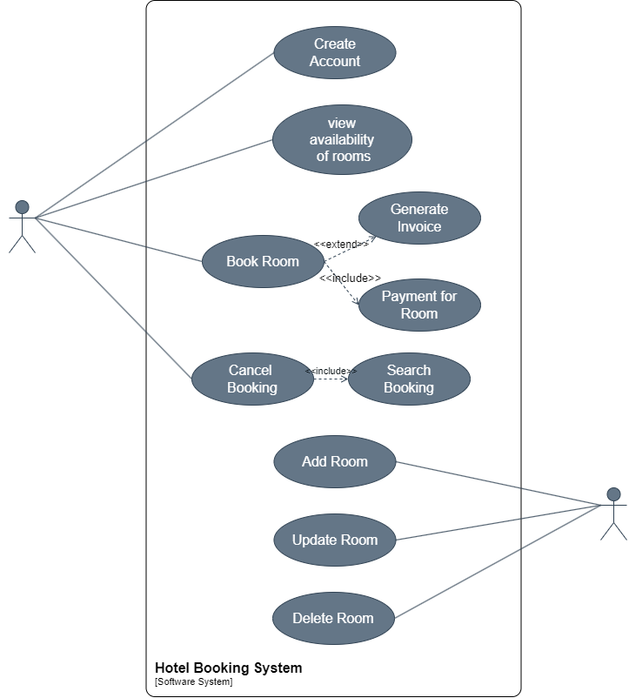

**2.8 E-R DIAGRAM :**

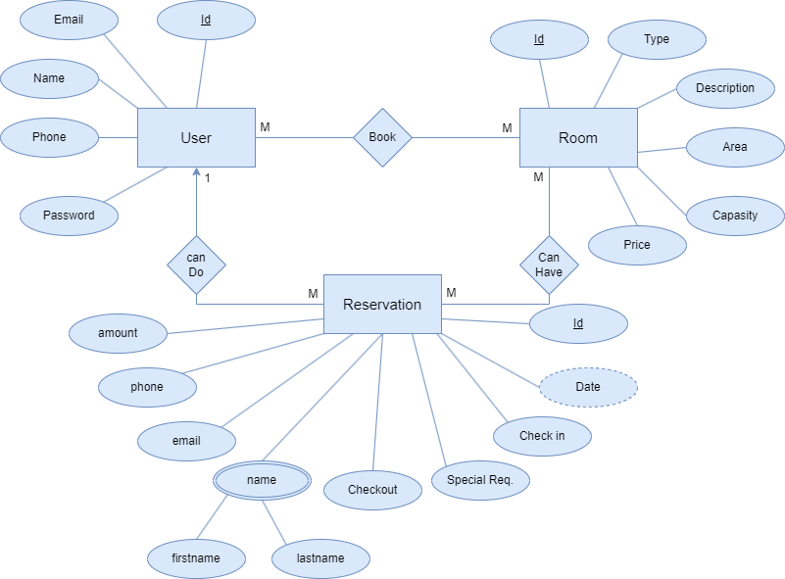

**3. EXTERNAL INTERFACE REQUIREMENTS**

**3.1 USER INTERFACES:**

* The user interface for system shall be compatible to any type of web browser such as Mozilla Firefox, Google Chrome, and Internet Explorer.

**3.2 HARDWARE INTERFACES:**

* **Server side:**
* Monitor :resolution of 1024*768 or above
* Processor: intel or AMD 2GHZ
* Ram: 4 GB or above
* Disk space: 10GB or above
* **Client side:**
* Monitor :resolution of 1024*768 or above
* Processor: intel or AMD 1GHZ
* Ram : 512 MB or above
* Disk space: 2GB or above

**3.3 SOFTWARE INTERFACES:**

* Front end technologies : HTML,CSS,JAVASCRIPT
* Back end language : c#
* Development Tool : Visual Studio 2022
* Database server : MySQL

**3.4 COMMUNICATION INTERFACES:**

* The System shall be using HTTP/HTTPS Or TCP/IP for communication over Internet

**4. SYSTEM FEATURES**

**4.1 FUNCTIONAL REQUIRENMENTS:**

* Our system has following general requirements:

R.1 : MANAGING ROOM DETAILS

R.2: REGISTRATION :

R.3 : LOGIN :

R.4 : VIEW THE ROOM DETAILS:

R.5 : ROOM BOOKING

**R.1 : MANAGING ROOM DETAILS**

R.2.1 : View available rooms

Input : select view room details option

Output : rooms are displayed

R.2.2 : Update room details

Input : New details for room provided

Output : changes made will be affected in room details

**R.2: REGISTRATION :**

Description : Users can register themselves

R.3.1 : Select register option

Input : Register option selected

Output : User will be asked to enter Full Name, Phone Number, Email, Gender, password and confirm password

R.3.2 : Provide details for registration

Input : details provided

Output : User will be registered

Processing : If user has not already registered then registration process will be done.

**R.3 : LOGIN :**

Description : User and admin can login to the system

R.4.1 : Select login option

Input : Login option selected

Output : User or Admin will be asked to enter username and password

Processing : If user has already registered him/herself then only he/she will be logged in to the system

**R.4 : VIEW THE ROOM DETAILS:**

Description : User can check the details about every room before booking

R.6.1 : Select book now option

Input : view rooms option selected

Output : shows the details about rooms

R.6.2 : Select particular room to view the facilities

Input : room selected

Output : details of the room displayed

**R.5 : ROOM BOOKING**

Description : user can book room and make payment

R.7.1 : Select the room

Input : room selected

Output : User prompted to provide details

R.7.2 : Provide the details

Input : Details provided

Output : User prompted with payment option

R.7.3 : Select payment option.

Input : Payment option selected.

Output : requested method will be provided to pay the bill

R.7.4 : bill generation

Input : select bill generate option

Output : Bill will be generated

**5. OTHER NONFUNCTIONAL REQUIREMENTS**

**5.1 PERFORMANCE REQUIREMENTS**

**NF1.**Results for cross checking of availability of rooms in internal database and customer’s choice shall be in 5 seconds.

**NF2.**Web page UI load time should within 3 seconds.

**NF3.**Redirection page load time should be within 3 seconds.

**NF4.**Data in database should be updated within 3 seconds.

**NF5.**Data in database should be updated within 2 seconds

**5.2 SAFETY REQUIREMENTS**

**NF6.** Customer’s personal details shall be encrypted.

**5.3 SOFTWARE QUALITY ATTRIBUTES**

* **Correctness:** This system should satisfy the normal regular Hotel Management operations precisely to fulfil the end user objectives
* **Efficiency:** Enough resources to be implemented to achieve the particular task efficiently without any hassle.
* **Flexibility:** System should be flexible enough to provide space to add new features and to handle them conveniently.
* **Integrity:** System should focus on securing the customer information and avoid data losses as much as possible
* **Portability:** The system should run in any Microsoft windows environment.
* **Maintainability:** The system should be maintainable.
* **Testability**: The system should be able to be tested to confirm the performance and clients specifications.

**5.5 GOAL OF IMPLIMENTATION**

In the future we are implementing the following function into our system.

* Alert and notification
* Multiple payment gateway
* Guest history
* Easy retrieved and storage of data and information
* Daily count of guest that arrive and departure from hotel
* Daily weekly and monthly calculation of guest booked, arrived and departed from hotel
* Improved data management efficiency