Fee Management System

Project Proposal & Module Documentation
Developed by: Kapil
Date: September 2025

Table of Contents
- 1. Introduction
- 2. Developer Introduction
- 3. Features / Modules Overview
- 4. Technology Stack
- 5. Benefits for Client
- 6. Detailed Module Documentation
- 6.1 Admin Account Management
- 6.2 Student Fee Management Module
- 6.3 Teacher Salary Management Module
- 6.4 Utility Functions
- 9. Future Scope
- 10. Glossary
- Screenshots & Prototype Explanation

1. Introduction
The Fee Management System is designed to digitalize and automate the process of managing student fees and teacher salary in schools and colleges. The system provides separate modules for administrators, students, and teachers, ensuring smooth operation and record-keeping.

2. Developer Introduction
This project is developed by Kapil Verma. As a passionate software developer, I focus on building practical solutions using Java Swing for GUI and SQLite for database management. The aim of this project is to deliver an efficient, user-friendly, and reliable application.

3. Features / Modules Overview
- Admin Account Management (Registration, Login, Logout)
- Student Fee Management (Dashboard, Add/Edit/Delete, Fee Deposit, Receipts, View History, Promote Student)
- Teacher Salary Management (Dashboard, Add/Edit/Delete, Pay Salary, Salary History)
- Utility Functions (Number-to-Words Conversion, Automatic ID Generation)

4. Technology Stack
- Frontend: Java Swing (GUI)
- Backend: Java JDBC
- Database: SQLite (Lightweight, Portable, Serverless)
- IDE: NetBeans / IntelliJ IDEA / Eclipse

5. Benefits for Client
- Improved accuracy in fee and salary records
- Automated report generation
- User-friendly graphical interface
- Secure login and user management
- Scalable and easy to maintain

6. Detailed Module Documentation

5.1 Admin Account Management
- Admin Registration: Allows a new administrator to create an account using a school code, email, and password.
- Admin Login: Provides secure access to the dashboard using email and password.
Logout: Securely ends the session.

5.2 Student Fee Management Module
- View Student Dashboard: Summary of total students, fees collected, and dues.
- Add New Student: Enter student details (Name, Parents' Names, Class, Fees).
- Edit/Delete Student: Update or remove student records.
- Search Student: Find a student by Name or ID.
- Fee Deposit & Receipt: Record payments and auto-generate receipts.
- Payment History: View complete history of transactions.
- Promote Student: Archive old records and move student to next class.
- View Pending Fees List: Track unpaid fees.

5.3 Teacher Salary Management Module
- View Teacher Dashboard: Summary of total teachers and salary details.
- Add/Edit/Delete Teacher: Manage teacher profiles.
- Pay Salary: Record salary payments.
- View Salary History: Complete salary transactions per teacher.

5.4 Utility Functions
- Number to Words Conversion: Converts numeric amounts to words for receipts.
- Automatic ID Generation: Auto-generates IDs for students (S001, S002) and teachers (TID001, TID002).

. Future Scope
- Integration with online payment gateways (UPI, Cards).
- Automated email/SMS notifications for fee reminders.
- Cloud support for remote multi-branch access.
- Role-based access (Admin, Accountant, Teacher).

10. Glossary
- SQLite: Lightweight, serverless database used in this project.
- Receipt: Official confirmation document for payment.

6. Screenshots & Prototype Explanation
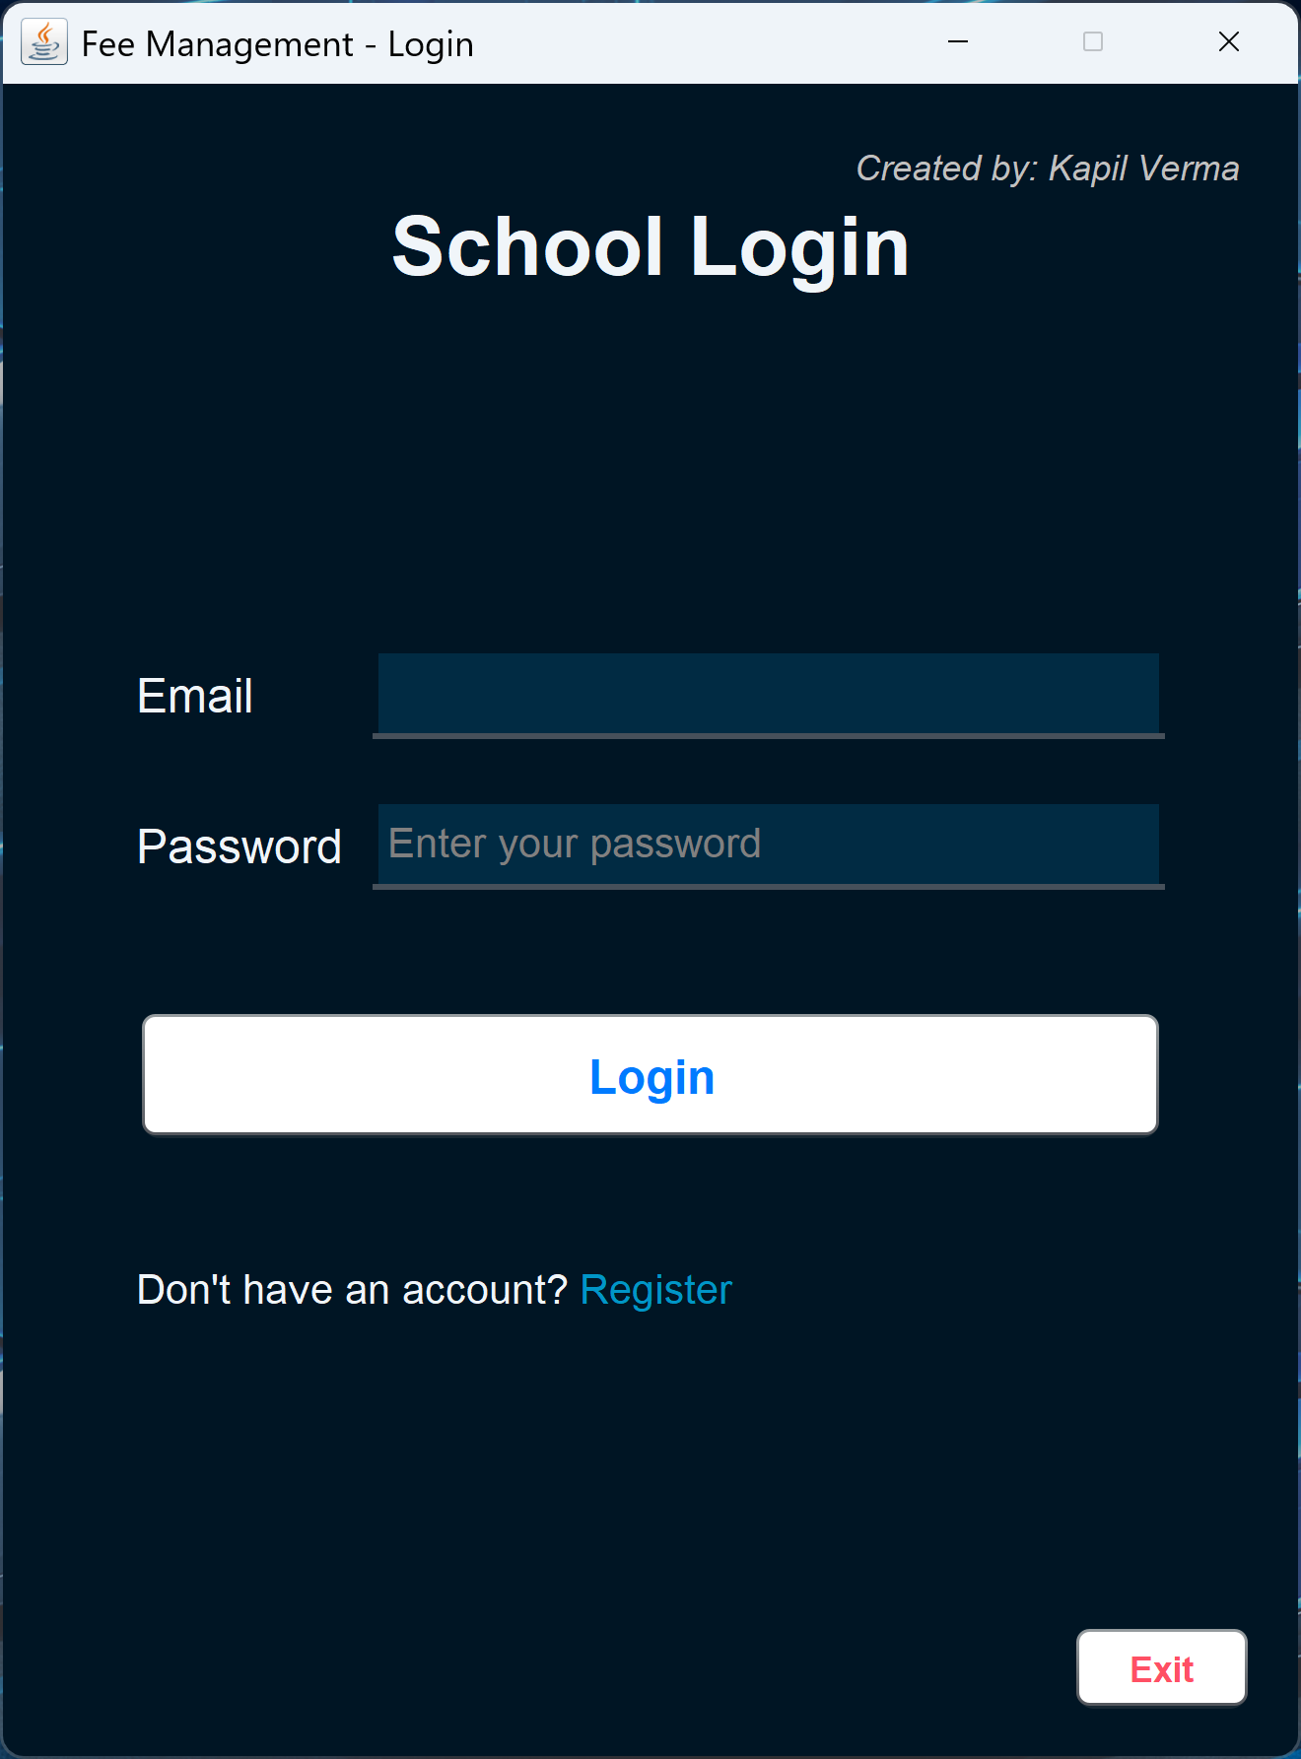
This is School Login Windows
This is School Management Dashboard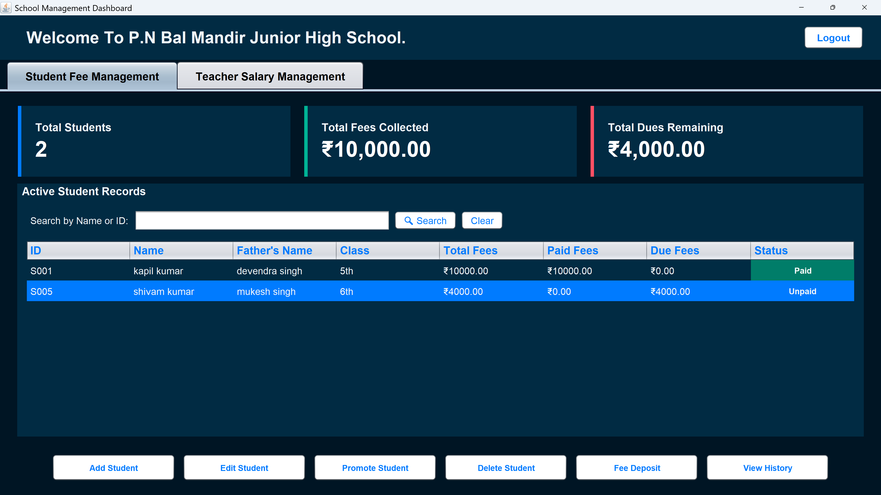

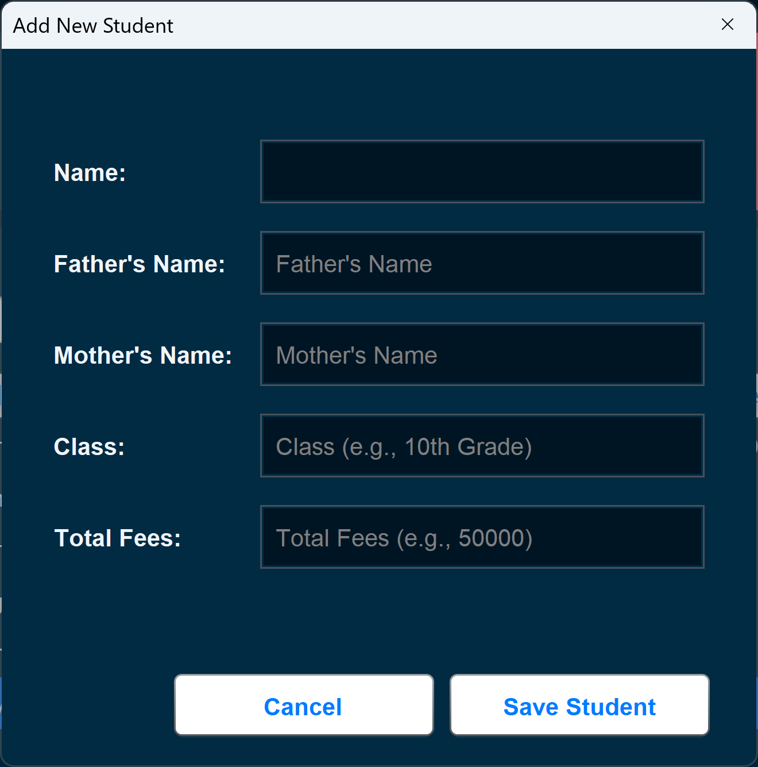
This is Student Fee Entry Screen

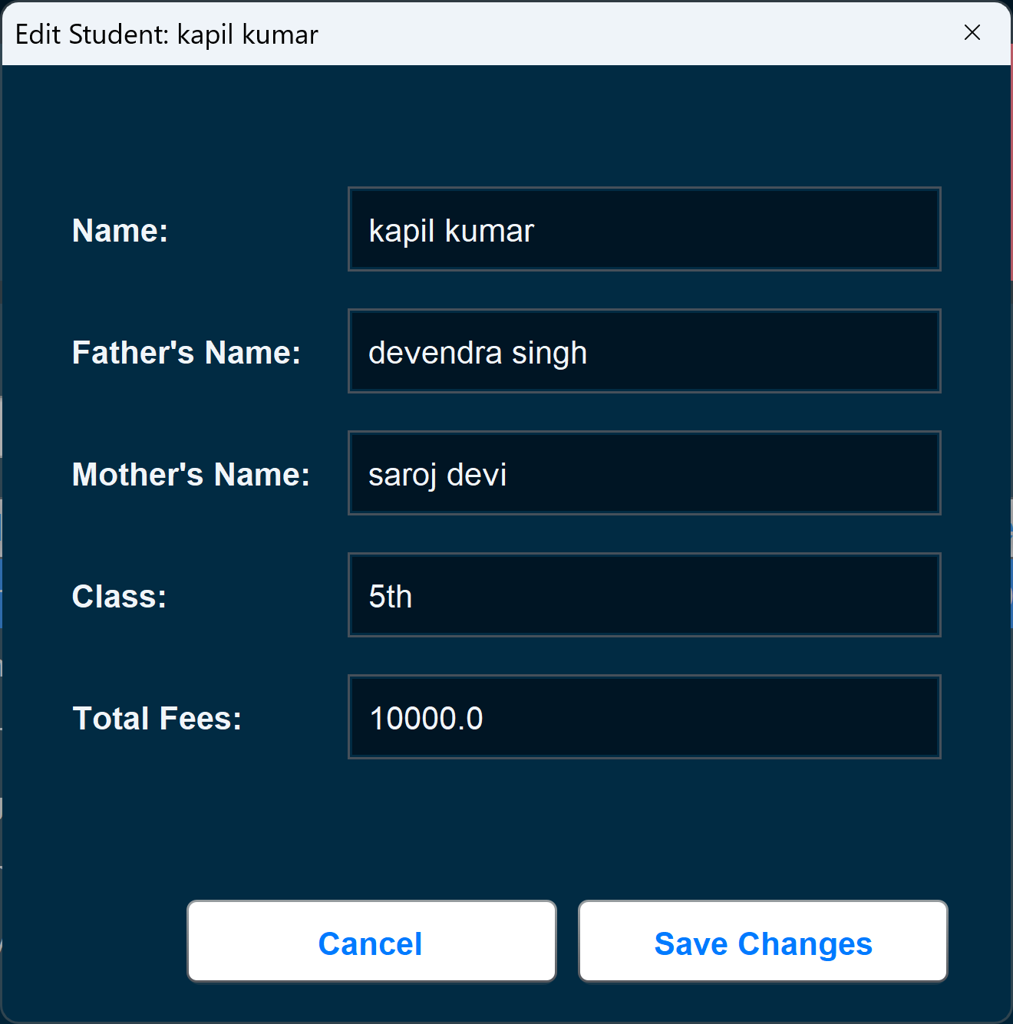
This is Edit Student Information Screen

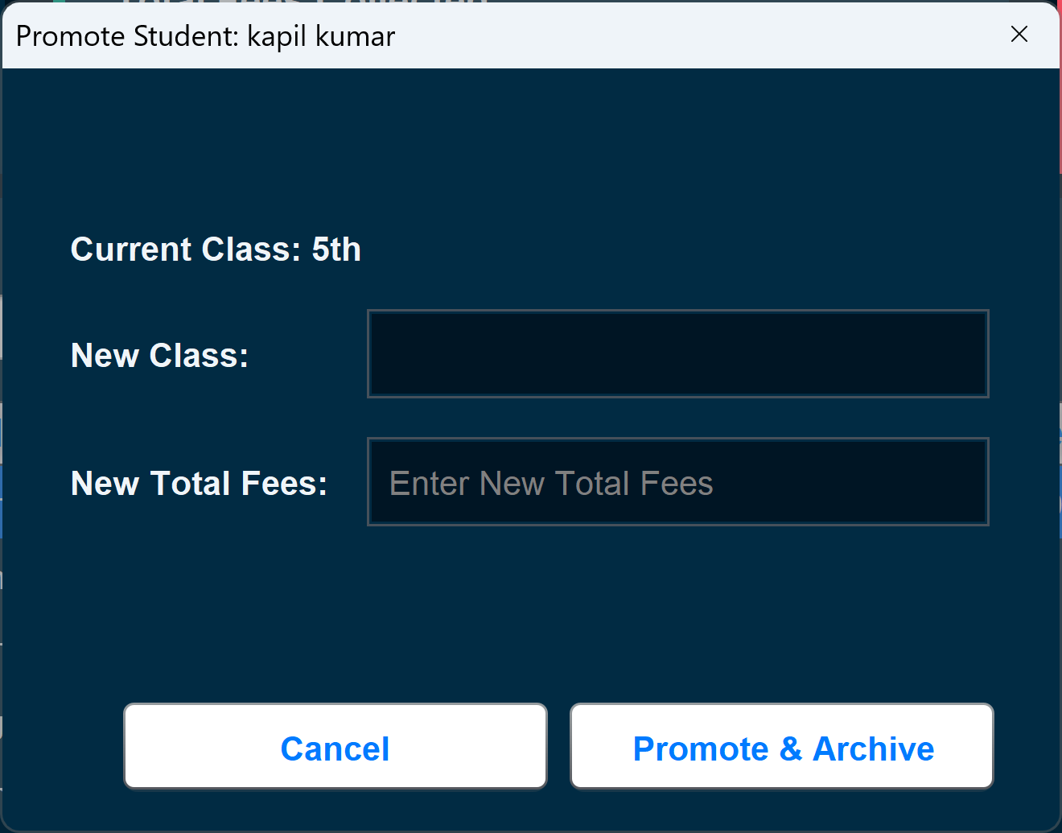
This is Promote Student Screen – Used to move a student to the next class,

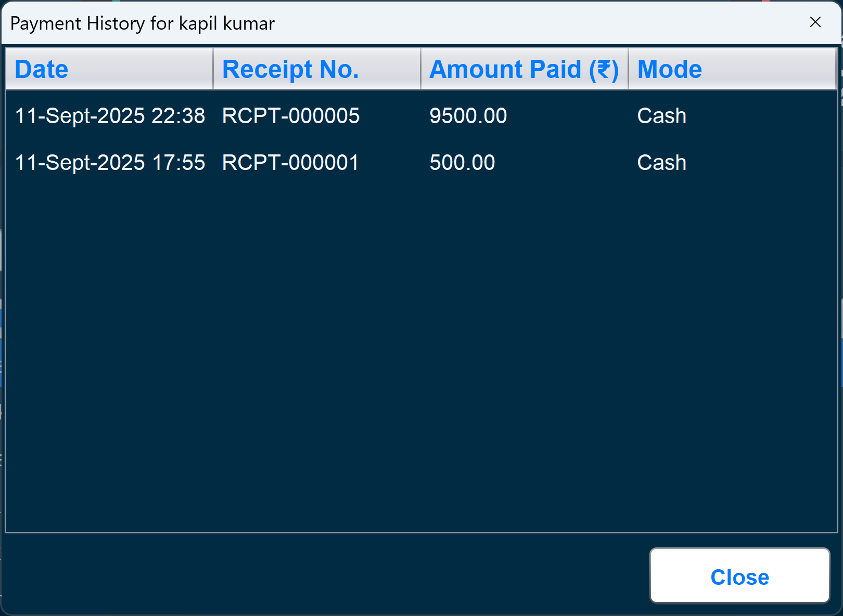
Payment History Module – Shows all past transactions of a student.

