**Department of Computer Science and Engineering**

**Graphic Era deemed to be University, DEHRADUN**



**Project Requirement and Specification**

**On**

**AGE AND GENDER PREDECTION**

**(CSE VI Semester Mini project)**

**2021-2022**

**Submitted to:**  **Submitted by :** Mr. Arun Chauhan Kapish Pandoh

Roll. No.: 2014702

CSE-DS & AI-VI-Sem

**CONTEXT:**

This project has been done as part of my course for B. Tech at GRAPHIC ERA UNIVERSITY, DEHRADUN.

**MOTIVATIONS:**

Deep Learning has found huge applications in the fields of Computer vision. Some of the most important applications of computer vision are in the fields that deal with facial data. Face Detection and recognition are being widely used in security-based applications

The motivation behind this is to build an application for age and gender classification using a model that is suitable for real life predictions. Many models are focusing on datasets with constrained faces and are not suitable for in-the-wild estimation. In this we will focus on deep learning end-to-end methods.

**OBJECTIVE:**

The main objective of this project is to develop methods for detecting age and gender using images.

Age and gender prediction has become one of the more recognized fields in deep learning, due to the increased rate of image uploads on the internet in today’s data driven world. Humans are inherently good at determining one’s gender, recognizing each other and making judgements about ethnicity but age estimation still remains a formidable problem

**CHALLENGE:**

Age and gender information are very important for various real world applications, such as social understanding, biometrics, identity verification, video surveillance, human-computer interaction, electronic customer, crowd behavior analysis, online advertisement, item recommendation, and many more. Despite their huge applications, being able to automatically predicting age and gender from face images is a very hard problem, mainly due to the various sources of intra-class variations on the facial images of people, which makes the use of these models in real world applications limited.

**REQUIREMENT OF PROJECT:**

* Software Requirements :

Any Python IDE (Jupyter Notebook ,Google Colab ,Spider)

* Environment and Tools :

Numpy

Pandas

Tensorflow

Keras

Matplotlib

Sklearn

* Dataset :

# UTKFace

<https://www.kaggle.com/datasets/jangedoo/utkface-new>

**METHODOLOGY:**

Deep learning is a subset of machine learning, which is essentially a neural network with three or more layers. These neural networks attempt to simulate the behavior of the human brain—albeit far from matching its ability—allowing it to “learn” from large amounts of data. While a neural network with a single layer can still make approximate predictions, additional hidden layers can help to optimize and refine for accuracy.

Deep learning drives many artificial intelligence (AI) applications and services that improve automation, performing analytical and physical tasks without human intervention.

Deep learning technology lies behind everyday products and services (such as digital assistants, voice-enabled TV remotes, and credit card fraud detection) as well as emerging technologies (such as self-driving cars).

I have used CNN in my project which is a Deep Learning Algorithm.

**ALGORITHM USED : Convolutional Neural Networks** **(CNN)**

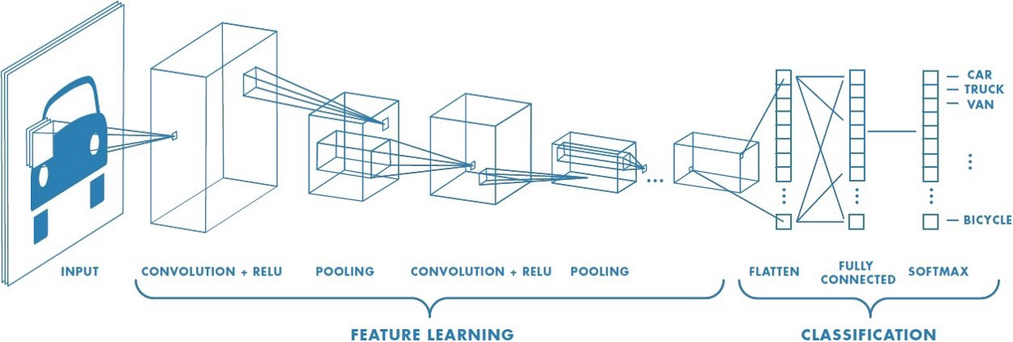

A Convolutional Neural Network (ConvNet/CNN) is a Deep Learning algorithm which can take in an input image, assign importance (learnable weights and biases) to various aspects/objects in the image and be able to differentiate one from the other. The pre-processing required in a ConvNet is much lower as compared to other classification algorithms. While in primitive methods filters are hand-engineered, with enough training, ConvNets have the ability to learn these filters/characteristics.

Convolutional neural networks are distinguished from other neural networks by their superior performance with image, speech, or audio signal inputs. They have three main types of layers, which are:

* Convolutional layer
* Pooling layer
* Fully-connected (FC) layer

### ***Convolutional Layer:***

*The convolutional layer is the core building block of a CNN, and it is where the majority of computation occurs. It requires a few components, which are input data, a filter, and a feature map*

### ***Pooling Layer*:**

### *Pooling layers, also known as downsampling, conducts dimensionality reduction, reducing the number of parameters in the input. Similar to the convolutional layer, the pooling operation sweeps a filter across the entire input, but the difference is that this filter does not have any weights. Instead, the kernel applies an aggregation function to the values within the receptive field, populating the output array. There are two main types of pooling:*

* ***Max pooling:****As the filter moves across the input, it selects the pixel with the maximum value to send to the output array. As an aside, this approach tends to be used more often compared to average pooling.*
* ***Average pooling:****As the filter moves across the input, it calculates the average value within the receptive field to send to the output array.*

### ***Fully-Connected Layer:***

*The name of the full-connected layer aptly describes itself. As mentioned earlier, the pixel values of the input image are not directly connected to the output layer in partially connected layers. However, in the fully-connected layer, each node in the output layer connects directly to a node in the previous layer.*

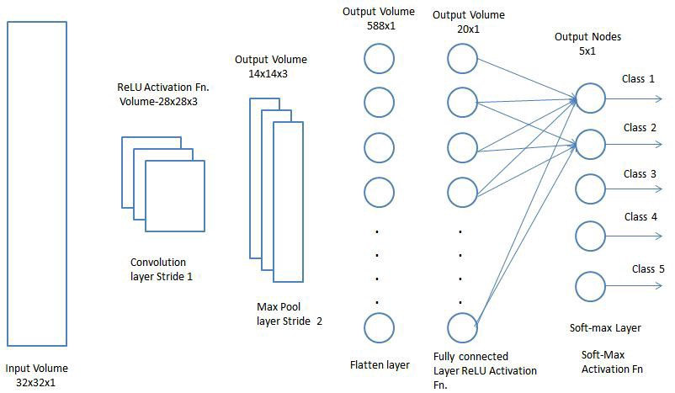

**SOURCE CODE:**

[**https://github.com/KapishPandoh/Mini-Project/tree/main/Sem_06**](https://github.com/KapishPandoh/Mini-Project/tree/main/Sem_06)

**CONCLUSION:**

We have seen how to predict gender and sex from a facial image. We trained and tested the proposed model on the UTKFace dataset consisting a large variety of faces from different ages, genders and ethnicities. Through experimental studies, we show that the prediction accuracy of the model for both age and gender prediction tasks .We also showed that providing the prediction of the gender model as one of the input signal for the age-prediction branch, can improve the accuracy of predicted age values. Through visualization of the attention maps of the trained model, we show that the model learned to focus on the most salient part of the face, useful for predicting age and gender.

**REFERENCE:**

* For dataset: [*https://www.kaggle.com/datasets/jangedoo/utkface-new*](https://www.kaggle.com/datasets/jangedoo/utkface-new)
* For resolving errors:[*https://stackoverflow.com/*](https://stackoverflow.com/)
* For Understanding the topics :[*www.google.com*](http://www.google.com/) *,* [*www.youtube.com*](http://www.youtube.com/) *,* [*www.medium.com*](http://www.medium.com/) *,* [*https://docs.python.org*](https://docs.python.org/)