Правки:
Лабораторная работа N1

Распечатка файла even-odd.cpp

#include "mlisp.h"

double dd = 29;
double mm = 4;
double yyyy = 1999;

double even__bits(double n);
double odd__bits(double n);
double display__bin(double n);
double report__results(double n);

double even__bits(double n){
return (n == 0 ? 1
: (remainder(n, 2) == 0 ?
even__bits(quotient(n, 2))
: odd__bits(quotient(n, 2))));
}

double odd__bits(double n){
return (n == 0 ? 0
: remainder(n, 2) == 0 ?
odd__bits(quotient(n, 2))
: true ? even__bits(quotient(n, 2))
: _infinity);
}

double display__bin(double n){
display(remainder(n, 2));
return n == 0 ? 0 : display__bin(quotient(n, 2));
}

double report__results(double n){
display("Happy birthday to you!\n\t");
display(n); display(" (decimal)\n\t");
display__bin(n); display("(reversed binary)\n");
display("\teven?\t"); display(even__bits(n) == 1 ? "yes" : "no");
newline();
display("\todd?\t"); display(odd__bits(n) == 1 ? "yes" : "no");
newline();
return 0;
}

int main(){
display(report__results(dd * 1000000 +
mm * 10000 +
yyyy));
newline();

std::cin.get();
return 0;
}

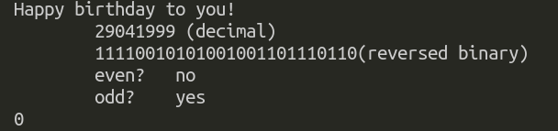
Скриншот запуска на C++

Скриншот запуска на Лиспе

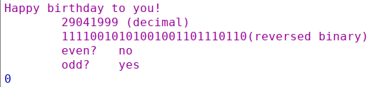

Лабораторная работа N2

Распечатка файла golden-section.cpp
#include "mlisp.h"

double a = 0;
double b = 2;
double eps = 0.00001;
double mphi = 0;
double xmin = 0;

double fun(double x);
double golden__section__search(double a, double b);
double golden__start(double a, double b);
double __KAV__try(double a, double b, double xa, double ya, double xb, double yb);

double fun(double x){
x = x - double(109) / 110 / e;
return 5 * expt(log(expt(atan(x - 2), 2)), 4) - x - 7;
}

double golden__section__search(double a, double b){
{
double xmin = a < b ? golden__start(a, b) : golden__start(b, a);
newline();
return xmin;
}
}

double golden__start(double a, double b){
mphi = 0.5 * (3 - sqrt(5));
{
double xa = a + mphi * (b - a);
double xb = b - mphi * (b - a);
return __KAV__try(a, b, xa, fun(xa), xb, fun(xb));
}
}

double __KAV__try(double a, double b, double xa, double ya, double xb, double yb){
return (abs(a - b) < eps ? (a + b) * 0.5
: (true ?
(display("+"), ya < yb ?
b = xb,
xb = xa,
yb = ya,
xa = a + mphi * (b - a),
__KAV__try(a, b, xa, fun(xa), xb, yb)
: (a = xa,
xa = xb,
ya = yb,
xb = b - mphi * (b - a),
__KAV__try(a, b, xa, ya, xb, fun(xb))))
: _infinity));
}

int main(){
xmin = golden__section__search(a, b);
display("interval=\t[");
display(a);
display(" , ");
display(b);
display("]\n");
display("xmin=\t\t");
display(xmin); newline();
display("f(xmin)=\t");
display(fun(xmin)); newline();
std::cin.get();
return 0;
}

Распечатка файла golden-section.ss
;golden-section
(define a 0)(define b 2)
(define z 0)
(define (fun x)
(set! x (- x (/ 109 110 e)))
(set! z x)
(- (* 5 (expt (log (expt (atan (- z 2)) 2)) 4)) z 7)
; 5*ln^4(arctg^2(z-2)) - z - 7
)
(define eps 0.00001)
(define (golden-section-search a b)
(let(
(xmin(if(< a b)(golden-start a b)(golden-start b a )))
)
(newline)
xmin
)
)
(define (golden-start a b)
(set! mphi(* 0.5(- 3(sqrt 5))))
(let(
(xa (+ a (* mphi(- b a))))
(xb (- b (* mphi(- b a))))
)
(try a b xa (fun xa) xb (fun xb))
)
)
(define mphi 0)
(define (try a b xa ya xb yb)
(cond((<(abs (- a b))eps) (* (+ a b)0.5))
(#t (display "+")
(cond((< ya yb)(set! b xb)
(set! xb xa)
(set! yb ya)
(set! xa (+ a (* mphi(- b a))))
(try a b xa (fun xa) xb yb)
)
(else (set! a xa)
(set! xa xb)
(set! ya yb)
(set! xb (- b (* mphi(- b a))))
(try a b xa ya xb (fun xb))
)
)
)
)
)
(define xmin 0)
(set! xmin(golden-section-search a b))
(display"interval=\t[")
(display a)
(display" , ")
(display b)
(display"]\n")
(display"xmin=\t\t")
xmin
(display"f(xmin)=\t")
(fun xmin)

Скриншот запуска на C++

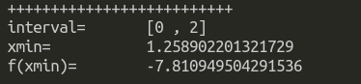
Скриншот запуска на Лиспе
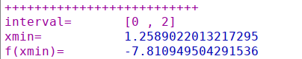
Лабораторная работа N3

Распечатка файла coin19.cpp
//coin19.cpp 2019
#include "mlisp.h"

double VARIANT = 9;
double LAST__DIGIT__OF__GROUP__NUMBER = 8; //6,8
double LARGEST__COIN = 20;

bool implication_Q(bool x_Q, bool y_Q);
double cc(double amount, double largest__coin);
double count__change(double amount);
double next__coin(double coin);
double GR__AMOUNT();

bool implication_Q(bool x_Q, bool y_Q){
return !(x_Q && !y_Q);
}

double cc(double amount, double largest__coin){
return ((amount == 0 || largest__coin == 1) ? 1
: implication_Q(amount >= 0, largest__coin == 0) ? 0
: (cc(amount, next__coin(largest__coin)) +
cc(amount - largest__coin, largest__coin)));
}

double count__change(double amount){
return cc(amount, LARGEST__COIN);
}

double next__coin(double coin){
return (coin == 20 ? 15
: coin == 15 ? 10
: coin == 10 ? 5
: coin == 5 ? 3
: coin == 3 ? 2
: 1);
}

double GR__AMOUNT(){
return remainder(100 * LAST__DIGIT__OF__GROUP__NUMBER + VARIANT, 137);
}

int main(){
display(" KAV variant ");
display(VARIANT); newline();
display(" 1-2-3-5-10-15-20"); newline();
display("count__change for 100 \t= ");
display(count__change(100)); newline();
display("count__change for ");
display(GR__AMOUNT());
display(" \t= ");
display(count__change(GR__AMOUNT())); newline();

std::cin.get();
return 0;
}

Распечатка файла coin19.ss
(define VARIANT 9)
(define LAST-DIGIT-OF-GROUP-NUMBER 8)
(define LARGEST-COIN 20)

(define (implication? x? y?) (not (and x? (not y?))))

(define (cc amount largest-coin) (cond
((or (= amount 0) (= largest-coin 1)) 1)
((implication? (>= amount 0) (= largest-coin 0)) 0)
(else (+ (cc amount (next-coin largest-coin))
(cc (- amount largest-coin) largest-coin))) )
)

(define (count-change amount) (cc amount LARGEST-COIN))

(define (next-coin coin) (cond ((= coin 20) 15)
((= coin 15) 10)
((= coin 10) 5)
((= coin 5) 3)
((= coin 3) 2)
(else 1) )
)

(define (GR-AMOUNT) (remainder (+ (* 100 LAST-DIGIT-OF-GROUP-NUMBER) VARIANT) 137))

(display " KAV variant ")
(display VARIANT) (newline)
(display " 1-2-3-5-10-15-20") (newline)
(display "count__change for 100 \t= ")
(display (count-change 100)) (newline)
(display "count__change for ");
(display (GR-AMOUNT))
(display " \t= ")
(display (count-change (GR-AMOUNT)))(newline)

Скриншот запуска на C++

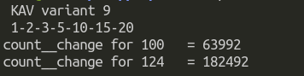

Скриншот запуска на Лиспе
