SoftUni Forum Workshop – Part 2
This application is created as a workshop for the Angular Couse @ Software University

Task Requirements
So far, we have created one dynamic page which lists all themes sorted by two different criteria. The next step is to implement few more pages and route between them. You will be provided with HTML and CSS skeleton for all other additional pages that you must create. There is one catch, half of these pages require authentication. You must create some properties or services that fake this authentication. Because we don’t know yet how to manipulate forms properly or the real case with the authentication and authorization. We will fix that later when we have the knowledge to do so.

Logged in navigation bar
When the "user" is "logged in", they should see the following navigations:
The mini nav-bar includes:
- [Username's profile] a-tag should refer to the profile page ("localhost:4200/profile ")
- [Logout] a-tag should refer to ("localhost:4200/logout")
The nav-bar below the logo of the SoftUni forum includes:
- [Home] a-tag should refer to the home page ("localhost:4200/home")
- [Themes] a-tag should refer to the "page with all themes" ("localhost:4200/themes")
- [New Theme] a-tag should refer to the "create theme" ("localhost:4200/add-theme")
Use the isLoggedIn signal from AuthService to conditionally display navigation options for logged-in users. Bind navigation visibility to the signal, so it updates reactively based on login state.


Not logged in navigation bar
When the user is "not logged in" he should see the following navigations:
The mini nav-bar includes:
- [Login] a-tag should refer to the home page ("localhost:4200/login ")
- [Register] a-tag should refer to ("localhost:4200/register")


Home page (Not Logged in)
This is the home page ("localhost:4200/home"). This is a welcome user page. The welcome component that we have already can be reused here. All "users" can access this page no matter of their authentication. The not logged in user view:
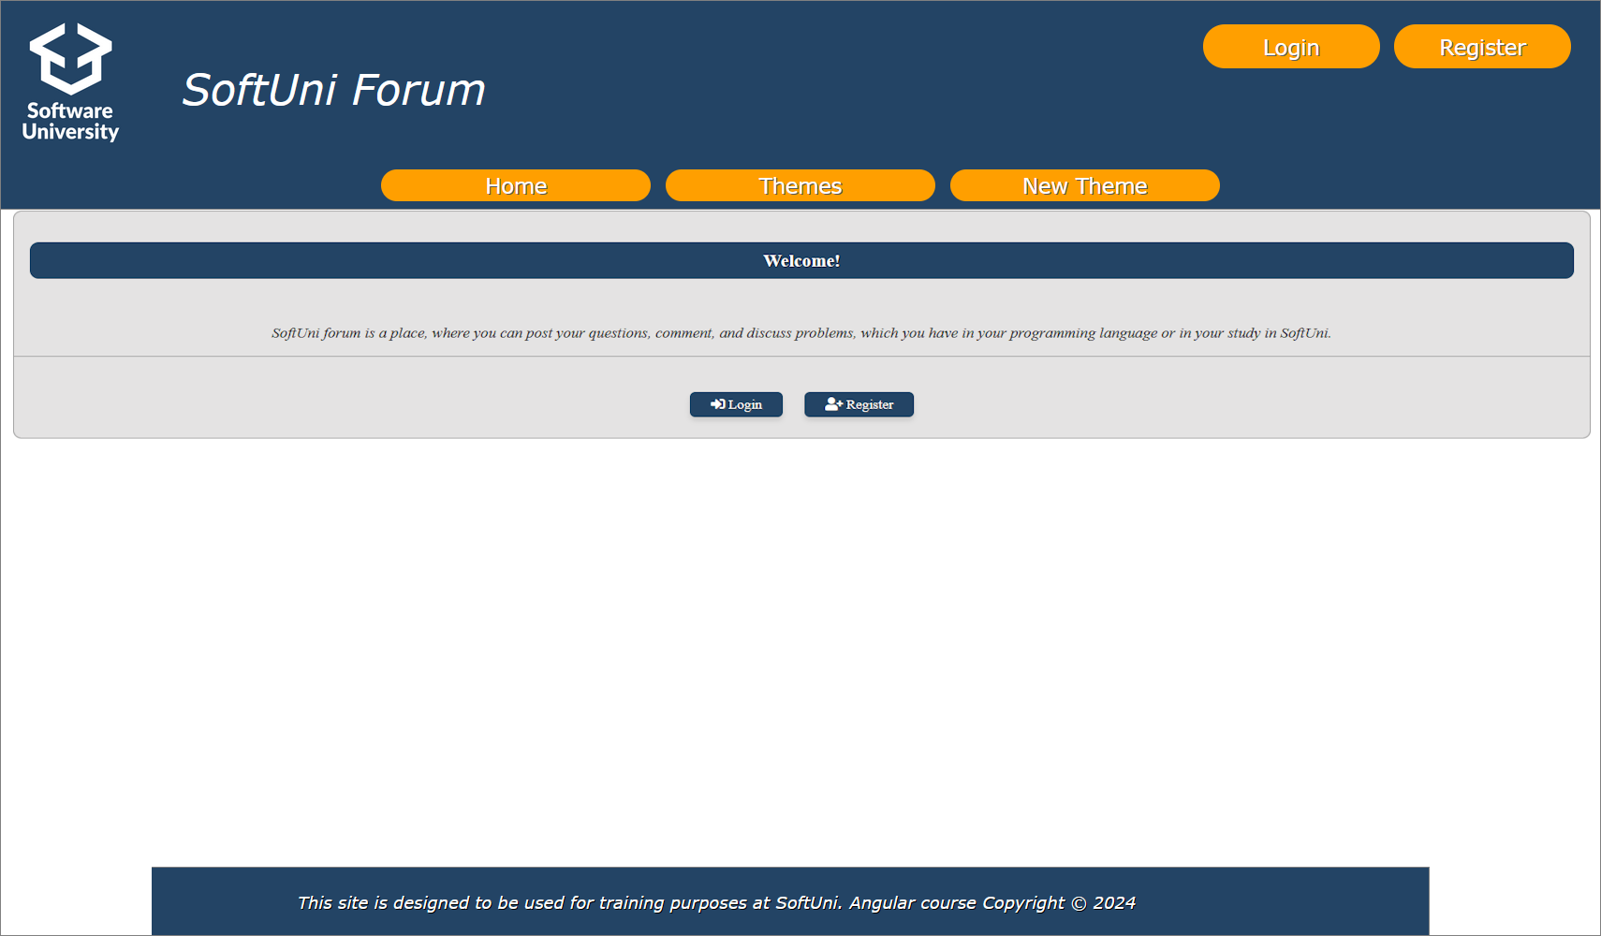

Home page (Logged in)
The logged in user view:
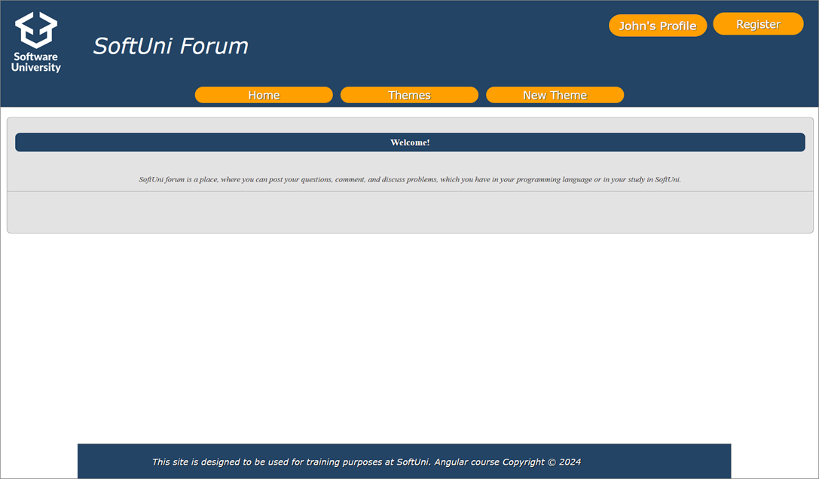

Register (Not Logged in)
This is the register page ("localhost:4200/register"). Use signals in AuthService to manage the isLoggedIn state reactively. For now, we don't have a database with user registration. So, make sure each registered user is stored in userService or some other appropriate place.
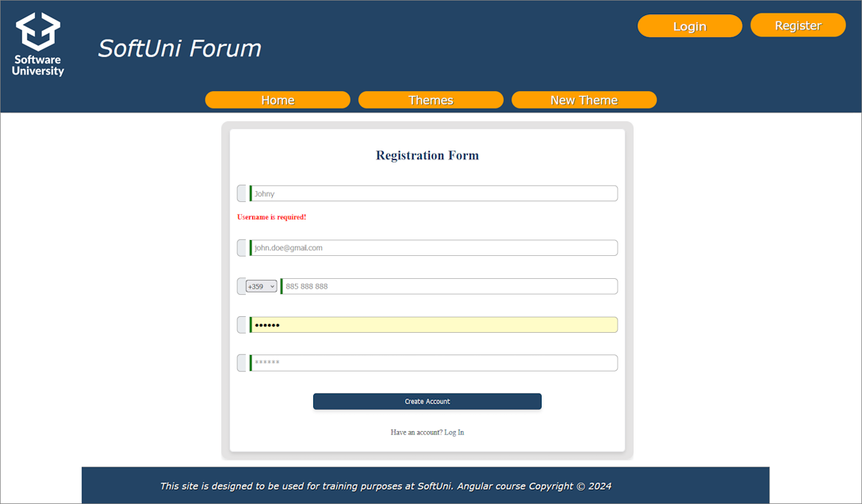

Login (Not Logged in)
This is the login page ("localhost:4200/login"). This will be another point of your app to use signals in AuthService to manage the isLoggedIn state reactively. For now, we don't have a database with user registration. So, make sure each registered user is stored in userService or some other appropriate place. Each of them can log in successfully.
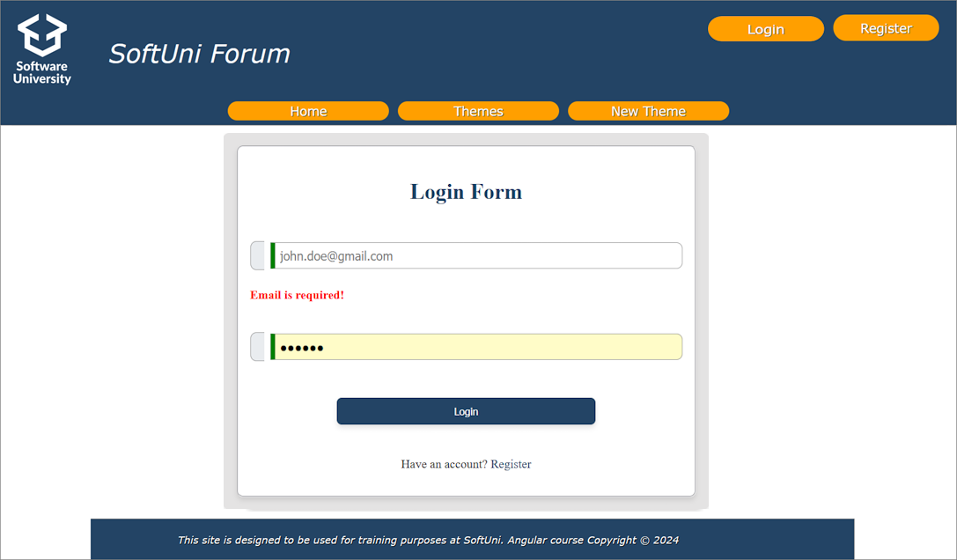

Themes page (Not Logged in)
This is the themes page ("localhost:4200/themes "). This is the page we already have. All "users" can access this page no matter of their authentication. By clicking the title of a theme, you will be redirect to the theme content view. It is described below. There are several differences between the logged and anonymous user. The anonymous user should see the following:
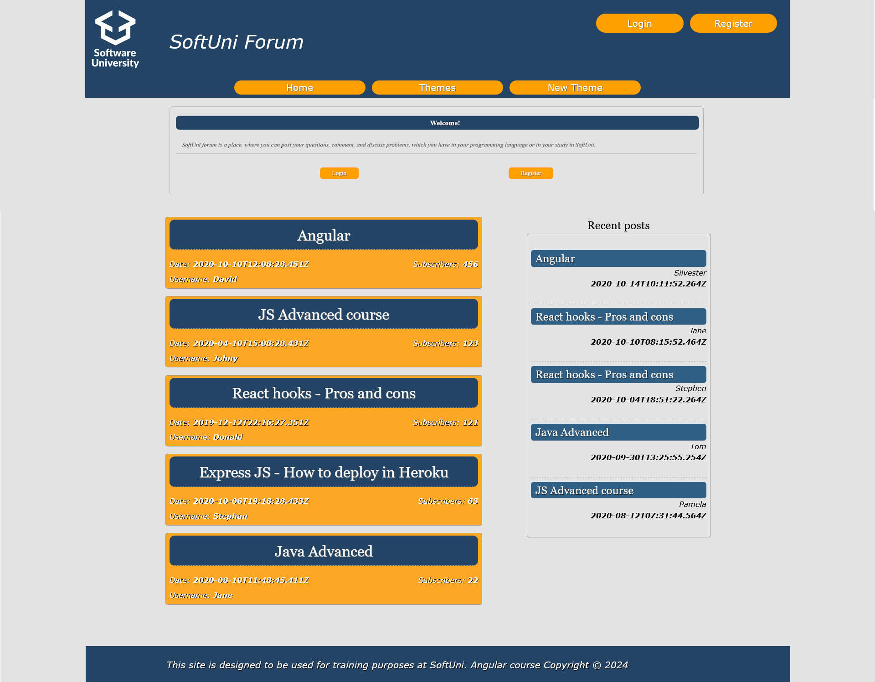

Themes page (Logged in)
This is the themes page ("localhost:4200/themes ") for logged in users:
NOTE: Because you are still not really logged in, you can hardcode this userId ('5fa64b162183ce1728ff371d') in your service, to write your logic for subscribed users (Red and Green buttons).
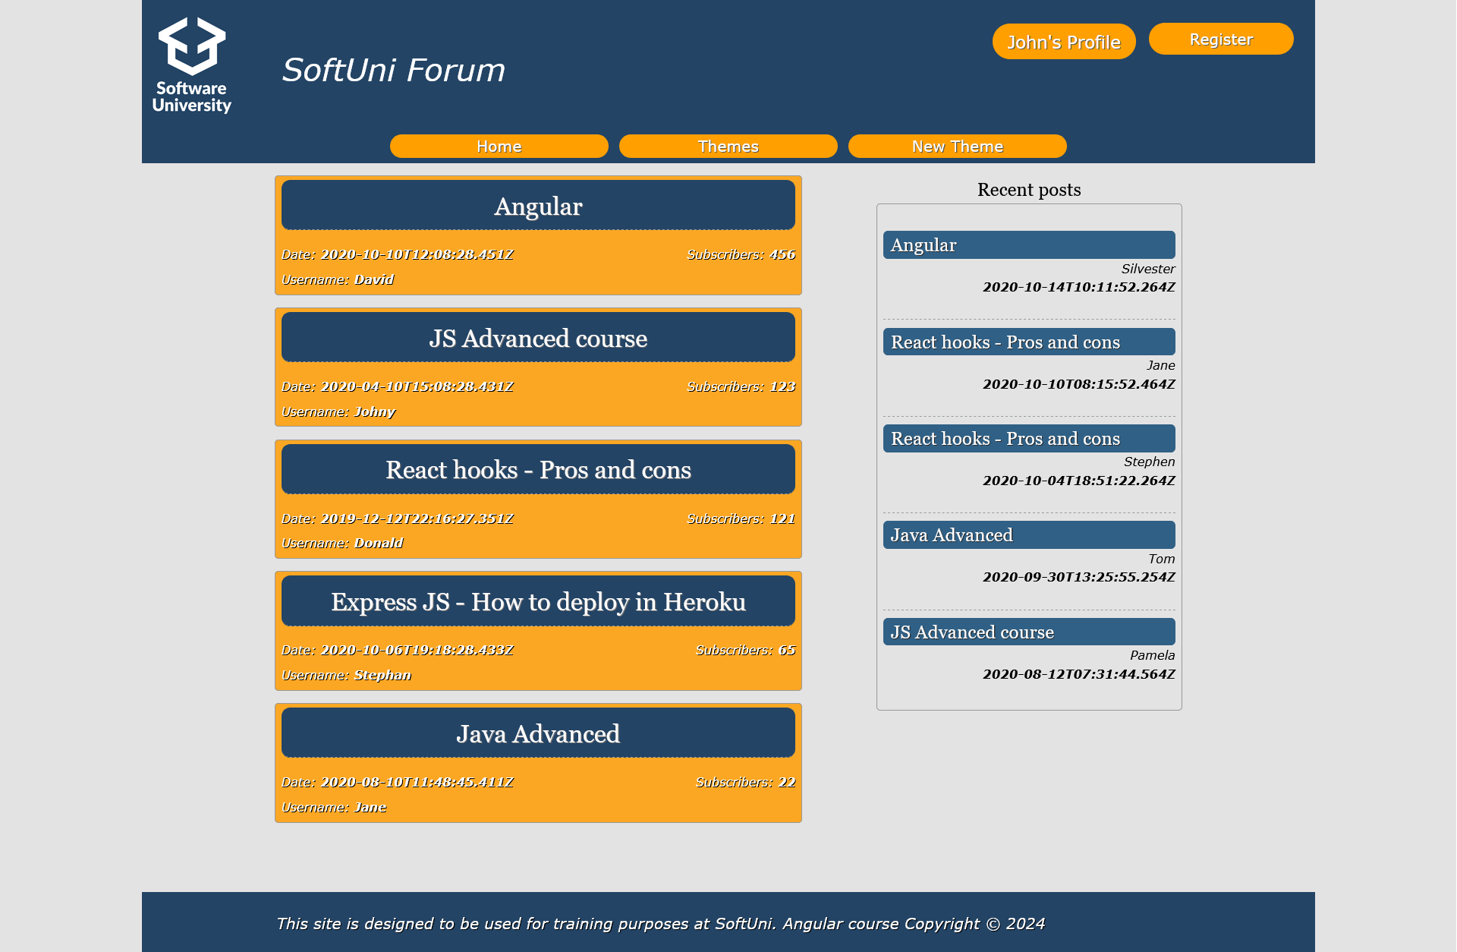

Theme comments (Not Logged in)
This is the theme comments page ("localhost:4200/themes/:themeId "), where the user can see all the posts for the selected theme.
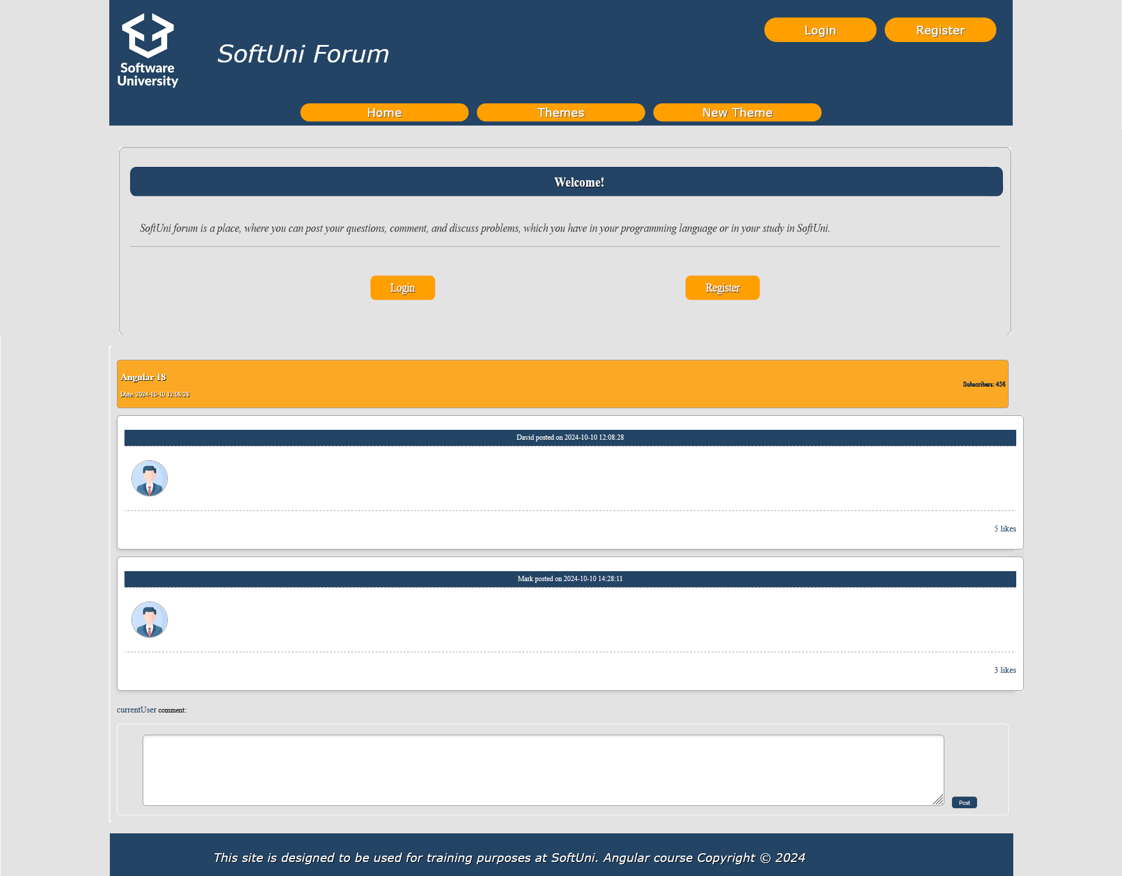

Theme comments (Logged in)
The logged in user can write new comment or like the other user's posts.
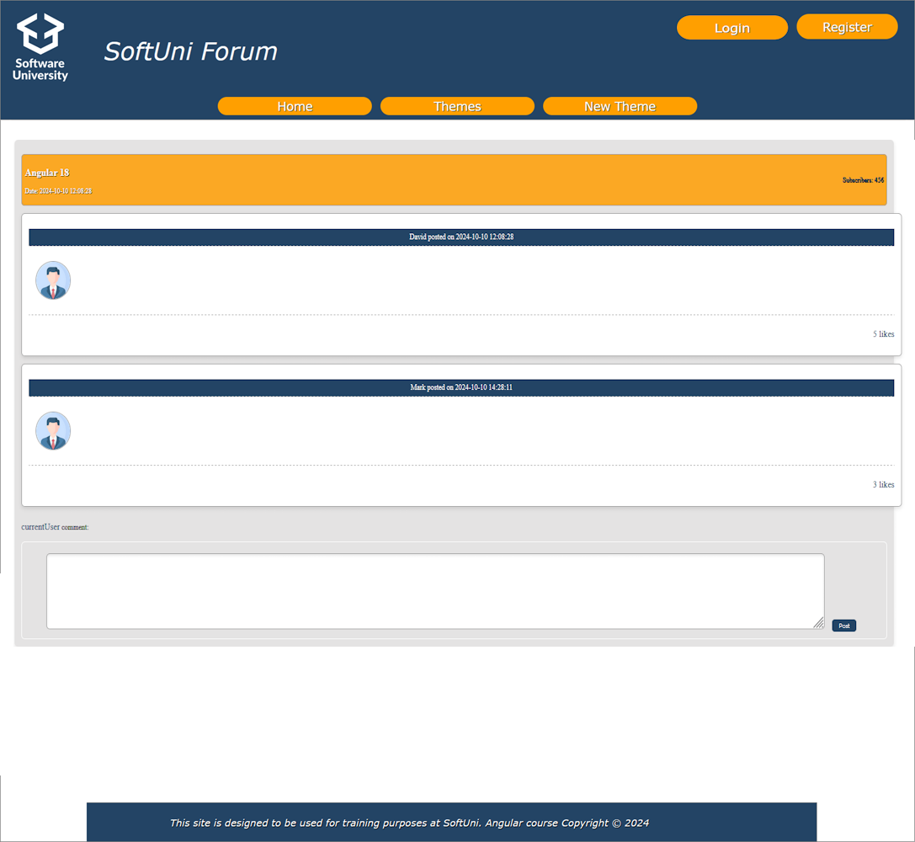

Create New Theme (Logged in only)
This is the create new theme page ("localhost:4200/themes ") where each user (logged in) can create his own theme.
- When "Post" button is clicked, you can try to make "POST" request to ("localhost:4200/themes") with the given theme information. After successful creation, redirect the current "user" to the theme comments page of his new created theme.
- When "Cancel" button is clicked, redirect the user to home page.
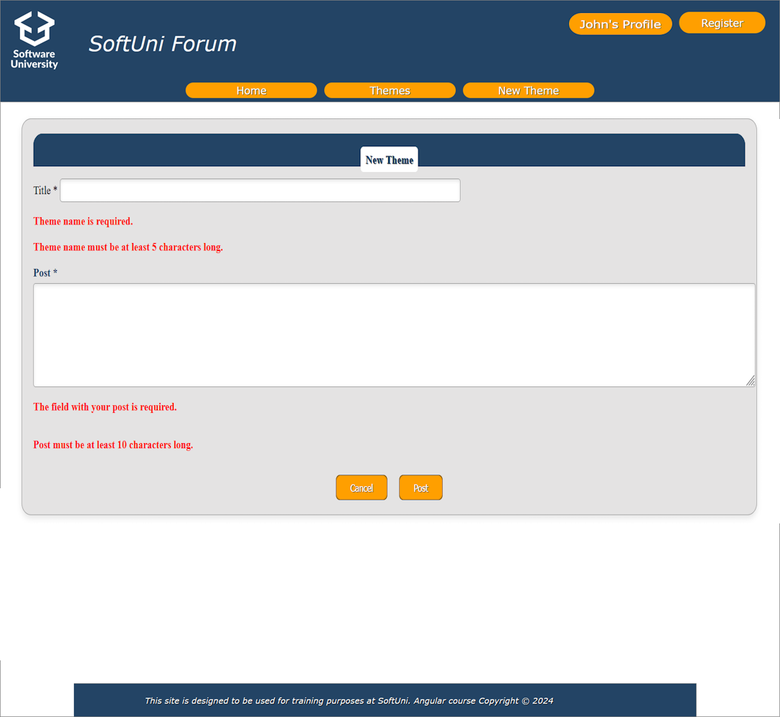

Profile (Logged in)
This is the profile page ("localhost:4200/profile"). This page will show the information about the currently logged in user. For now, the data in this page will be static, except if you create more than the fake isLoggedIn property. The "Edit" button will replace the information fields with input fields, but this will be made in the next workshop, when you learn more about handling forms.
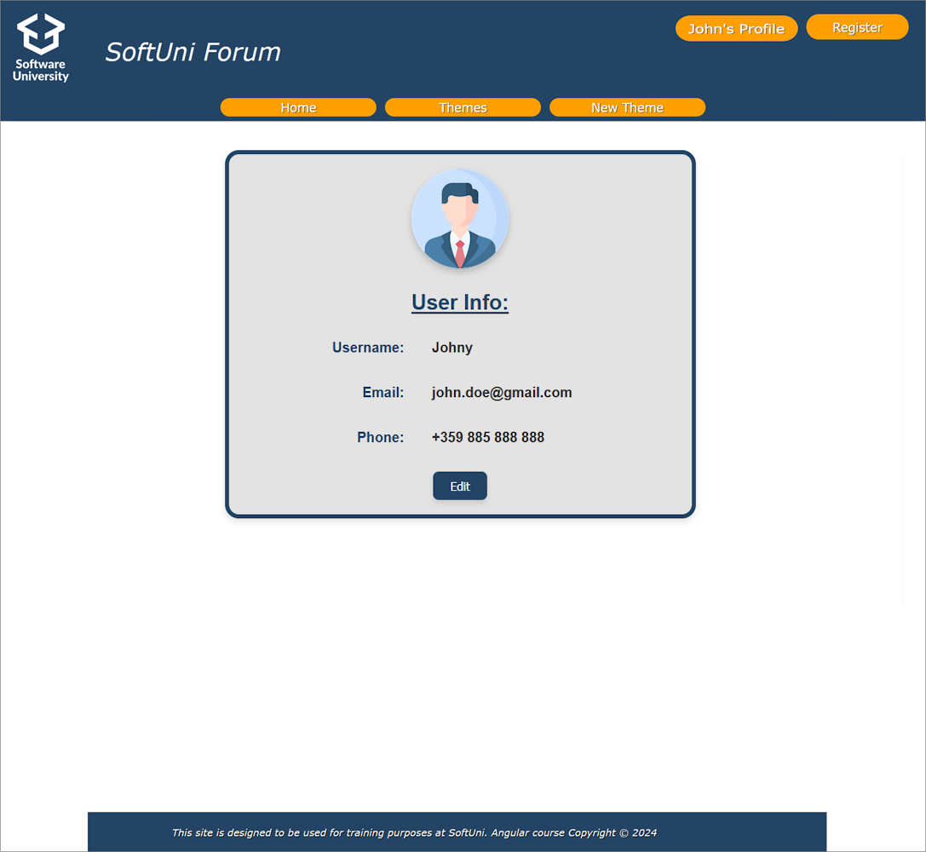

Invalid routes
This is the page for all invalid routes ("localhost:4200/?????? "). Use it if invalid path or wrong one is accessed.
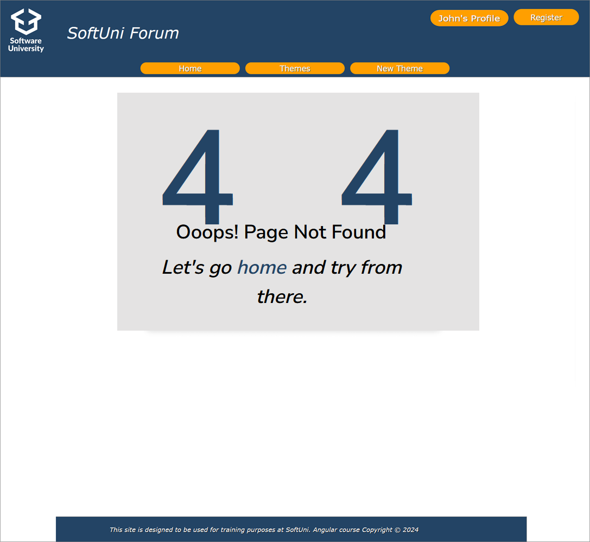

Protected routes
Set up lazy loading for feature modules (e.g., Themes, Auth, and Home) using routing. Directly reference standalone components in routes without declaring them in modules, where applicable. Protect logged-in routes with guards.
GOOD LUCK! 😊

