SoftUni Forum Workshop – Part 4
This application is created as a workshop for the Angular Course @ Software University

Task Requirements
Last time you saw what JWT (JSON WEB TOKEN) is, and the INTERCEPTORS concept. Try to intercept the requests and responses between the front-end part and the back-end.

Auth Interceptor
Implement the AuthInterceptor using standalone components and service. This interceptor will retrieve the JSON Web Token (JWT) from the API response and attach it to subsequent requests for user authentication.

Error Interceptor
In some cases, errors will occur, that's inevitable. Use Angular's Signals API to reactively manage state changes for error messages and notifications in the ErrorInterceptor. Create the ErrorInterceptor as a standalone service to handle error responses globally in the application. Use Angular's error handling features to intercept HTTP errors and display them through a styled notification, such as using a <p> element in the header, with styles provided in .error-message and .success-message classes.
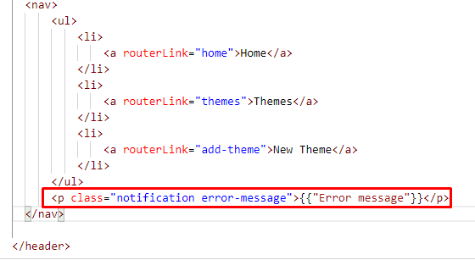
.notification{
position: fixed;
z-index: 10;
right: 8%;
top: 8%;
padding: 0.5rem;
border-radius: 0.5rem;
color: rgb(255, 255, 255);
font-style: italic;
text-decoration: underline;
box-shadow: 0 5px 10px rgb(204, 204, 204);
background-color: rgba(238, 74, 74, 0.699);
}

.error-message {
background-color: rgba(238, 74, 74, 0.699);
}

.success-message {
background-color: rgba(99, 230, 81, 0.699);
}

Lazy Loading
Lazy Loading helps us to download the web pages in chunks. Try to lazy load all the modules you can.

Pipes
Try to write pipes, as follows:
- Write a pipe for slicing long titles of the themes (25 chars max). You can use the SlicePipe, provided from Angular or write your own.
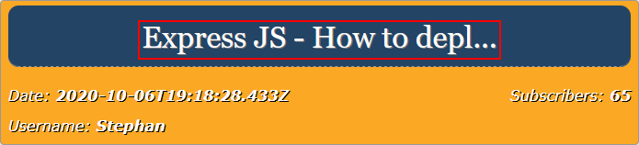
- Write a pipe to convert the date, as shown in the pictures:
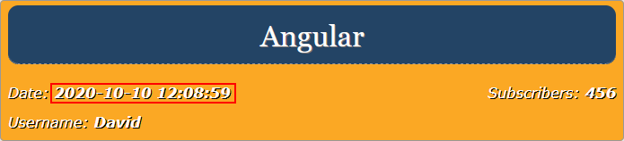
- Write another pipe, which calculates the time since the post is created:
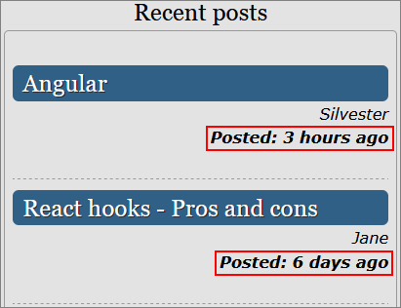
GOOD LUCK! 😊

