To: Director of Science and Technology
From: Research and Development
Date: 27th November 2019
Sir,

RE: Design of computer laboratory at NIA

- Introduction
The installation a computer laboratory in NIA will facilitate the administration, instructors and students to access hardware and software to fulfil the requirements of courses.
One of the facilities that requires the computer laboratory is the software developed, which allows instructors and student to conduct researches and management of courses automatically.
In additional to that, the software will keep all records related to students and courses attended in NIA.

- Physical layout
A room of 7.5mx4.9m is available to accommodate 20 computers and their accessories all connected to a centralized server by a local area network.
The inside layout will be flexible to allow the instructor moving and watch every student activity.

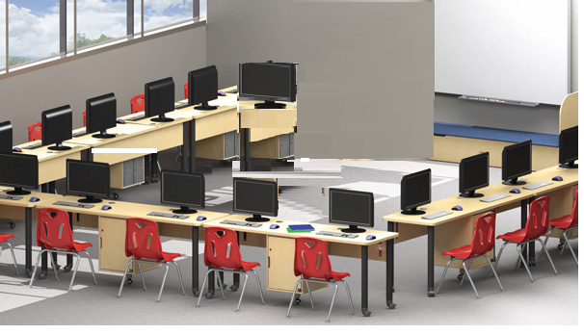

- Estimated budget
The estimated budget covers all the required equipment in order the computer laboratory to be operational.
No | Article | Quantity | Unit Price | Cost in Rwf
1 | Server | 1 | 5,000,000 | 5,000,000
2 | Computers | 20 | 1,000,000 | 20,000,000
3 | Power Extensions | 8 | 7,500 | 60,000
4 | Local Area Network equipment, trucking and installation | 1 | 1,000,000 | 1,000,000
5 | MDF tables | 9 | 345,000 | 3,105,000
6 | Executive high back leather chairs | 22 | 265,000 | 5,830,000
7 | Air Conditioner + Installation | 1 | 3,000,000 | 3,000,000
Total |  |  |  | 37,995,000

