EVALUATION REPORT

**TO: INVESTMENT COMMITTEE**

**FROM: MUHANGA**

**PROJECT: POULTRY (Purchasing Chicken and Cages)**

**BUSINESS NAME: BELICA B POULTRY LTD**

**PROMOTER (M.D):**  **HORANIMANA Sandrine**

**PREPARED BY: Jean Paul HAKIZIMANA**

1. SUMMARY OF THE PROJECT FINANCING

|  |  |  |
| --- | --- | --- |
| * 1. Promoter (M.D) | : | HORANIMANA Sandrine |
| * 1. Business Name |  | BELICA B POULTRY |
| * 1. Project | : | Poultry (Purchasing Chicken and Cages) |
| * 1. Business Sector | : | Agribusiness |
| * 1. Location of the project | : | Shyogwe, Muhanga |
| * 1. Total cost of the project | : | **Rwf 13,020,260** |
| * 1. BDF Loan Requested | : | Rwf 10,000,000 |
| * 1. BDF Loan Recommended | : | Rwf 10,000,000 |
| * 1. Subject of financing | : | Chicken, Equipment, Working Capital |
| * 1. Grant | **:** | Rwf 3,000,000 |
| * 1. Interest | **:** | 12% |
| * 1. Grace period | **:** | 6 Months |
| * 1. Payback period | **:** | 4 Years |
| * 1. Type of collaterals | **:** | Land located in Nyakabungo Village, Kagugu Cell, Kinyinya Sector, Gasabo District, Kigali city with value of Rwf 11,500,000 |

**EXECUTIVE SUMMARY**

1. **Business Status**

**Name of Business:** Belica B Poultry Ltd

**TIN:** 108011776

**Registration Date:** 30/05/2018

**Promoter: Horanimana Sandrine**

**ID: 1 1991 7 0172533 1 52 Tel:** 0787 399 073

**Village:** Amajyambere

**Cell:** Rwampara

**Sector:** Kagarama

**District:** Kicukiro, Kigali city

1. **Business Location**

Belica B Poultry Ltd is located:

Village: Munyinya

Cell: Ruli

Sector: Shyogwe

District: Muhanga

1. **Business description**

The project is Poultry where a promoter wishes to purchase twenty chicken cages and they will cost **Rwf 5,668,060,** each cage will be able also to keep 160 chickens. Those cages will have nipple drinkers, stainless, ball valve, water tank, white PVC feed trough, connectors for water pipes and feed troughs included.

The cages also have the following system:

* Chicken feeding system
* Chicken drinking system
* Egg collecting system

These cages keep a lot of chickens, they don’t take a big place, you can use small place for a thousand chickens. Chickens cannot transmit the diseases because a chicken remain in one place, chickens cannot walk around. The cages also help in managing the chicken’s food and water. Collecting eggs also is very easy because the cages have a place of eggs.

Promoter will also buy 2,000 chickens, one chick costs **Rwf 1,200,** now the promoter has 279 chickens, she get 250 eggs per day but after expanding the project she will be able to get **2100** eggs per day. In this project the promoter also will need the working capital because those 2,000 chicks, chicks will spend for months without laying (eggs).

1. Shareholding

|  |  |  |  |  |  |  |
| --- | --- | --- | --- | --- | --- | --- |
|  | Shareholder’s Name | I.D Number | Qualification | Position | %age shares | Contact |
|  | Horanimana Sandrine | **1 1991 7 0172533 1 52** | Bachelor of Office Administration and Management | Managing Director | 100 | 0787399073 |

**MANAGEMENT**

The promoter is Horanimana Sandrine she is married, she has Bachelor of office administration and management, She got a training of Poultry that is why she is interesting in poultry and she has experience of 3 years in Poultry.

Her own contribution is Rwf **11,020,260 (Chicken and Buildings)**, She has no other Source of income but as I said above she has 279 Chickens which give her an income of Rwf 100,000.

***Belica B Poultry Ltd structure***

|  |  |  |
| --- | --- | --- |
| **Title / Position / Name** | **Monthly Salary Rwf** | **Qualification / Experience** |
| M.D – Horanimana Sandrine | 200,000 | Bachelor of office Administration and management |
| Manager | 100,000 | Secondary |
| Veterinary | 80,000 | Secondary |
| Cleaner | 40,000 | Primary |

**OPERATIONS**

The project is Poultry and the product is egg, the promoter will sell eggs. The chicken will be in cages where feeding and giving them water will be very easy, collecting eggs will be easy also. The promoter will buy 2000 chicken from Agrotech Ltd (Rwanda), one chick is Rwf 1,200. The promoter will purchase 20 chicken Cages from HENAN BOYAJIUHUA ANIMAL HUSBANDRY CO. LTD (china) each keeps 160 chickens.

Promoter has a big contract with House of Cake in Kigali; she will pack the Eggs in Trays.

**MARKET**

There is a big market of Eggs the promoter has no problem of the market because the market is too big; she has a contract with house of cake of 62,000 eggs per Month.

**FINANCIALS**

**USE OF FUNDS / HOW FUNDS WILL BE INVESTED.**

|  |  |  |  |  |
| --- | --- | --- | --- | --- |
| **Details** | **Total Cost (Rwf)** | **Owner's contribution (Rwf)** | | **BDF Loan and Grant (Rwf)** |
| **Realized** | **to be Realized** |
| **1. Collecting Information** | | | | |
| Business Plan | 100,000 | - | - | 100,000 |
| Transport | 20,000 | 10,000 | 10,000 |  |
| Communication | 20,000 | 15,000 | 5,000 |  |
| Certificates | 70,000 | 10,000 | 60,000 |  |
| **S/Total** | **210,000** | **35,000** | **75,000** | **100,000** |
| **2. INVESTMENT** | | | | |
| Chicks | 2,400,000 | **-** | **-** | 2,400,000 |
| Chicken | 1,674,000 | 1,674,000 |  |  |
| Chicken Cages | 5,668,060 | - | - | 5,668,060 |
| **S/Total** | **9,742,060** | **1,674,000** | **-** | **8,068,060** |
| **3. WORKING CAPITAL** | | | | |
| **3.1. Fixed Cost** | | | | |
| Salaries | 420,000 |  | 420,000 |  |
| **Total** | **420,000** | **-** | **420,000** | **-** |
| **3.2. Variable Cost** | | | | |
| Feeding Chicken | 2,403,200 |  | 571,260 | 1,831,940 |
| Vaccine and medicines | 75,000 |  | 75,000 |  |
| Communication | 20,000 |  | 20,000 |  |
| Transport | 150,000 |  | 150,000 |  |
| **Total** | **2,648,200** |  | **816,260** | 1,831,940 |
| **S/Total** | **3,068,200** | **-** | **1,236,260** | 1,831,940 |
| **Grand Total(1+2+3)** | **13,020,260** | **1,709,000** | **1,311,260** | **10,000,000** |
| **Percentage** | **100** | **13** | **10** | **77** |
| **Owner’s Contribution** | **23** | **3,020,260** | |  |

**Income Statement of Belica B Company**

|  |  |  |  |  |  |
| --- | --- | --- | --- | --- | --- |
| **Year** | **1** | **2** | **3** | **4** | **5** |
| Revenues | 56,388,000 | 62,026,800 | 68,229,480 | 75,052,428 | 82,557,671 |
| Variable costs | 37,039,200 | 40,743,120 | 44,817,432 | 49,299,175 | 54,229,093 |
| **Gross Profit** | **19,348,800** | **21,283,680** | **23,412,048** | **25,753,253** | **28,328,578** |
| **Fixed Cost** | | | | | |
| Salaries | 5,040,000 | 5,544,000 | 6,098,400 | 6,708,240 | 7,379,064.00 |
| Loan Interests | 761,965 | 578,059 | 370,829 | 137,317 | (125,810) |
| Depreciation | 683,403 | 683,403 | 683,403 | 683,403 | 683,403 |
| **Total** | **6,485,368** | **6,805,462** | **7,152,632** | **7,528,960** | **7,936,657** |
| **Profit before tax** | **12,863,432** | **14,478,218** | **16,259,416** | **18,224,293** | **20,391,921** |
| **Profit After tax** | **12,863,432** | **14,478,218** | **16,259,416** | **18,224,293** | **20,391,921** |

**Balance Sheet of Belica B Company**

|  |  |  |  |  |  |
| --- | --- | --- | --- | --- | --- |
| **Year** | **1** | **2** | **3** | **4** | **5** |
| **Fixed Assets and Current Assets** | | | | | |
| Chicken Cages | 5,668,060 | 5,384,657 | 5,101,254 | 4,817,851 | 4,534,448 |
| Chicken shed | 8,000,000 | 7,600,000 | 7,220,000 | 6,859,000 | 6,516,050 |
| Chicken | 1,674,000 | 1,674,000 | 1,395,000 | 360,000 | 1,800,000 |
| Chicks | 2,400,000 | 12,000,000 | 12,000,000 | 10,000,000 | 2,400,000 |
| Business plan | 100,000 | 100,000 | 100,000 | 100,000 | 100,000 |
| Inventory | 2,403,200 | 2,403,200 | 2,403,200 | 2,403,200 | 2,403,200 |
| Bank | 12,863,432 | 12,874,879 | 30,207,573 | 21,038,671 | 29,178,566 |
| **Total** | **33,108,692** | **42,036,736** | **58,427,027** | **45,578,722** | **46,932,264** |
| **Financed by** | | | | | |
| Owner’s Contribution | 10,245,260 | 22,137,432 | 38,396,849 | 25,443,293 | 28,707,971 |
| Loan | 10,000,000 | 5,421,085 | 3,770,762 | 1,911,136 | 0 |
| Profit | 12,863,432 | 14,478,218 | 16,259,416 | 18,224,293 | 18,224,293 |
| **Total** | **33,108,692** | **42,036,736** | **58,427,027** | **45,578,722** | **46,932,264** |

**Expenses**

|  |  |  |  |  |  |
| --- | --- | --- | --- | --- | --- |
| No | **Details** | **Quantity** | **Cost per Unit(Rwf)** | **Total Cost per Month (Rwf)** | **Total cost per Year (Rwf)** |
| 1 | Feeding chckens | 296 KG | 320 | 2,841,600 | 34,099,200 |
| 2 | Vaccine and Medicines | 1 | 75,000 | 75,000 | 900,000 |
| 3 | Transport | 1 | 150,000 | 150,000 | 1,800,000 |
| 8 | Communicaton | 1 | 20,000 | 20,000 | 240,000 |
| **Total** | | | | **3,086,600** | **37,039,200** |

**Revenues**

|  |  |  |  |  |  |
| --- | --- | --- | --- | --- | --- |
| No | **Products** | **Quantity** | **Price** | **Monthly Revenue (Rwf)** | **Revenue per Year (Rwf)** |
| 1 | Eggs | 2100 | 73 | 4,599,000 | 55,188,000 |
| 2 | Fertilizer | 100 | 1,000 | 100,000 | 1,200,000 |
| **Total** | | | | **4,699,000** | **56,388,000** |

**Recommendation**

I therefore, recommend this project of Innovation in agri-business to IC for further analysis and I recommend also BDF to finance this project because the promoter is committed, she has feasible project with large market, and the promoter will employ 4 employees. The promoter also has a significant contribution and the project is not start –up.

**Done at Muhanga on 18th June 2018**

**By**

**Hakizimana Jean Paul**

**Investment Analyst**

**BDF Muhanga Branch**

***Below are the Fields visit photos***

*The house where she will put Chicken Cages*

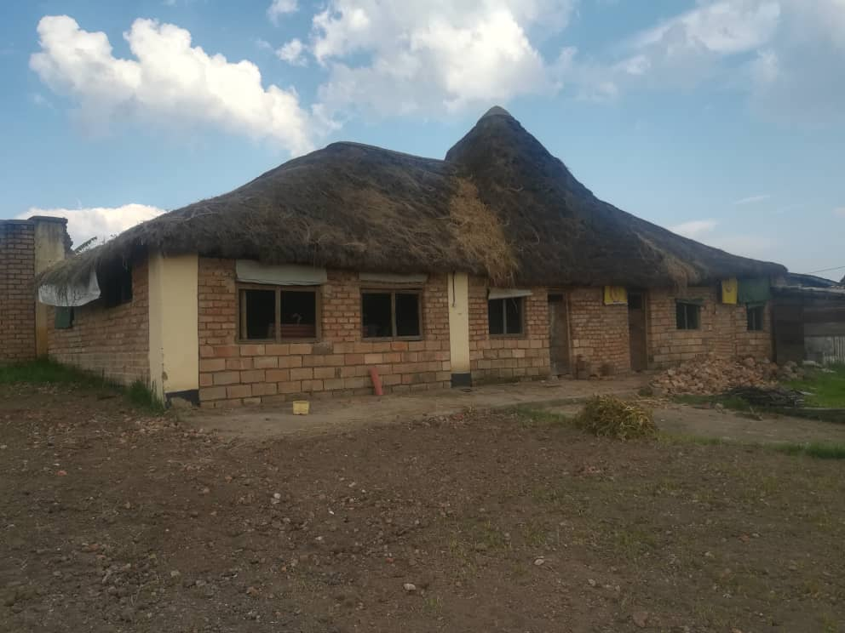

*Inside the house where she wants to fix the Chicken cages*

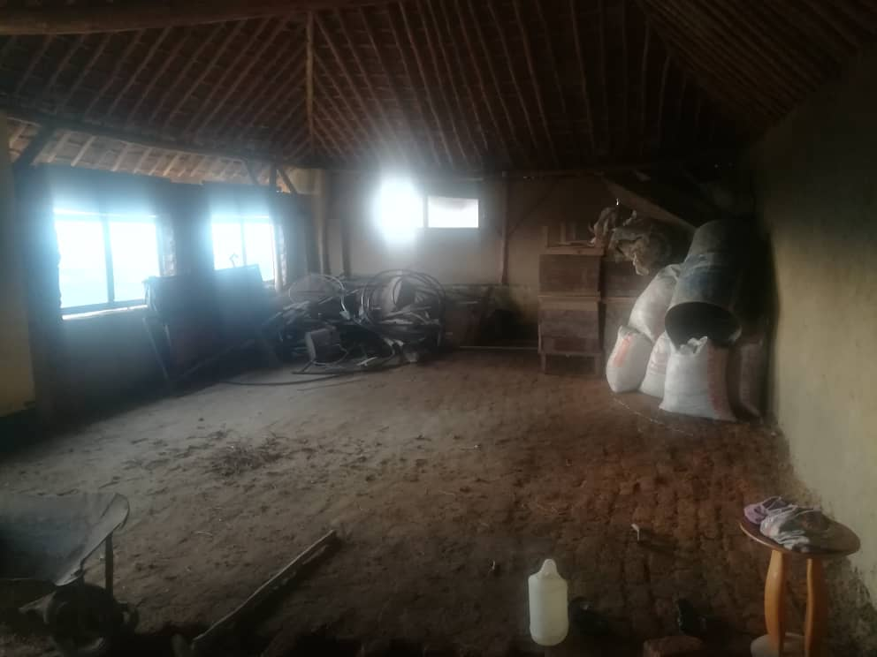

*Chickens*

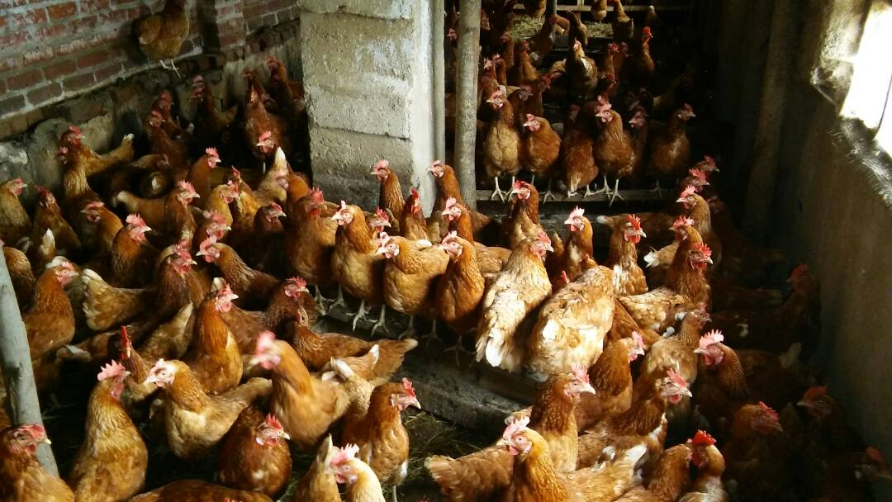

*Current Chicken shed and the water tank*

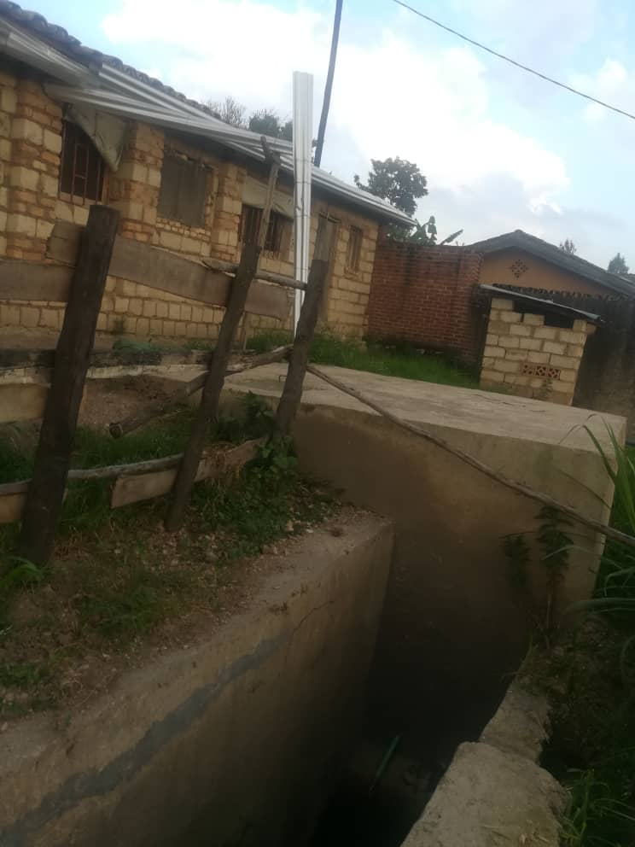

*The chicken Cages she wants to purchase*

