Game Design Document

Fill up the following document

1. Write the title of your project.

Bolwing Alley

1. What is the goal of the game?

The goal of the game is to topple maximum bowling pins in the bowling alley.

1. Write a brief story of your game.

You have gone to a bowling alley to bowl. Try to score the maximum

points in each level to continue playing in the bowling alley.

1. Which are the playing characters of this game?

* Playing characters are the ones who respond to the user based on the input from the user.
* Cars, monkeys, dinos, wizards, etc., are the playing characters in the game.

|  |  |  |
| --- | --- | --- |
| Number | Character Name | What can this character do? |
| 1 | Ball | Topples the bowling pins |
| 2 |  |  |
| 3 |  |  |
| 4 |  |  |
| 5 |  |  |
| 6 |  |  |
| 7 |  |  |
| 8 |  |  |

1. Which are the Non-Playing Characters of this game?

* Non-Playing characters are the ones that don't have an action or behavior when the user interacts with the game.
* Hurdles, stones, bananas, coins, etc., are non-playing characters in the game.

|  |  |  |
| --- | --- | --- |
| Number | Character Name | What can this character do? |
| 1 | Pin 1 | Hurdle |
| 2 | Pin 2 | Hurdle |
| 3 | Pin 3 | Hurdle |
| 4 | Pin 4 | Hurdle |
| 5 | Pin 5 | Hurdle |
| 6 |  |  |
| 7 |  |  |
| 8 |  |  |

Draw your imagination of this game. What does this game look like?

* Draw the game either on your computer or on paper.
* Add images of the game scenes to show each of the playing and non-playing characters at least once.

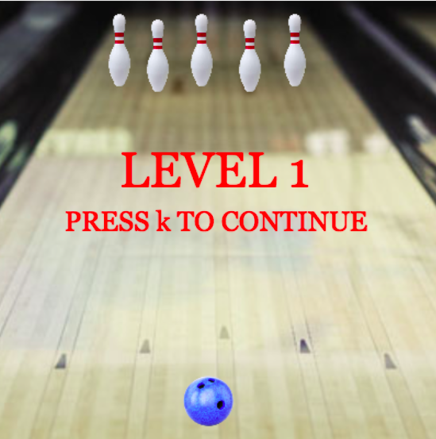

How do you plan to make your game engaging?

As the levels increase, it gets harder to hit the bowling pins and proceed to the next levels.