- input wire clk,

- input wire resetn,

- input wire [31:0] s_axi_awaddr,

- input wire s_axi_awvalid,

- output wire s_axi_awready,

- input wire [31:0] s_axi_wdata,
- input wire [3:0] s_axi_wstrb,
- input wire s_axi_wvalid,
- output wire s_axi_wready,
- output wire [1:0] s_axi_bresp,
- output wire s_axi_bvalid,
- input wire s_axi_bready,
- input wire [31:0] s_axi_araddr,
- input wire s_axi_arvalid,
- output wire s_axi_arready,

- output wire [31:0] s_axi_rdata,
- output wire [1:0] s_axi_rresp,
- output wire s_axi_rvalid,
- input wire s_axi_rready,
- output reg [31:0] rw_reg0,
- output reg [31:0] rw_reg1,
- output reg [31:0] rw_reg2,
- output reg [31:0] rw_reg3,
- input wire [31:0] ro_reg0,
- input wire [31:0] ro_reg1,
- input wire [31:0] ro_reg2,
- input wire [31:0] ro_reg3

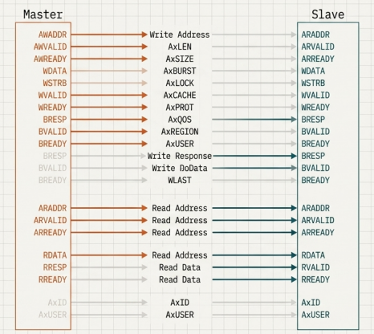

In this the master only sends signals?

Source 3 correction in the code

Strictly speaking, AXI allows the Write Address (AW) and Write Data (W) to arrive in any order or even at the same time.

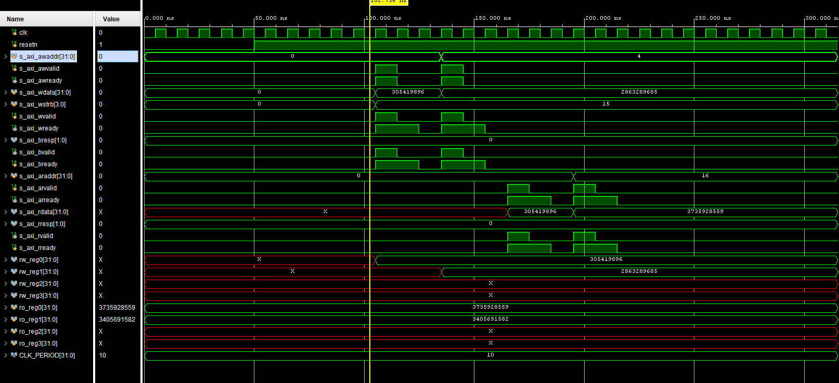

Vivado Simulator 2020.1
Time resolution is 1 ps
[WRITE] Addr: 0x00000000, Data: 0x12345678
[WRITE] Addr: 0x00000004, Data: 0xaaaa5555
[READ] Addr: 0x00000000, Data: 0x12345678
[READ] Addr: 0x00000010, Data: 0xdeadbeef
Simulation Finished
$finish called at time : 315 ns : File "C:/Users/VLSI/axi_4_lite/axi_4_lite.srcs/sim_1/new/tb.v" Line 138

Master and Slave handshake

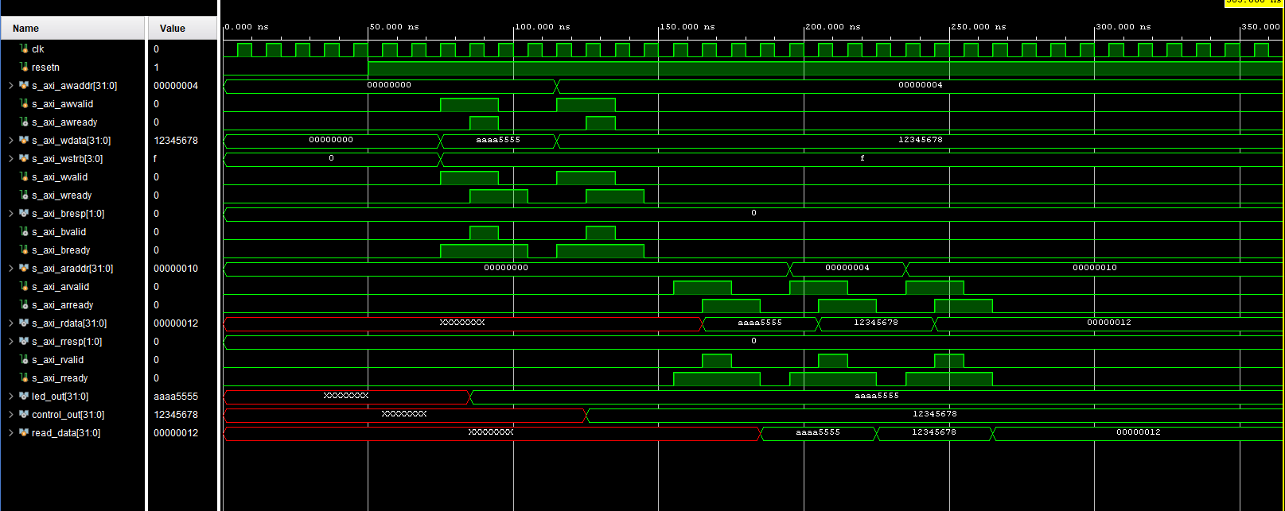

Sources used

file:///C:/Users/VLSI/Desktop/23/002/verilog/axi_4_lite/case_study/ppt/AXI_Protocol_Masterclass.pdf

https://github.com/arhamhashmi01/Axi4-lite
https://www.controlpaths.com/utils/axi4lite_gen/
https://en.wikipedia.org/wiki/Burst_mode_(computing)
https://github.com/alexforencich/verilog-axi/tree/master/tb/axi_interconnect

