Verification-Aware Evaluation of a RISC-V SoC Integrating a Lightweight TPU Accelerator
Akshit Kapoor
Shri Mata Vaishno Devi University, Katra, India
21bec099@smvdu.ac.in
Abstract. Verification of accelerator-integrated System-on-Chip (SoC) designs demands coverage across processor-driven firmware, memory-mapped peripheral control, streaming datapaths, and mixed-signal sensor behaviour. This work presents a RISC-V SoC integrating a lightweight Tensor Processing Unit (TPU) accelerator and sensor subsystem, evaluated through a structured, multi-technique verification methodology. The verification environment combines directed firmware testing, active and passive Universal Verification Methodology (UVM) with Register Abstraction Layer (RAL), a TPU-specific C reference model with layered scoreboard, mutation-based RTL fault analysis, targeted formal property checking, and Real Number Modelling (RNM) for the sensor interface. The selected firmware sigmoid workload requires 1,343 cycles before TPU integration and 372 cycles in the post-integration benchmark, corresponding to a 3.61× speedup. TPU transaction profiling reports 67 cycles: 7 for transmission, 58 for computation, and 2 for reception. Of ten injected RTL mutants, eight were viable and two were classified as equivalent; active UVM detected all eight viable mutants, while directed firmware and passive UVM each detected two. Five TPU control-boundary assertions passed in 30 bounded assertion-depth checks across proof depths 1, 2, 4, 6, 8, and 10. The 84-case RNM sweep reported no alarm mismatches. Seeded noise increased temperature-error mean absolute error from 0.0714 °C to 0.4524 °C. Together, these results provide complementary views of workload performance, fault observability, selected control properties, and modeled sensor behaviour.
Keywords: RISC-V; System-on-Chip; TPU; UVM; mutation testing; formal verification; real-number modelling; register abstraction layer, functional verification.

INTRODUCTION

RISC-V provides an open instruction-set architecture well suited to research-oriented SoC designs and customizable accelerator integration ¹. This work uses a compact PicoRV32 RV32I processor as the CPU, whose native valid/ready memory interface forms the transaction path into the system ². The resulting SoC combines processor execution, memory-mapped RAM, peripheral slaves, and an integrated TPU accelerator on a shared native bus, providing a concrete platform for evaluating both accelerator integration and its verification.
Adding an accelerator extends the verification problem beyond datapath correctness. The software workload must reach the correct address window, register accesses must be decoded and translated as specified, control-state transitions must follow the accelerator protocol, and streamed operands must satisfy AXI-Stream interface requirements. The sensor subsystem introduces a further challenge: it involves analog-inspired quantities that two-state digital stimulus alone cannot adequately represent.
UVM provides a reusable, scalable SystemVerilog verification methodology applicable from block-level to full system-level environments ³. SystemVerilog contributes assertions, functional coverage, constrained-random stimulus, and direct programming interface (DPI) foreign-language bindings used throughout the verification flow ⁴. However, a UVM environment alone does not guarantee that the relevant architectural state space has been exercised. Firmware-driven tests are inherently bounded by the transactions the software generates, and passive monitors can only observe those same transactions. Active bus-level stimulus provides a complementary reachability path, deliberately targeting address regions and control boundaries that the selected firmware never exercises.
This observation motivates the use of multiple verification techniques rather than reliance on a single metric. Two practical questions structure the evaluation. First, what cycle-level change is measured when the software sigmoid workload is offloaded to the integrated TPU path? Second, which injected RTL faults are observable through directed firmware, passive UVM, active UVM, and formal property checking? Real Number Modelling (RNM) is additionally applied to examine sensor behaviour under both deterministic and seeded-noise stimulus conditions.
The primary contribution of this work is a verification-aware evaluation methodology, not a novel TPU microarchitecture. The approach integrates processor-driven firmware testing, active bus-directed stimulus, RAL-based register modelling, C reference-model scoreboarding, mutation-based fault analysis, and targeted formal checking into a single coherent flow. Each technique addresses a distinct aspect of the system, allowing functional behaviour, stimulus reachability, fault observability, control-path properties, and mixed-signal sensor behaviour to be examined independently and cross-validated. The relationship between these techniques and the overall design flow is illustrated in Figure 1.

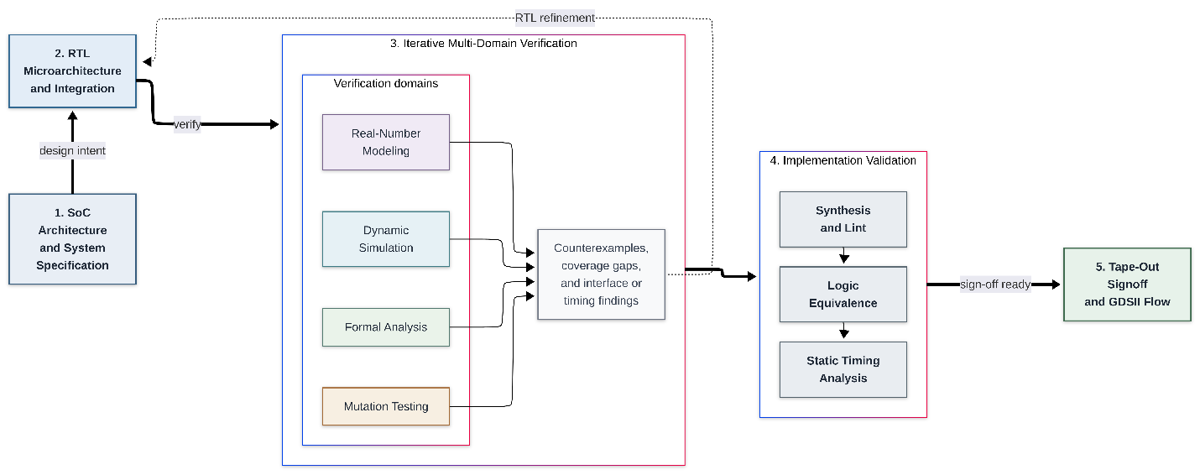

FIGURE 1. SoC development and verification flow. Verification is applied iteratively across simulation, formal analysis, mutation testing, RNM, and implementation-oriented validation, with feedback to RTL development.

RELATED WORK
UVM has been widely used for verification of RISC-V-based SoCs and their subsystems. Minhas et al. presented a coverage-driven and constrained-random verification methodology for the SweRVolf RISC-V SoC. Their work used UVM, reusable verification components, directed and constrained-random tests, and functional coverage to verify an AXI-to-Wishbone bridge, Wishbone interconnect, and GPIO subsystem. The results showed that the approach was effective for subsystem-level verification, particularly when the integrated IPs were already pre-verified ²¹.

UVM has also been applied to specialized hardware interfaces. Yu developed a UVM-based environment for an SPI controller with dual BRAMs and eight SPI channels, focusing on FIFO operation, state-machine behaviour, clock-domain-crossing conditions, and continuous read/write requests ²⁴. Bhaskar and Goyal combined directed and constrained-random testing with SystemVerilog assertions, functional coverage, and UVM for I2C and SPI verification. Their study reported high functional, code, and assertion coverage along with fault-injection analysis ²⁵. These works show the effectiveness of reusable UVM environments, but their focus is mainly on individual subsystems or communication protocols rather than an accelerator-integrated RISC-V SoC.

Mutation testing provides another way to evaluate the effectiveness of a verification environment. Wu et al. proposed MANTRA, a hardware mutation-testing framework based on realistic hardware bugs. The study introduced 19 mutation operators and evaluated them using CirFix and OpenCores designs, showing how mutation analysis can be used to assess whether a verification flow is capable of detecting implementation faults ⁹. This motivates the use of mutation testing in the present work to examine not only whether the SoC passes its functional tests, but also which verification paths are capable of exposing injected RTL faults.
Formal verification provides complementary results by checking specified properties beyond the finite set of simulation scenarios. However, the complexity of the design can make full-system formal analysis difficult. This motivates applying formal verification selectively at well-defined control and routing boundaries, where properties can be analyzed without introducing unnecessary datapath state into the proof.

For mixed-signal behaviour, Balasubramanian and Hardee describe real-number modelling as a signal-flow abstraction that represents analog behaviour using discrete real-valued data within a digital simulation environment. Their work highlights the ability of RNM to support faster SoC-level verification while retaining behavioural information such as voltage levels and threshold crossings ²⁶. This approach provides the basis for using RNM in the sensor path of the present SoC to evaluate temperature and noise behaviour alongside the digital verification flow.

Overall, the reviewed studies demonstrate effective approaches for RISC-V subsystem verification, protocol verification, mutation analysis, formal checking, and mixed-signal modelling. However, these approaches are generally evaluated within their respective verification domains. This work brings them together in an accelerator-integrated RISC-V SoC and, importantly, examines which stimulus paths make specific RTL faults observable. Firmware-driven testing, passive UVM, and active UVM are therefore evaluated separately, while mutation testing, targeted formal verification, and RNM provide additional results for fault detection, control correctness, and sensor behaviour.

BASELINE RISC-V SOC
Figure 2 shows the top-level organization of the SoC, consisting of a processor and memory-mapped interconnect connected to the integrated peripheral blocks. The peripheral subsystem includes memory, sensor, I/O and RF, and video and AI functionality. The detailed implementation of these blocks is described in the following subsections.

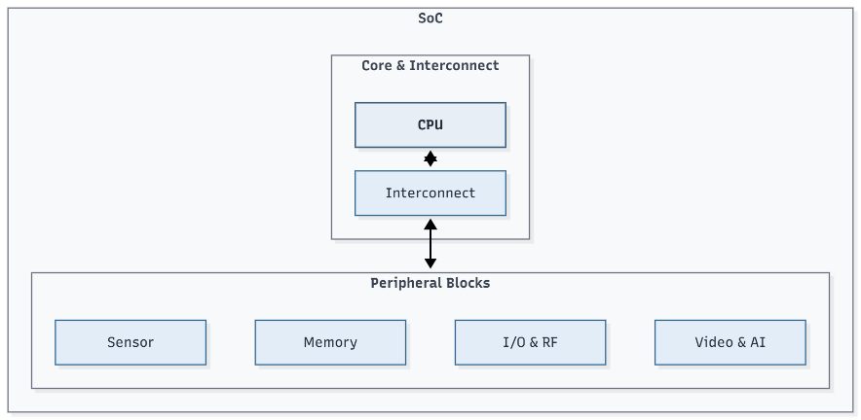
FIGURE 2. Top-level organization of the RISC-V SoC showing the processor, interconnect, and integrated peripheral blocks.

- System Architecture

The SoC is a single-master, memory-mapped RISC-V system. The PicoRV32 processor connects to the soc_mem_interconnect through the cpu_bus_adapter, which maps the PicoRV32 mem_wstrb signal to the native bus m_write and m_strb signals. The interconnect uses combinational address decoding and transaction routing, while transaction completion depends on the selected slave's ready response.
Unmapped accesses are completed with zero read data, consistent with the absence of a bus-error response on the native interface. The system address map is given in Table I.

TABLE 1. SoC System Address Map

Peripheral | Base Address | Size
RAM | 0x0000_0000 | 64 KB
GPIO | 0x0001_0000 | 4 KB
RF Telemetry | 0x0001_1000 | 4 KB
Sensor Status | 0x0001_2000 | 4 KB
VDP | 0x0001_3000 | 4 KB
TPU | 0x0001_4000 | 4 KB

B. Peripheral Subsystems

Each peripheral occupies a 4 KB address window and connects to the interconnect through a 12-bit local address interface. The GPIO peripheral provides configurable input/output control, while the RF telemetry peripheral exposes read-only identification and status registers. The sensor status peripheral monitors battery level and temperature using threshold-based alarm logic. The Video Display Processor (VDP) generates VGA timing and operates across the system-clock and pixel-clock domains, with clock-domain crossing handled using Gray-code synchronization for pixel counters and toggle-based handshaking for configuration registers. The TPU peripheral is described separately in Section IV.

C. Firmware Baseline and Performance Characterization

The sigmoid activation function is selected as the benchmark workload because it represents a neural-network inference operation that can be offloaded to the integrated TPU. For the baseline measurement, the sigmoid computation is executed entirely in software on the PicoRV32 processor and requires 1343 cycles for the selected input set.
After TPU integration, the same workload is executed through the hardware-accelerator path. Post-integration simulation measures 372 cycles, corresponding to a 3.61× speedup relative to the 1343-cycle firmware baseline. These measurements are specific to the selected sigmoid workload and are not intended as general-purpose TPU performance benchmarks.
TPU transaction-level profiling further separates the accelerator execution into transmit, computation, and receive phases, as summarized in Table II. The measured TPU transaction requires 67 cycles, comprising 7 cycles for transmission, 58 cycles for computation, and 2 cycles for reception.

TABLE 2. TPU Transaction Phase Breakdown

Phase | Cycles
AXI-Stream Transmit | 7
Computation | 58
AXI-Stream Receive | 2
Total | 67

The 67-cycle figure represents the TPU execution window, whereas the 372-cycle system-level measurement includes the surrounding processor-driven execution and control overhead.

TPU INTEGRATION
The TPU ^{13, 20} is added without replacing the SoC's native bus. Instead, a 32-bit memory-mapped wrapper, nn_axi_wrapper, defines the architectural boundary between the processor and the accelerator. The wrapper exposes 64-bit weight, input, and result registers through pairs of 32-bit accesses. On the accelerator side, nn_axis_master packages the programmed data into a seven-beat AXI4-Stream transaction containing five weight values and two input values.
At the register and control boundary, START, BUSY, and DONE behaviour separates processor-visible control from the streaming accelerator interface. The verification environment observes both AXI-stream activity and result registers. The accelerator datapath uses fixed-point arithmetic with FRAC_BITS=10. The focus here is the integration and verification behaviour supported by the available tests rather than a formal proof of the complete numerical datapath ⁵, ⁶. The TPU latency plot shows 7 transmit cycles, 58 computation cycles, and 2 receive cycles.

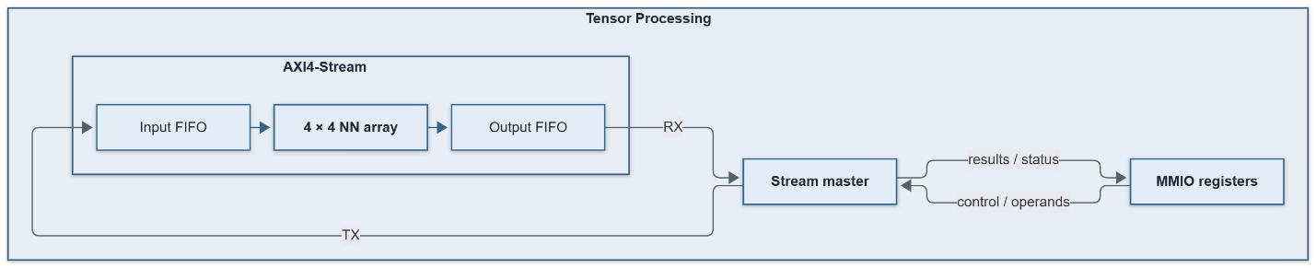
FIGURE 3. TPU integration boundary extracted from the SoC architecture, showing the memory-mapped nn_axi_wrapper, nn_axis_master, and AXI-stream accelerator path.

Figure 3 isolates the accelerator interface from the larger SoC. The CPU continues to use the native 32-bit system bus, while nn_axi_wrapper collects the programmed 64-bit operands and nn_axis_master converts them into seven AXI4-Stream beats for the TPU.

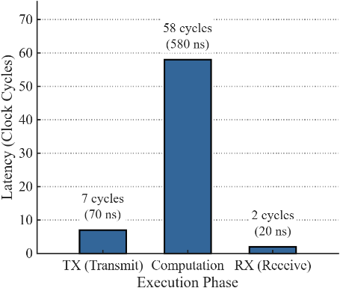
FIGURE 4. Measured TPU transaction latency breakdown: 7 cycles for transmit, 58 cycles for computation, and 2 cycles for receive, for a total of 67 cycles.

PERFORMANCE BENCHMARKING
The supplied integration results compare the selected firmware workload before and after TPU integration. The benchmark plot shows 1343 cycles for the pre-TPU implementation and 372 cycles for the post-TPU implementation, with a plotted cycle ratio of 3.61×. The latency data also separates accelerator computation from communication. In the supplied breakdown, 58 cycles are attributed to computation, or 86.6% of the reported TPU path, while 9 cycles are attributed to communication, or 13.4%.

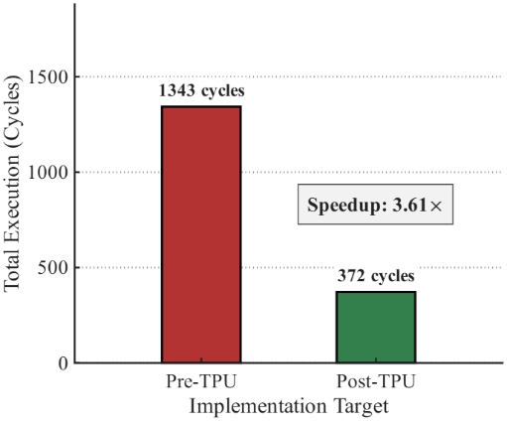 | 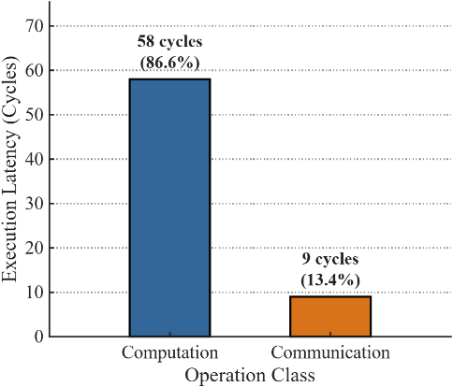

FIGURE 5. (a) TPU speedup comparison for the selected workload: 1343 pre-TPU cycles and 372 post-TPU cycles, with the plotted speedup of 3.61×. (b) TPU computation-versus-communication breakdown: 58 computation cycles and 9 communication cycles.

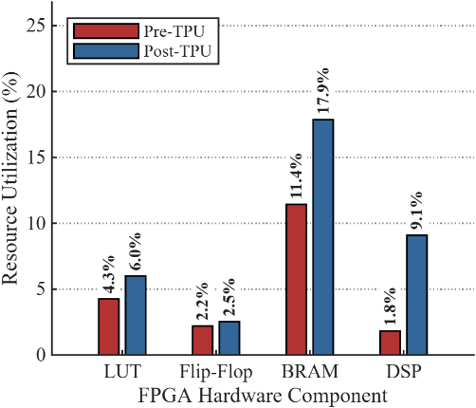

FIGURE 6. FPGA resource-utilization comparison before and after TPU integration for LUT, flip-flop, BRAM, and DSP resources.

TABLE 2.

Measurement | Cycles | Share of TPU total
Transmit | 7 | 10.4%
Compute | 58 | 86.6%
Receive | 2 | 3.0%
Total TPU path | 67 | 100%
Firmware sigmoid | 1343 | Software reference

VERIFICATION METHODOLOGY

The verification environment separates processor-driven stimulus from bus-directed stimulus, allowing the same SoC interface to be exercised through independent verification paths. Figure 8 shows the UVM environment structure, while Figure 9 presents the scope of the formal verification environment. Together, these components provide complementary simulation- and property-based checks of the SoC.

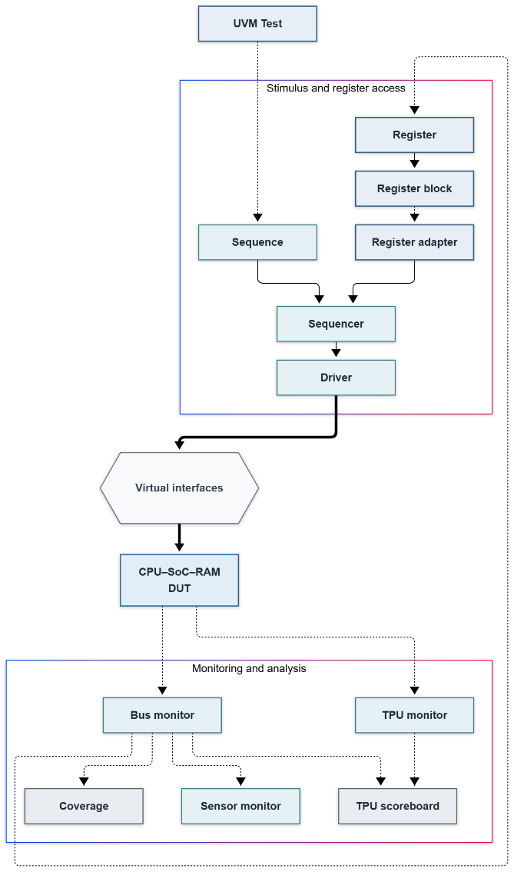

FIGURE 7. UVM verification architecture with active native-bus stimulus, passive monitors, RAL, TPU/sensor observation, and scoreboard-based checking.

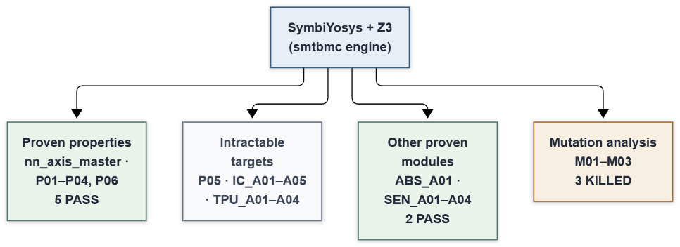
FIGURE 8. Formal verification architecture. Formal properties are attached at selected architectural boundaries, with deterministic environment models and a severed TPU datapath used to keep control-oriented proofs tractable.

- UVM Environment Structure

The UVM environment is organized around two main functions: stimulus and register access, and monitoring and analysis.
In the stimulus plane, the active native-bus agent consists of a virtual sequence (soc_tpu_seq), sequencer, and driver. The driver applies bus-level transactions to the DUT through the soc_native_if virtual interface. Register access is provided through the register abstraction layer (RAL), consisting of the register block (soc_reg_block), register adapter (soc_reg_adapter), and register predictor (soc_reg_predictor). The adapter converts RAL frontdoor operations into native-bus sequence items, which are sent to the sequencer. The predictor observes bus transactions through the monitor and updates the RAL mirror, keeping the register model synchronized with the observed DUT state.
In the monitoring and analysis plane, the native-bus monitor observes transactions on the SoC bus and distributes them to the TPU scoreboard, functional coverage collector, and sensor monitor. A dedicated TPU monitor independently observes the AXI-Stream interface and forwards the accelerator transactions to the TPU scoreboard. The scoreboard compares the observed TPU results with expected values generated by the C DPI-C reference model.
The same environment supports three verification modes. In directed firmware mode, the PicoRV32 processor generates the bus transactions while the verification components observe the resulting activity. In passive UVM mode, the firmware continues to drive the workload while UVM monitors, the scoreboard, and coverage components observe and analyze the transactions. In active UVM mode, the processor is held in reset and the UVM agent directly drives the native bus, allowing specific address regions, registers, and control conditions to be targeted independently of the selected firmware workload.

- RAL Register Models

The RAL subsystem covers the five memory-mapped peripheral windows: GPIO, RF telemetry, sensor status, VDP, and TPU. The TPU register block is located at base address 0x0001_4000 and models the complete MMIO register map, including control and status registers at offsets 0x00–0x04, weight registers W0–W4 at 0x10–0x34, input registers INPUT0–INPUT1 at 0x38–0x44, and read-only result registers RESULT0–RESULT1 at 0x50–0x5C.
RAL-based checks verify reset values, write retention for writable registers, read-only behaviour for result registers, START/BUSY control sequencing, and the response to unmapped offsets (see FIGURE 9.). The sensor register model is connected to the RNM-based sensor path and includes the corresponding ADC conversion and digital control interface, consistent with the sensor verification architecture (see FIGURE 10.).

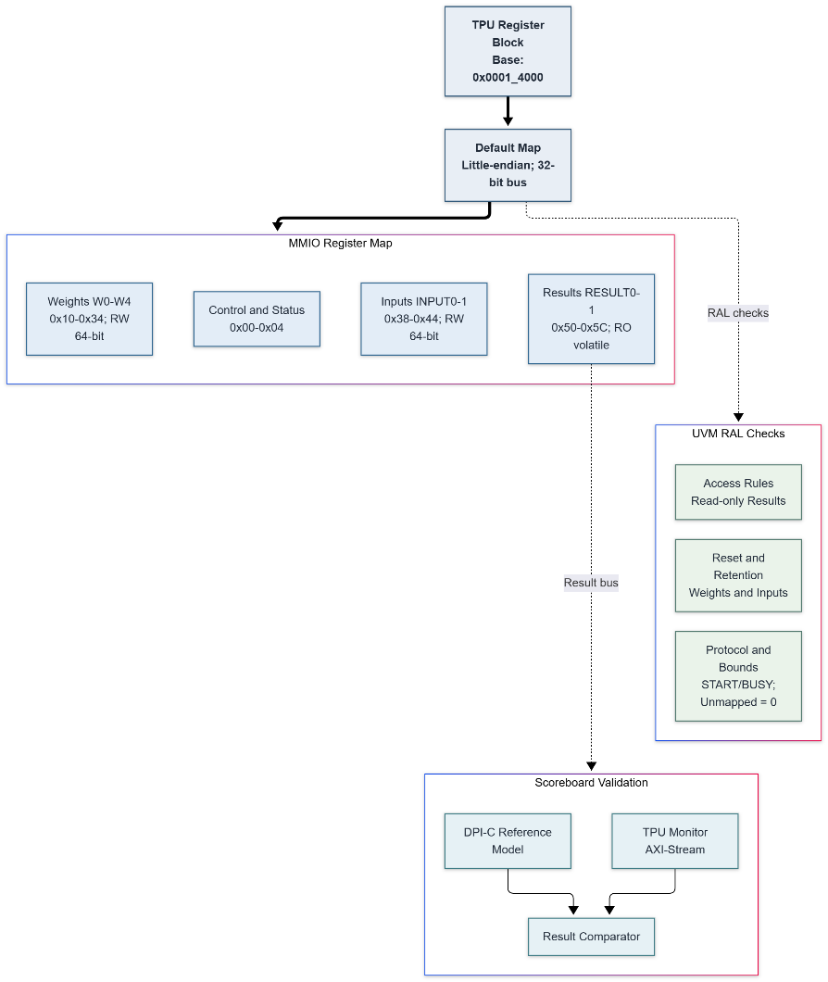

FIGURE 9. UVM verification architecture with active native-bus stimulus, passive monitors, RAL, TPU/sensor observation, and scoreboard-based checking.

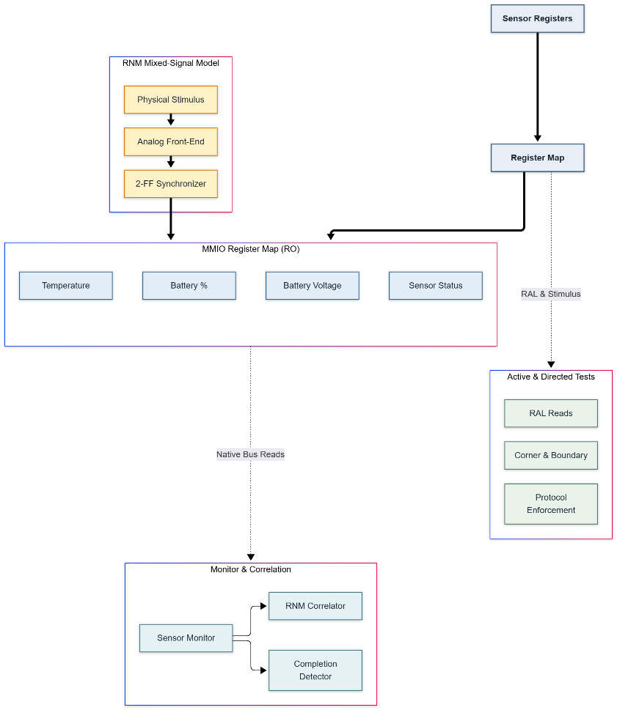

FIGURE 10. Sensor Subsystem Verification Architecture.
Block diagram showing the RNM mixed-signal front-end, digital MMIO register map, UVM RAL frontdoor access path, and monitor-based Python correlation flow.

- Test Descriptions

In passive UVM mode, the firmware continues to execute the selected workload while the UVM monitors, scoreboard, and coverage collector observe the resulting transactions. In active UVM mode, the processor is held in reset and the UVM agent directly drives the native bus. This allows targeted accesses to registers and address regions that are not exercised by the selected firmware workload and provides an independent stimulus path for mutation-based fault detection.

- Formal Verification Scope

Figure 9 illustrates the formal verification scope. Formal properties are checked using SymbiYosys with the SMT-BMC engine and Z3 solver. Rather than attempting to prove the complete SoC and TPU datapath as a single model, the verification is decomposed into smaller control, interface, and routing boundaries.
Five AXI-Stream properties on nn_axis_master are verified: TVALID stability (P01), payload stability (P02), transfer qualification (P03), TLAST behaviour on the final beat (P04), and BUSY/DONE sequencing (P06). Additional properties cover the abstract CPU/RAM interface, sensor peripheral behaviour, SoC interconnect routing, and TPU control behaviour. The TPU control properties are analyzed through a formal-only wrapper that isolates the control boundary and severs the numerical payload path responsible for excessive symbolic complexity. Similarly, deterministic mock-slave behaviour is used for interconnect analysis to constrain unnecessary downstream state.
These abstractions are used only for formal analysis and do not modify the production RTL. They allow control, routing, and interface properties to be verified at tractable boundaries, while numerical TPU behaviour is checked through simulation and reference-model comparison. The resulting formal campaign includes 30/30 passing TPU control-boundary runs across proof depths of 1, 2, 4, 6, 8, and 10, together with passing checks for the CPU/RAM abstraction, sensor properties, interconnect, and TPU interface.

VERIFICATION TEST PLAN
- Interface Details

TABLE 3.

Interface Name | Signals | Description
soc_native_if | Requests: m_valid, m_write, m_addr[31:0] , m_wdata[31:0], m_strb[3:0]  Responses: m_ready, m_rdata[31:0] | Native bus interface between the UVM agent and the SoC interconnect. In Active mode, the testbench forces the interconnect request inputs from this interface. The UVM driver holds requests until m_ready, captures m_rdata, then returns the bus to idle. The driver timeout is 500 cycles

- Firmware Testing

TABLE 4.

Firmware | Test case | Stimulus / check | Pass criteria
FW03 — TPU | Operand load and start | Write five weights and two inputs; issue START. | TPU accepts the programmed values and starts.
FW03 — TPU | Completion and results | Poll DONE; read RESULT0 and RESULT1; record results and elapsed cycles in debug RAM. | DONE occurs before the polling limit; success marker is written. Result values are not compared against expected values.
FW04 — Sensor | Telemetry and status | Read battery, voltage, temperature, and status; check reserved bits, battery-low threshold, and temperature alarm. | Reserved bits are zero; status flags match the sensor readings.
FW04 — Sensor | Unmapped read | Read sensor offset 0x10. | Read returns zero.
FW04 — Sensor | Read-only register | Write zero to battery percentage, then read it again. | Value remains unchanged.
FW04 — Sensor | Completion reporting | Record elapsed cycles and write the completion marker. | Success marker is written; failures record an error code and failure marker.

- Coverage Plan

TABLE 5.

Cover-group name | Coverpoint | Coverbins | Disable condition | Sampling event | Remark
soc_cg | cp_write | READ, WRITE | None | soc_cg.sample()  after the monitor observes m_valid && m_ready | Covers transaction direction.
soc_cg | cp_target | RAM, GPIO, RF, SENSOR, VDP, TPU, UNMAPPED; illegal bin UNKNOWN | None | Same completed-transaction sampling | Target is assigned from the transaction address. Unknown target values are illegal.
soc_cg | cp_strb | READ_STRB, BYTE0–BYTE3, HALFWORD_LOW, HALFWORD_HIGH, FULL_WORD, OTHER | None | Same completed-transaction sampling | OTHER is the default bin for strobe values not listed explicitly.
soc_cg | cp_addr | RAM_BASE, RAM_LOW, GPIO_RANGE, RF_RANGE, SENSOR_RANGE, VDP_RANGE, TPU_RANGE, UNMAPPED, OTHER_UNMAPPED | None | Same completed-transaction sampling | OTHER_UNMAPPED is a default bin; it also includes RAM addresses 0x100–0xFFFF, so its name is broader than “unmapped.”
soc_cg | cp_wdata | ZERO, ONES, AA, FIVE, OTHER | iff (tr.write) | Same completed-transaction sampling; sampled only for writes | Data patterns are 0x00000000, 0xFFFFFFFF, 0xAAAAAAAA, and 0x55555555; OTHER catches remaining values.
soc_cg | cp_ready | READY, NOT_READY | None | Same completed-transaction sampling | The monitor only publishes when m_valid && m_ready; therefore NOT_READY cannot be sampled with the current monitor.
soc_cg | cross_rw_target | Cross of cp_write × cp_target | None | Same completed-transaction sampling | Cross coverage for operation type and target.
soc_cg | cross_addr_target | Cross of cp_addr × cp_target | None | Same completed-transaction sampling | Intended to expose address/target mismatches.
soc_cg | cross_write_strb | Cross of cp_write × cp_strb, with ignored combinations | None | Same completed-transaction sampling | Ignores read transactions with write strobes and writes with READ_STRB.

- UVM Active Test
The sensor corner-case tests are F-12 (soc_active_sensor_corner_test), and the TPU corner-case tests are F-13 (soc_active_tpu_corner_test) given in the below Table

TABLE 6.

Feature Number | Feature Details and Description | Testcase Name
F-01 | Read sensor-window address 0x0001_2800; expect zero. | soc_active_sensor_test
F-02 | Read the sensor battery-percent register through RAL;  check UVM register access status. | soc_active_sensor_ral_test
F-03 | Read sensor-window unmapped addresses 0x0001_2800  and 0x0001_2FFC; expect zero for both. | soc_active_sensor_unmapped_test
F-04 | Read RF ID at 0x0001_100C; expect 0x5246_5430. | soc_active_rf_id_test
F-05 | Write 0xDEAD_BEEF to TPU address 0x0001_4010, then  read it back and compare. | soc_active_tpu_decode_test
F-06 | Write 0x0000_00FF to GPIO DIR at 0x0001_0008; the  driver must receive transaction completion. | soc_active_gpio_ready_test
F-07 | Write a word, update byte lane 1, then read  back 0xAABB_FFDD. | soc_active_ram_strobe_test
F-08 | Read unmapped SoC address 0x0001_F000; expect zero. | soc_active_unmapped_hang_test
F-09 | Read sensor battery status at 0x0001_2000; expect  0x0000_0050. | soc_active_sensor_status_test
F-10 | Through RAL, check the VDP color register’s default value,  write 0x0011_2233, then read it back. | soc_active_vdp_ral_test
F-11 | Through RAL, check TPU reset state, weight/input  readback, result-register write-ignore, unmapped access,  BUSY behaviour, start/DONE polling, and result reads. | soc_active_tpu_ral_test
F-12 | Exercise sensor read-only behaviour, battery  thresholds, temperature boundaries, signed  temperature formatting, and status-bit combinations. | soc_active_sensor_corner_test
F-13 | Exercise TPU reset and access permissions, unmapped  offsets, byte/halfword strobes, all-ones and zero  operands, START/DONE behaviour, and selected Q6.10 values. | soc_active_tpu_corner_test

- Summary of the Test Plan

TABLE 7.

Technique | Stimulus abstraction | Tool | Primary purpose
Directed firmware | PicoRV32 executes FW03 (TPU) or FW04 (sensor), loaded with $readmemh. | QuestaSim | Verify software-driven SoC operation and collect firmware markers and cycle counts.
Passive UVM | Firmware continues to drive the CPU bus; UVM monitors transactions and the TPU scoreboard checks results against a C reference model. | QuestaSim + UVM | Check processor-generated transactions without replacing firmware stimulus.
Active UVM | UVM sequences drive the interconnect through the native bus interface; the testbench forces interconnect inputs from that interface. | QuestaSim + UVM | Exercise targeted addresses, register behavior, and protocol cases directly.
UVM RAL | Frontdoor register reads and writes use soc_reg_adapter and the native-bus sequencer. | QuestaSim + UVM RAL | Check register mapping, reset/readback behavior, access permissions, and TPU control/status behavior.
Formal | SVA properties are checked with bounded model checking at selected architectural boundaries. | SymbiYosys / Yosys-SMTBMC + Z3 | Check protocol, routing, control, and sensor threshold properties.
RNM | SystemVerilog real-valued sensor model → ADC model → digital sensor interface. | QuestaSim RNM | Model the sensor signal path and examine behavior with noise settings.

FUNCTIONAL COVERAGE

Functional coverage measures which stimulus bins were reached during the UVM run. The merged coverage report lists a covergroup metric of 43.65% and records 26 of 109 bins as covered, with 83 uncovered. The covered-bin hit rate is 23.85% (26/109), as separately reported by the flow. Uncovered bins show stimulus that was not observed in this run; they do not, by themselves, indicate design defects. Coverage is considered alongside corner-case testing, mutation results, formal results, and reference-model checking.

TABLE 8.

Coverage metric | Reported result | Meaning in this study
Covergroup metric | 43.65% | Merged UVM coverage metric
Covered bins | 26 / 109 | 26 covered; 83 uncovered
Covered-bin hit rate | 23.85% | Separate bin-hit metric reported by the flow

CORNER-CASE VERIFICATION
The TPU corner-case tests check register access, unmapped addresses, partial byte writes, zero and maximum operand patterns, signed fixed-point values, and START/DONE behavior. The test also issues a START request while the TPU is busy; the source comments say the RTL ignores it, though the test does not explicitly check that behavior. The checked-in test source does not establish a total of 64 cases, so that count is omitted here.
Sensor tests check battery and temperature boundaries, status combinations, writes to read-only registers, and values affected by ADC quantization. Temperature is supplied as a real-valued input and passes through the modeled sensor and ADC conversion chain before reaching the digital sensor registers. The test source defines these checks; a simulation log is needed to confirm their pass results.

MUTATION-BASED VERIFICATION

Ten RTL mutants were evaluated using directed firmware, passive UVM, and active UVM. Directed firmware and passive UVM each detected two of the eight viable mutants (25%). Active UVM detected all eight (100%). The remaining two mutants, M05 and M09, were classified as functionally equivalent and are excluded from the detection-rate denominator.

TABLE 9. Mutation outcomes for ten injected RTL faults across directed firmware, passive UVM, and active UVM. M05 and M09 are classified as equivalent and excluded from the viable-mutant detection-rate denominator.

Mutant | Injected fault | Directed FW | Passive UVM | Active UVM
M01 | TPU base-address decode error | Detected | Detected | Detected
M02 | Sensor local-address bit-mask error | Escaped | Escaped | Detected
M03 | GPIO ready routed from RF | Unobservable | Unobservable | Detected
M04 | RF read data routed from sensor | Unobservable | Unobservable | Detected
M05 | VDP write control stuck low | Unobservable | Unobservable | Equivalent
M06 | RAM byte strobe forced to 4'hF | Escaped | Escaped | Detected
M07 | RF valid stuck low | Unobservable | Unobservable | Detected
M08 | Sensor decode compared against VDP base | Detected | Detected | Detected
M09 | RAM address LSBs forced low | Escaped | Escaped | Equivalent
M10 | Unmapped ready stuck low | Unobservable | Unobservable | Detected

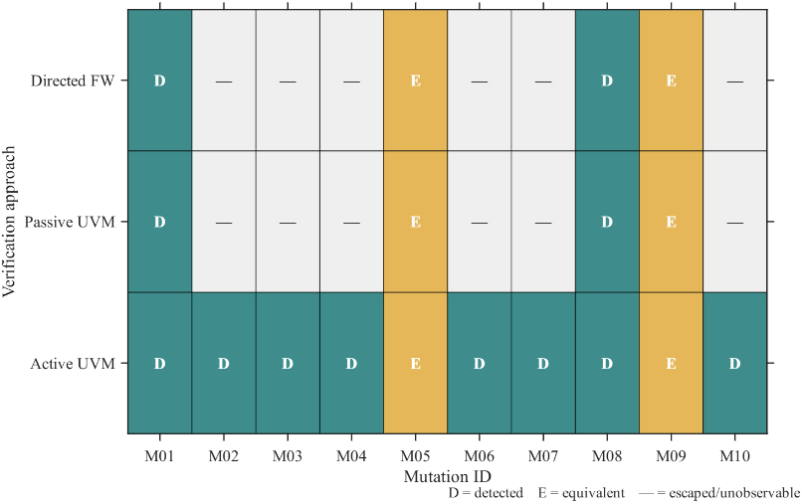 | 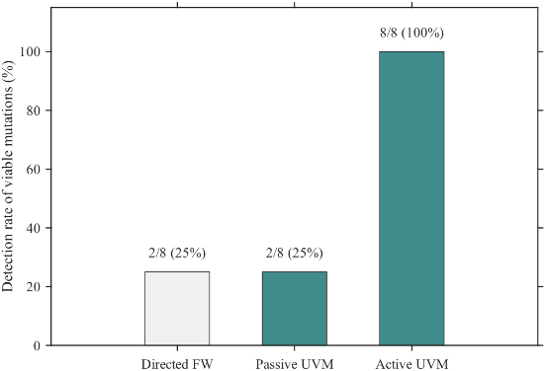
- (b)

Figure 11. Mutation-testing results: (a) Detection outcomes for each mutant across directed firmware, passive UVM, and active UVM; (b) detection rate among the eight viable mutants, with equivalent mutants M05 and M09 excluded.

FORMAL VERIFICATION
Formal checking targets selected design boundaries to keep the state space manageable. A CPU/RAM abstract-master run is recorded as passing at depth 10. For the TPU, a dedicated control-boundary harness checks START and transaction control without including the numerical payload datapath. Its five assertions passed in 30 bounded runs across depths 1, 2, 4, 6, 8, and 10. The two cover goals, axis_start and m_axis_tvalid, were reached at depths 6, 8, and 10.
The other saved results need qualification: the sensor checker’s assertions and covers are not shown as elaborated in its runs; the interconnect’s depth-10 run timed out, and its depth-1 PASS does not establish the bound checker’s properties; the TPU interface run is recorded as an error. These results therefore do not support claiming that all listed routing, sensor, and TPU-interface properties passed. Numerical datapath correctness is assessed through simulation and reference-model checking.

TABLE 10. Formal verification targets and recorded results

Formal target | Assertion properties / groups | Cover goals | Bound / depth | Recorded result
CPU/RAM abstract master | ABS_A01  group; multiple  assertions | None | 10 | PASS, bounded; uses an abstract bus master
Sensor interface | SEN_A01–A04 | SEN_C01–C08 | 10 | Not established: checker is not shown in the elaborated model; cover run reports no goals or traces
Interconnect | IC_A01–A03 | 2 cover  statements | Depth 1 and 10 attempted | No substantiated pass: depth-1 PASS does not establish checker properties; depth-10 run timed out
TPU interface | TPU_A01 group;  3 assertion  statements in source | TPU_C01–C03 | 10 | Not established: stored run reports an error; summary also records a timeout
TPU  control boundary | P05.1–P05.5 | 2 cover goals | 1, 2, 4, 6, 8, 10 | 30/30 bounded assertion runs PASS; both cover goals reached by depth 6

The TPU control cover logs show axis_start reached at step 3 and m_axis_tvalid at step 4. Formal results here is bounded and applies only to the stated properties and assumptions; it is not a proof of the complete PicoRV32 implementation or the TPU numerical datapath.

REAL-NUMBER MODELLING OF THE SENSOR PATH

Figure shows the RNM signal path: a SystemVerilog-real sensor model generates an analog voltage, the ADC model converts it into a digital sample, and the sensor registers expose the resulting values to the SoC over the native bus. The 84-case sweep included 42 noise-off and 42 seeded-noise cases across temperature and battery conditions. No alarm mismatches were reported.
As shown in Table 11, enabling noise increased temperature MAE from 0.714 to 4.524 tenths of a degree Celsius and RMSE from 0.845 to 4.726 tenths. The Pearson correlation between input temperature and MMIO temperature readback remained high: 1.000000 with noise off and 0.999997 with noise on. These results characterize the implemented RNM sweep; they do not measure physical sensor accuracy.

Table 11. RNM temperature-error metrics under noise-off and seeded-noise conditions. Correlation is Pearson’s r between input temperature and MMIO temperature readback.

Condition | Cases | MAE (tenths °C) | RMSE (tenths °C) | Correlation
Noise OFF | 42 | 0.714 | 0.845 | 1.000000
Noise ON | 42 | 4.524 | 4.726 | 0.999997

The heatmap shows pooled results and rounds the temperature correlation to 1.00; the table reports it separately for each noise condition.

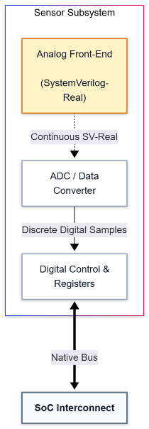

FIGURE 12. RNM sensor path from the SystemVerilog-real analog front end through ADC conversion and digital sensor registers to the SoC native bus.

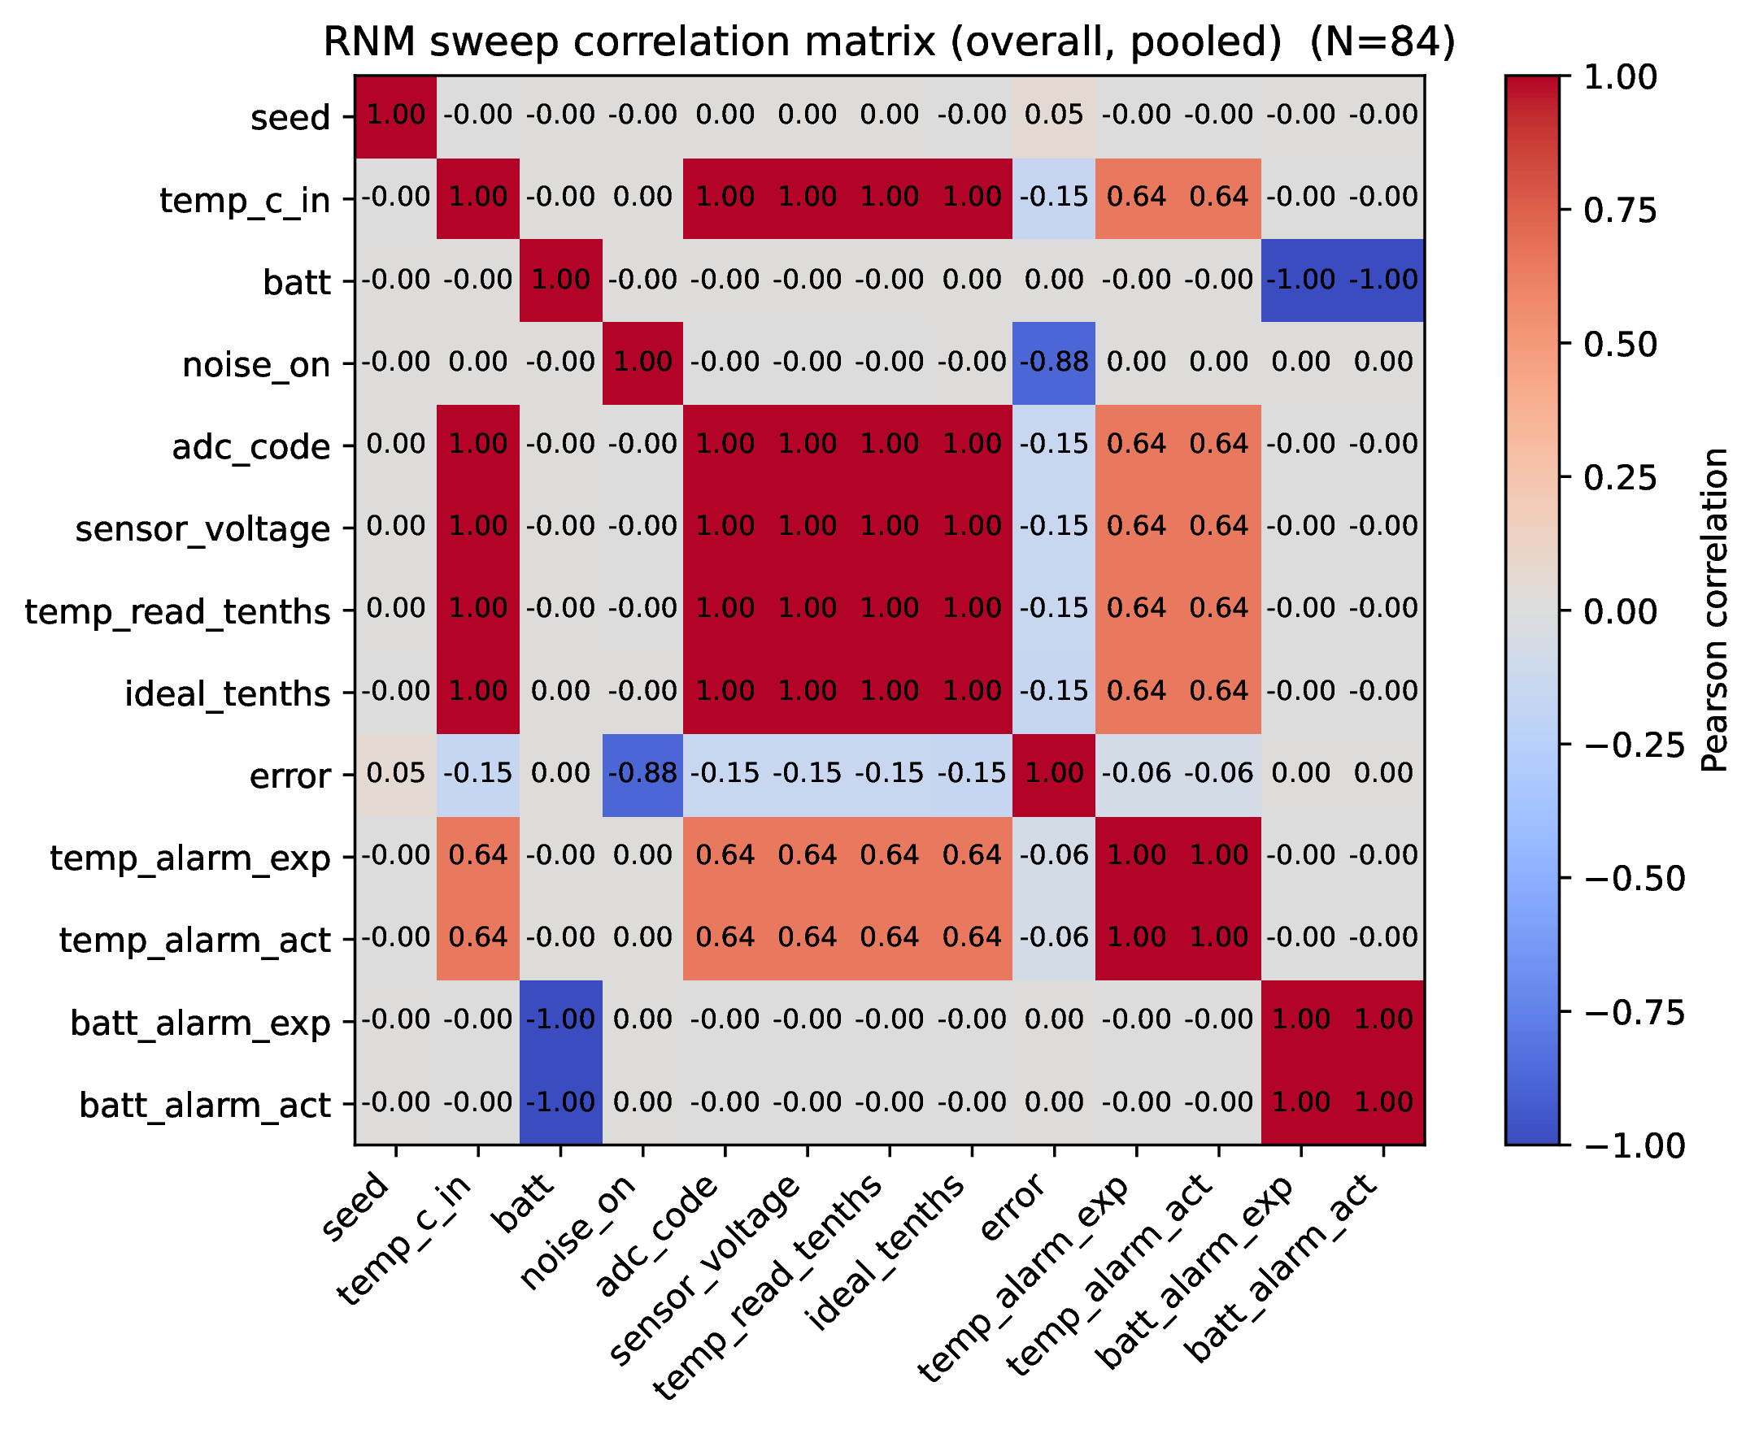
Figure 13. Pearson correlation matrix for the 84-point RNM sweep pooled across noise conditions. Values are rounded to two decimal places.

DISCUSSION
The results highlight the complementary roles of the verification methods. The firmware benchmark motivates accelerator integration by measuring workload performance. The TPU plots report accelerator transaction latency separately from the end-to-end measurement after TPU integration. Mutation testing adds another perspective: it evaluates whether the verification setup can detect deliberately injected faults.
The mutation results show how stimulus reachability affects fault detection. M02 escaped both directed firmware and passive UVM, but active UVM detected it by directly accessing the affected sensor boundary. M03, M04, M07, and M10 follow a similar pattern: they were unobservable along the firmware path used in these experiments, but active UVM detected them through direct native-bus stimulus. This reflects the limits of a particular workload’s stimulus, rather than a weakness in firmware-based verification generally.
Formal checking was applied to selected, tractable boundaries instead of the complete TPU numerical datapath. The targeted TPU control-boundary run reports five assertions passing across six bounded depths, from 1 to 10; its two cover properties were reached at the reported depths. Other formal runs encountered elaboration problems or timeouts, so the results support claims about the successfully checked properties only. They do not establish correctness of the complete processor or TPU datapath.
The RNM campaign provides model-level results for the sensor subsystem. Across the reported 84 cases, seeded noise increased temperature-error MAE while the reported correlation remained near one. These figures describe the implemented RNM model and parameter sweep; they are not measurements of a physical sensor. RNM/DMS is also used as an abstraction for mixed-signal verification [7], [8].
For the TPU computation, the MATLAB script uses the firmware’s input and weight constants to calculate a floating-point reference, while the hardware stores results in Q5.10. The script also converts the reference outputs to Q5.10 for comparison with the UVM results. The reported values, 0x02BD for the reference and 0x02A9 for the hardware, therefore indicate a small numerical difference. Their decoded values round to the same classification, 1, for this example. This supports agreement at the classification level; it does not show bit-exact agreement.

Table 12. MATLAB reference and TPU hardware comparison for a representative output
Check | MATLAB reference | TPU hardware | Observation
Computation representation | Floating-point calculation, with output converted to Q5.10 for comparison | Q5.10 fixed-point | Different arithmetic representations
Representative raw output | 0x02BD* | 0x02A9 | Small representation difference
Decoded output | Approximately 0.67 | Approximately 0.67 | Close values
Rounded classification | 1 | 1 | Same classification
*The MATLAB script calculates the expected register values at runtime; confirm that the generated output for this run is 0x02BD before publishing the table. The script’s listed UVM result0 ends in 0x02A9, but the 0x02BD value is not written as a literal in the source.

For the firmware’s input and weight values, the MATLAB reference and UVM hardware results are close across all eight outputs. Their raw Q5.10 values differ, but decoding and rounding produce the same classification sequence: 1, 0, 0, 1, 0, 1, 0, 1. The largest difference between the plotted values is approximately 0.0194. This comparison shows agreement for this test case; it does not demonstrate bit-exact equivalence.

FIGURE .

MATLAB reference and UVM TPU output comparison for the eight output elements. The values differ slightly, while their rounded classifications agree.

FINAL RESULTS
The integration results show a reduction from 1,343 cycles before TPU integration to 372 cycles after integration, corresponding to the reported 3.61× speedup. The accelerator-level plots report a latency of 67 cycles, comprising 7 setup, 58 computation, and 2 completion cycles. A separate breakdown reports 58 computation cycles and 9 communication cycles, also totaling 67 cycles. These figures describe distinct measurements: the 67-cycle accelerator latency is not treated as the 372-cycle post-integration execution time.

CONCLUSION
This study examined both TPU integration and verification in a RISC-V SoC. For the selected sigmoid workload, execution took 1,343 cycles before TPU integration and 372 cycles in the post-TPU benchmark, corresponding to the reported 3.61× cycle comparison. The TPU transaction path was measured separately at 67 cycles.
Using several verification methods revealed behaviors that a single method could miss. Active UVM detected all eight viable injected faults, including faults that the tested firmware flows did not expose. Formal checks covered selected properties at tractable design boundaries, and RNM was used to study the modeled sensor response, including the effect of seeded noise.
These findings apply to the workloads, RTL, mutations, formal boundaries, and RNM conditions evaluated here. Taken together, they offer a practical assessment of the integration and verification results without claiming that every possible design behavior has been explored.

ACKNOWLEDGMENTS
The author thanks the open-source hardware and verification communities whose tools and standards support the implementation and evaluation flow used in this work.

REFERENCES

1. RISC-V International, “The RISC-V Instruction Set Manual, Volume I: Unprivileged Architecture,” Version 20260120 (2026). https://docs.riscv.org/reference/isa/unpriv/unpriv-index.html

2. C. Wolf, “PicoRV32: A Size-Optimized RISC-V CPU,” YosysHQ, source repository and documentation. https://github.com/YosysHQ/picorv32

3. Accellera Systems Initiative, “Universal Verification Methodology (UVM),” IEEE 1800.2 reference implementation and documentation (2020–2026). https://www.accellera.org/downloads/standards/uvm

4. IEEE, “IEEE Standard for SystemVerilog—Unified Hardware Design, Specification, and Verification Language,” IEEE Std. 1800-2023. https://standards.ieee.org/ieee/1800/7743/

5. YosysHQ, “SymbiYosys,” formal hardware verification workflow documentation. https://github.com/YosysHQ/SymbiYosys

6. Microsoft, “Bitvectors | Online Z3 Guide,” Z3 theorem prover documentation. https://microsoft.github.io/z3guide/docs/theories/Bitvectors/

7. Accellera Systems Initiative, “Universal Verification Methodology for Mixed-Signal (UVM-MS) 1.0” (2025). https://www.accellera.org/images/downloads/standards/uvm-ms/UVM-MS_1.0.pdf

8. N. Georgoulopoulos, T. Mamali, and A. A. Hatzopoulos, “Design and Verification of a SAR ADC SystemVerilog Real Number Model,” Journal of Electronic Testing 40, 315–328 (2024). doi:10.1007/s10836-024-06124-8.

9. J. Wu, Y. Lei, Z. Zhuo, X. Meng, D. Yang, P. Li, J. He, and X. Mao, “Mantra: Mutation Testing of Hardware Design Code Based on Real Bugs,” in Proc. 60th ACM/IEEE Design Automation Conference (DAC), 2023, pp. 1–6. doi:10.1109/DAC56929.2023.10247962.

10. V. Jiménez, M. Rodriguez, M. Dominguez de la Rocha, J. Sans, I. Díaz Ortega, L. Valente, V. L. Guglielmi, J. V. Quiroga Esparza, R. I. Genovese, N. Sonmez, and O. Palomar, “Functional Verification of a RISC-V Vector Accelerator,” IEEE Design & Test 40(3), 36–44 (2023). doi:10.1109/MDAT.2022.3226709.

11. AMD, “Vivado Design Suite User Guide: Synthesis (UG901)” and “Vivado Design Suite User Guide: Implementation (UG904)” (2026). https://docs.amd.com/r/en-US/ug901-vivado-synthesis; https://docs.amd.com/r/en-US/ug904-vivado-implementation

12. J. D. Hunter, “Matplotlib: A 2D Graphics Environment,” Computing in Science & Engineering 9(3), 90–95 (2007). https://matplotlib.org/stable/

13. Ween's Lab, “Part 8: Hardware Accelerator for Neural Networks,” ZYNQ FPGA Tutorial, Ween's Lab, 2025. https://weenslab.gitbook.io/pages/fpga-tutorials/zynq-fpga-tutorial/part-8-hardware-accelerator-for-neural-networks

14. VerificationGuide.com, “SystemVerilog/UVM Verification Resources.” http://www.verificationguide.com/

15. A. Kapoor, “vsd-riscv: Advanced Embedded Systems,” project source repository, GitHub. https://github.com/KapoorAkshit18/vsd-riscv

16. D. Welch, “picorv32_samples: PicoRV32 samples and source,” GitHub repository. https://github.com/dwelch67/picorv32_samples

17. FOSSi Foundation, “FOSSi Foundation,” technical video resources. https://www.youtube.com/@FOSSiFoundation

18. FOSSi Foundation, “M14 - 1 - Introduction to Video Displays,” video lecture. https://www.youtube.com/watch?v=QIybt6PHK8s

19. A. Kostovic, “Riscy-SoC,” project source repository. https://github.com/AleksandarKostovic/Riscy-SoC

20. W. Pan, “How Systolic Arrays Work,” William Pan Blog, March 31, 2025. https://william-pan.com/blog/systolic-array

21. M. K. Minhas, H. Waris, Y. Farooq, N. Mohyuddin, and S. Baloch, “Coverage-Driven and Constrained-Randomized Sub-System Level Verification Methodology for RISC-V Based SoCs,” in Proc. 20th International Bhurban Conference on Applied Sciences and Technology (IBCAST), 2023.

22. K. Salah, “A UVM-Based Smart Functional Verification Platform: Concepts, Pros, Cons, and Opportunities,” in Proc. 9th International Design and Test Symposium, 2014.

23. J. Ye, D. Pan, H. Liu, Y. Hu, J. Zhou, K. Xu, X. Fang, X. Wang, N. Guan, and Z. Jiang, “UVmarvel: an Automated LLM-aided UVM Machine for Subsystem-level RTL Verification,” in Proc. 63rd ACM/IEEE Design Automation Conference (DAC), 2026.

24. Y. Yu, “Functional Verification of SPI Controller using UVM,” Master’s thesis, Department of Electrical and Information Technology, Faculty of Engineering, Lund University, 2026.

25. A. Bhaskar and P. Goyal, “Coverage Driven and Assertion Based Verification of I2C and SPI Protocols using SystemVerilog and UVM for Scalable VLSI Systems,” in Proc. 13th International Conference on Microelectronics, Circuits and Systems (Micro2026), 2026.

26. S. Balasubramanian and P. Hardee, “Solutions for Mixed-Signal SoC Verification Using Real Number Models,” Cadence Design Systems, technical paper.

