**CS5590 Bigdata Programming - Lab Assignment 2**

Team Id : 14

Member 1 : Ruthvic Punyamurtula Member 2 : Shankar Pentyala

Class Id : 16 Class Id : 15

**Hive Usecase**

Question 1:

Hive,we choose heroes information data set.

Sample data:

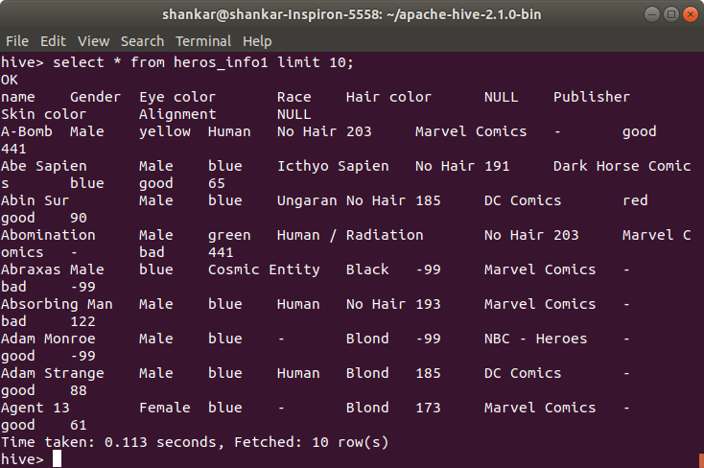

**Query :**

**1.**

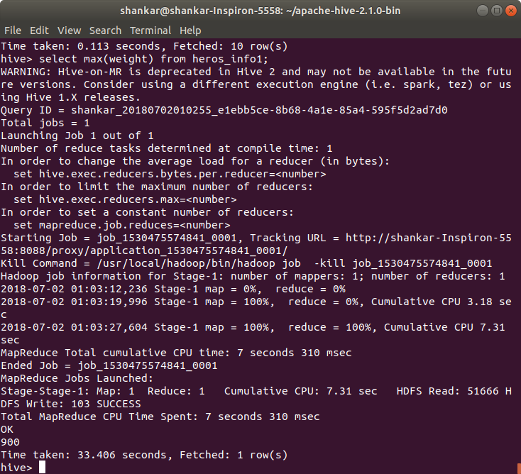

**The maximum weight of any super hero is 900.**

**Time taken : 33.406 seconds**

**2.**

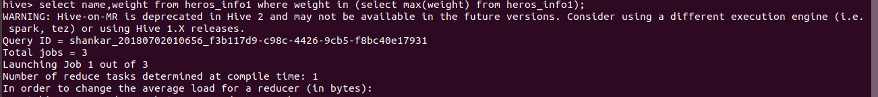

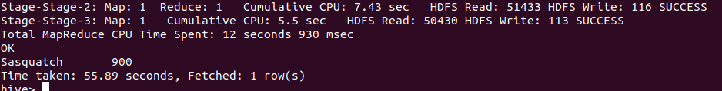

**The super hero who has maximum weight is sasquatch.**

**Time taken : 55.89 seconds**

**3. Number of male super heroes are:**

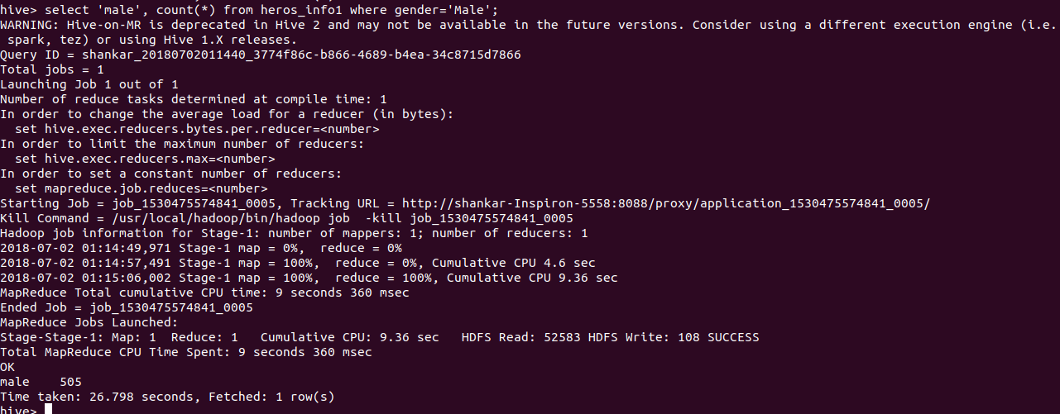

**Male 505**

**Time taken : 26.798 seconds**

**4. Number of female super heroes are :**

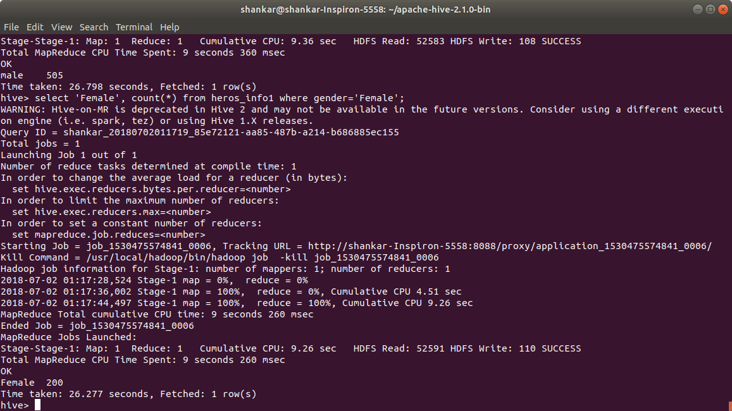

**Female 200**

**Time taken 26.277 seconds**

**5. List of Top super heroes publishers:**

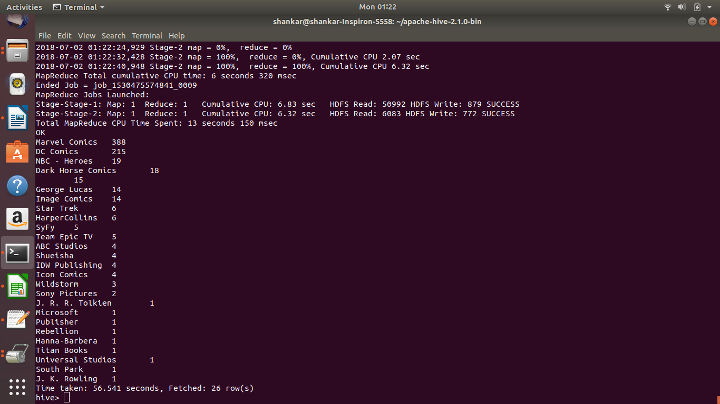

**Marvel Comics stands first with 388 publishes**

**Time taken : 56.541 seconds**

**6. Trending Super Heroes Eye color**

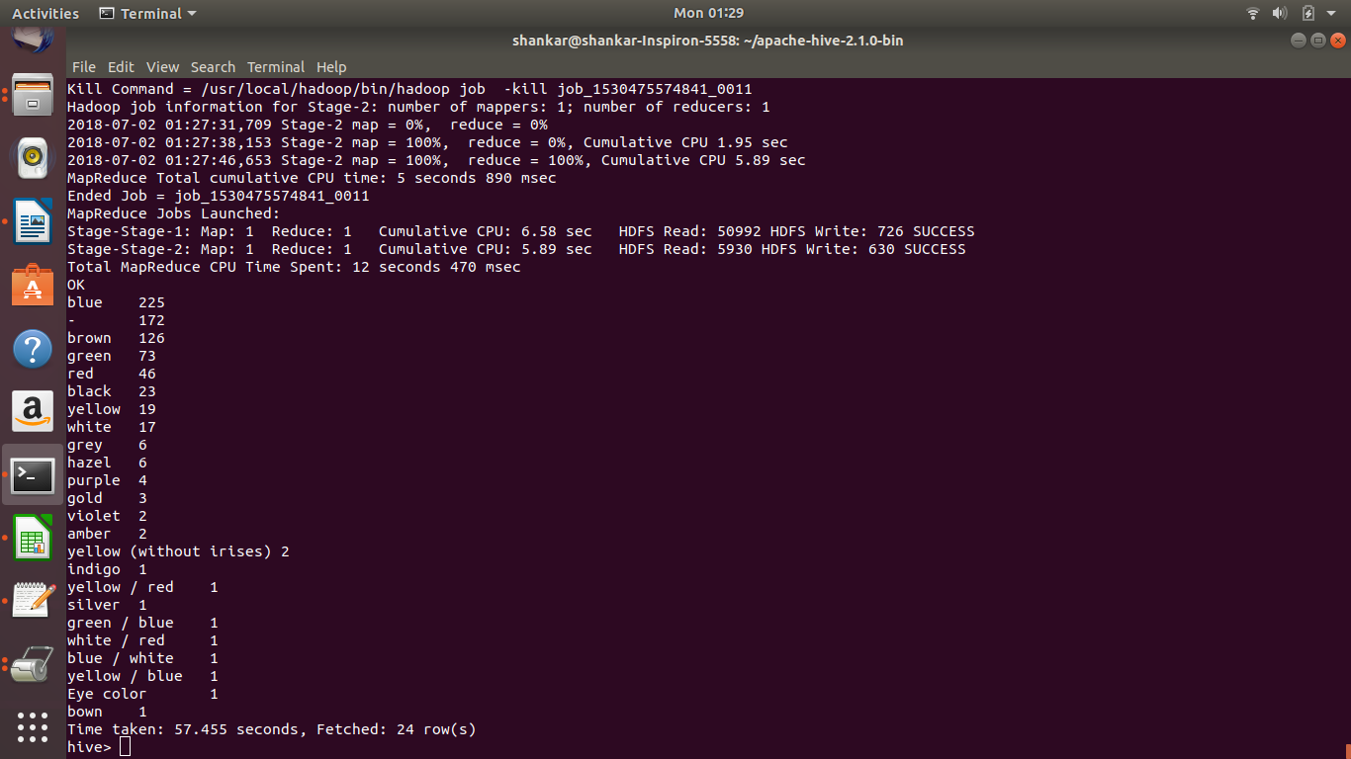

**Blue is Trending**

**Time Taken : 57.455 seconds**

**7. Trending super hero :**

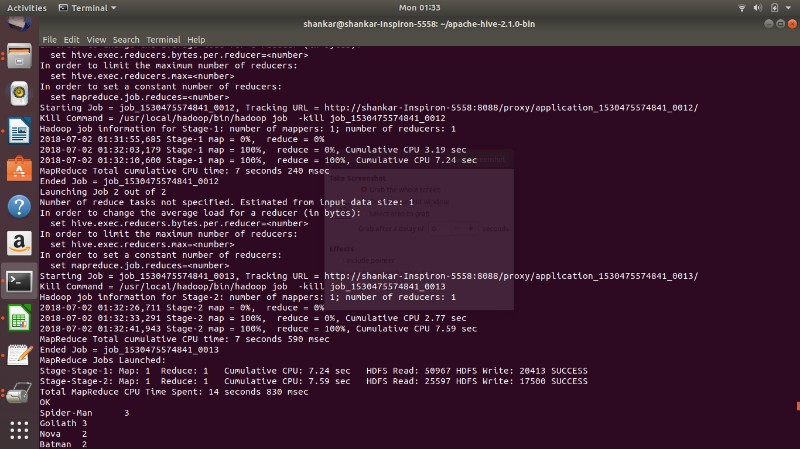

**Spider Man is the trending super hero**

**Time taken : 58.464 seconds**

**8. Super Heroes who has gone bald ;-)**

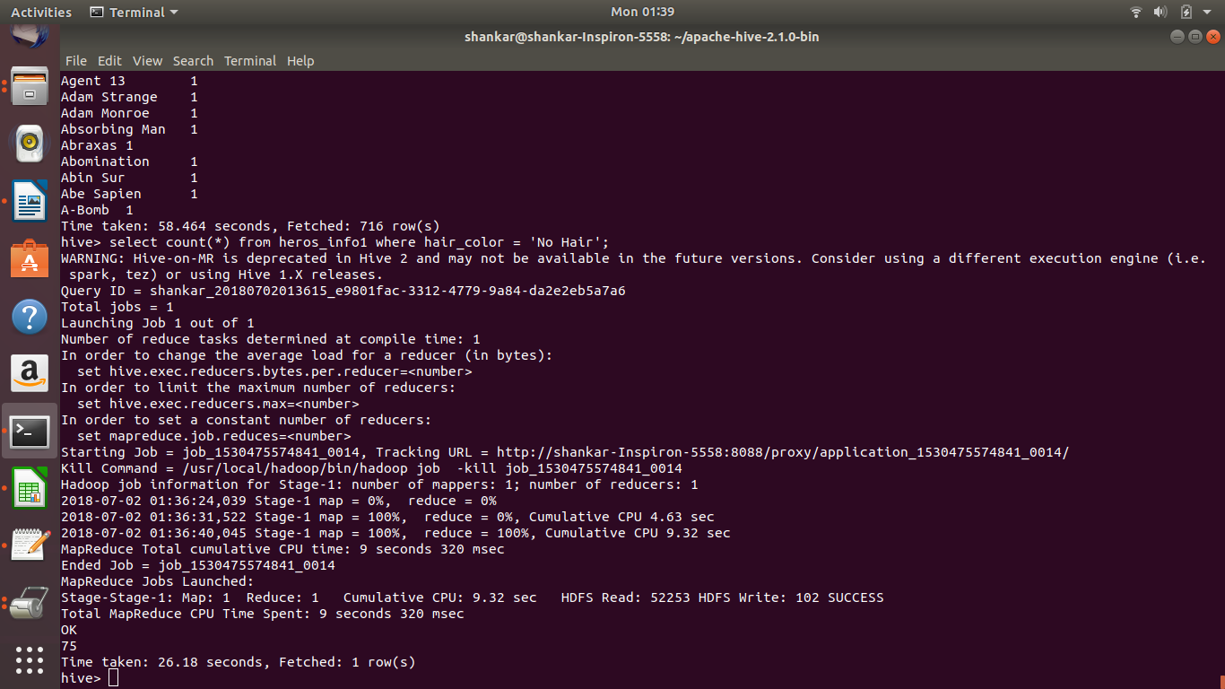

**There are 75 super heroes who have no hair.**

**Time taken : 26.18 seconds.**

**9. Black Super Heroes?**

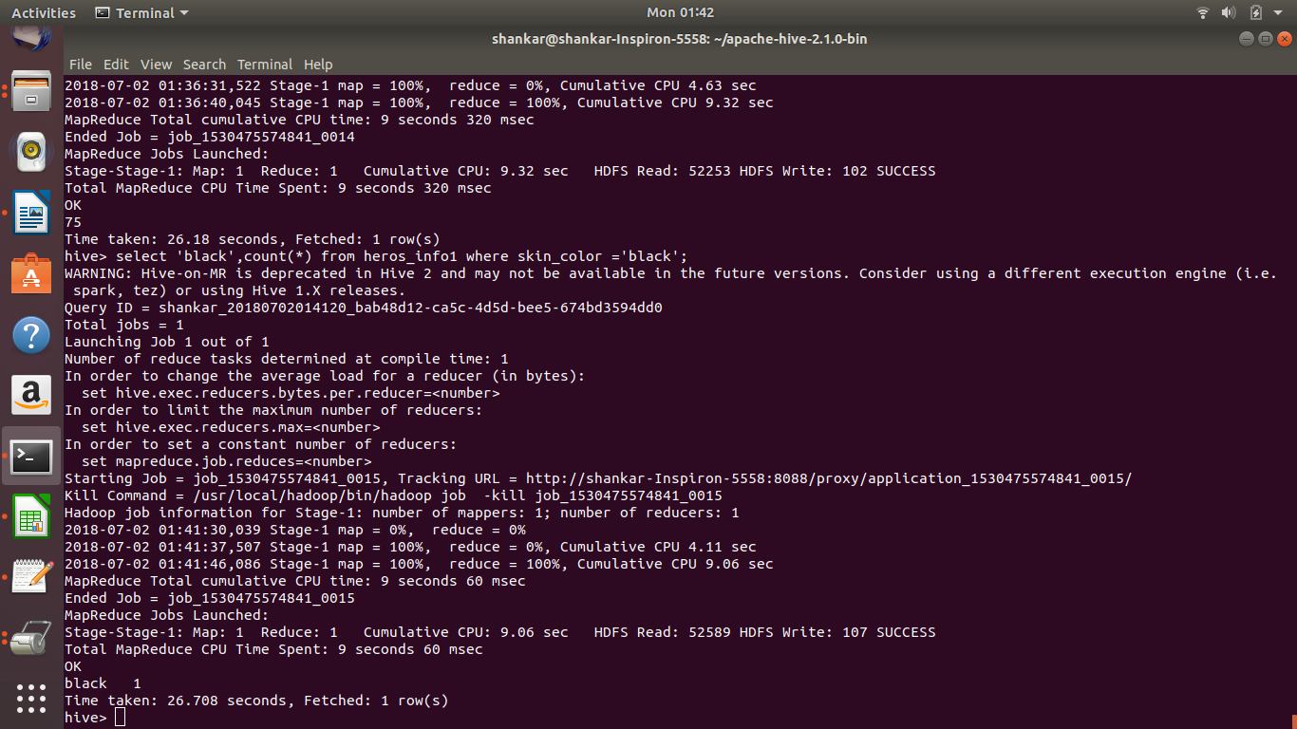

**Unfortunately,there is only 1 black super hero.**

**Time taken : 26.708 seconds**

**10. Vampires?**

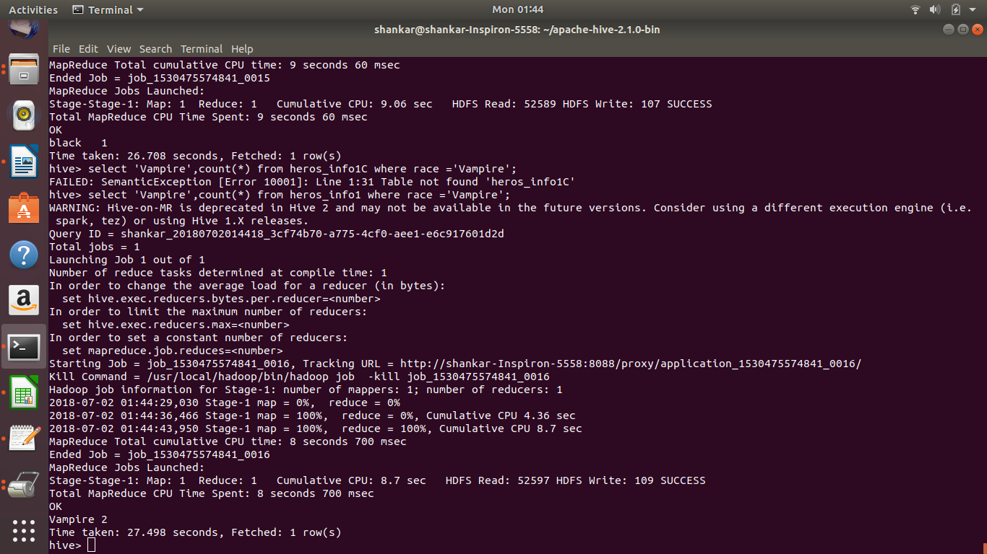

**2 of the super heroes are Vampires.**

**Time taken : 27.498 seconds.**

**Solr Usecase**

**Q1. Finding super heroes with bald hair**

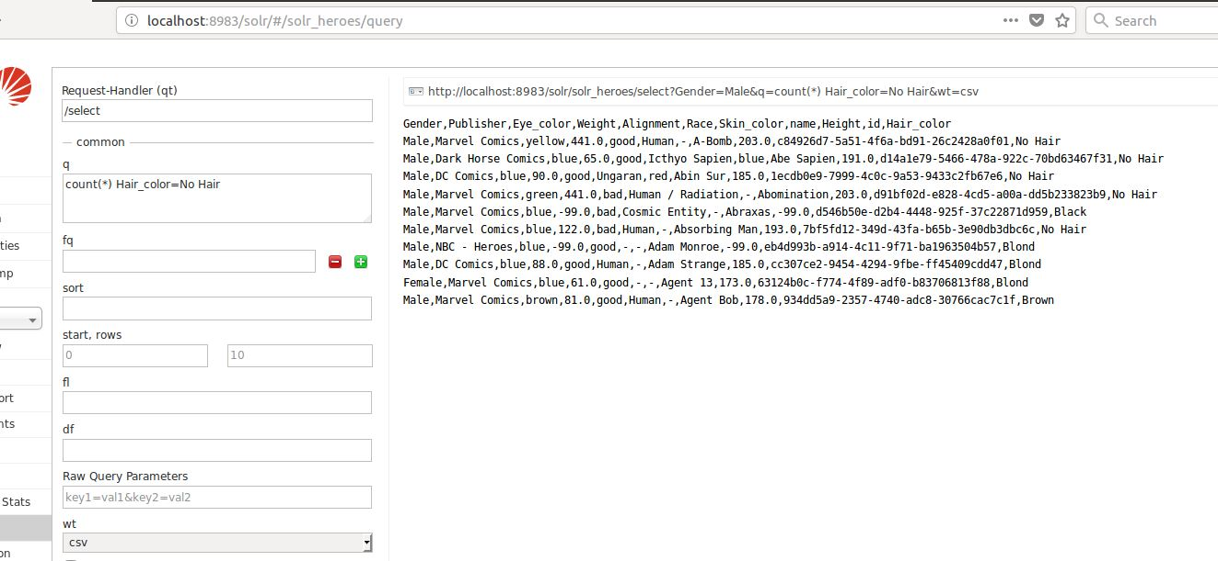

**Time elapsed : 15msec**

**Q2. Retrieving the details of “New God”**

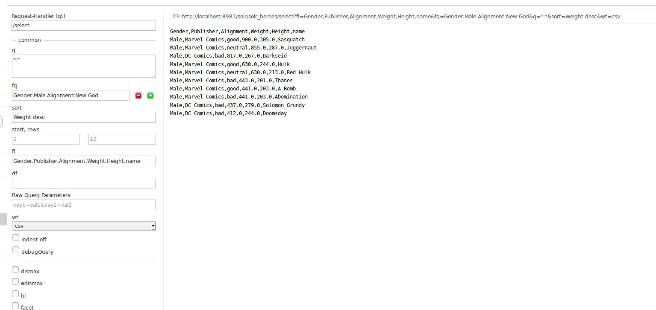

**Time elapsed : 2msec**

**Q3. Details of super heroes published by marvel and those who have blue eyes**

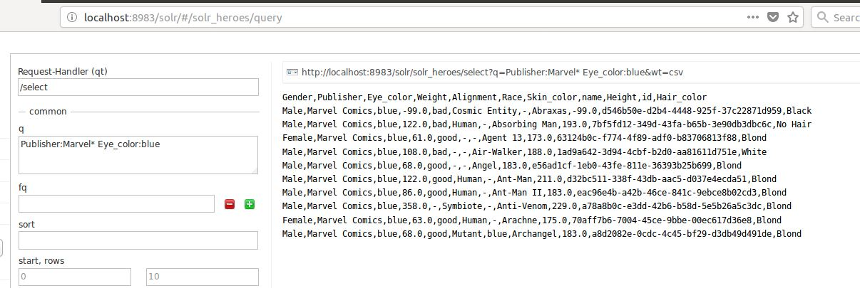

**Time elapsed : 5msec**

**Q4 . Super heroes between weight range 200-300**

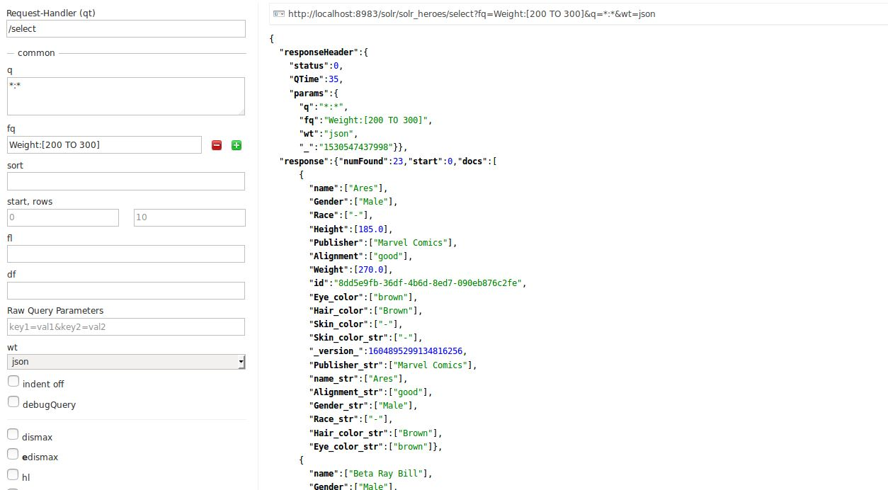

**Time elapsed : 35msec**

**Q5. Retrieving the top 10 male with weight in descending order**

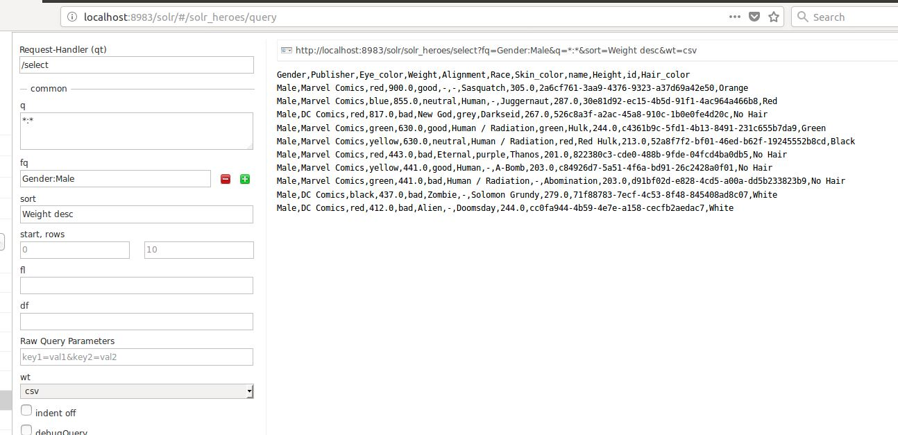

**Time elapsed : 10msec**

**Q6. Retrieving the top 10 female with height in descending order**

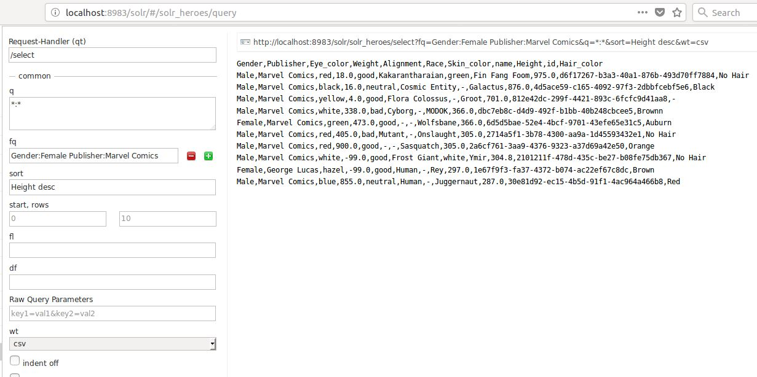

**Time elapsed : 10msec**

**Q7. Facet query with field as Publisher**

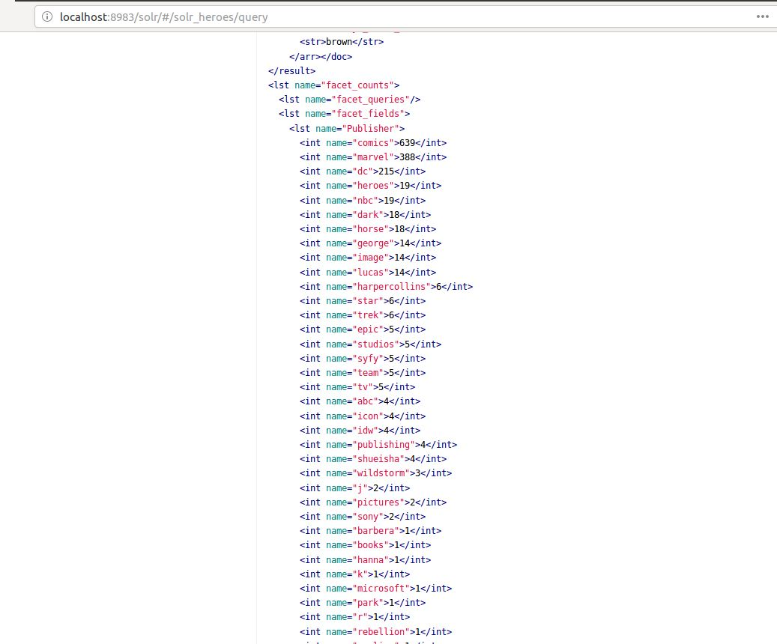

**Time elapsed : 30msec**

**Q8. Details of super heroes with type as Vampire**

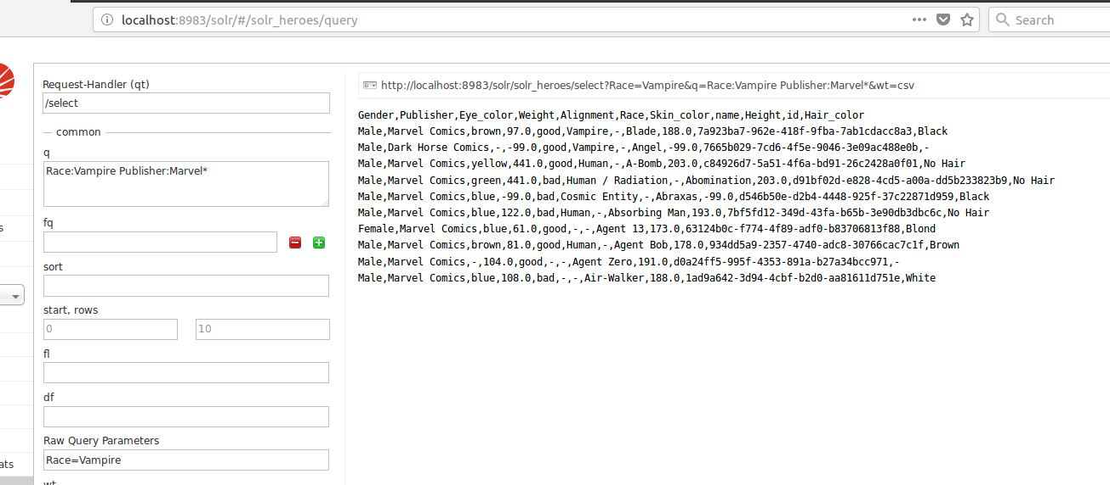

**Time elapsed : 15msec**

**Q9. Count the number of male super heroes**

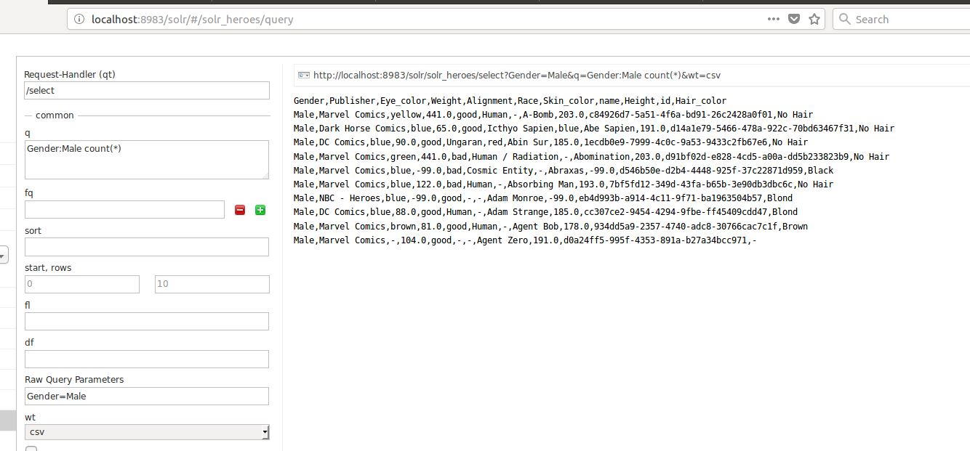

**Time elapsed : 5msec**

**Q10 . Count the number of female super heroes**

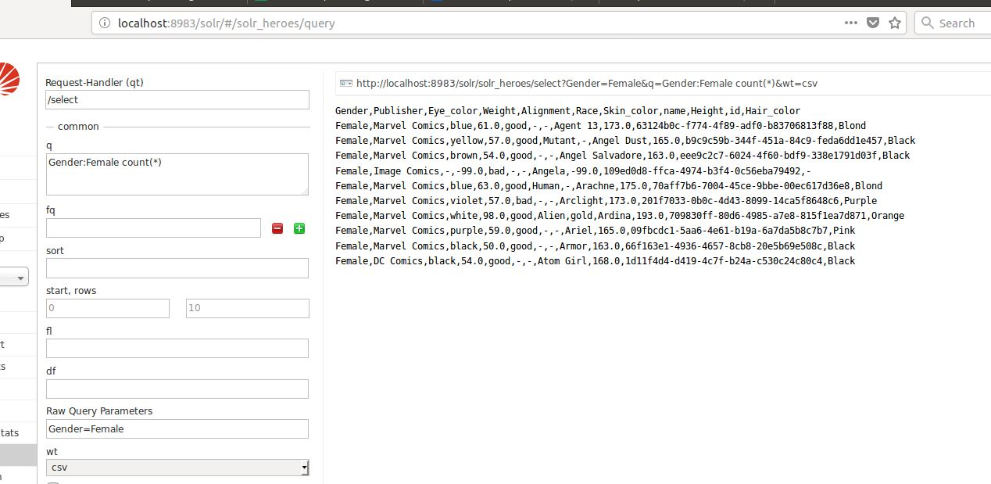

**Time elapsed : 3msec**

**-------------------------------------------------- Thank you ----------------------------------**