**CS/SE 6360.002/003- Assignment 3**

**Due Date:** October 16, 2016

**1.** A database is being constructed to keep track of the teams and games of a sports league. A team has a number of players, not all of whom participate in each game. It is desired to keep track of the players participating in each game for each team, the positions they played in that game, and the result of the game. Design an ER schema diagram for this application, stating any assumptions you make. Choose your favorite sport (e.g., soccer, baseball, football).

**2.** Following is the data requirements for an art museum:

* The museum has a collection of ART_OBJECTS . Each art object has a unique IDNo, and Artist, if known, a Year (when created, if known) a Title and a Description. The art objects are categorized in several ways, as discussed below.
* ART_OBJECTS are categorized based on types. There are three main types, Painting, Sculpture and Statue, plus an ‘Other’ category for those that don’t fit into one of the main types.
* A PAINTING has a PaintType (oil, watercolor, etc) a material on which it is CrawnOn (paper, canvas, wood) and Style (modern, abstract etc)
* A SCULPTURE or a STATUE has a Material from which it was created (wood, stone, etc) Height, Weight and Style.
* An art object in the OTHER category has a Type(print, photo, etc) and Style.
* ART_OBJECTS are also categorized as PERMANENT_COLLECTION, which are owned by the museum (DateAcquired, whether it is OnDisplay or Stored and Cost) or BORROWED, which has information on the Collection (where it was borrowed from), DateBorrowed, and DateReturned.
* ART_OBJECTS also have information describing their country-culture using information on country/culture of Origin (Italian, Egyptian, American, Indian etc) and Period(Renaissance, Modern, Ancient)
* The museum keeps track of ARTISTS’s information, if known: Name, DateBorn, DateDied, CountryOfOrigin, Period, MainStyle and Description. The name is assumed unique.
* Different EXHIBITIONS occur, each having a Name, StartDate and EndDate. EXHIBITIONS are related to all the art objects that were on display during the exhibition.
* Information is kept on other COLLECTIONS with which the museum interacts, including Name (unique), Type (museum, personnel etc), Description, Address, Phone and ContactPerson.

**a.** Draw an EER diagram for this application. Discuss any assumptions you make.

**b.** Map the designed EER diagram to relational schema.

**3.** Consider the ER diagram in following figure. Map the given conceptual schema to relational database schema.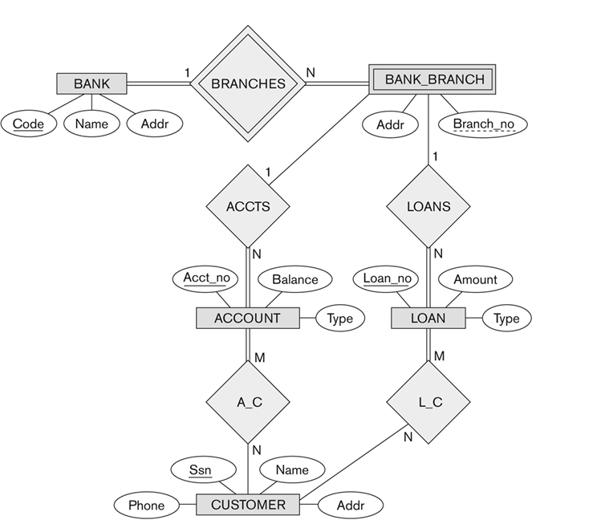

**4.** Consider the EER diagram in below figure for a car dealer. Map the EER schema into a set of relations. For the VEHICLE to CAR/TRUCK/SUV specialization, consider the four options (8A, 8B, 8C, 8D) and show the relational schema design for all options.

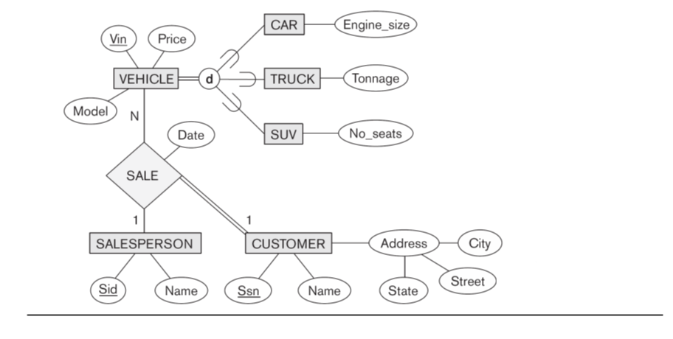

**Each item (1, 2a, 2b, 3, 4) is 20 points.**