CLINTIX

BHUVANESWARI KAPULURU

FOUNDER @ CLINTIX

ONLINE RETAIL ANALYSIS

By CLINTIX

[clyntix@gmail.com](mailto:clyntix@gmail.com)

+91 9490710484

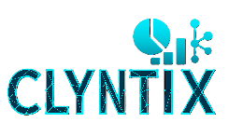

**Online Retail Analysis**

**1. Business Problem**

The retail dataset contained millions of transactions, but business teams lacked insights into customer loyalty, churn, and seasonal patterns. Without analytics, marketing campaigns struggled to target the right customers.

**2. Objective**

To analyze large-scale retail transactions using Python and uncover:

* Patterns in customer loyalty and churn.
* Seasonal sales spikes.
* High-value and at-risk customers.

**3. Technology Stack & Skills Applied**

* **Tools & Platforms:** Python, Pandas, Matplotlib
* **Skills:** Exploratory Data Analysis (EDA), Data Cleaning, RFM Segmentation, Visualization, Statistics
* **Database:** CSV Transaction Data

**4. Solution Approach**

1. **Data Cleaning –** Processed 500K+ records, handled nulls, duplicates, and inconsistencies.
2. **EDA –** Explored seasonal sales, churn trends, and product demand patterns.
3. **RFM Segmentation** – Classified customers as loyal, potential loyal, at-risk, or churned.
4. **Visualization –** Built Python plots for revenue trends, customer segments, and loyalty metrics.

**5. Key Insights & Business Impact**

* Increased **campaign targeting accuracy by 30%**.
* Identified high-value customers and designed loyalty-focused campaigns.
* Flagged churn-prone customers for retention strategies.

**6. Visuals / Screenshots**

*Placeholders for monthly revenue trends, RFM segmentation charts, and churn rate visualizations.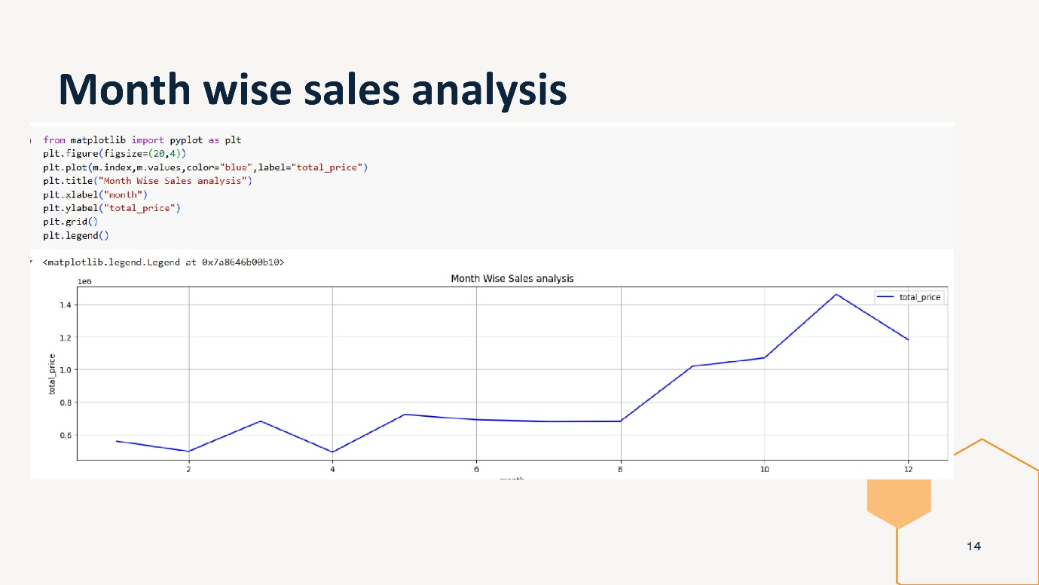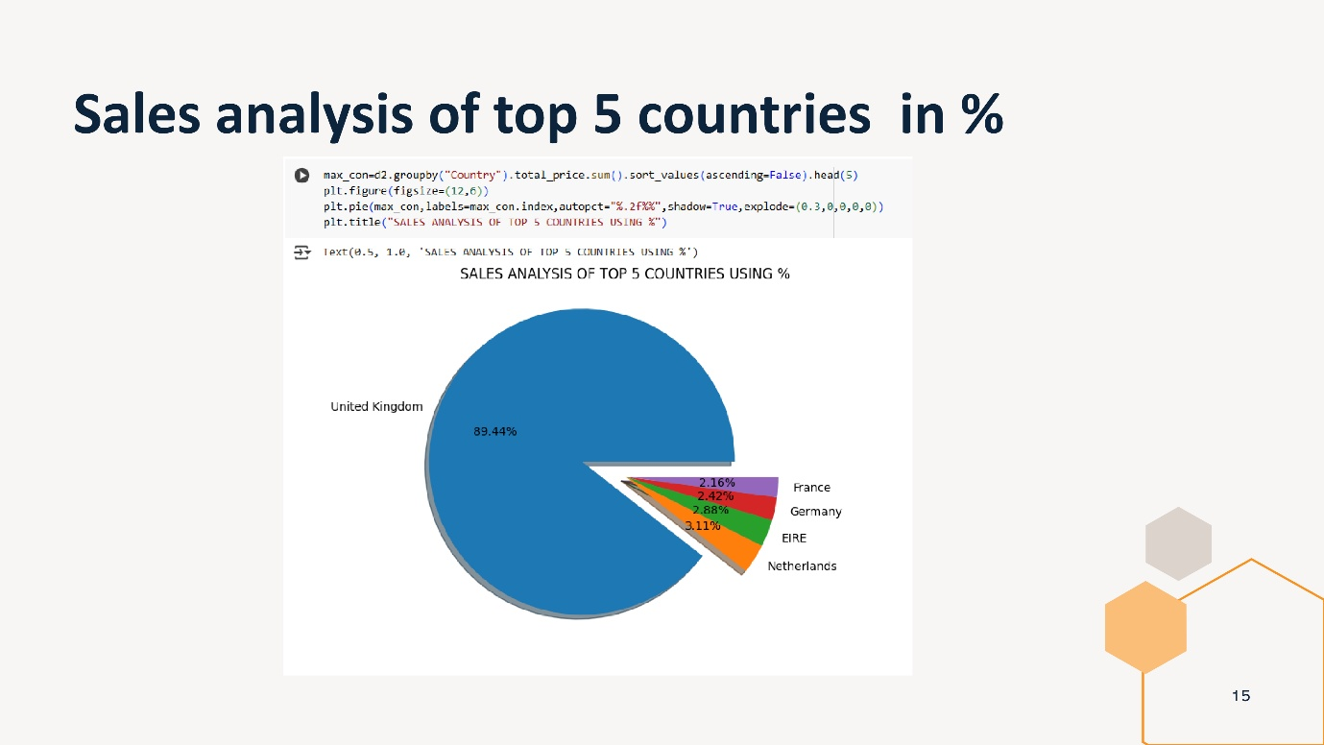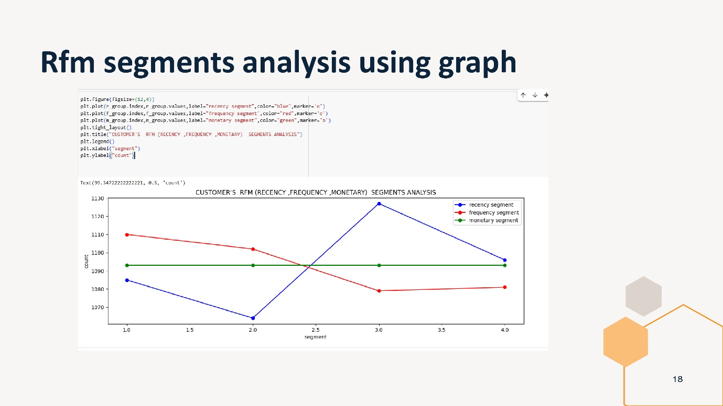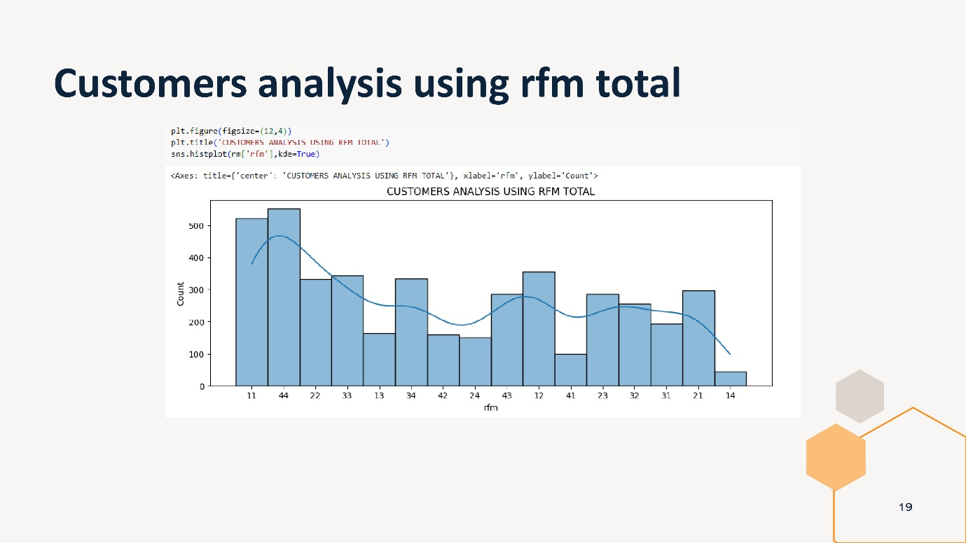*

**7. Reference Links**

* GitHub: [Repo](https://github.com/KapuluruBhuvaneswariVspdbct/ONLINE_RETAIL_ANALYSIS)

**8. Conclusion**

The Online Retail Analysis project highlighted how **Python-based analytics** can extract deep insights from large datasets, enabling better targeting, retention, and growth strategies.